COLLEGE OF ENGINEERING
DEPARTMENT OF CHEMICAL AND PETROLEUM ENGINEERING

PROCESS DYNAMICS & CONTROL
CHE 531 ASSIGNMENT II

BY

ABUBAKAR MUNIRATU ONEHDEFOJO
14/ENG01/016

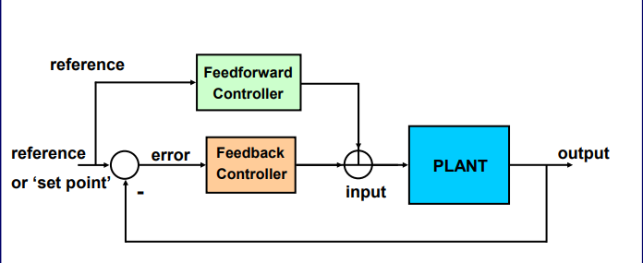
Figure 1. Feedforward and Feedback Controller

Feed Forward Control System
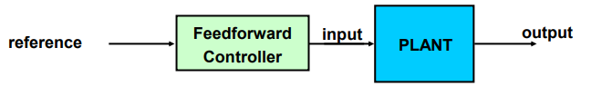
Figure 1. 1. Feed forward Control system
A feed forward system may measure a number of secondary variables in addition to the primary one. Control element responds to change in command or measured disturbance in a pre-defined way based on prediction of plant behavior.
- It can react before error actually occurs
- Overcome sluggish dynamics and delays
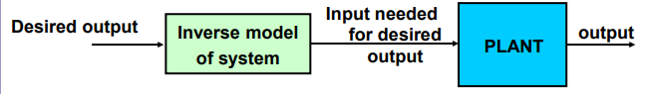
- Does not jeopardize stability.
Figure 1. 2. Feed forward Control system
The above is a model-based prediction of input.
4. Ideally consists of exact inverse model of the plant.
5. Can compensate for known plant dynamics, delays (before you get errors).
6. No sensors needed System response must be predictable
For example, a feed forward thermostat might measure external as well as internal temperatures, and it might sense whether doors and windows are open or closed. If the system senses that it is cold outside and someone opens a window, the system will proactively turn on the furnace in an attempt to prevent the temperature in the house from falling. Instead of waiting for the temperature to change at the thermostat, the system anticipates the effect of the open window and attempts to counteract the heat loss. Another example of a feed forward system is a video card that increases fan speed in response to intense graphics activity in an attempt to dissipate heat before the temperature actually begins to climb.

Limitations of feedforward control
- Effects of disturbance or command input must be predictable
- May not generalize to other conditions
- Will not be accurate if the system changes

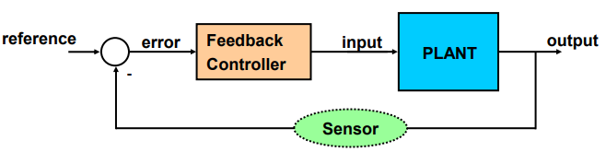
Feedback Control System
Figure 1. 3. Feedback Control system
Plant System: to be controlled
Reference: Desired value of output (also ‘set point’)
Controller: Computes compensatory command to the plant based on error
Sensor: (implied)
A feedback system measures a value and reacts to changes in that value. It is a control system which measures the variable of direct importance after a disturbance had its effect on it. Below are the features of a feedback controller:
- Reactive / Error-driven
- Automatically compensates for disturbances (controller acts on error)
- Automatically follows change in desired state (set point can change)
- Can improve undesirable properties of system/plant
- Can be very simple
For instance, your thermostat measures the ambient temperature in your home, and if the temperature falls below its minimum setting, the thermostat activates the furnace to warm your home back to the appropriate temperature. The thermostat measures the temperature, but it also feeds that value back into its control scheme to maintain the temperature.

Combining feedback and feedforward
Feedforward and feedback are often used together referring to figure 1. Feedforward component provides rapid response while Feedback component fills in the rest of the response accurately, compensating for errors in the model.

REFRENCES
https://www.clear.rice.edu/engi128/Handouts/Lec10-Control.pdf

