NAME: NWOSU CHISOM JOY

DEPARTMENT: CHEMICAL ENGINEERING

MATRIC NUMBER: 14/ENG01/021

COURSE TITLE: PROCESS DYNAMIC AND CONTROL I

COURSE CODE: CHE 531

DATE: 15TH OCTOBER, 2017

QUESTION
Compare and contrast feedforward and feedback control system.

ANSWERS
What is feedforward control system?
A feed forward system may measure a number of secondary variables in addition to the primary one. For example, a feed forward thermostat might measure external as well as internal temperatures, and it might sense whether doors and windows are open or closed. If the system senses that it is cold outside and someone opens a window, the system will proactively turn on the furnace in an attempt to prevent the temperature in the house from falling. Instead of waiting for the temperature to change at the thermostat, the system anticipates the effect of the open window and attempts to counteract the heat loss. Another example of a feed forward system is a video card that increases fan speed in response to intense graphics activity in an attempt to dissipate heat before the temperature actually begins to climb.

What is feedback control system?
A feedback system measures a value and reacts to changes in that value. For instance, your thermostat measures the ambient temperature in your home, and if the temperature falls below its minimum setting, the thermostat activates the furnace to warm your home back to the appropriate temperature. The thermostat measures the temperature, but it also feeds that value back into its control scheme to maintain the temperature.

COMPARISM
Feedback and Feedforward are two types of control schemes for systems that react automatically to changing environmental dynamics. Each utilizes sensor to measure important factors and a set of rules to react to changes in those factor.
CONTRACT
Sr. no | Point of Difference | Feedback control system | Feed Forward Control system
1 | Definition | Systems in which corrective action is taken after disturbances affect the output | Systems in which corrective action is taken before disturbances affect the output
2 | Necessary requirement | Not required | Measurable Disturbance or noise
3 | Corrective action | Corrective action taken after the disturbance occurs on the output. | Preventive action taken before the actual disturbance occurs on the output.
4 | Block Diagram | 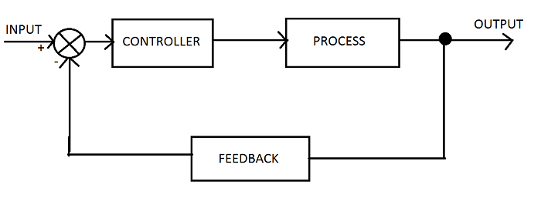 | 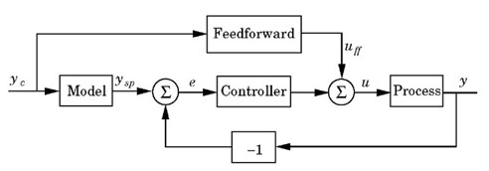
5 | Control Variable adjustment | Variables are adjusted depending on errors. | Variables are adjusted based on prior knowledge and predictions.
6 | Example | Use of roll sensor as feedback element in ship stabilization system. | Use of flowmeter as feed forward block in temperature control systems.

