OMAGBEMI AARON
16/ENG06/058
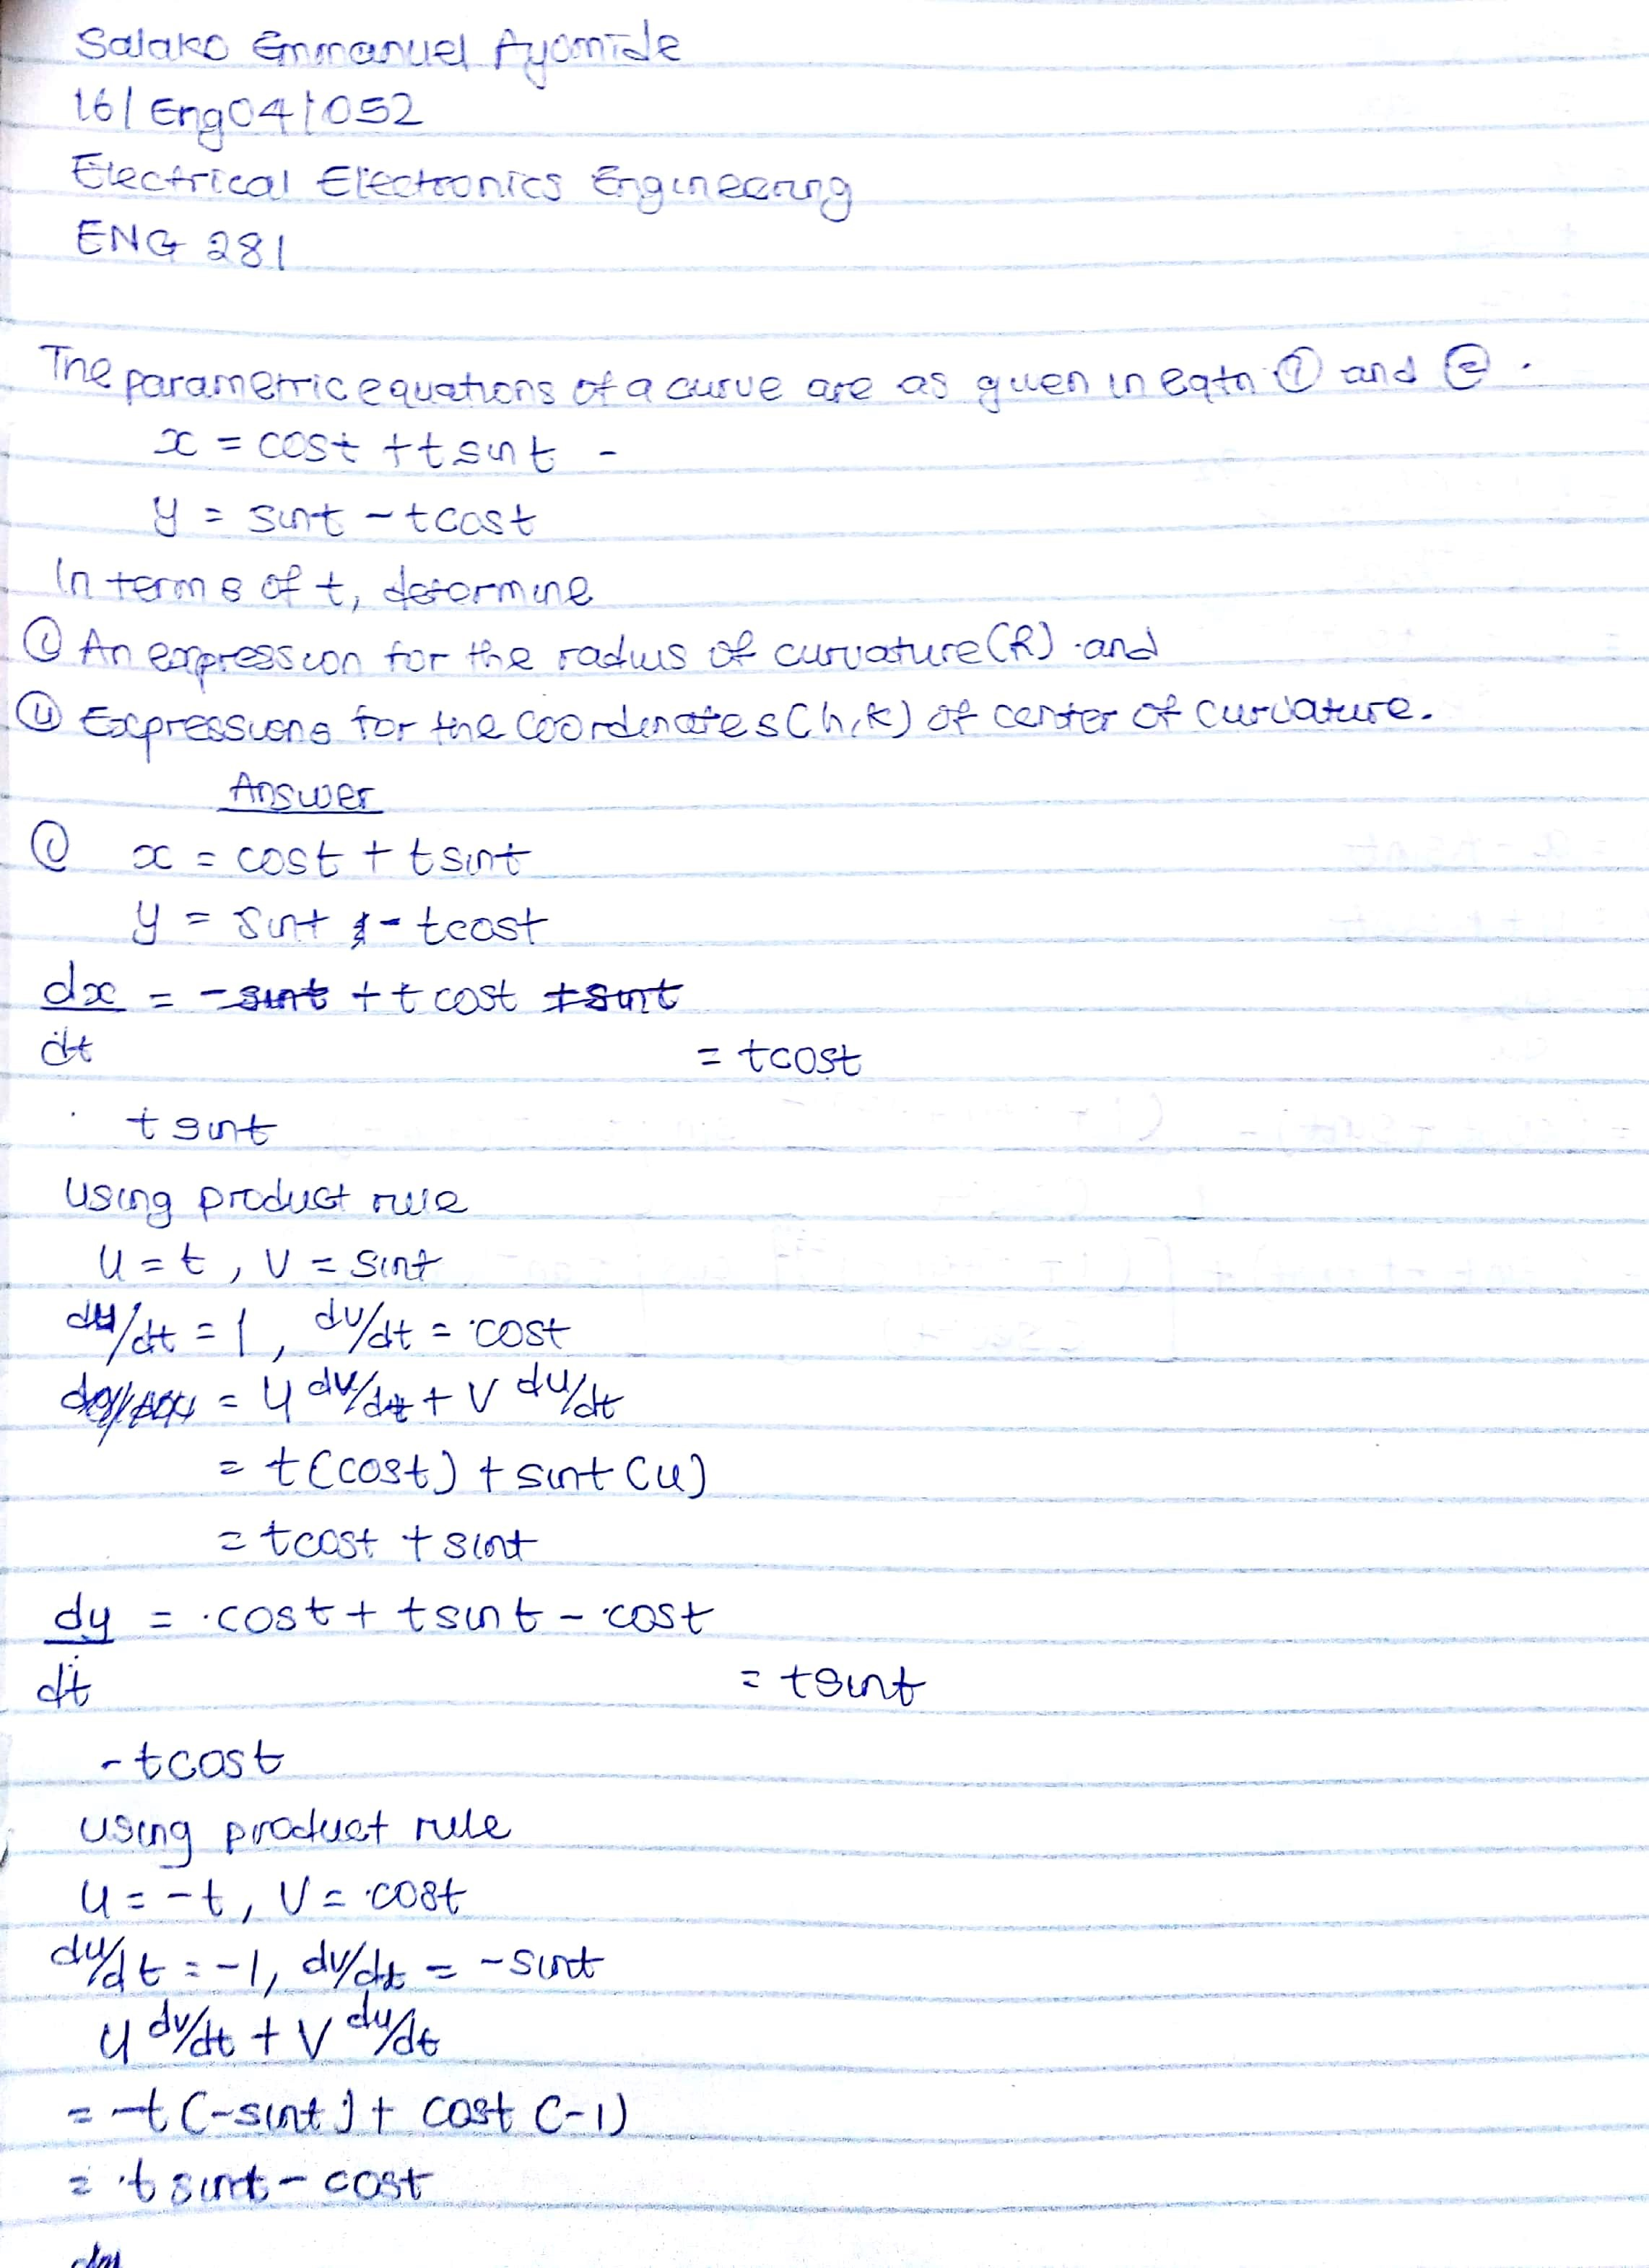
MECHANICAL ENGINEERING
ENG 281: ENGINEERING MATHEMATICS I
