NAME: CHIJIOKE CHIOMA MIRIAM
MAT NO: 14/ENG02/034
DEPT: CHEMICAL ENGINEERING
LEVEL: 500
PROCESS DYNAMICS AND CONTROL 1 (CHE 531) ASSIGNMENT 2
Compare and contrast a feed forward and feedback control system
Feed Forward Control System
A feed forward system is a term describing an element or pathway within a control system that passes a controlling signal from a source in its external environment, often a command signal from an external operator, to a load elsewhere in its external environment. A control system which has only feed-forward behavior responds to its control signal in a pre-defined way without responding to how the load reacts. Feed-Forward provides enhanced disturbance rejection capability which is essential to maintaining control of some highly dynamic, interacting processes. An example is a video card that increases fan speed in response to intense graphics activity in an attempt to dissipate heat before the temperature actually begins to climb.
In feed forward control the disturbances are measured and the controlled parameter is calculated based on some mathematical (or logical) model. There is no feedback to see if the system is really in the desired state or "how far" it is form the desired state. If disturbances not measured cause the systems outputs to differ from the desired one, the controller will not react.

Feedback back Control System
A feedback system measures a value and reacts to changes in that value. For instance, a thermostat which measures the ambient temperature in a home, and if the temperature falls below its minimum setting, the thermostat activates the furnace to warm the home back to the appropriate temperature. The thermostat measures the temperature, but it also feeds that value back into its control scheme to maintain the temperature.
In feedback control the systems outputs are measured and if they do not match the desired output (reference) the controlled parameter is recalculated. If the input does not change, these differences usually come from disturbances. The controller has a feedback from the systems output which quantifies "how far" it is from the desired state, regardless of what causes this difference.
S/N |  | Feed Forward | Feed Backward
1. | Definition | Systems in which corrective action is taken before disturbances affect the output | Systems in which corrective action is taken after disturbances affect the output
2. | Necessary requirement | Measurable Disturbance or noise | Not required
3. | Corrective action | Corrective action taken before the actual disturbance occurs on the output. | Corrective action taken after the disturbance occurs on the output.
4. | Block Diagram | 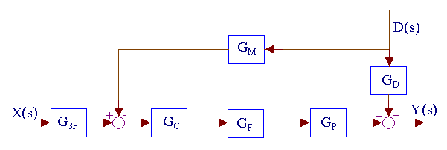 | 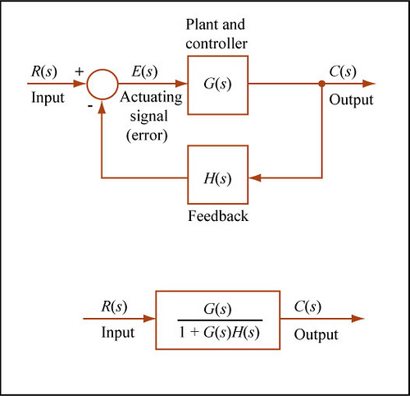
5. | Control Variable adjustment | Variables are adjusted based on prior knowledge and predictions. | Variables are adjusted depending on errors.
6. | Examples | Use of flow meter as feed forward block in temperature control systems. | Use of roll sensor as feedback element in ship stabilization system.
Table 1 showing the contrast between feed forward and feedback control systems
Comparison between feed forward and feed back
Both feed forward and feedback controls are deployed in control systems design.
They both have inputs and an output.

