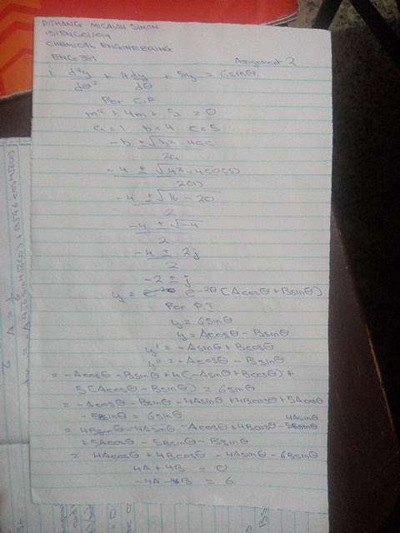
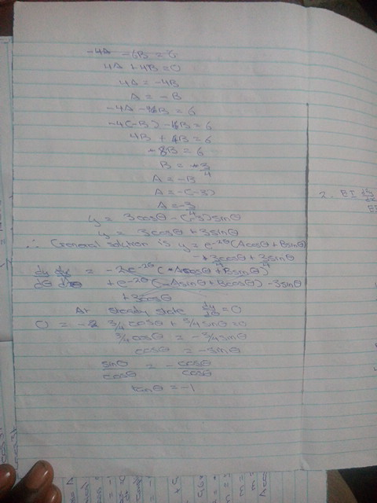
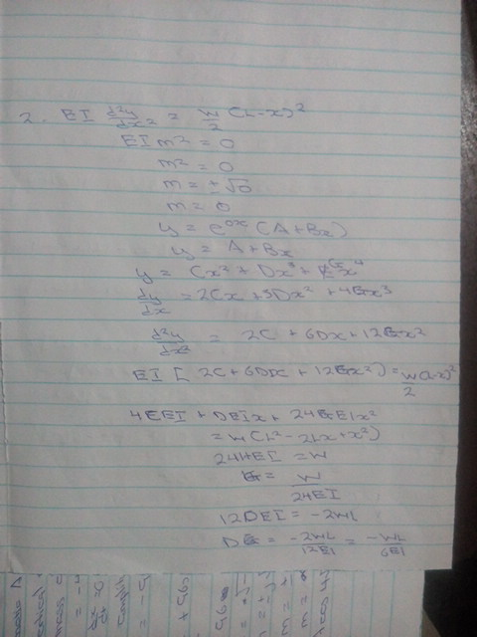
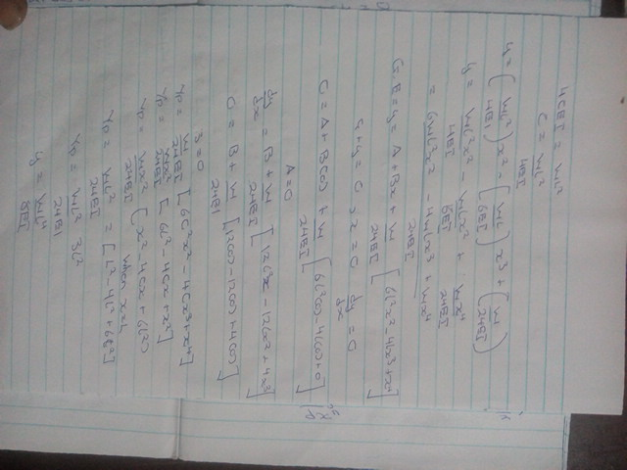

θ | y
0 | -0.75
5 | -0.68178
10 | -0.60837
15 | -0.53033
20 | -0.44825
25 | -0.36277
30 | -0.27452
35 | -0.18418
40 | -0.09244
45 | 0
50 | 0.092443
55 | 0.184182
60 | 0.274519
65 | 0.362767
70 | 0.448254
75 | 0.53033
80 | 0.60837
85 | 0.681779
90 | 0.75
95 | 0.812513
100 | 0.868842
105 | 0.918559
110 | 0.961285
115 | 0.996695
120 | 1.024519
125 | 1.044546
130 | 1.056624
135 | 1.06066
140 | 1.056624
145 | 1.044546
150 | 1.024519
155 | 0.996695
160 | 0.961285
165 | 0.918559
170 | 0.868842
175 | 0.812513
180 | 0.75
185 | 0.681779
190 | 0.60837
195 | 0.53033
200 | 0.448254
205 | 0.362767
210 | 0.274519
215 | 0.184182
220 | 0.092443
225 | 0
230 | -0.09244
235 | -0.18418
240 | -0.27452
245 | -0.36277
250 | -0.44825
255 | -0.53033
260 | -0.60837
265 | -0.68178
270 | -0.75

