Olomowewe Zainab omodunni

15/ENG 01/012

Chemical engineering

CHE 311 Assignment

4/10/2017

1. classification of flows with illustration

A. Steady and unsteady flow

Steady flow refers to the flow in which the fluid properties at a point in the system do not change over time. Simply, it’s a flow in which the velocity of the fluid at a particular fixed point does not change with time. E.g. a constant discharge through a pipe

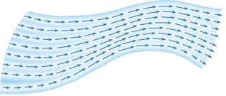

Fig 1.0 Illustration of a steady flow

Unsteady flow

UnSteady flow refers to the flow in which the fluid properties change over time. Simply, it’s a flow in which the velocity of the fluid can differ between two points . E.g .flow through a tight pipe bend.

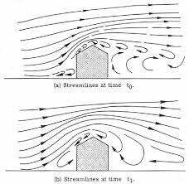

Fig 2.0 illustration of an unsteady flow

B. compressible and incompressible

Compressible flow refers to the fluid flow in which the fluid's density varies with the trending pressure. E.g. shock waves around sharp and blunt bodies

Incompressible flow (isochoric flow) refers to a flow in which the material density is constant within a fluid parcel—an infinitesimal volume that moves with the flow velocity.

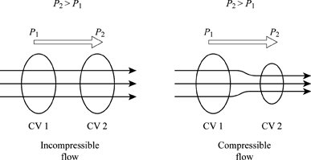

Fig 3.0 illustration of compressible and incompressible flows

C. uniform and non-uniform

A uniform flow is that in which the flow parameters remain constant with distance along the flow path. E.g. flow of a liquid through a pipeline of constant diameter

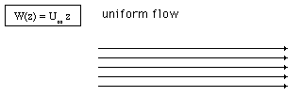

Fig 4.0 Illustration of a uniform flow

non-uniform flow is that in which the flow parameters vary and are different at different points on the flow path. E.g a wave travelling along a channel

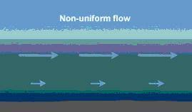

Fig 5.0 illustration of a non-uniform flow

D. rotational and irrotational flow

Rotational flow is a flow in which the fluid particles while flowing along stream lines rotate about their own axis .

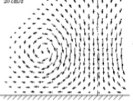

Fig 6.0 illustration of a rotational flow

Irrotational flow is a flow in which the fluid particles while flowing along stream lines don’t rotate about their own axis.

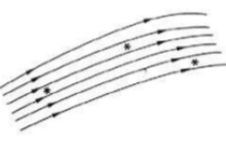

Fig. 7.0 illustration of an irrational flow

E. viscous and non-viscous

viscous flow A type of fluid flow in which there is a continuous steady motion of the particles, the motion at a fixed point always remaining constant. The flow of the fluid is usually accompanied by much viscosity

An inviscid flow is the flow of an ideal fluid that’s assumed to have no viscosity.

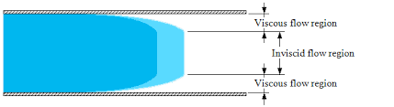

Fig 8.0 Illustration of a viscous and an inviscid flow

F. separated and non-separated flow

A flow is said to be separated when the fluid flow becomes detached from the surface of the object, and instead takes the forms of eddies and vortices.

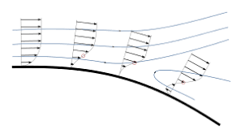

Fig 9.0 illustration of a separated flow

A non-separated flow is that which doesn’t become detached from the surface of the object it comes in contact with.

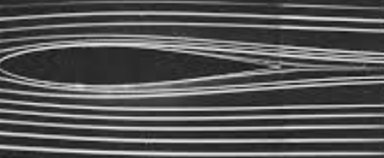

Fig 10.0 illustration of a non-separated flow

