NAME: SAKA YETUNDE BODUNRIN
MATRIC NO: 15/ENG01/016
DEPARTMENT: CHEMICAL ENGINEERING
COURSE CODE: CHE 301
ASSIGNMENT
Steady and Unsteady Flows
Velocity, pressure and other properties of fluid flow can be functions of time (apart from being functions of space). If a flow is such that the properties at every point in the flow do not depend upon time, it is called a steady flow. Mathematically speaking for steady flows,
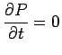
where P is any property like pressure, velocity or density. Thus,
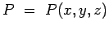
Unsteady or non-steady flow is one where the properties do depend on time.
It is needless to say that any start up process is unsteady. Many examples can be given from everyday life- water flow out of a tap which has just been opened. This flow is unsteady to start with, but with time does become steady.
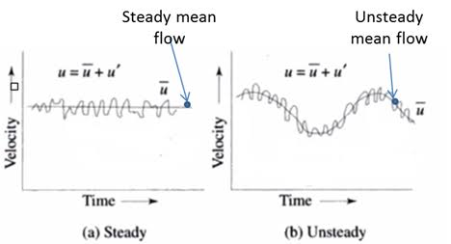

Compressible and Incompressible Flows
The compressibility of a fluid is the reduction of the volume of the fluid due to external pressures acting on it. A compressible flow is the flow that experiences volume reduction in the presence of an external pressure. The quantitative measurement of the compressibility is taken as the relative volume change of the liquid in response for a pressure change. In reality, every gas is highly compressible, but liquids are not highly compressible. The density of the fluid can be changed with application of pressure.
An incompressible flow is a flow whose volume does not change due to external pressure. Most of the basic calculations done in fluid dynamics are done assuming the flow is incompressible. The approximation of incompressibility is acceptable for most of the liquids as their compressibility is very low. However, the compressibility of gases is high, so gases cannot be approximated as incompressible fluids. The compressibility of an incompressible fluid is always zero. The density of the fluid cannot be changed by applying pressure.
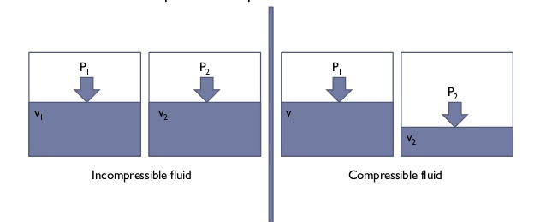
Uniform and non-uniform flow
A uniform flow is one in which all velocity vectors are identical (in both direction and magnitude) at every point of the flow for any given instant of time. Flows for which this is not true are said to be non-uniform.

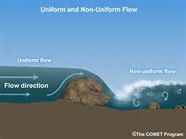

Rotational and Irrotational Flow
To classify any flow as Rotational or Irrotational the angular motion of the fluid elements is analysed. If the angle between the two intersecting lines of the boundary of the fluid element changes while moving in the flow, then the flow is a Rotational Flow. But if the fluid element rotates as a whole and there is no change in angles between the boundary lines then the flow is Irrotational Flow.
This means that there should be some deformation in the fluid element in a Rotational Flow. Such deformation of the fluid element or the shear strain is necessarily caused by tangential forces or shear stresses. Shear stresses are caused by viscosity, thus the flow of viscous fluids is rotational. But this does not mean that the flow of non-viscous or ideal fluid is always irrotational. The flow of ideal fluids can be rotational by external work or heat interaction.
Viscous and Inviscid flow
Viscous flow is the flow in which the frictional effects are significant. Inviscid flow is the flow of an inviscid fluid, in which the viscosity of the fluid is equal to zero.
When two fluid layers move relative to one other, a friction force develops between them and the slower layer tries to slow down the faster layer. This internal resistance to flow is quantified by the fluid property viscosity, which is a measure of internal stickiness of the fluid. Viscosity is caused by cohesive forces between the molecules in liquids and by molecular collisions in gases. There is no fluid with zero viscosity, and thus all fluid flows involve viscous effects to some degree. However, in many flows of practical interest, there are regions (typically regions not close to solid surfaces) where viscous forces are negligibly small compared to inertial or pressure forces. Neglecting the viscous terms in such inviscid flow regions greatly simplifies the analysis without much loss in accuracy.
The development of viscous and inviscid regions of flow as a result of inserting a flat plate parallel into a fluid stream of uniform velocity is shown. The fluid sticks to the plate on both sides because of the no-slip condition, and the thin boundary layer in which the viscous effects are significant near the plate surface is the viscous flow region. The region of flow on both sides away from the plate and unaffected by the presence of the plate is the inviscid flow region.
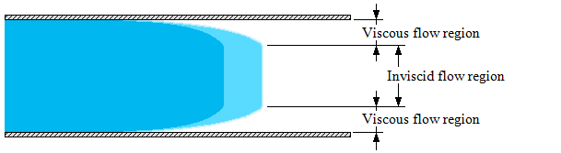
Separated and Unseparated flow
Flow separation occurs when the boundary layer travels far enough against an adverse pressure gradient that the speed of the boundary layer relative to the object falls almost to zero. The fluid flow becomes detached from the surface of the object, and instead takes the forms of eddies and vortices. In aerodynamics, flow separation can often result in increased drag, particularly pressure drag which is caused by the pressure differential between the front and rear surfaces of the object as it travels through the fluid.
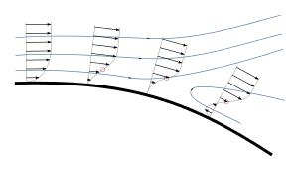
a) Separated flow

