NAME: PATRICK EMEKA OBIANWUZIA
MATRIC NUMBER: 15/SCI14/018
COURSE CODE: CHE 311

CLASSIFICATION OF FLOWS
- COMPRESSIBLE AND INCOMPRESSIBLE FLOW
Compressible flow (gas dynamics) is the branch of fluid mechanics that deals with flows having significant changes in fluid density. Gases, mostly, display such behaviour. While all flows are compressible, flows are usually treated as being incompressible when the Mach number (the ratio of the speed of the flow to the speed of sound) is less than 0.3 (since the density change due to velocity is about 5% in that case). The study of compressible flow is relevant to high-speed aircraft, jet engines, rocket motors, high-speed entry into a planetary atmosphere, gas pipelines, commercial applications such as abrasive blasting, and many other fields.
incompressible flow (isochoric flow) refers to a flow in which the material density is constant within a fluid parcel—an infinitesimal volume that moves with the flow velocity. An equivalent statement that implies incompressibility is that the divergence of the flow velocity is zero (see the derivation below, which illustrates why these conditions are equivalent).
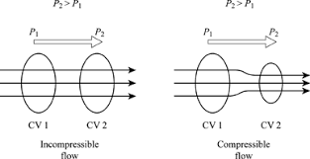

- UNIFORM AND NON UNIFORM FLOW
The flow is defined as uniform flow when in the flow field the velocity and other hydrodynamic parameters do not change from point to point at any instant of time.
When the velocity and other hydrodynamic parameters changes from one point to another the flow is defined as non-uniform flow.

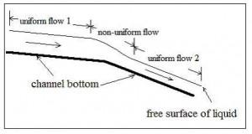

- ROTATIONAL AND IRROTATIONAL FLOW
Irrotational flow is flow in which all the tiny bits of fluid are moving along and translating and going around obstacles and what have you without every rotating about their own infinitesimal centers of gravity.
A fluid flow is said to be a rotational if fluid particles are rotating about their own mass center, otherwise the flow is irrotational.

- VISCOUS AND INVISCID FLOWS
Inviscid flow is the flow of an inviscid fluid, in which the viscosity of the fluid is equal to zero.
Flows in which the frictional effects are significant are called viscous flows

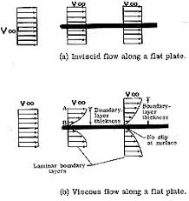

- SEPARATED AND UNSEPARATED FLOWS
Flow separation occurs when the boundary layer travels far enough against an adverse pressure gradient that the speed of the boundary layer relative to the object falls almost to zero
