COLLEGE OF ENGINEERING
DEPARTMENT OF CHEMICAL AND PETROLEUM ENGINEERING

PROCESS DYNAMICS & CONTROL
CHE 531 ASSIGNMENT II

BY

ABUBAKAR MUNIRATU ONEHDEFOJO
14/ENG01/016

QUESTION 1
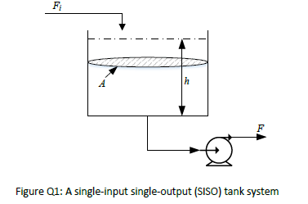

Mass Balance
$\frac{dm}{dt}=Ṁ_{in}-Ṁ_{out}$ -----------------------------------(1a)
$ρ=\frac{m}{V}$ $m=ρV$ $Ṁ=ρF$
$\frac{d(ρV)}{dt}=ρ_{in}F_{in}-ρ_{out}F_{out}$-------------------------(1b)
$ρ\frac{dV}{dt}=ρ\left(F_{in}-F_{out}\right)$-------------------------------(1c)
$\frac{dV}{dt}=F_{in}-F_{out}$--------------------------------------(2)
$F=β\sqrt{h}$ $V=Ah$
$\frac{d(Ah)}{dt}=F_{in}-β\sqrt{h}$---------------------------------(3a)
$A\frac{dh}{dt}=F_{in}-β\sqrt{h}$----------------------------------(3b)
$A\frac{dh}{dt}+β\sqrt{h}=F_{in}$-----------------------------------(4)
$β\sqrt{h}$ is a non-linear term. To develop the linearized approximation for the non-linear model, the Taylor series expansion of the term, $β\sqrt{h}$, around a point $h_{0}$ will be taken:
$$β\sqrt{h}=β\sqrt{h_{0}}+{\left[\frac{d}{dh}β\sqrt{h}\right]}_{h=h_{0}}\left(h-h_{0}\right)+{\left[\frac{d^{2}}{dh^{2}}β\sqrt{h}\right]}_{h=h_{0}}\frac{{\left(h-h_{0}\right)}^{2}}{2!}+…$$
$$=β\sqrt{h_{0}}+\frac{β}{2\sqrt{h_{0}}}\left(h-h_{0}\right)-\frac{β^{2}}{8^{3}\sqrt{{h_{0}}^{2}}}{\left(h-h_{0}\right)}^{2}+…$$
Neglecting terms of order two and higher. We’ll have:
$β\sqrt{h}≈β\sqrt{h_{0}}+\frac{β}{2\sqrt{h_{0}}}\left(h-h_{0}\right)$-----------(*)
Substituting equation (*) in equation (4) will give
$A\frac{dh}{dt}+\frac{β}{2\sqrt{h_{s}}}h=F_{i}-\frac{β}{2}\sqrt{h_{s}}$-------------------(5)
The equation above is the dynamic state equation. At steady state, the equation will be:
$A\frac{dh_{s}}{dt}+\frac{β}{2\sqrt{h_{s}}}h_{s}=F_{is}-\frac{β}{2}\sqrt{h_{s}}$-------------------(6)
Subtracting equation 6 from 5
$A\frac{d(h-h_{s})}{dt}+\frac{β}{2\sqrt{h_{s}}}(h-h_{s})=(F_{i}-F_{is})$-------------------(7)
But $h^{'}=h-h_{s}$ $F^{'}=F_{i}-F_{is}$, then equation (7) will become
$A\frac{dh^{'}}{dt}+\frac{β}{2\sqrt{h_{s}}}h^{'}=F^{'}$-------------------(8)
Dividing through by $\frac{β}{2\sqrt{h_{s}}}$ will give
$\frac{2A\sqrt{h_{s}}}{β}\frac{dh^{'}}{dt}+h^{'}=\frac{2\sqrt{h_{s}}}{β}F^{'}$--------------------(9)
Let $τ_{p}=\frac{2A\sqrt{h_{s}}}{β}$ and $K_{p}=\frac{2\sqrt{h_{s}}}{β}$
Then equation (9) will be
$τ_{p}\frac{dh^{'}}{dt}+h^{'}= K_{p}F^{'}$----------------(10)
To find the transfer function, we’ll have to get the Laplace of the system:
$$y=y(s)$$
$$y^{'}\left(t\right)=sy\left(s\right)-y\left(0\right)$$
$τ_{p}[s\overline{h}\left(s\right)-\overline{h}\left(0\right)]+\overline{h}\left(s\right)= K_{p}\overline{F}\left(s\right)$----------------(11)
$$h=h_{s}, \overline{h}\left(0\right)=0$$
$τ_{p}s\overline{h}\left(s\right)+\overline{h}\left(s\right)= K_{p}\overline{F}\left(s\right)$-------------------------------12
$\overline{h}\left(s\right)\left(τ_{p}s+1\right)=K_{p}\overline{F}\left(s\right)$--------------------------------------12a
$G\left(s\right)=\frac{\overline{h}\left(s\right)}{\overline{F}\left(s\right)}=\frac{K_{p}}{\left(τ_{p}s+1\right)}$----------------------------------------13
Equation 13 is the transfer function equation.
$$A=2.5m^{2} h_{s}=4m β=2\frac{m^{\frac{5}{2}}}{min}$$
$$τ_{p}=\frac{2A\sqrt{h_{s}}}{β}=\frac{2*2.5*\sqrt{4}}{2}=5$$
and
$$K_{p}=\frac{2\sqrt{h_{s}}}{β}=\frac{2*\sqrt{4}}{2}=2$$
$$G\left(s\right)=\frac{\overline{h}\left(s\right)}{\overline{F}\left(s\right)}=\frac{K_{p}}{\left(τ_{p}s+1\right)}=\frac{2}{5s+1}$$
To solve manually:
$$G\left(s\right)=\frac{\overline{h}\left(s\right)}{\overline{F}\left(s\right)}=\frac{K_{p}}{\left(τ_{p}s+1\right)}=\frac{2}{5s+1}$$
$$\overline{h}\left(s\right)=\frac{2}{5s+1}\overline{F}\left(s\right)$$
Applying a unit step change in the manipulated variable:
$$\overline{h}\left(s\right)=\frac{2}{5s+1}*\frac{1}{s}=\frac{2}{s\left(5s+1\right)}$$
Solving by Partial fraction
$$\overline{h}\left(s\right)=\frac{2}{s\left(5s+1\right)}=\frac{A}{s}+\frac{B}{5s+1}$$
$$2=A\left(5s+1\right)+Bs$$
Let $s=0$
$$2=A\left(5(0)+1\right)+B(0)$$
$$A=2$$
Let $s=-\frac{1}{5}$
$$2=A\left(5(-\frac{1}{5})+1\right)+B(-\frac{1}{5})$$
$$B=-10$$
$$\overline{h}\left(s\right)=\frac{2}{s\left(5s+1\right)}=\frac{2}{s}-\frac{10}{5s+1}$$
Taking the inverse Laplace of $\overline{h}\left(s\right)$ will give:
$$\overline{h}\left(t\right)=L^{-1}\left\{\overline{h}\left(s\right)\right\}=L^{-1}\left\{\frac{2}{s}-\frac{10}{5s+1}\right\}$$
$$\overline{h}\left(t\right)=L^{-1}\left\{\frac{2}{s}\right\}-L^{-1}\left\{\frac{10}{5s+1}\right\}$$
$$\overline{h}\left(t\right)=L^{-1}\left\{\frac{2}{s}\right\}-{2*L}^{-1}\left\{\frac{1}{s+\frac{1}{5}}\right\}$$
$$\overline{h}\left(t\right)=2-2e^{-\frac{1}{5}t}$$
$$\overline{h}\left(t\right)=2(1-e^{-\frac{1}{5}t})$$
$At t=1min, h(t)= 0.362538$, the model reaches steady state at t=30mins

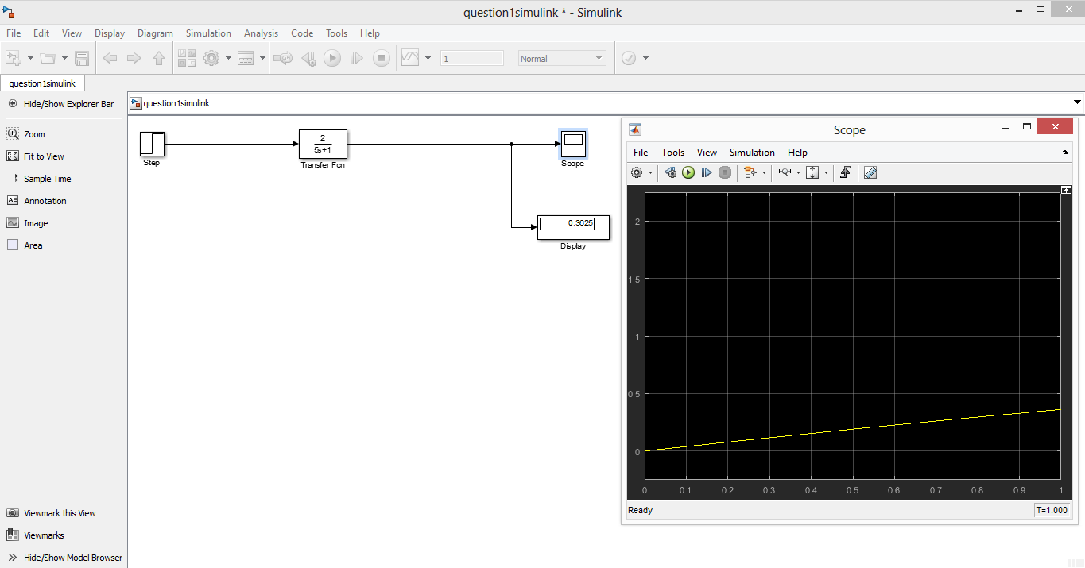
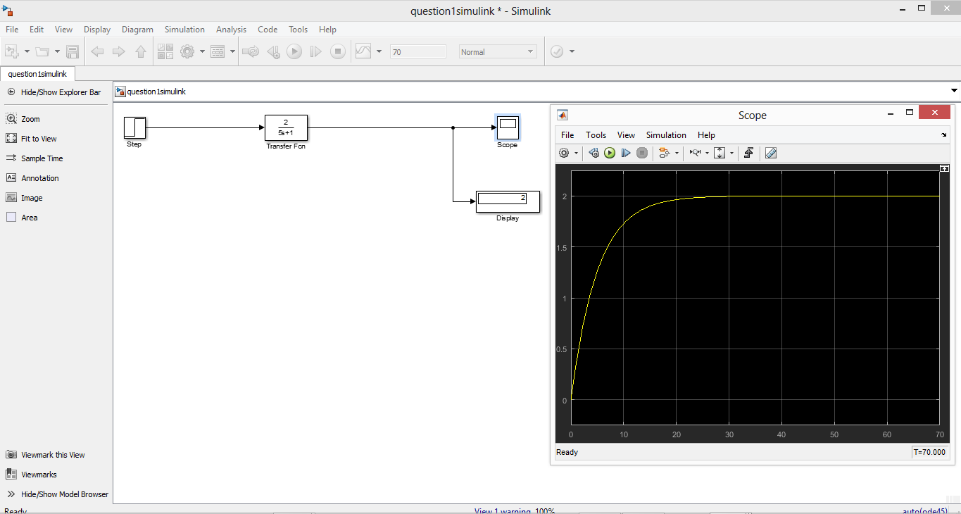
QUESTION 2
$$G_{p}\left(s\right)=\frac{2}{5s+1}$$
$$G_{f}\left(s\right)=G_{m}\left(s\right)=1, k_{c}=1.5$$
Set point method:
$$y\left(s\right)=\frac{G_{p}\left(s\right)G_{f}\left(s\right)G_{c}\left(s\right)}{1+G_{p}\left(s\right)G_{f}\left(s\right)G_{c}\left(s\right)G_{m}\left(s\right)}Y_{sp}\left(s\right)$$
$$y\left(s\right)=\frac{\frac{2}{5s+1}*1.5}{1+\frac{2}{5s+1}*1.5}*\frac{3}{s}$$
$$y\left(s\right)=\frac{\frac{3}{5s+1}}{1+\frac{3}{5s+1}}*\frac{3}{s}=\frac{3}{5s+4}*\frac{3}{s}=\frac{9}{s(5s+4)}$$
Solving by Partial fraction
$$y\left(s\right)=\frac{9}{s\left(5s+4\right)}=\frac{A}{s}+\frac{B}{5s+4}$$
$$9=A\left(5s+4\right)+Bs$$
Let $s=0$
$$9=A\left(5(0)+4\right)+B(0)$$
$$A=\frac{9}{4}$$
Let $s=-\frac{4}{5}$
$$9=A\left(5(-\frac{4}{5})+4\right)+B(-\frac{4}{5})$$
$$B=-\frac{45}{4}$$
$$y\left(s\right)=\frac{9}{s\left(5s+4\right)}=\frac{9}{4}*\frac{1}{s}-\frac{45}{4}\left(\frac{1}{5s+4}\right)$$
$$y\left(s\right)=\frac{9}{4}\left(\frac{1}{s}-\frac{5}{5s+4}\right)$$
$$y\left(s\right)=\frac{9}{4}\left(\frac{1}{s}-\frac{1}{s+\frac{4}{5}}\right)$$
Taking the inverse Laplace of $\overline{h}\left(s\right)$ will give:
$$y\left(t\right)=L^{-1}\left\{y\left(s\right)\right\}=\frac{9}{4}\left[L^{-1}\left\{\frac{1}{s}-\frac{1}{s+\frac{4}{5}}\right\}\right]$$
$$y\left(t\right)=\frac{9}{4}\left[L^{-1}\left\{\frac{1}{s}\right\}-L^{-1}\left\{\frac{1}{s+\frac{4}{5}}\right\}\right]$$
$$y\left(t\right)=$$
$$y\left(t\right)=\frac{9}{4}(1-e^{-\frac{4}{5}t})$$

