NAME: AKOMOLAFE DAVID OLUSEGUN
MATRIC N0: 15/ENG01/003
DEPARTMENT: CHEMICAL ENGINEERING
COURSE CODE: CHE 311

- Explain the following types of flows:

- Compressible and incompressible flow
When change in density in a flow is non-zero it is called compressible flow whereas when change in density in a flow is zero it is called incompressible flow

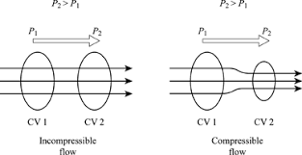

- Uniform and non-uniform flow.
Uniform flow is the flow of a fluid in which each particle moves along its line of flow with constant speed and in which the cross section of each stream tube remains unchanged whereas flow is said to be non-uniform, when there is a change in velocity of the flow at different points in a flowing fluid, for a given time.

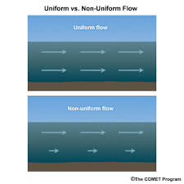

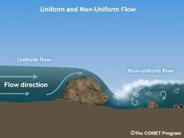

- Rotational and irrotational flow.

When a fluid particle rotates about its centre of mass, while moving in the direction of flow it is referred to as rotational whereas when a fluid particle rotates about its centre of mass, while moving in the direction of flow it is referred to as rotational.

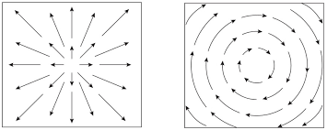

- Viscous and inviscid flow.

Viscous flows are always rotational because of shear stress that is exerted on the fluid element due to viscosity.
Inviscid flow is the flow of an inviscid fluid, in which the viscosity of the fluid is equal to zero.

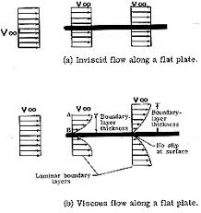

- Separated and unseparated flow

