NAME: ABAI OMOLOLA MARY
DEPARTMENT: CHEMICAL ENGINEERING
MATRIC NUMBER: 15/ENG01/001
COURSE CODE: CHE 311

STEADY FLOW:
A steady flow is the one in which the quantity of liquid flowing per second through any section, is constant. This is the definition for the ideal case. True steady flow is present only in Laminar flow. In turbulent flow, there are continual fluctuations in velocity. Pressure also fluctuate at every point. But if this rate of change of pressure and velocity are equal on both sides of a constant average value, the flow is steady flow. The exact term use for this is mean steady flow.

UNSTEADY FLOW:
A flow in which quantity of liquid flowing per second is not constant, is called unsteady flow.
Unsteady flow is a transient phenomenon. It may be in time become steady or zero flow. For example when a valve is closed at the discharge end of the pipeline. Thus, causing the velocity in the pipeline to decrease to zero. In the meantime, there will be fluctuations in both velocity and pressure within the pipe.
Unsteady flow may also include periodic motion such as that of waves of beaches. The difference between these cases and mean steady flow is that there is so much deviation from the mean. And the time scale is also much longer.
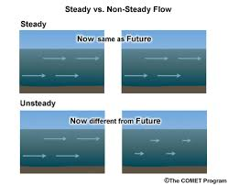
Fig 1.1 diagram showing steady and unsteady flow

Uniform

A uniform flow is one in which the velocity is same at a given instant at every point the fluid.

Non-uniform flow
A non-uniform flow is one in which velocity is not constant at a given instant.

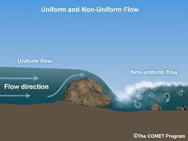
Fig 1.2 showing uniform and non uniform flow

ROTATIONAL FLOW:
The flow in which the fluid particles also rotate about their own axes while flowing, is called rotational flow. Distortion in this case is less than irrotational flow.
For example
In a rotational flow if a match stick is thrown on the surface of the moving fluid, it will rotateabout its own axes

IRROTATIONAL FLOW:

Irrotational flow is a flow in which each element of the moving fluid undergoes no net rotation with respect to a chosen coordinate axes from one instant to other. A well-known example of irrotational motion is that of the carriages of the Ferris wheel (giant wheel).

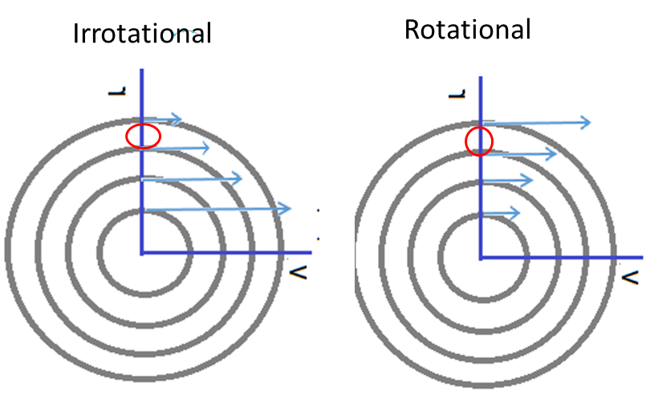
Fig 2.1 diagram showing rotational and irrorational flow

VISCOUS FLOW:
A type of fluid flow in which there is a continuous steady motion of the particles, the motion at a fixed point always remaining constant.

INVISCID FLOW:
A flow is said to be inviscid if the effects of viscosity are absent. Since all real fluids have finite viscosity, strictly speaking the concept of inviscid flow is applicable only to ideal fluids. However, the fluid flow away from the solid boundary may be approximated as inviscid flow as the effects of viscosity are significant only in a narrow region close to the solid boundary (boundary layer).

