**NAME: OTUEKONG.C. WILLIAM**

**MATRIC NUMBER: 15/SCI01/040**

**COURSE CODE: CSC309**

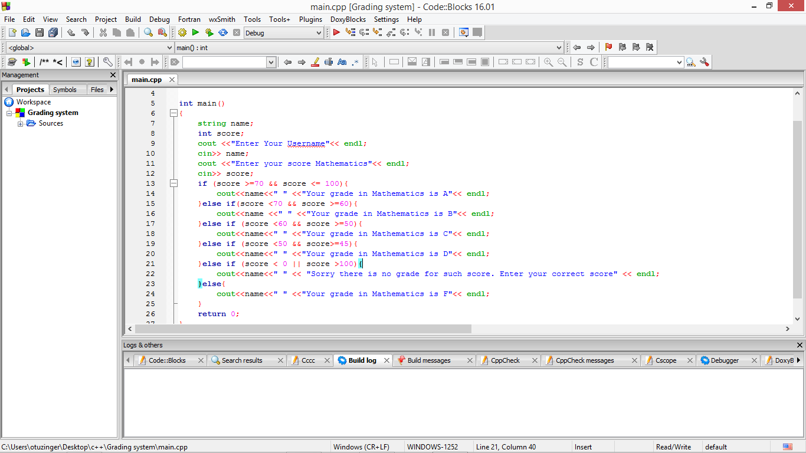Grading system picture

