NAME: OLADOSU F. OLUWAFERANMI

MATRIC. NO: 15/SCI01/029

COURSE: CSC 309

A SIMPLE GRADING SYSTEM PROGRAM

SOURCE CODE:
1.
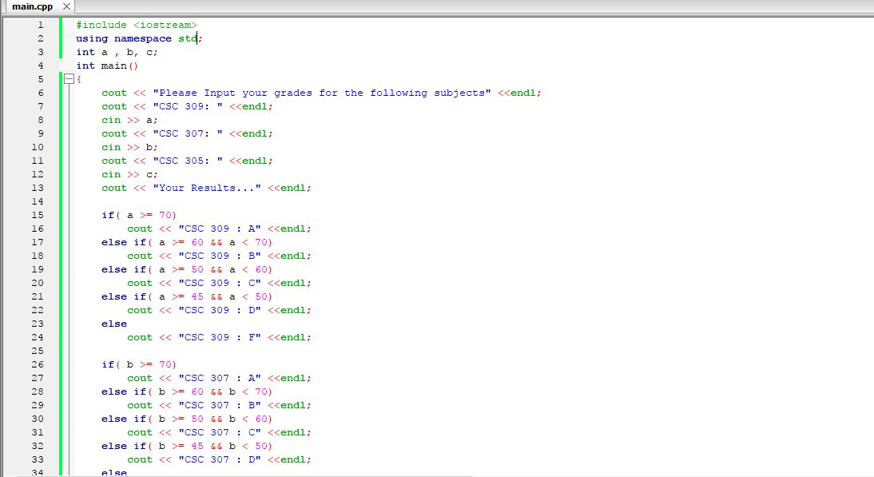
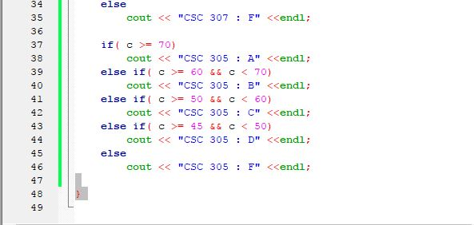

2.

Results:

1.
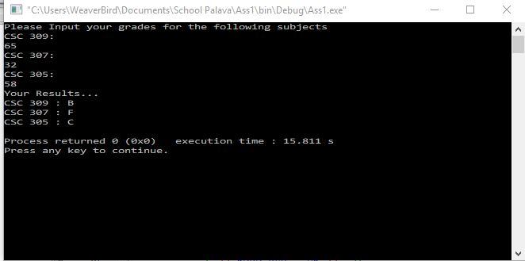
2.

