GLASSWARE CLEANING
MLS 201

Introduction
Laboratory procedures require specific, sensitive and precise methods for a reliable result.
These methods should involve good glassware cleaning to ensure excellent laboratory results.
In all instances laboratory wares should be physically clean, chemical residue free, grease free and be sterile.
Laboratory glassware are a variety of materials made of glass used for scientific experiments and analysis in all fields of science especially the diagnostic and research field of medicine.

Types of Laboratory Glassware
Merck glassware
Duran glassware
Rankem glassware
Borosil R glassware
Borosilicate quality glassware
Hydrometer
Thermometer
Crucibles-silica
-Examples of glassware items include;
*Beakers
*Test tubes
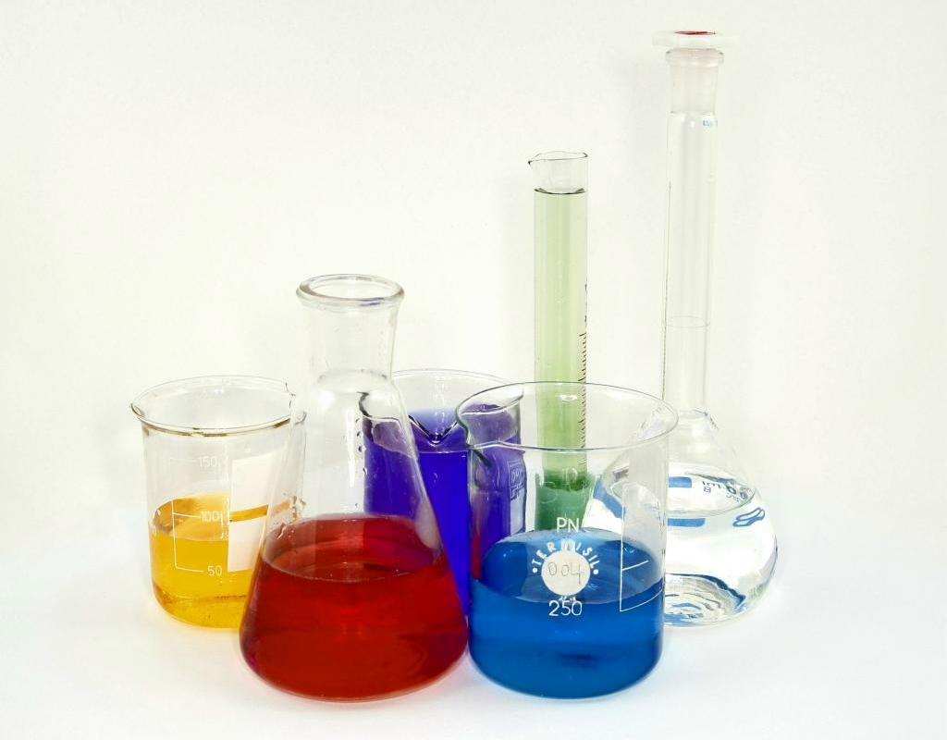
*Glass petri dishes
*Pipettes
*Graduated cylinders
*Microscopic slides
*Jars etc.

Glassware cleaning
Glassware cleaning is dependent on the type of glass and the agent to be cleaned off the glass.
In lieu of this, there are different method of glassware cleaning.
1. Initial Glass Cleaning
This is the first step in glassware cleaning.
If the glassware isn’t clean after these initial steps you can go on to more aggressive cleaning protocols.
Method
Scrape away any thick solid material from the glass if possible.

Glassware cleaning(Methods)
Wipe away any grease from the glass joints with a solvent like acetone which can be used to help remove the grease.
Put the glassware in a warm cleaning solution of detergent and water.
Use a brush or cleaning pad to clean any residue or contamination.
Rinse with tap water first, followed by deionized water and allow to dry.
Most new glass is slightly alkaline and should be washed upon receipt and generally can be soaked in a 1% HCL or HNO3 solution before wash , rinse in tap followed by DI water and allow to dry.

Glassware cleaning(Methods)
2. Mild Cleaning Methods
If the initial cleaning method fails try gentle solvents for long term soaking.
When dealing with the gentle aqueous solutions heat soaking or, in some instances, mechanical agitation such as stirring, shaking, or sonication can enhance its productivity.
The common gentle aqueous cleaning mixtures are described below.

Common Gentle Aqueous Cleaning Mixtures and their Uses

Deionized water for diluting out absorbed ions – passive soaking.
Dilute surfactants Solubilizing lipid material – agitation, brushing, rubbing or sonication.
Protein or saccharide hydrolyzing enzymes Breaking larger structures into soluble molecules – passive soaking.
Metal chelating compounds Insoluble salts become more so by removing the metal ion – passive soaking.
Dilute strong acids Insoluble salt’s anion is soluble as its acid form – soak or agitation.
Concentrated weak acids Insoluble salt’s anion is soluble as its acid form – soak or brush.
Dilute solutions of: Phosphates, Carbonates or Ammonia All create low levels of hydroxide ions for solubilizing weak insoluble acidic solids or hydrolyzing ester bonds – soak, agitate or brush.

Glassware cleaning(Methods)
3. Using Organic Solvents
- Organic solvents are often used to remove contaminants from glass.
- Basically, if it can be readily dissolved in an organic solvent it can be removed by these means.
- The use of organic solvents is complicated due to their flammability and toxicity.
- When working with solvents proper ventilation and appropriate PPE (suitable glove compatibility with the solvent) are necessary.
- Moistening a cloth with solvent is good for easily accessed surfaces.
- Agitating solvent inside of a glass container is another method.

Glassware cleaning(Methods)
4. Aggressive Cleaning Methods
If the mild, aqueous and organic solvent methods described above are not effective then aggressive cleaning method is adopted.
This method involves releasing the adhered material/ contaminant by removing the top layer of silicon oxide of the glass.
It can also be done by oxidizing the material itself from the glass surface.
This can be achieved by soaking the glass in 2% hydrofluoric acid or a base bath (sodium or potassium hydroxide in either ethanol or isopropanol) before rinsing and cleaning in detergent.

Glass cleaners
Detergents are the best e.g. Alconox.
They can be used for handwashing, soaking and automatic washer.
Always use soft brushes.
Always rinse glass well and do a final DI rinse.
Chromic Acid or Chromogen
It is a great cleaner and also removes organic residues.
Use gloves and well ventilate the area when using chromic acid as it is a carcinogen and very corrosive.
Make sure metal clamps or flanges are removed.
It is best to fill the vessel or soak the item in the solution for a short time in a plastic tub so that you can contain the wash material.
Then rinse immediately several times before proceeding to a detergent wash.
Make sure the residual chromic acid is diluted after use and disposed properly according to your local or company regulations.
Removal of Grease

