UZOUKWU MELLISA CHINAZOM
15/ENG01/020
CHEMICAL ENGINEERING
CHE 311 ASSIGNMENT
Find the meaning and illustration of the following
Steady and Unsteady Flow
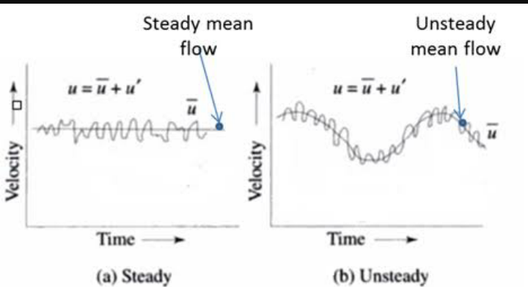
Steady flow is one which all conditions at any point in a stream remain constant with respect to time , It can also be one which the quantity of liquid flowing per second through any section is constant. WHILE unsteady flow is one which velocity is not constant at a given instant, it can also be quantity of liquid flowing per second is not constant .
True steady flow is present only in laminar flow. In turbulent flow there are continual fluctuations in velocity . Pressure also fluctuate at every point . but if this rate of change of pressure and velocity are equal on both sides of a constant average value, the flow is steady flow.
Unsteady flow is a transient phenomenon . it may be in time become steady or zero flow. For example when a valve is closed at a discharge end of a pipeline to decrease zero. In the mean time there will be fluctuation in both velocities and pressure within the pipe . unsteady flow may also include periodic motion such as that of waves of beaches . the difference between these cases and mean steady flow is that there is so much deviation from the mean . and time scale is also much longer.
Compressible and Incompressible Flow
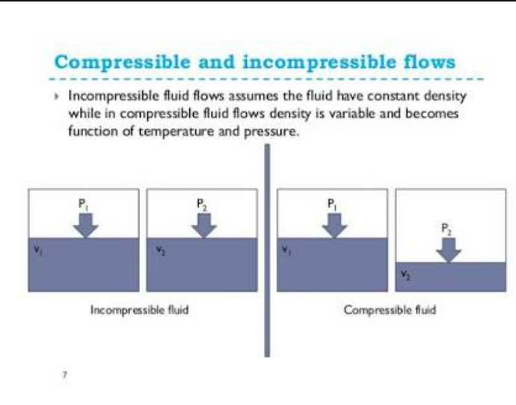
In most cases liquids behave as though the are incompressible and can be analyzed on that assumption . as we have already seen the one important exception to this rule is when liquid flow is brought to rest abruptly . for gaseous flow, the situation is rather more complicated . at low speeds gases essentially behaves as though they are incompreeible . but above a match number of about 0.3, compressibility become important . at speed approaching that of sound , new phenomena , not found under conditions of incompressible flow occur . the major difference between compressible and incompressible flows is that in the former the fluid density varies throughout the flow , whereas in the latter it is everywhere constant . incompressible flows can be analysed by invoking the laws relating to conservation of mass , conservations of energy and newton’s law of motion . these fundamental laws apply equally to compressible flows which however , are more complex because either study also involve the laws of thermodynamics.
Uniform and non-uniform
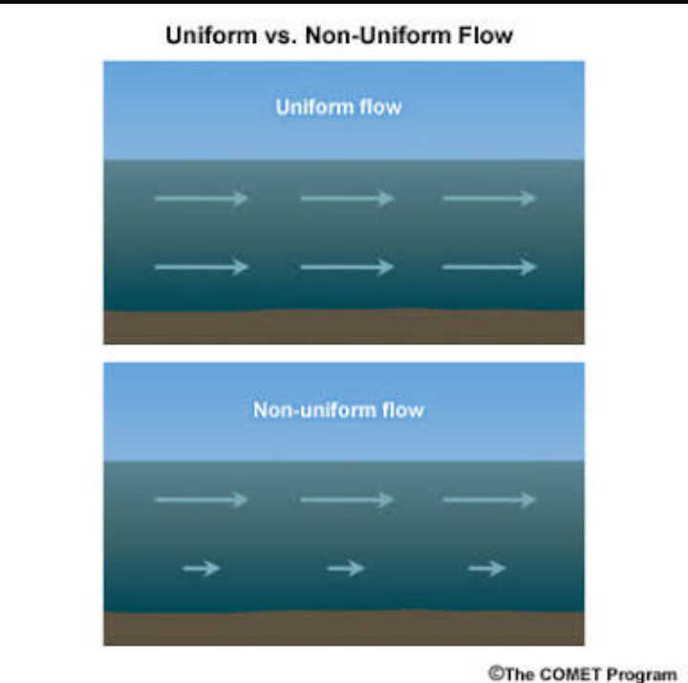
A flow is uniform if the velocity does not change either in magnitude or direction from one section to another in the part of the channel under consideration . the condition is achieved only if the cross section of the flow does not change along the length of the channel, and thus the depth of the liquid must be unchanged . consequently , uniform flow is characterized by the liquid surface being parallel to the base of the channel. Constant of the velocity across any one section of the stream is not however required for uniformity in the sense just defined ; it is sufficient for velocity profile to be the same at all cross-sections.. flow in which the liquid surface is not parallel to the base of the channel is said to be non uniform , or more usually varied since the depth of the liquid continuously varies from one another r. the change in depth maybe rapid of gradual and so it is common to speak of rapidly varied flow and gradually varied flow. Uniform flow may of course exist in one part of a channel while varied flow exist in another part.
Rotational and irrotational flow
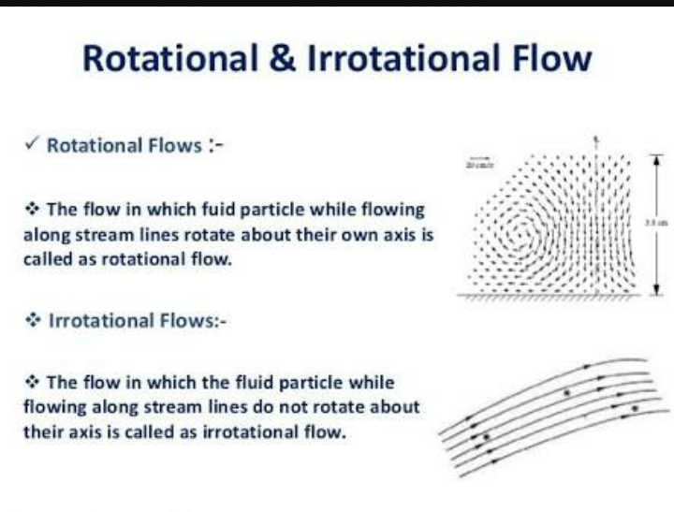
Irrational flow is the flow in which the element of moving fluid suffers no net rotation from one instant to the next with respect to the given frame of reference it can also be the flow in which fluid particles do not rotate about their own axes and retain their original orientations is called an irrational flow an example is if an irrational flow ,if a match stick is thrown on the surface of the moving fluid , it does not rotate about its axis but retain its original orientation.
Rotational flow is the flow in which the fluid particle also rotates about their own axes while flowing is called rotational fluid. An example is if a match stick is thrown on the surface of the moving fluid , it will rotate about its own axes .
Viscous and inviscid flow.
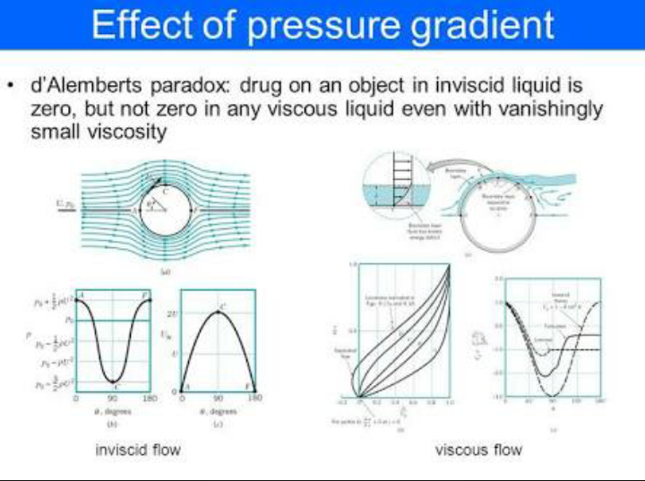
The fluid flow in which frictional effects become signification, are treated as viscous flow . when two fluid layers move relatively to each other , frictional force develops between them which is quantified by the fluid property viscosity . boundary layer flow s are the example of viscous flow. Neglecting the viscous terms in the governing equation , the flow can be treated as inviscid flow.
Separated and unseparated flow
