ADEYELU TEMITOPE OPEMIPO
16/ENG01/023
CHEMICAL ENGINERRING
FLUID FLOW: CHE 311
1. VISCOUS AND NON-VISCOUS FLOW
Viscous flow is a flow in which fluid moves in adjacent layers without slip. they occurs at low velocity and their shear stresses are of small magnitude while Non-viscous flow is characterized by random, erratic, unpredictable motion of fluid particles which results in eddy currents non-viscous they occurs at higher velocities and their shear stresses are much greater.
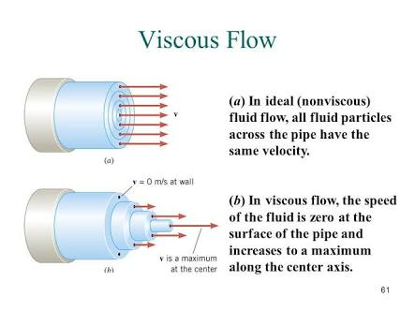
2. STEADY AND UNSTEADY FLOW
Steady Flow is the flow in which fluid characteristics like velocity, pressure, density etc. at a point does not changes with time. E.g flow of water with constant discharge through a pipeline is as steady flow while Unsteady Flow is the flow in which fluid characteristics like velocity, pressure, density etc. at a point changes with time .E.g flow of water with varying discharge though a pipe is as unsteady flow.
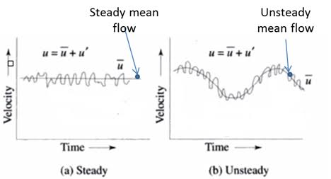
3. UNIFORM AND NON-UNIFORM FLOW
Uniform flow is a flow in which velocity at a given time does not change with respect to space (length of direction of flow) E.g flow through a long straight pipe of uniform diameter is considered as uniform flow while Non- uniform flow is a flow in which velocity at a given time changes with respect to space (length of direction of flow) E.g flow through a long pipe with varying cross section is consider as non-uniform flow.
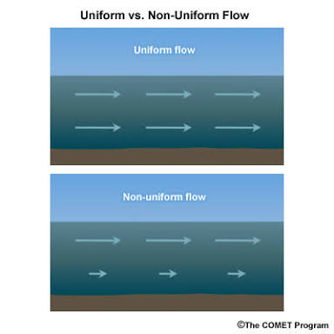
4. COMPRESSIBLE AND INCOMPRESSIBLE FLOW
Compressible flow is the flow in which the density does not remain constant for the fluid flow
E.g. problems involving flight of rockets, aircrafts, flow of air in problems concerned with turbomachines, compressor blades, and flow of gases through openings like nozzles while Incompressible flow is the flow in which the density is constant for the fluid flow is called as incompressible flow. E.g. problems involving liquids i.e. hydraulics problems, flow of gases in machines like fans and blowers.
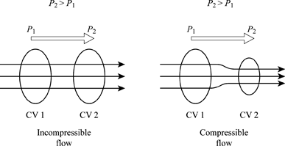
5. ROTATIONAL AND NON-ROTATIONAL FLOW
Rotational Flow is a flow that the angle between the two intersecting lines of the boundary of the fluid element changes while moving in the flow while Non-rotational Flow is a flow that the fluid element rotates as a whole and there is no change in angles between the boundary lines.
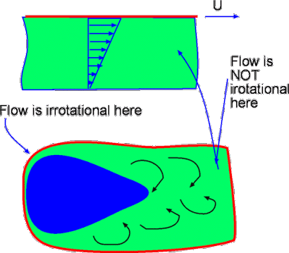
6. SEPARATED AND UNSEPARATED FLOW
Separated flow is a flow that remains attached without separation while Unseparated flow is a flow that separates and creates the region of reverse flow E.g separation.
