NAME: OJUKWU ZENITA NGOZI
DEPATMENT: CHEMICAL ENGINEERING
MATRIC NUMBER : 15/ENG01/011
COURSE: CHE 311(FLUID FLOW)
DATE: 7TH OCTOBER 2017.
QUESTION
CLASSIFICATION OF FLOW with ILLUSTRATIONS:
- STEADY AND UNSTEADY FLOW:
Steady flow is such that the properties at every point in the flow do not depend upon time,or one can say that the velocity or pressure of fluid particles at any point is constant as time passes.
Unstedy flow on the other hand exits whenever the velocity at a point in the fluid changes as time passes.

ILLUSTRATION OF THE MOVEMENT OF A STEADY AND A NON-STEADY FLOW
- COMPRESSIBLE AND INCOMPRESSIBLE FLOW:
Compressible flow is the branch of fluid mechanics that deals with flows having significant changes in fluid density.Gases,mostly ,display such behavior .While all flows are compressible flows are usually treated as being incompressible when the Mach number(the ratio of the speed of the flow to the speed of sound)is less than 0.3.The study of compressible flow is relevant to high-speed aircraft, jet engines, rocket motors, high-speed entry into a planetary atmosphere, gas pipelines e.t.c.
Incompressible flow refers to a flow in which the material density is constant within a fluid parcel-an infinitesimal volume that moves with the flow velocity.An equivalent statement that incompressible flow implies that the density remains constant within a parcel of fluid that moves with the flow velocity.
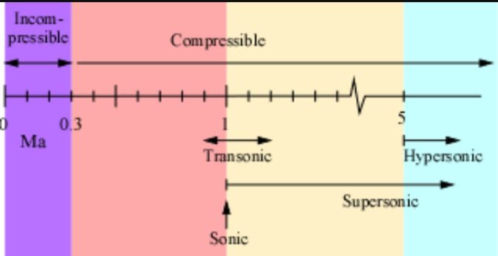
ILLUSTRATION OF THE DIVIATION OF COMPRESSIBLE AND INCOMPRESSIBLE FLOW.
- UNIFORM AND NON-UNIFORM FLOW:
Uniform flow is the flow in which conditions of flow remains constant from section to section.Example:Constant discharge through a constant diameter pipe.
While non-uniform is the flow in which conditions of flow does not remain constant from section to section,Example;Constant discharge through variable diameter pipe.
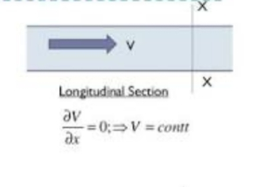ILLUSTRATION OF UNIFORM FLOW
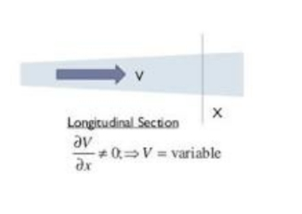
ILLUSTRATION OF NON-UNIFORM FLOW
- ROTATIONAL AND IRROTATIONAL FLOW:
If the fluid particles flowing alone stream lines,also rotates about their own axis then the flow is said to be rotational.But if fluid particles do not rotate about their own axis then the flow is irrotational.
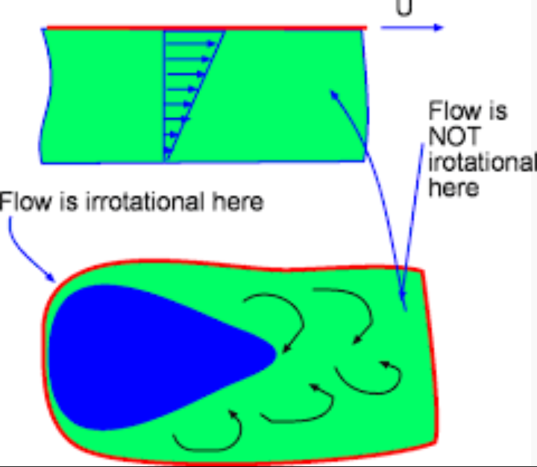
ILLUSTRATION OF THE ROTATIONAL AND IRROTATIONAL FLOW
- VISCOS AND INVISCID FLOW:
Inviscid flow is the flow of an inviscid fluid,in which the viscosity of the fluid is equal to zero and no dissipation of mechanical energy.Viscous flow are those in which fluid friction has significant effects on the fluid motion.A viscous fluid such as honey ,does not allow readily and is said to have a large viscosity.In contrast,water is less viscous and flows more readily.
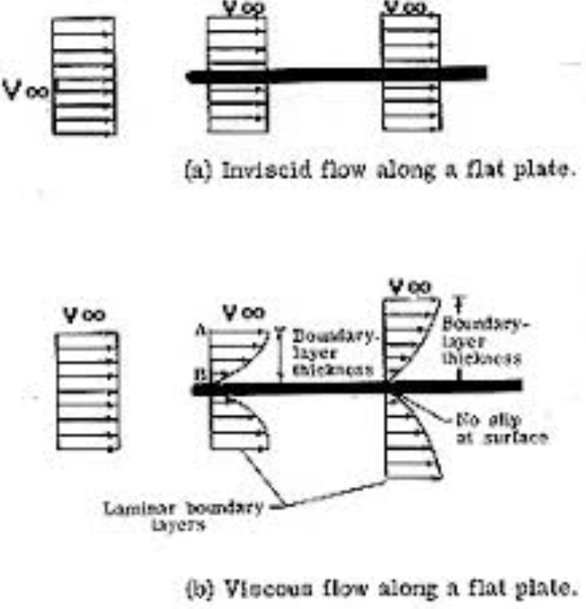
ILLUSTRATION OF A VISCOUS AND INVISCID FLUID FLOW
- SEPERATION AND UNSEPERATED FLOW:
Flow separation occurs when the boundary layer travels far enough against an adverse pressure gradient that the speed of the boundary layer relative to the object falls almost to zero.The fluid flow becomes detatched from the surface of the object,and instead takes the forms of eddies and vortices.In aerodynamics ,flow separation can often lead to increased drag,particularly pressure drag which is caused by the pressure differential between the front and rear surfaces of the object as it travels through the fluid.
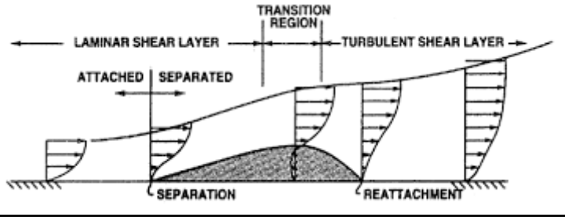
ILLUSTRATION OF THE SEPERATION AND UNSEPERATED FLOW

