NDUBUISI DAVID KELECHI
15/ENG01/008
CHEMICAL ENGINEERING
CHE311

TYPES OF FLOW WITH DIAGRAMATICAL ILLUSTRATIONS:
- Steady and unsteady flow
- Steady flow is the type of flow in which the fluid characteristics like velocity, pressure, density at any point, does not change with time (the fluid characteristics are constant).
- Unsteady flow is the type of flow in which the velocity, pressure or density at any point changes with respect to time. When the flow is unsteady, the fluid’s velocity can differ between two points. The rate of flow through any cross-section of a pipe is not constant.
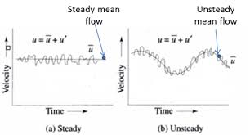
- Compressible and incompressible flow
- Compressible flow is the type of flow in which the density of the fluid changes from point to point (in other words, density is not constant for this flow). Examples include the flow of gases through orifices, etc.
- Incompressible flow is that type of flow in which the density is constant for the fluid flow. Liquids are generally considered flowing incompressible. An example is subatomic aerodynamics.
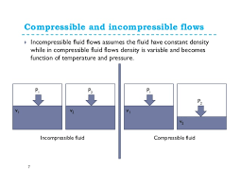

- Uniform and non-uniform flow
- Uniform flow is the type of flow, in which velocity of flow does not change either in magnitude or in direction at any point in a flowing fluid for a given time. For example, the flow of liquid
- s under pressure through long pipeline with a constant diameter.
- Non uniform flow is the type of flow in which the velocity of the flow changes at different points in a flowing fluid, for a given time; example is the flow of liquids under pressure through long pipelines of varying diameter.
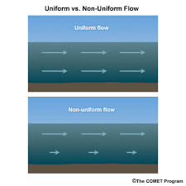
- Rotational and irrotational flow
- Rotational flow is when the fluid particles while moving in the direction of the flow, rotate about their mass centers. Flow near the solid boundaries is rotational. Example is the motion of liquid in a rotating tank.
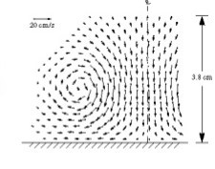an illustration of rotational flow
- Irrotational flow is when the fluid particles while moving in the direction of flow, do not rotate about their mass centers. Example is the flow above a drain hole of a stationary tank or a wash basin.
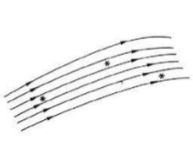an illustration of irrotational flow
- Viscous and inviscid flow
- Viscous flow are flows in which the frictional effects are significant. It is a type of fluid flow in which there is a continuous steady motion of the particles, the motion at a fixed point always remain constant.
- Inviscid flow is the flow where the viscosity of a fluid is equal to zero.
Viscosity of a fluid is the measure of its resistance to gradual deformation by shear stress.
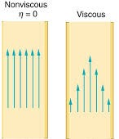
- Seperated and unseparated flow
- A separated flow is the boundary layer separation that occurs whenever there is a change in velocity of the fluid in either magnitude or direction, and is too large for the fluid to adhere to the solid surface.
- Unseparated flow

