NAME: ERHIANO AGHOGHO VICTOR
DEPARTMENT: CHEMICAL ENGINEERING
MATRIC NO: 15/ENG01/005
COURSE CODE: CHE 311
Definition of steady flow: a flow in which the velocity of the fluid at a particular fixed point does not change with time

Unsteady or non-steady flow is one where the properties do depend on time. Steady and Unsteady Flows
We have noted previously (see Velocity Field ) that velocity, pressure and other properties of fluid flow can be functions of time (apart from being functions of space). If a flow is such that the properties at every point in the flow do not depend upon time, it is called a steady flow. Mathematically speaking for steady flows,
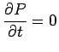 | (3.4)
where P is any property like pressure, velocity or density. Thus,
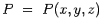 | (3.5)

Unsteady or non-steady flow is one where the properties do depend on time.
It is needless to say that any start up process is unsteady. Many examples can be given from everyday life- water flow out of a tap which has just been opened. This flow is unsteady to start with, but with time does become steady.
Some flows, though unsteady, become steady under certain frames of reference. These are called pseudosteady flows. On the other hand a flow such as the wake behind a bluff body is always unsteady.
Unsteady flows are undoubtedly difficult to calculate while with steady flows, we have one degree less complexity.

Definition of uniform flow. flow of a fluid in which each particle moves along its line of flow with constant speed and in which the cross section of each stream tube remains unchanged.
Compressible flows are usually high speed flows with Mach numbers greater than about 0.3. ... The key differentiation between compressible and incompressible is the velocity of the flow. A fluid such as air that is moving slower than Mach 0.3 is considered incompressible, even though it is a gas.

Uniform and Non-uniform Flows
- Uniform Flow
The flow is defined as uniform flow when in the flow field the velocity and other hydrodynamic parameters do not change from point to point at any instant of time.
For a uniform flow, the velocity is a function of time only, which can be expressed in Eulerian description as
Implication:
- For a uniform flow, there will be no spatial distribution of hydrodynamic and other parameters.
- Any hydrodynamic parameter will have a unique value in the entire field, irrespective of whether it
changes with time − unsteady uniform flow OR
does not change with time − steady uniform flow.
- Thus ,steadiness of flow and uniformity of flow does not necessarily go together.

- Non-Uniform Flow
When the velocity and other hydrodynamic parameters changes from one point to another the flow is defined as non-uniform.
Important points:
1. For a non-uniform flow, the changes with position may be found either in the direction of flow or in directions perpendicular to it.
2.Non-uniformity in a direction perpendicular to the flow is always encountered near solid boundaries past which the fluid flows.
Reason: All fluids possess viscosity which reduces the relative velocity (of the fluid w.r.t. to the wall) to zero at a solid boundary. This is known as no-slip condition.

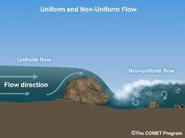

Rotational or Irrotational Flow
To classify any flow as Rotational or Irrotational the angular motion of the fluid elements is analyzed. If the angle between the two intersecting lines of the boundary of the fluid element changes while moving in the flow, then the flow is a Rotational Flow. But if the fluid element rotates as a whole and there is no change in angles between the boundary lines then the flow cannot be Rotational Flow, so it is Irrotational Flow.
This means that there should be some deformation in the fluid element in a Rotational Flow. Such deformation of the fluid element or the shear strain is necessarily caused by tangential forces or shear stresses. Shear stresses are caused by viscosity, thus the flow of viscous fluids is rotational. But this does not mean that the flow of non-viscous or ideal fluid is always irrotational. The flow of ideal fluids can be rotational by external work or heat interaction.

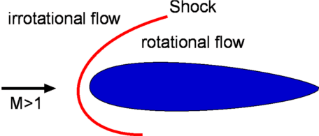
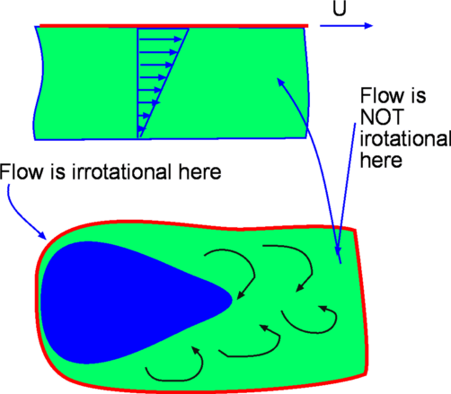

Viscous flow A type of fluid flow in which there is a continuous steady motion of the particles, the motion at a fixed point always remaining constant.
inviscid flow is the flow of an inviscid fluid, in which the viscosity of the fluid is equal to zero
An inviscid flow is the flow of an ideal fluid that is assumed to have no viscosity. 