NAME: OMOKAGBO SHADRACH EGAMEH
MATRIC: 16/ENG01/026
DEPT: CHEMICAL ENGINEERING

ASSIGNMENT: EXPLAIN WITH DIAGRAMS THEY TYPE OF FLUID FLOWS
- 1. ROTATIONAL AND IRROTATIONAL
To classify any flow as Rotational or Irrotational the angular motion of the fluid elements is analyzed. If the angle between the two intersecting lines of the boundary of the fluid element changes while moving in the flow, then the flow is a Rotational Flow. But if the fluid element rotates as a whole and there is no change in angles between the boundary lines then the flow cannot be Rotational Flow, so it is Irrotational Flow.
This means that there should be some deformation in the fluid element in a Rotational Flow. Such deformation of the fluid element or the shear strain is necessarily caused by tangential forces or shear stresses. Shear stresses are caused by viscosity, thus the flow of viscous fluids is rotational. But this does not mean that the flow of non-viscous or ideal fluid is always irrotational. The flow of ideal fluids can be rotational by external work or heat interaction.
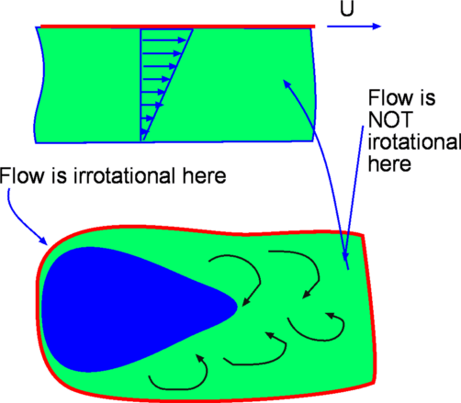

2. compressible and incompressible flow
All fluids are compressible to some extent; that is, changes in pressure or temperature cause changes in density. However, in many situations the changes in pressure and temperature are sufficiently small that the changes in density are negligible. In this case the flow can be modelled as an incompressible flow.
- Compressible flow is the type of flow in which the density of the fluid changes from point to point (in other words, density is not constant for this flow). Examples include the flow of gases throughorifices, etc.
- Incompressible flow is that type of flow in which the density is constant for the fluid flow. Liquids are generally considered flowing incompressible. An example is subatomic aerodynamics.
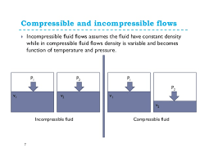

3.Uniform and non-uniform flow
- Uniform flow is the type of flow, in which velocity of flow does not change either in magnitude or in direction at any point in a flowing fluid for a given time. For example, the flow of liquid
- s under pressure through long pipeline with a constant diameter.
- Non uniform flow is the type of flow in which the velocity of the flow changes at different points in a flowing fluid, for a given time; example is the flow of liquids under pressure through long pipelines of varying diameter.
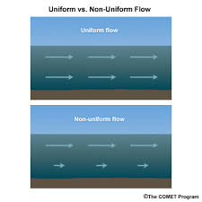

4.Viscous and inviscid flow
- Viscous flow are flows in which the frictional effects are significant. It is a type of fluid flow in which there is a continuous steady motion of the particles, the motion at a fixed point always remain constant.
- Inviscid flow is the flow where the viscosity of a fluid is equal to zero.
Viscosity of a fluid is the measure of its resistance to gradual deformation by shear stress.
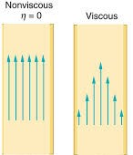

5.Steady and unsteady flow
- Steady flow is the type of flow in which the fluid characteristics like velocity, pressure, density at any point, does not change with time (the fluid characteristics are constant).
- Unsteady flow is the type of flow in which the velocity, pressure or density at any point changes with respect to time. When the flow is unsteady, the fluid’s velocity can differ between two points. The rate of flow through any cross-section of a pipe is not constant.
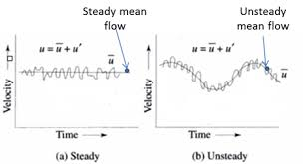

3.viscous and inviscid flow

