NAME: NWOGU AMARACHUKWU SARAH
MATRIC NO: 15/ENG01/009
DEPARTMENT: CHEMICAL ENGINEERING.

CHE 361

CLASSIFICATION OF FLUID FLOW

STEADY AND UNSTEADY FLOW
A flow that is not a function of time is called steady flow. Steady-state flow refers to the condition where the fluid properties at a point in the system do not change over time. Time dependent flow is known as unsteady (also called transient[5]). Whether a particular flow is steady or unsteady, can depend on the chosen frame of reference. For instance, laminar flow over a sphere is steady in the frame of reference that is stationary with respect to the sphere. In a frame of reference that is stationary with respect to a background flow, the flow is unsteady.

Turbulent flows are unsteady by definition. A turbulent flow can, however, be statistically stationary. According to Pope:[6]

The random field U(x,t) is statistically stationary if all statistics are invariant under a shift in time.

This roughly means that all statistical properties are constant in time. Often, the mean field is the object of interest, and this is constant too in a statistically stationary flow.

Steady flows are often more tractable than otherwise similar unsteady flows. The governing equations of a steady problem have one dimension fewer (time) than the governing equations of the same problem without taking advantage of the steadiness of the flow field.
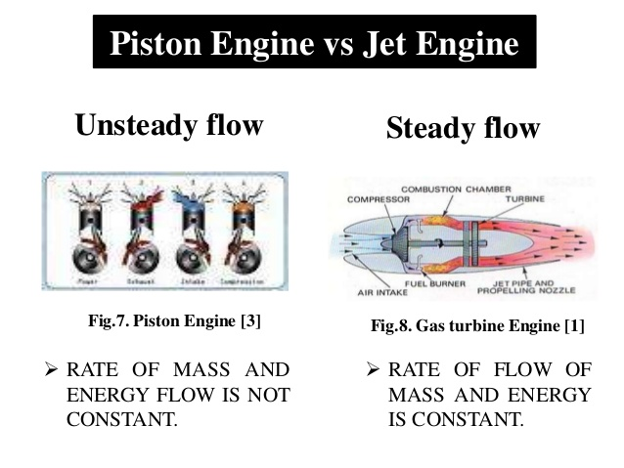
Examples of steady and unsteady flow
UNIFORM AND NON UNIFORM FLOW
The other classification criterion for the fluid flow is based on the variation of the flow parameters with distance or space. It characterizes the flow as uniform or non-uniform. The fluid flow is a uniform flow if the flow parameters remain constant with distance along the flow path. And the fluid flow is non-uniform if the flow parameters vary and are different at different points on the flow path.
For a uniform flow, by its definition, the area of the cross section of the flow should remain constant. So a fitting example of the uniform flow is the flow of a liquid thorough a pipeline of constant diameter. And contrary to this the flow through a pipeline of variable diameter would be necessarily non-uniform.
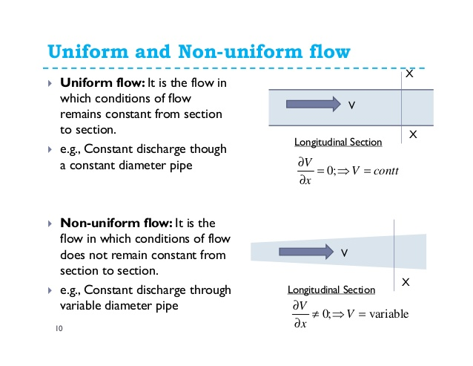
Examples of Different Flow Types
Steady and Uniform Flow: Flow through a pipeline of constant diameter with a discharge constant with time.
Steady and Non-Uniform Flow: Fixed discharge flow through a tapering pipe. Water flow through a river with a constant discharge is also a good example of such flow as the span of river generally varies with distance and amount of water flow in river is constant.
Unsteady and Uniform Flow: A flow through pipeline of constant cross section with sudden changes in fluid discharge or pressure.
Unsteady and Non-Uniform Flow: Pressure surges in a flow through a pipe of variable cross section. A practical example can be the water flow in the network of canals during water release. Uniform and non-uniform flow

VISCOUS AND INVISCID FLOW
The dynamic of fluid parcels is described with the help of Newton's second law. An accelerating parcel of fluid is subject to inertial effects.

The Reynolds number is a dimensionless quantity which characterises the magnitude of inertial effects compared to the magnitude of viscous effects. A low Reynolds number (Re<<1) indicates that viscous forces are very strong compared to inertial forces. In such cases, inertial forces are sometimes neglected; this flow regime is called Stokes or creeping flow.

In contrast, high Reynolds numbers (Re>>1) indicate that the inertial effects have more effect on the velocity field than the viscous (friction) effects. In high Reynolds number flows, the flow is often modeled as an inviscid flow, an approximation in which viscosity is completely neglected. Eliminating viscosity allows the Navier–Stokes equations to be simplified into the Euler equations. The integration of the Euler equations along a streamline in an inviscid flow yields Bernoulli's equation. When, in addition to being inviscid, the flow is irrotational everywhere, Bernoulli's equation can completely describe the flow everywhere. Such flows are called potential flows, because the velocity field may be expressed as the gradient of a potential energy expression.
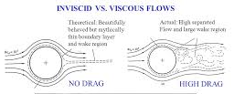
Inviscid and viscous flows

COMPRESSIBLE AND INCOMPRESSIBLE FLOW
All substances are compressible to a certain extent, i.e. of variable density. However, in many practical situations, the density variations are so small that they can be neglected and the density can be considered constant. Flows that are modeled assuming constant density are called incompressible, and is typical of liquids. An incompressible flow satisfies ∇ • v = div v = 0 (B.2) Compressible flows can be classified as subsonic, transonic or supersonic, depending on the Mach number Ma, ratio between the local fluid velocity and the local propagation speed of the sound. The flow in gases can be considered incompressible if Ma < 0.3.
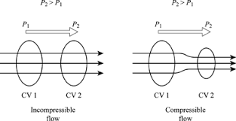
Incompressible and Compressible flow
ROTATIONAL AND IRROTATIONAL FLOW
To classify any flow as Rotational or Irrotational the angular motion of the fluid elements is analyzed. If the angle between the two intersecting lines of the boundary of the fluid element changes while moving in the flow, then the flow is a Rotational Flow. But if the fluid element rotates as a whole and there is no change in angles between the boundary lines then the flow cannot be Rotational Flow, so it is Irrotational Flow.
This means that there should be some deformation in the fluid element in a Rotational Flow. Such deformation of the fluid element or the shear strain is necessarily caused by tangential forces or shear stresses. Shear stresses are caused by viscosity, thus the flow of viscous fluids is rotational. But this does not mean that the flow of non-viscous or ideal fluid is always irrotational. The flow of ideal fluids can be rotational by external work or heat interaction.
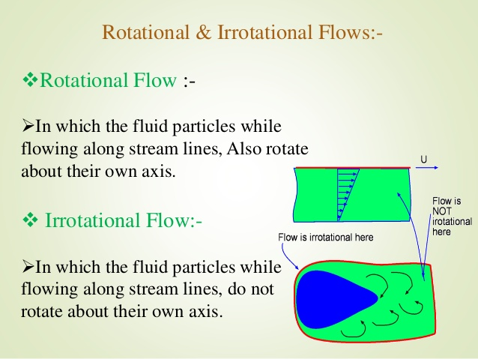
Rotational and irrotational flow

