NAME: PITMANG MICAIAH SIMON
MATRIC NO: 15/ENG01/014
DEPARTMENT: CHEMICAL ENGINEERING
COURSE CODE: CHE311
Fluid evenness: Steady or unsteady flow
Fluid flow can be steady or unsteady, depending on the fluid’s velocity:
- Steady. In steady fluid flow, the velocity of the fluid is constant at any point.
- Unsteady. When the flow is unsteady, the fluid’s velocity can differ between any two points.
For example, suppose you’re sitting by the side of a stream and note that the water flow is not steady: You see eddies and backwash and all kinds of swirling. Imagine velocity vectors for a hundred points in the water, and you get a good picture of unsteady flow — the velocity vectors can be pointing all over the map, although the velocity vectors generally follow the stream’s overall average flow.
Fluid squeezability: Compressible or incompressible flow
Fluid flow can be compressible or incompressible, depending on whether you can easily compress the fluid. Liquids are usually nearly impossible to compress, whereas gases (also considered a fluid) are very compressible.
A hydraulic system works only because liquids are incompressible — that is, when you increase the pressure in one location in the hydraulic system, the pressure increases to match everywhere in the whole system. Gases, on the other hand, are very compressible — even when your bike tire is stretched to its limit, you can still pump more air into it by pushing down on the plunger and squeezing it in.
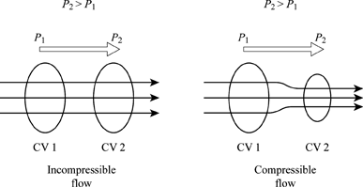
Fluid thickness: Viscous or non-viscous flow
Liquid flow can be viscous or non-viscous. Viscosity is a measure of the thickness of a fluid, and very gloppy fluids such as motor oil or shampoo are called viscous fluids.
Viscosity is actually a measure of friction in the fluid. When a fluid flows, the layers of fluid rub against one another, and in very viscous fluids, the friction is so great that the layers of flow pull against one other and hamper that flow.
Viscosity usually varies with temperature, because when the molecules of a fluid are moving faster (when the fluid is warmer), the molecules can more easily slide over each other. So when you pour pancake syrup, for example, you may notice that it’s very thick in the bottle, but the syrup becomes quite runny when it spreads over the warm pancakes and heats up.
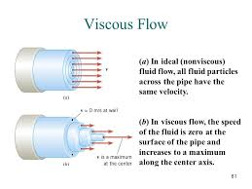
Fluid spinning: Rotational or irrotational flow
Fluid flow can be rotational or irrotational. If, as you travel in a closed loop, you add up all the components of the fluid velocity vectors along your path and the end result is not zero, then the flow is rotational.
To test whether a flow has a rotational component, you can put a small object in the flow and let the flow carry it. If the small object spins, the flow is rotational; if the object doesn’t spin, the flow is irrotational.
For example, look at the water flowing in a brook. It eddies around stones, curling around obstacles. At such locations, the water flow has a rotational component.
Some flows that you may think are rotational are actually irrotational. For example, away from the center, a vortex is actually an irrotational flow! You can see this if you look at the water draining from your bathtub. If you place a small floating object in the flow, it goes around the plug hole, but it does not spin about itself; therefore, the flow is irrotational.
On the other hand, flows that have no apparent rotation can actually be rotational. Take a shear flow, for example. In a shear flow, all the fluid is moving in the same direction, but the fluid is moving faster on one side. Suppose the fluid is moving faster on the left than on the right. The fluid isn’t moving in a circle at all, but if you place a small floating object in this flow, the flow on the left side of the object is slightly faster, so the object begins to spin. The flow is rotational.
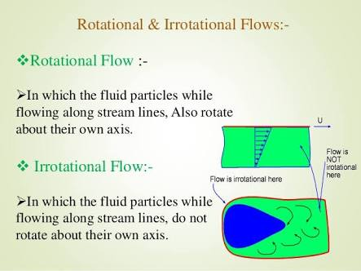
Classification Based on Variation with Space: Uniform and Non-uniform
The other classification criterion for the fluid flow is based on the variation of the flow parameters with distance or space. It characterizes the flow as uniform or non-uniform. The fluid flow is a uniform flow if the flow parameters remain constant with distance along the flow path. And the fluid flow is non-uniform if the flow parameters vary and are different at different points on the flow path.
For a uniform flow, by its definition, the area of the cross section of the flow should remain constant. So a fitting example of the uniform flow is the flow of a liquid thorough a pipeline of constant diameter. And contrary to this the flow through a pipeline of variable diameter would be necessarily non-uniform.
