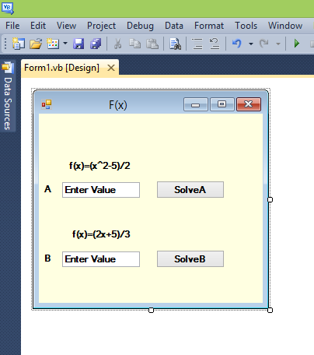

Name: Gambo Musyapha Lawal (16/sci01/014)
Department: Computer Science
CSC201 Assignment 2!
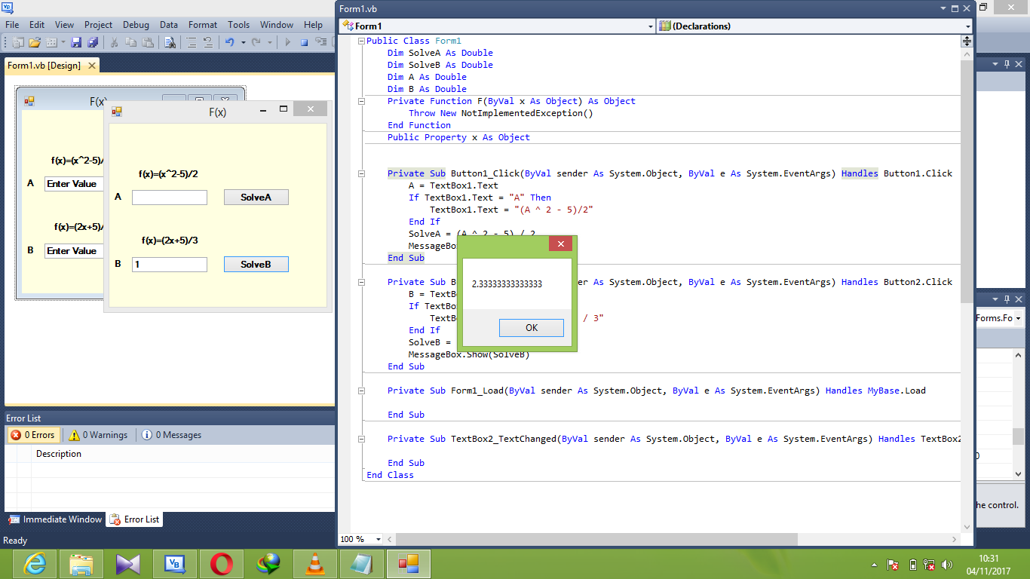
CODE
Public Class Form1
Dim SolveA As Double
Dim SolveB As Double
Dim A As Double
Dim B As Double
Private Function F(ByVal x As Object) As Object
Throw New NotImplementedException()
End Function
Public Property x As Object

Private Sub Button1_Click(ByVal sender As System.Object, ByVal e As System.EventArgs) Handles Button1.Click
A = TextBox1.Text
If TextBox1.Text = "A" Then
TextBox1.Text = "(A ^ 2 - 5)/2"
End If
SolveA = (A ^ 2 - 5) / 2
MessageBox.Show(SolveA)
End Sub

Private Sub Button2_Click(ByVal sender As System.Object, ByVal e As System.EventArgs) Handles Button2.Click
B = TextBox2.Text
If TextBox2.Text = "B" Then
TextBox2.Text = "(B * 2 + 5) / 3"
End If
SolveB = (B * 2 + 5) / 3
MessageBox.Show(SolveB)
End Sub

Private Sub Form1_Load(ByVal sender As System.Object, ByVal e As System.EventArgs) Handles MyBase.Load

End Sub

Private Sub TextBox2_TextChanged(ByVal sender As System.Object, ByVal e As System.EventArgs) Handles TextBox2.TextChanged

End Sub
End Class

