OTEGBEYE OLORUNLEKE
COMPUTER SCIENCE DEPARTMENT
16/SCI01/038
CSC 201

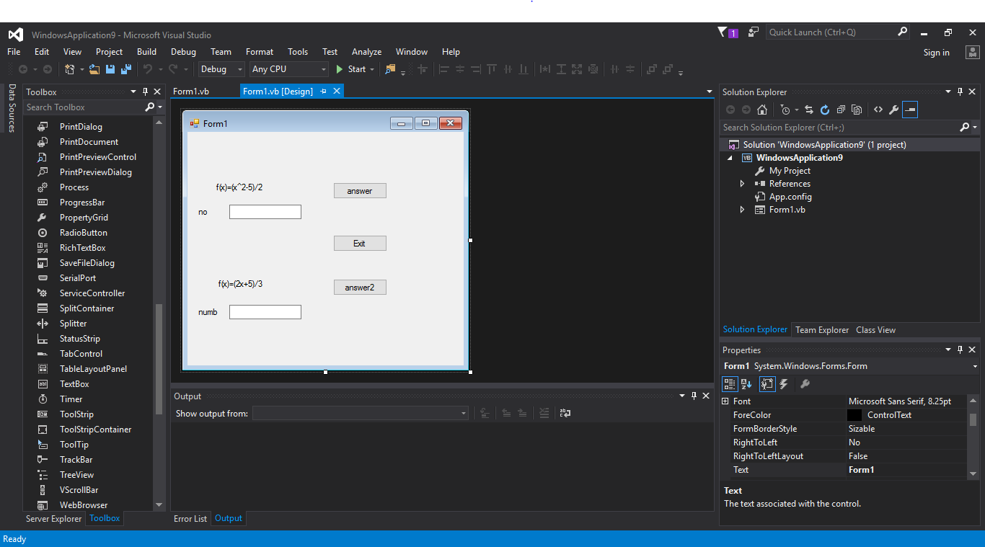

ANSWER BUTTON (1) TEXTBOX2
TEXTBOX 1 LABEL EXIT ANSWER BUTTON (2)

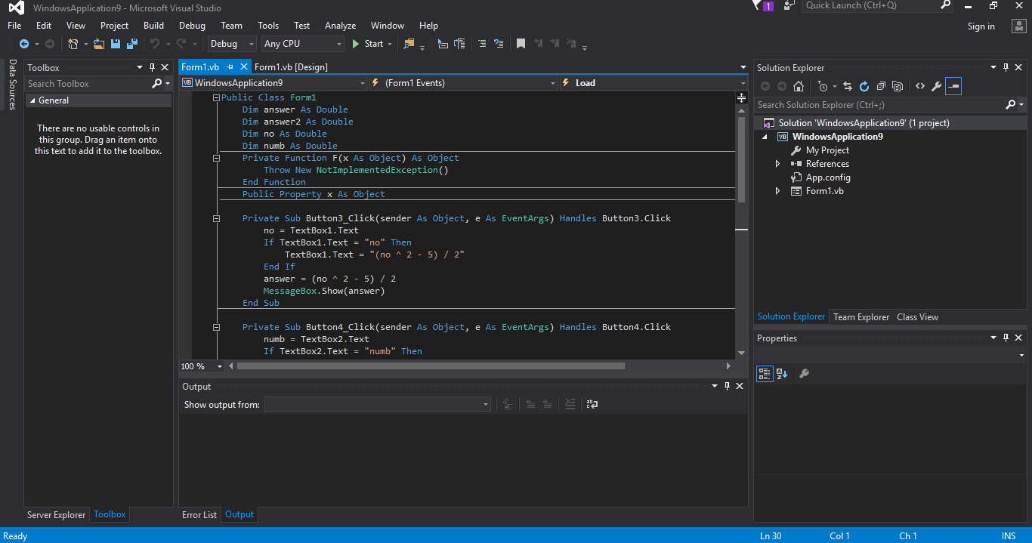

CODE

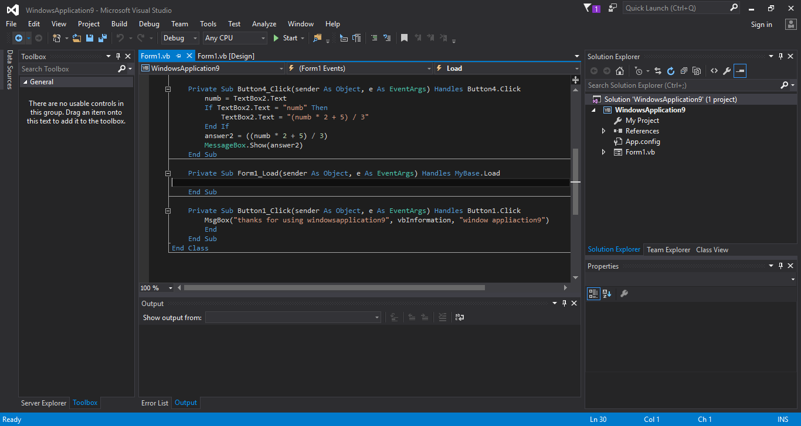

CODE

