Textbox2

Textbox1

Label1

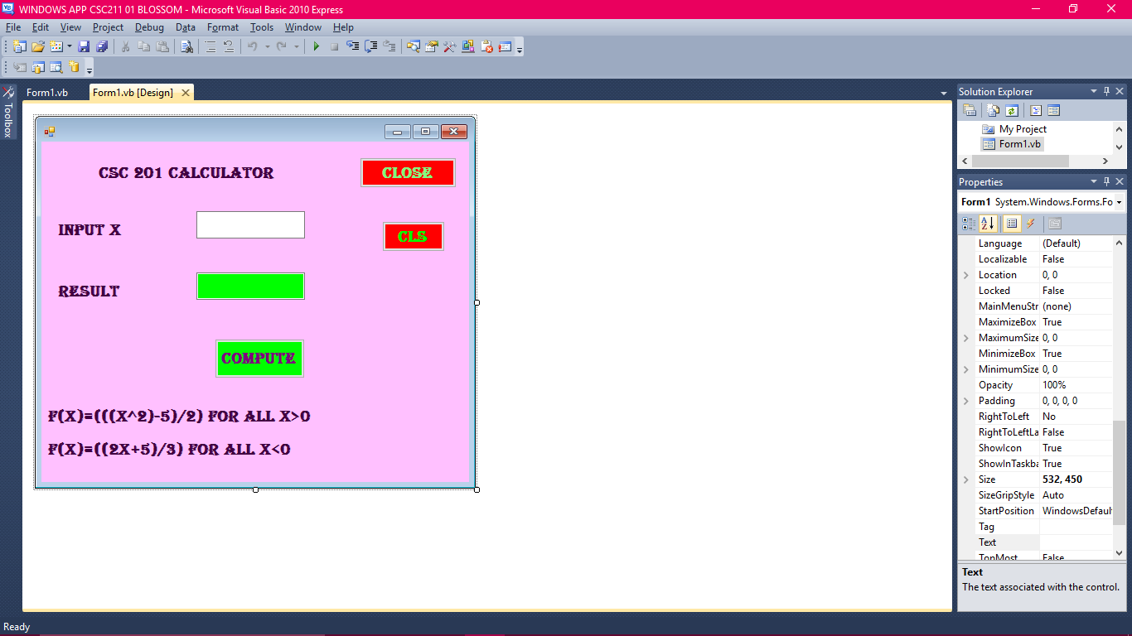
Label2

Button1
Button3
Button2
Public Class Form1

Private Sub Button1_Click(ByVal sender As System.Object, ByVal e As System.EventArgs) Handles Button1.Click
If TextBox1.Text > 0 Then
TextBox2.Text = (((TextBox1.Text ^ 2) - 5) / 2)
Else
TextBox2.Text = (((2 * TextBox1.Text) + 5) / 3)
End If
End Sub

Private Sub Button2_Click(ByVal sender As System.Object, ByVal e As System.EventArgs) Handles Button2.Click
Dim response As Integer
response = MsgBox("CLEARING PAST DATA!!", vbInformation, "WARNING!")
TextBox1.Text = ""
TextBox2.Text = ""
End Sub

Private Sub Button3_Click(ByVal sender As System.Object, ByVal e As System.EventArgs) Handles Button3.Click
MsgBox("THANKS FOR USING CALCULATOR", vbInformation, "CALCULATOR")
End
End Sub
End Class

