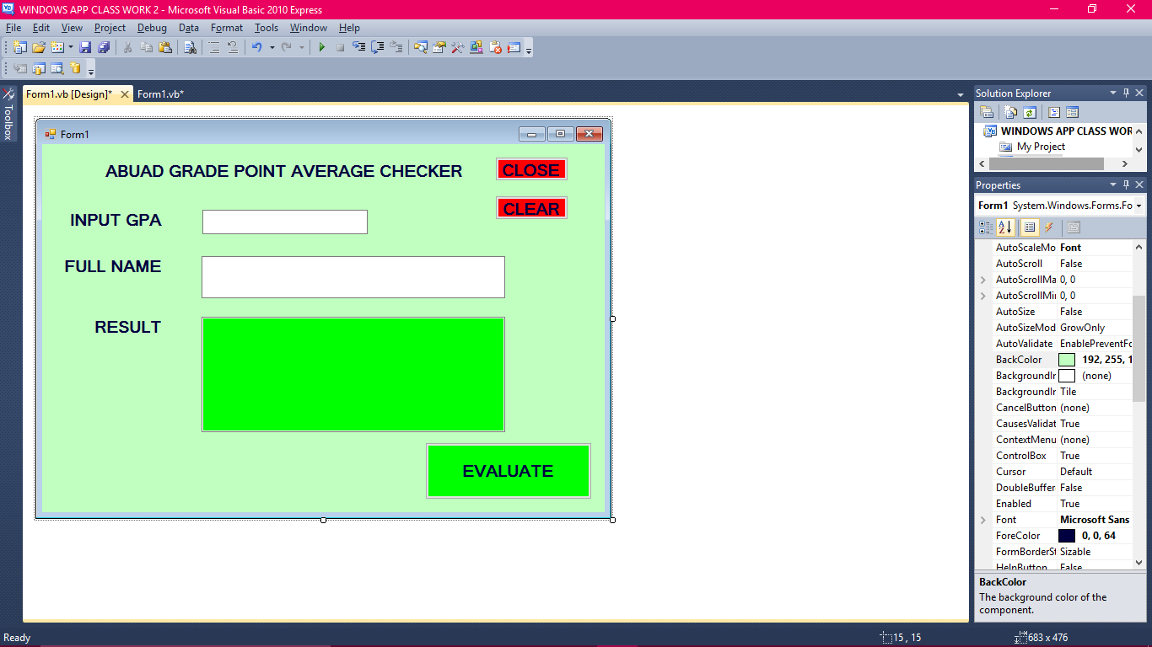
TEXTRESULT
TEXTNAME
BUTTON2
BUTTON3
BUTTON1
TEXTRESULT
ABEL3
LABEL1
LABEL4
LABEL3

Public Class Form1

Private Sub EVALUATE_Click(ByVal sender As System.Object, ByVal e As System.EventArgs) Handles EVALUATE.Click
If TextGPA.Text > 5.0 Then
TextRESULT.Text = TextNAME.TEXT & "YOU CANT SCORE ABOVE 5.0!!"
ElseIf (TextGPA.Text >= 4.5 And TextGPA.Text <= 5.0) Then
TextRESULT.Text = TextNAME.Text & ";YOU SCORED" & TextGPA.Text & ";CONGRATULATIONS!!! YOU ACHIVED A FIRST CLASS, KEEP IT UP"
ElseIf (TextGPA.Text >= 3.5 And TextGPA.Text < 4.5) Then
TextRESULT.Text = TextNAME.Text & ";YOU SCORED" & TextGPA.Text & ";CONGRATULATIONS YOU ACHIVED A SECOND CLASS UPPER, YOU CAN DO BETTER"
ElseIf (TextGPA.Text >= 2.5 And TextGPA.Text < 3.5) Then
TextRESULT.Text = TextNAME.Text & ";YOU SCORED" & TextGPA.Text & ";YOU ACHIVED A SECOND CLASS LOWER, YOU CAN DO BETTER BETTER LUCK NEXT TIME"
ElseIf (TextGPA.Text >= 1.0 And TextGPA.Text < 2.5) Then
TextRESULT.Text = TextNAME.Text & ";YOU SCORED" & TextGPA.Text & ";THIRD CLASS , YOU WORK NEED SERIOUS IMPROVEMENT "
Else
TextRESULT.Text = TextNAME.Text & ";YOU SCORED" & TextGPA.Text & ";PASS; YOU ARE ADVICED TO WITHDRAW FROM THE UNIVERSITY"
End If
End Sub

Private Sub CLEAR_Click(ByVal sender As System.Object, ByVal e As System.EventArgs) Handles CLEAR.Click
MsgBox("AREW YOU SURE YOU WANT TO CLEAR PREVIOUS WORK?", vbYesNoCancel, "GRADE POINT AVERAGE")
TextGPA.Text = ""
TEXTRESULT.TEXT = ""
End Sub

Private Sub CLOSE_Click(ByVal sender As System.Object, ByVal e As System.EventArgs) Handles CLOSE.Click
MsgBox("THANKS FOR USING ABUADS GPA CHECKER", vbYesNoCancel, "GRADE POINT AVERAGE")
End
End Sub
End Class

