NAME: OLADOSU FIYINFOLU OLUWAFERANMI

15/SCI01/029

300L

CSC 309 ASSIGNMENT SOLUTION

SOURCE CODE:
1.
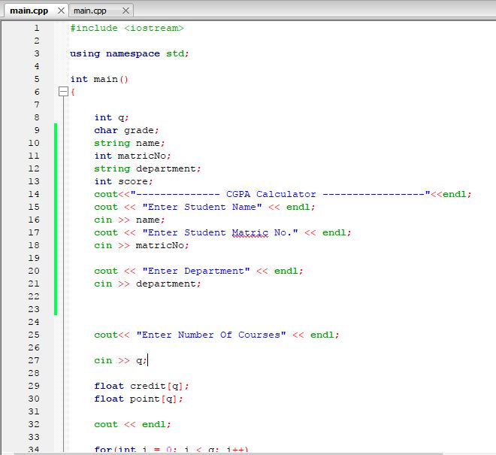
2.
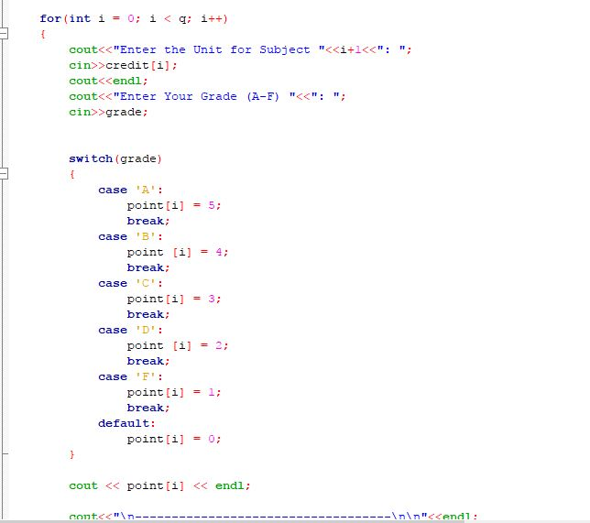

3.
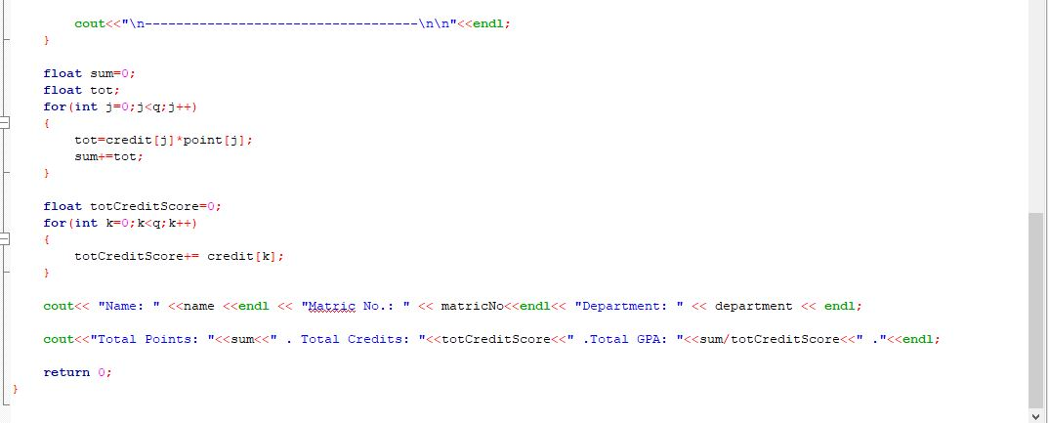

RESULTS:

1.
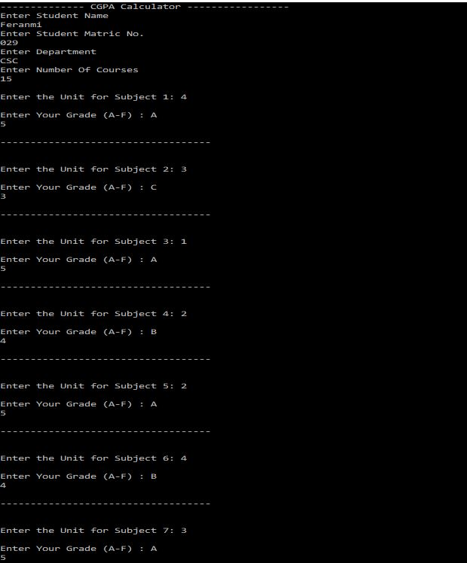

2.
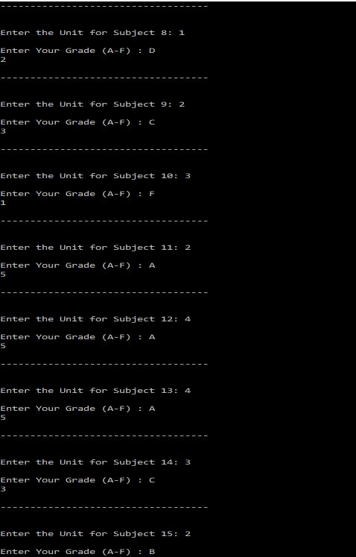

3.

