ODIA ANITA PRISCILLIA

I6/SCI01/029

CSC201 ASSINMENT 5/11/2017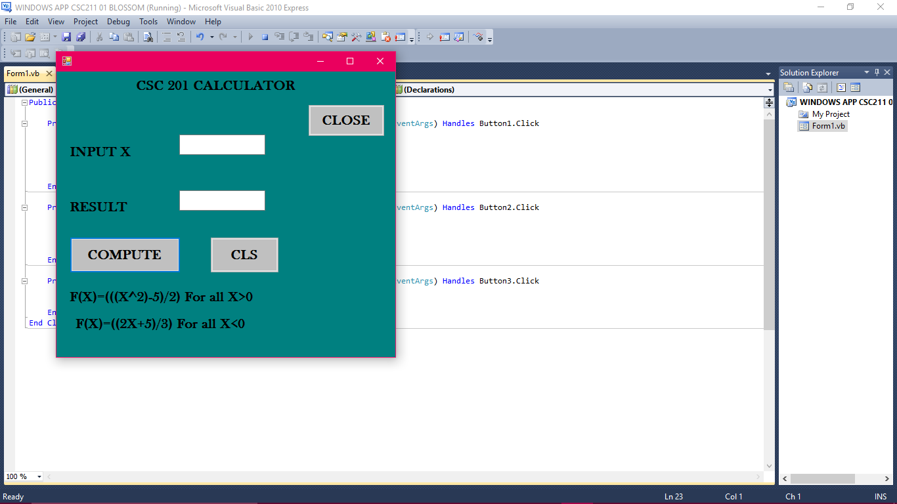 Public Class Form1

Button 2

Textbox 2

Textbox1

Label1



Label 2

Label 3

Button3

Label 4

Label 5

Button 1

Private Sub Button1_Click(ByVal sender As System.Object, ByVal e As System.EventArgs) Handles Button1.Click

If TextBox1.Text > 0 Then

TextBox2.Text = (((TextBox1.Text ^ 2) - 5) / 2)

Else

TextBox2.Text = (((2 * TextBox1.Text) + 5) / 3)

End If

End Sub

Private Sub Button2_Click(ByVal sender As System.Object, ByVal e As System.EventArgs) Handles Button2.Click

Dim response As Integer

response = MsgBox("CLEARING PAST DATA!!", vbInformation, "WARNING!")

TextBox1.Text = ""

TextBox2.Text = ""

End Sub

Private Sub Button3_Click(ByVal sender As System.Object, ByVal e As System.EventArgs) Handles Button3.Click

MsgBox("THANKS FOR USING CALCULATOR", vbInformation, "CALCULATOR")

End

End Sub

End Class