OKEKE OTITOCHI MARY-ANN

16/SCI01/030

COMPUTER SCIENCE

CSC 201

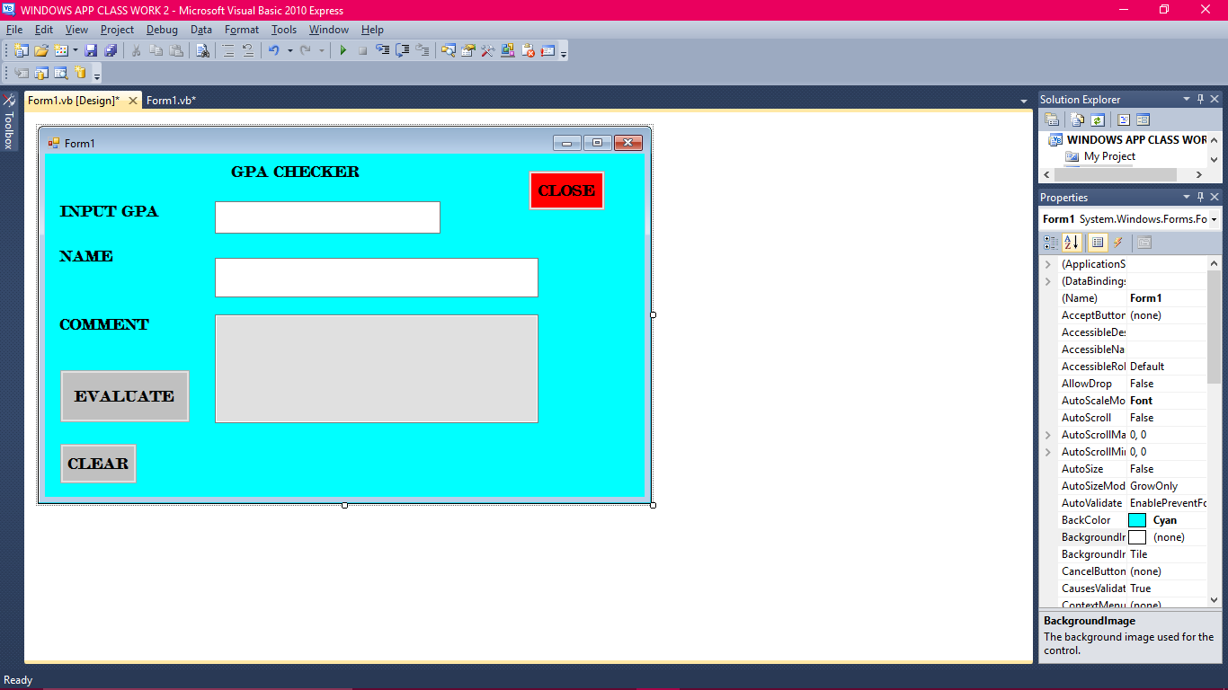

LABEL1

Label2

Label3

Label4

Button1

Button 2

Textbox1

Textbox2

Textbox3

Button3

Public Class Form1

Private Sub EVALUATE_Click(ByVal sender As System.Object, ByVal e As System.EventArgs) Handles EVALUATE.Click

If TextGRADE.Text > 5.0 Then

TEXTCOMMENT.Text = TextN.Text & "ERROR!!!!!!!"

ElseIf (TextGRADE.Text >= 4.5 And TextGRADE.Text <= 5.0) Then

TEXTCOMMENT.Text = "FIRST CLASS, GREAT WORK KEEP IT UP"

ElseIf (TextGRADE.Text >= 3.5 And TextGRADE.Text < 4.5) Then

TEXTCOMMENT.Text = "SECOND CLASS UPPER,KEEP IT UP YOU CAN DO BETTER"

ElseIf (TextGRADE.Text >= 2.5 And TextGRADE.Text < 3.5) Then

TEXTCOMMENT.Text = "SECOND CLASS LOWER, YOU CAN DO BETTER KEEP IT UP"

ElseIf (TextGRADE.Text >= 1.0 And TextGRADE.Text < 2.5) Then

TEXTCOMMENT.Text = "THIRD CLASS , WORK HARDER "

Else

TEXTCOMMENT.Text = "PASS, DISSAPOINTION!"

End If

End Sub

Private Sub CLEAR_Click(ByVal sender As System.Object, ByVal e As System.EventArgs) Handles CLEAR.Click

TextGRADE.Text = ""

TEXTCOMMENT.Text = ""

TextN.Text = ""

End Sub

Private Sub CLOSE_Click(ByVal sender As System.Object, ByVal e As System.EventArgs) Handles CLOSE.Click

End

End Sub

End Class