GOYA AMEBE-OBARI AWIANKELE
16/SCI03/007

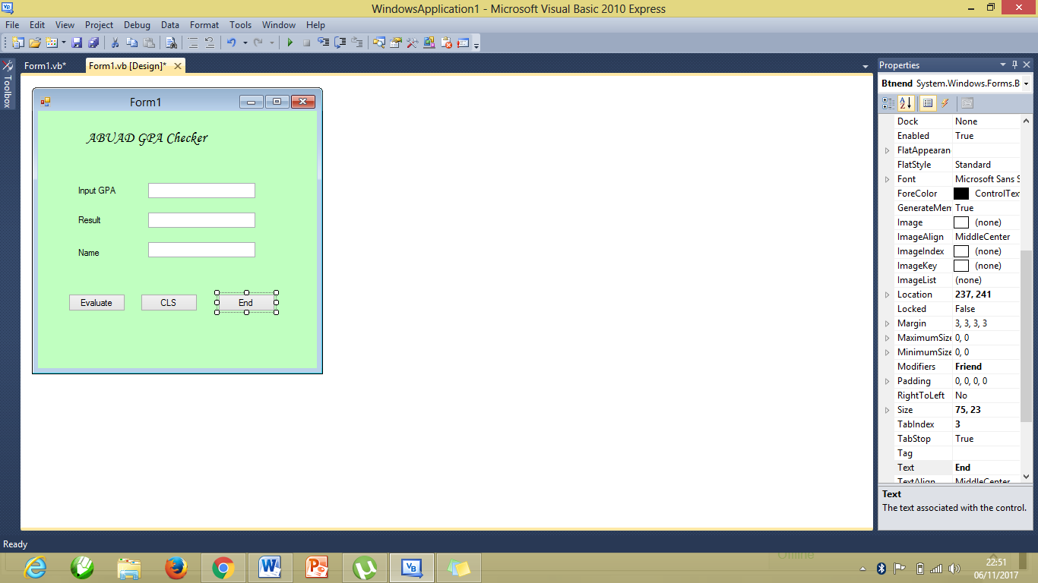

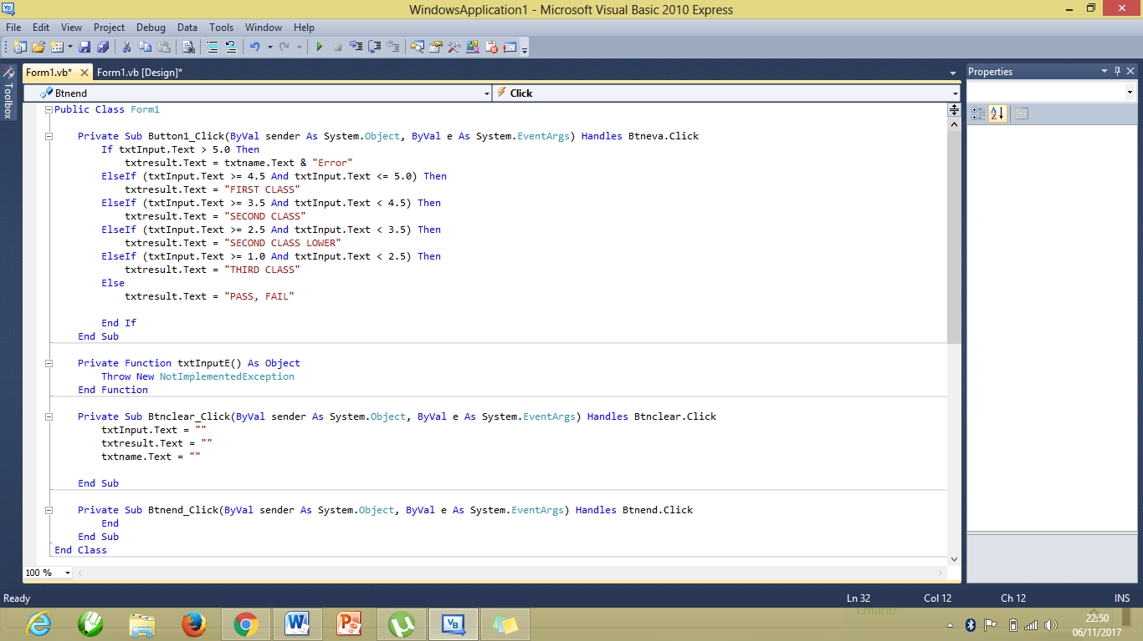
Public Class Form1

Private Sub Button1_Click(ByVal sender As System.Object, ByVal e As System.EventArgs) Handles Btneva.Click
If txtInput.Text > 5.0 Then
txtresult.Text = txtname.Text & "Error"
ElseIf (txtInput.Text >= 4.5 And txtInput.Text <= 5.0) Then
txtresult.Text = "FIRST CLASS"
ElseIf (txtInput.Text >= 3.5 And txtInput.Text < 4.5) Then
txtresult.Text = "SECOND CLASS"
ElseIf (txtInput.Text >= 2.5 And txtInput.Text < 3.5) Then
txtresult.Text = "SECOND CLASS LOWER"
ElseIf (txtInput.Text >= 1.0 And txtInput.Text < 2.5) Then
txtresult.Text = "THIRD CLASS"
Else
txtresult.Text = "PASS, FAIL"

End If
End Sub
Private Sub Btnclear_Click(ByVal sender As System.Object, ByVal e As System.EventArgs) Handles Btnclear.Click
txtInput.Text = ""
txtresult.Text = ""
txtname.Text = ""

End

