EZEANO NNAEMEKA PRINCE
COMPUTER SCIENCE DEPARTMENT

16/SCI01/012
CSC201

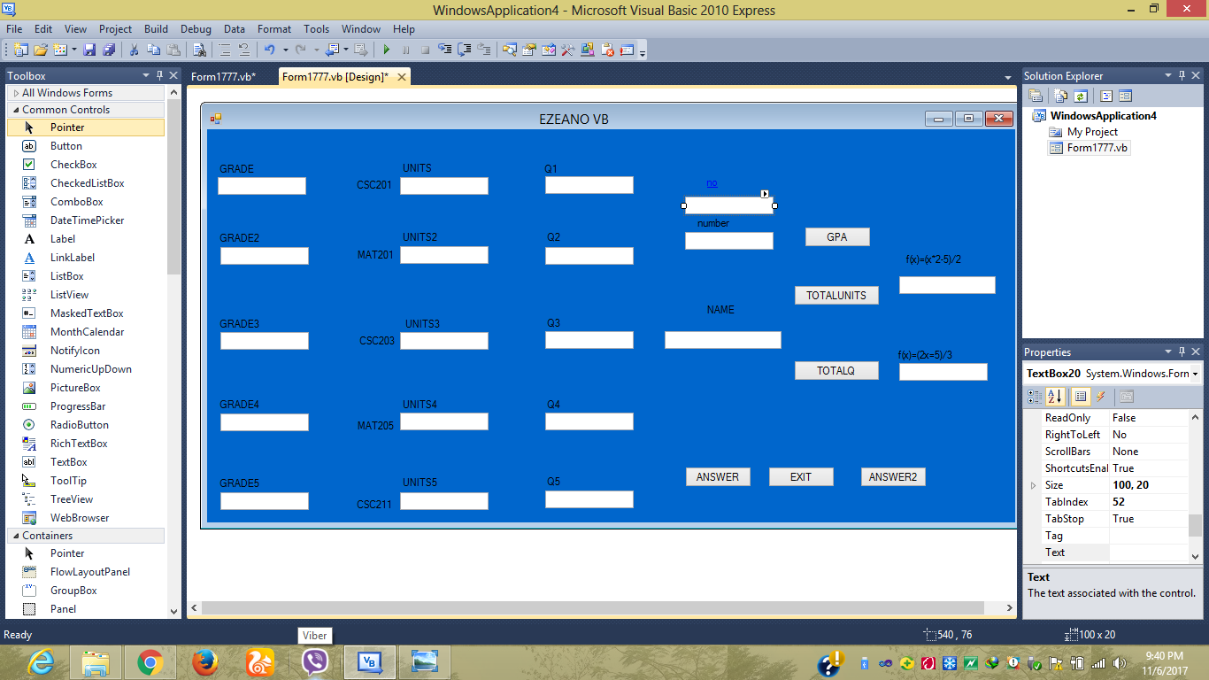

CODES

