AIMUEL EMMANUEL
16/SCI01/005
COMPUTER SCIENCE.
Csc 201

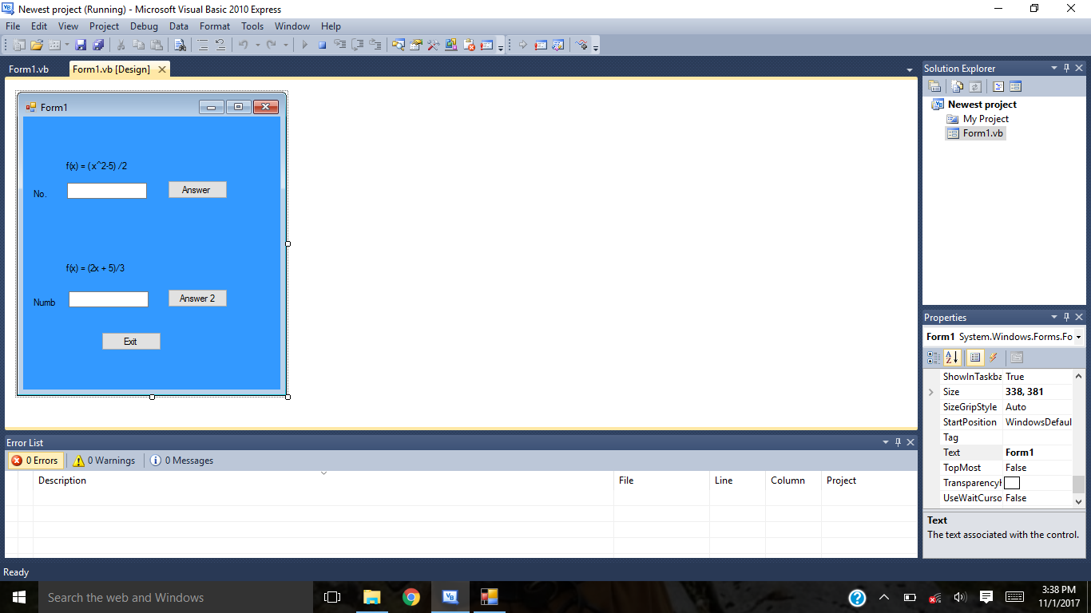
Textbox1 Answer button 2
Exit Textbox 2
Answer button 1

