OTEGBEYE OLORUNLEKE
GPA CALCULATOR
16/SCI01/038
COMPUTER SCIENCE DEPARTMENT
CSC201

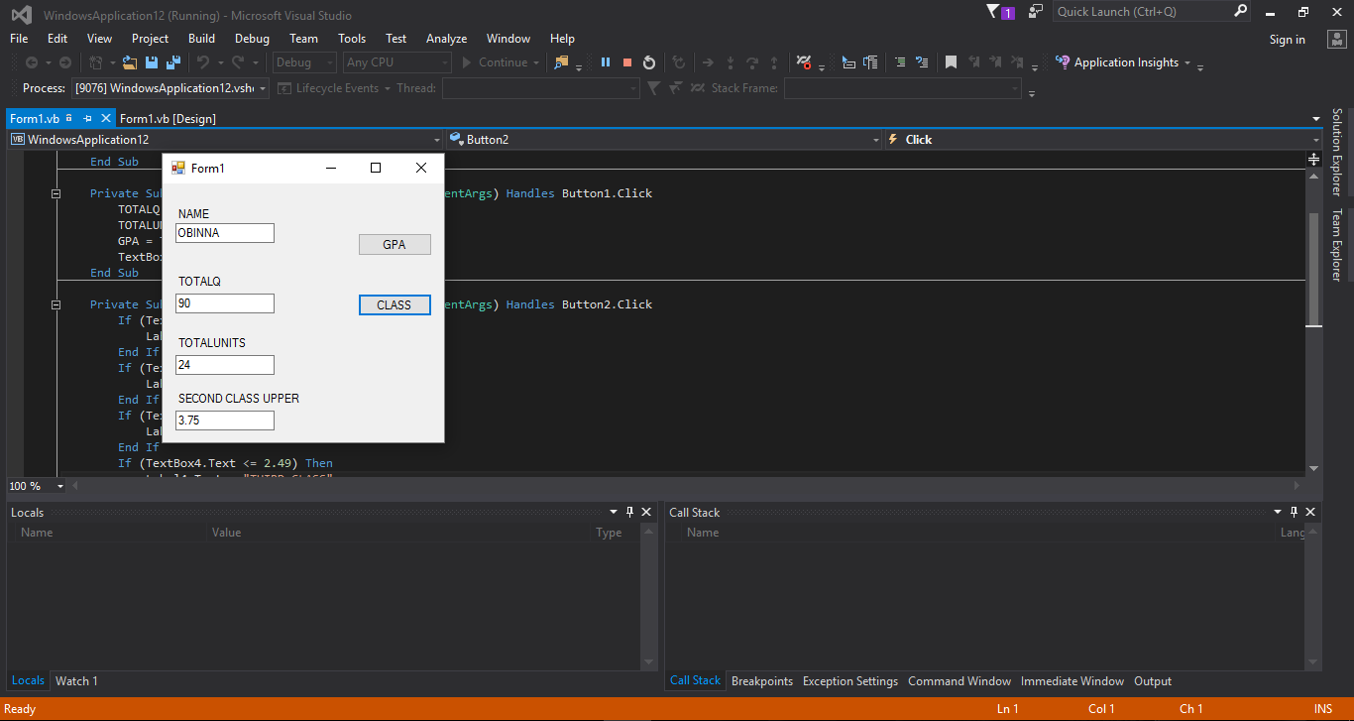

EXECUTED CODE

SECOND CLASS UPPER GPA
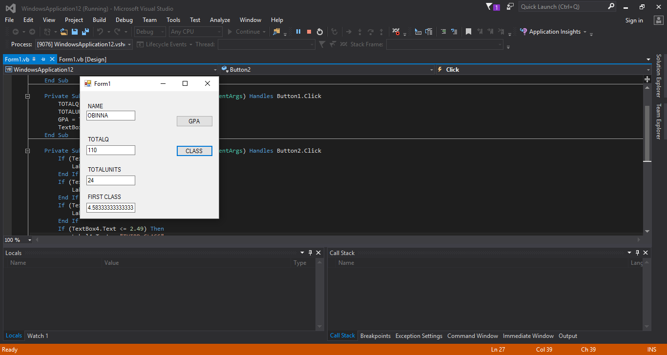

FIRST CLASS GPA

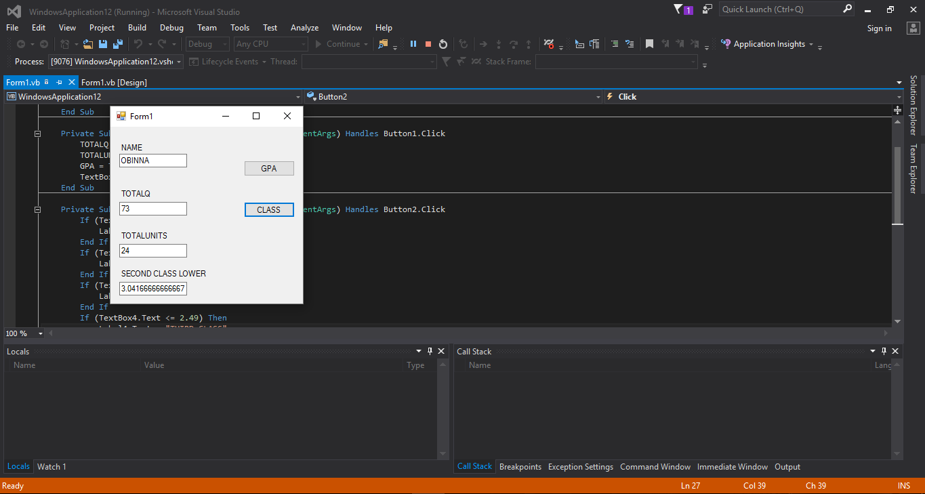

SECOND CLASS LOWER GPA

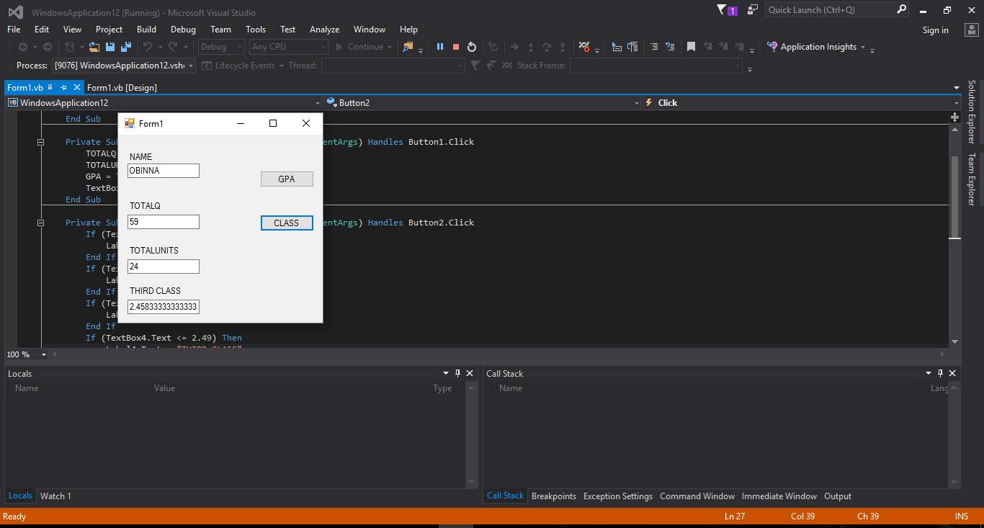

THIRD CLASS GPA

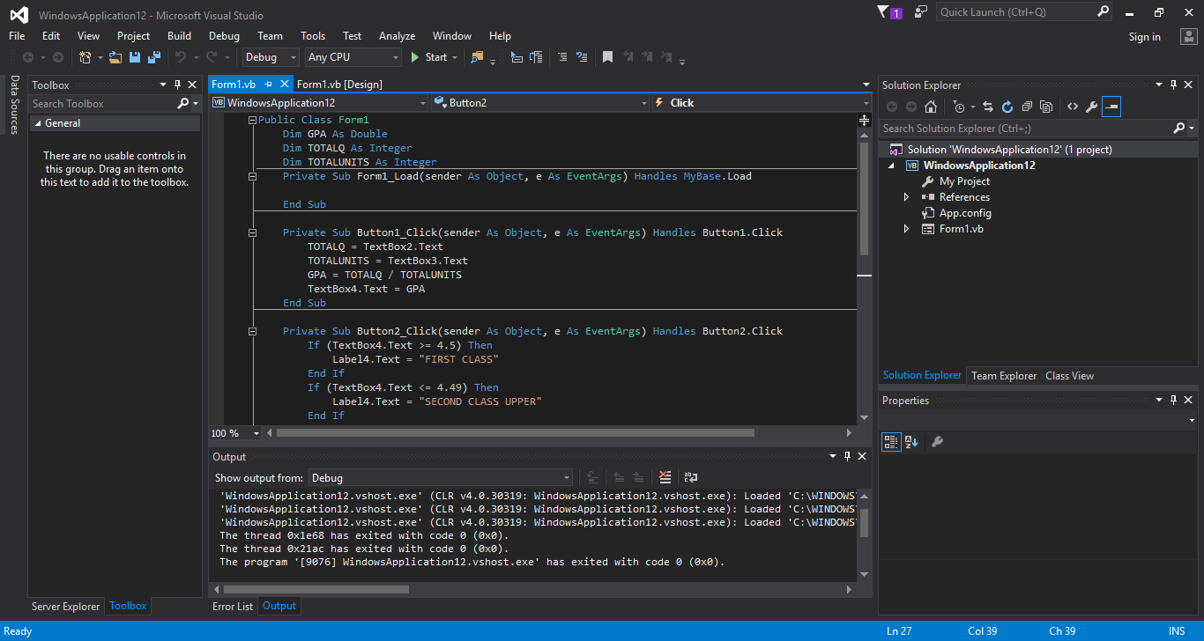

WRITTEN CODE

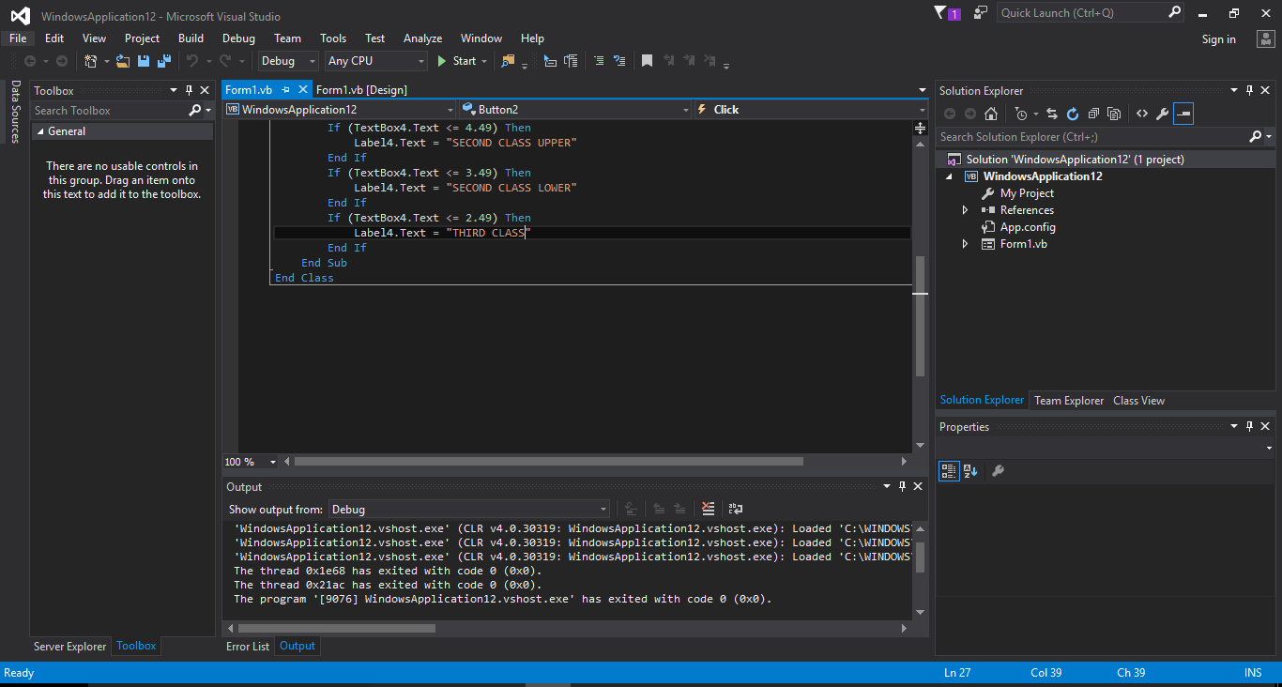

WRITTEN CODE
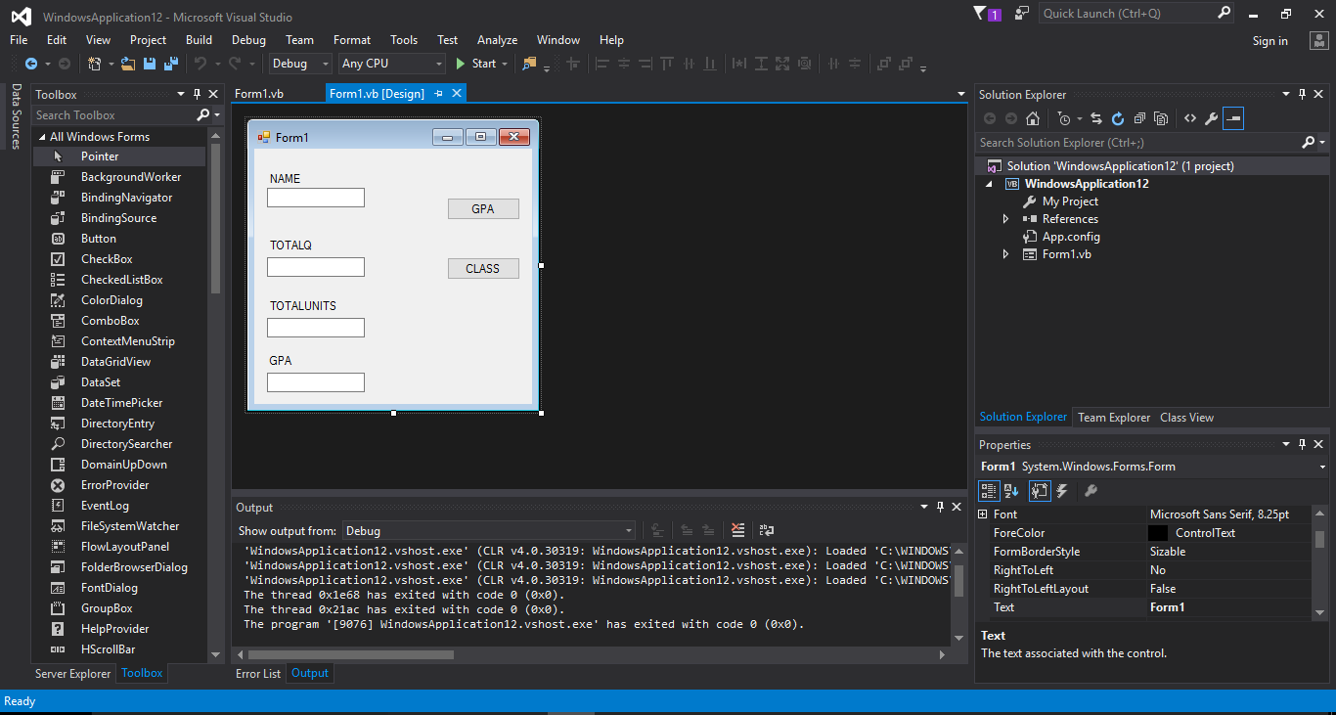

DESIGN VIEW

