AIMUEL EMMANUEL
GPA CALCULATOR
16/SCI01/005
COMPUTER SCIENCE
CSC201

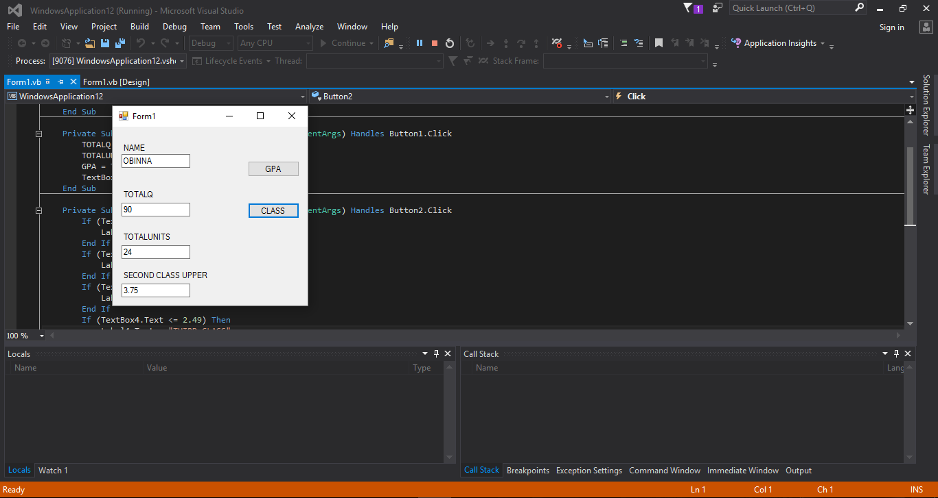

SECOND CLASS UPPER GPA
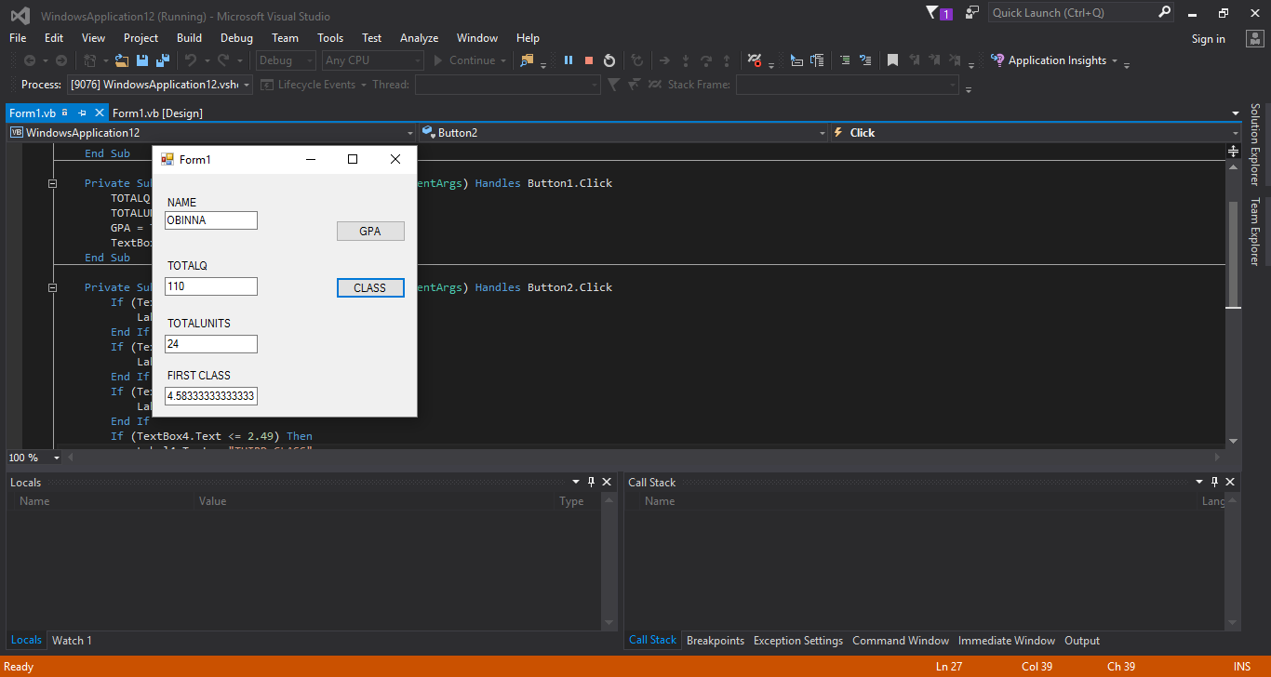

FIRST CLASS GPA

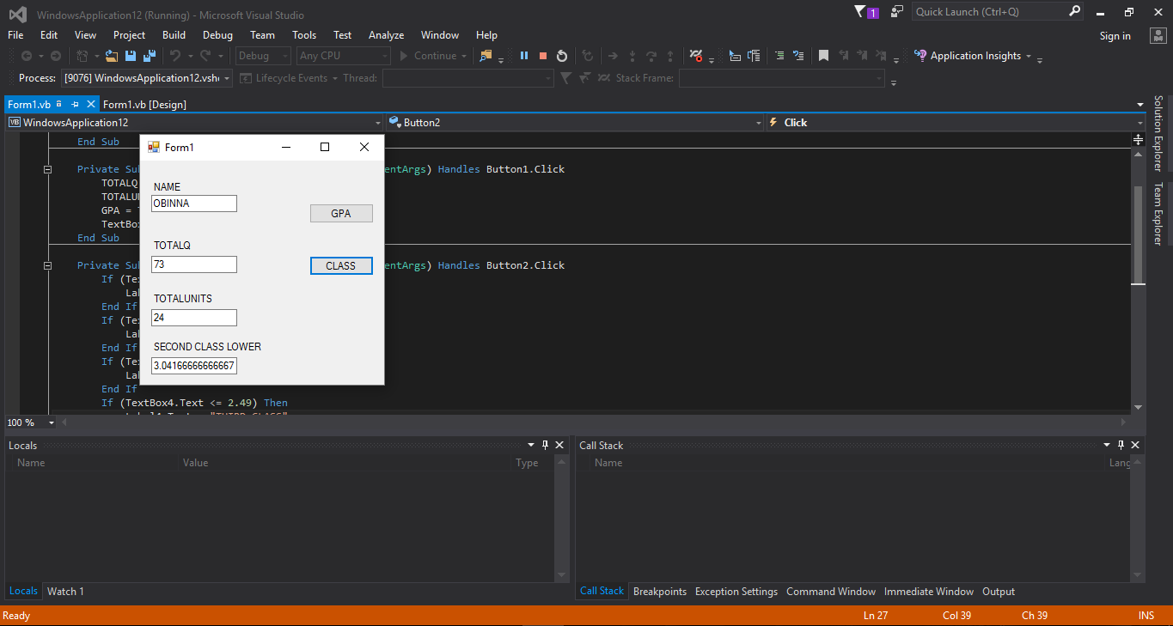

SECOND CLASS LOWER GPA

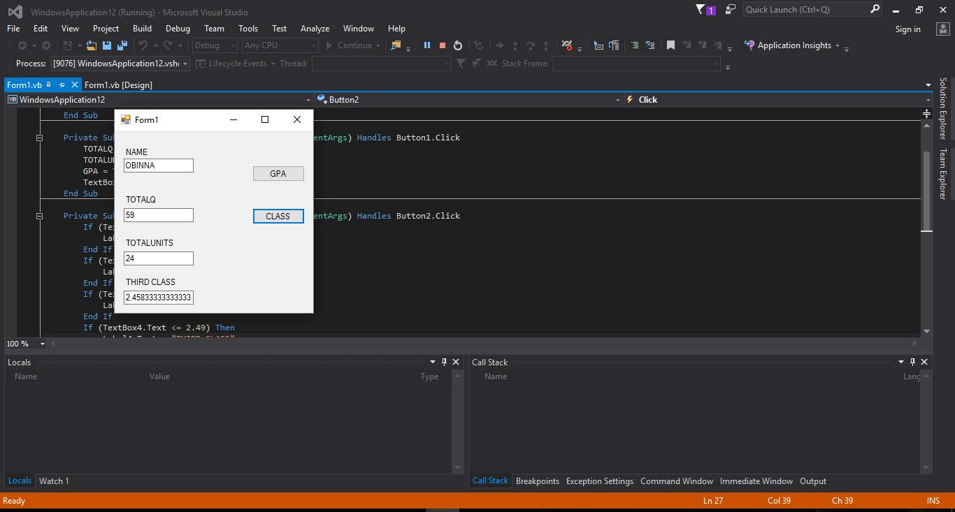

THIRD CLASS GPA

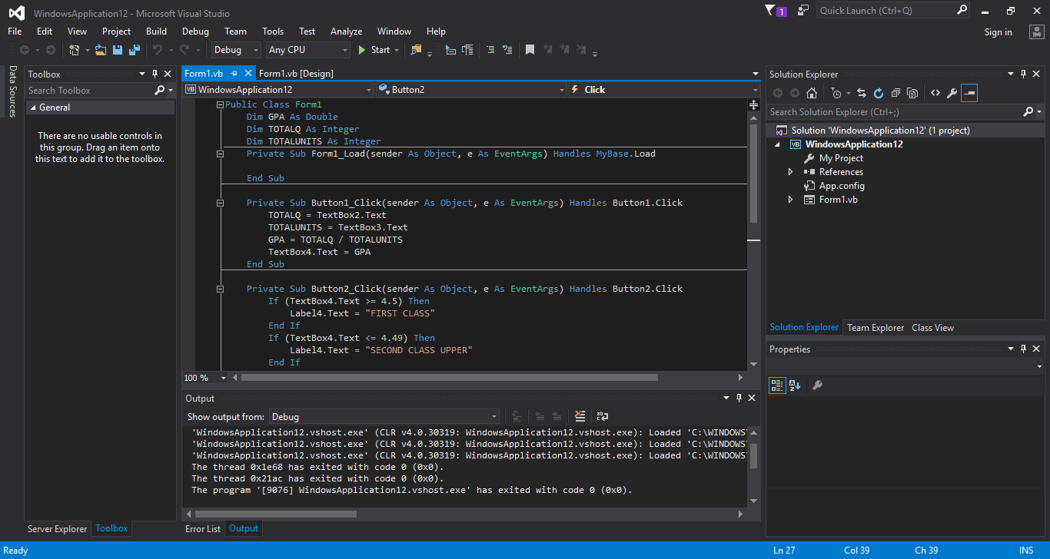

CODE

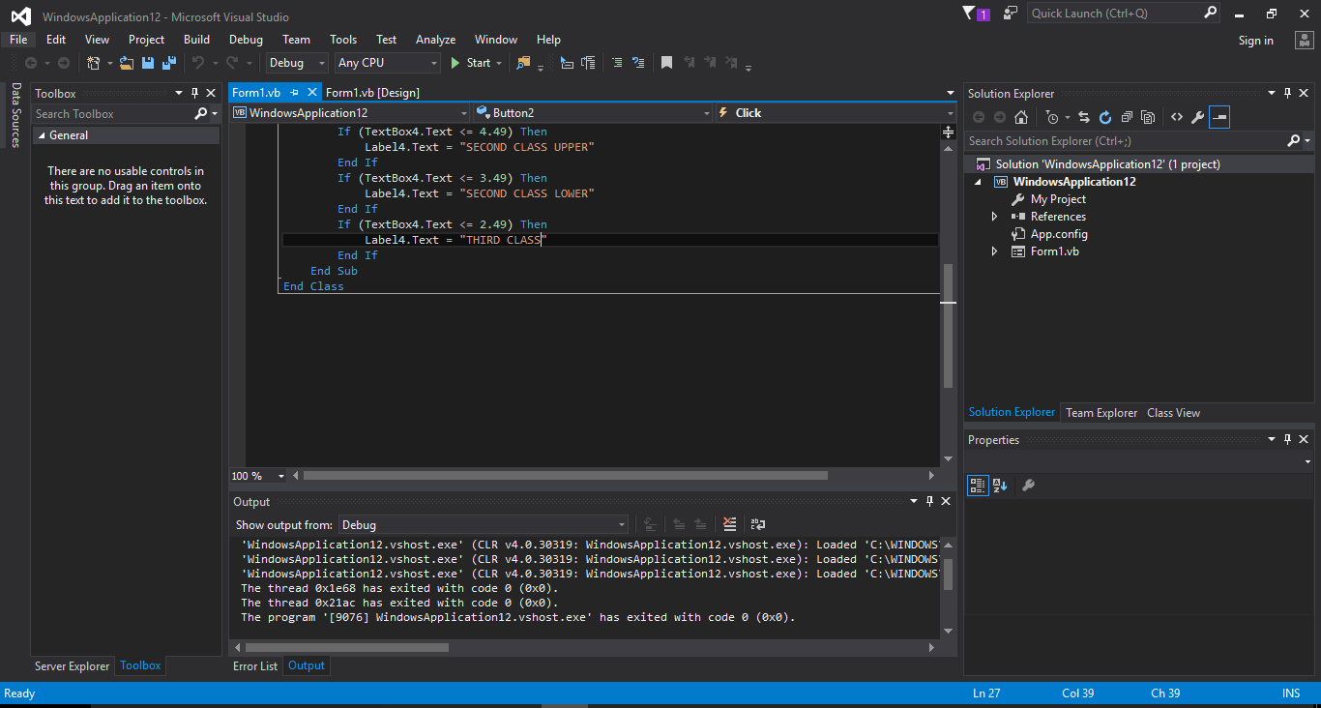

CODE
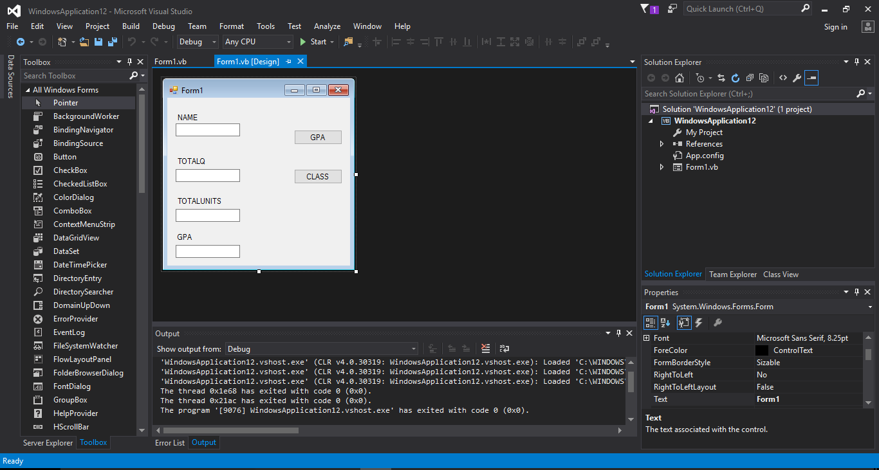

DESIGN

