NAME: GBENLE SHERIF
COMPUTER SCIENCE
MATRIC NO: 16/SCI01/015
CSC 201
ASSIGNMENT

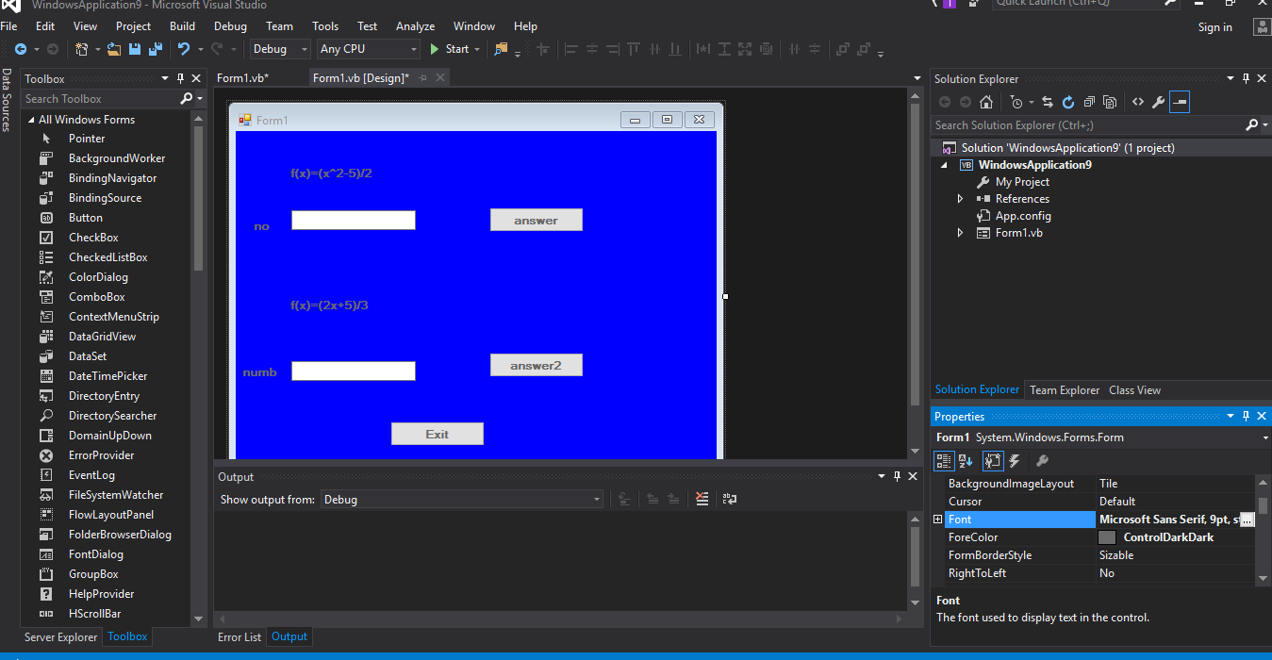
TEXTBOX.1
TEXTBOX.2 BUTTON 1
BUTTON 2

LABEL 1

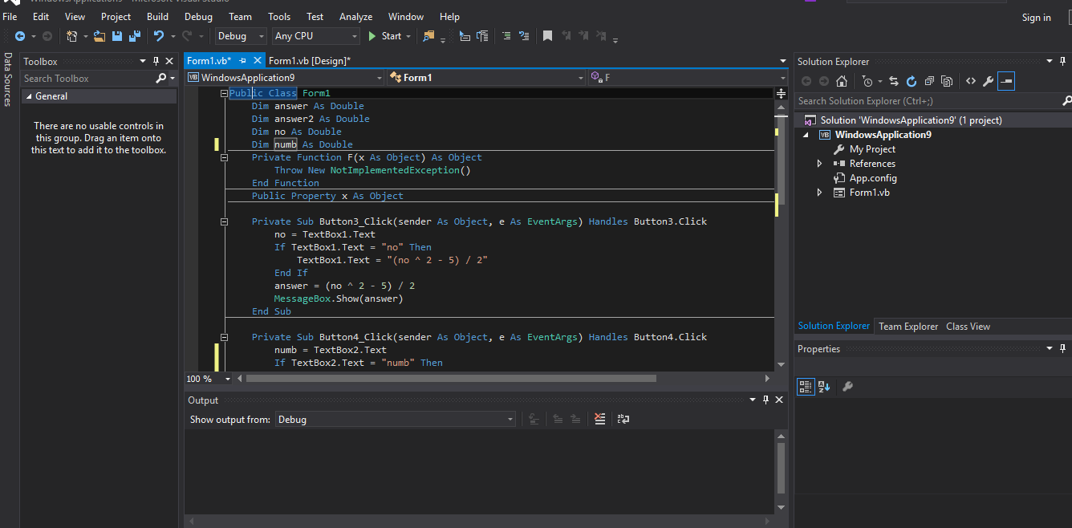

LABEL 2

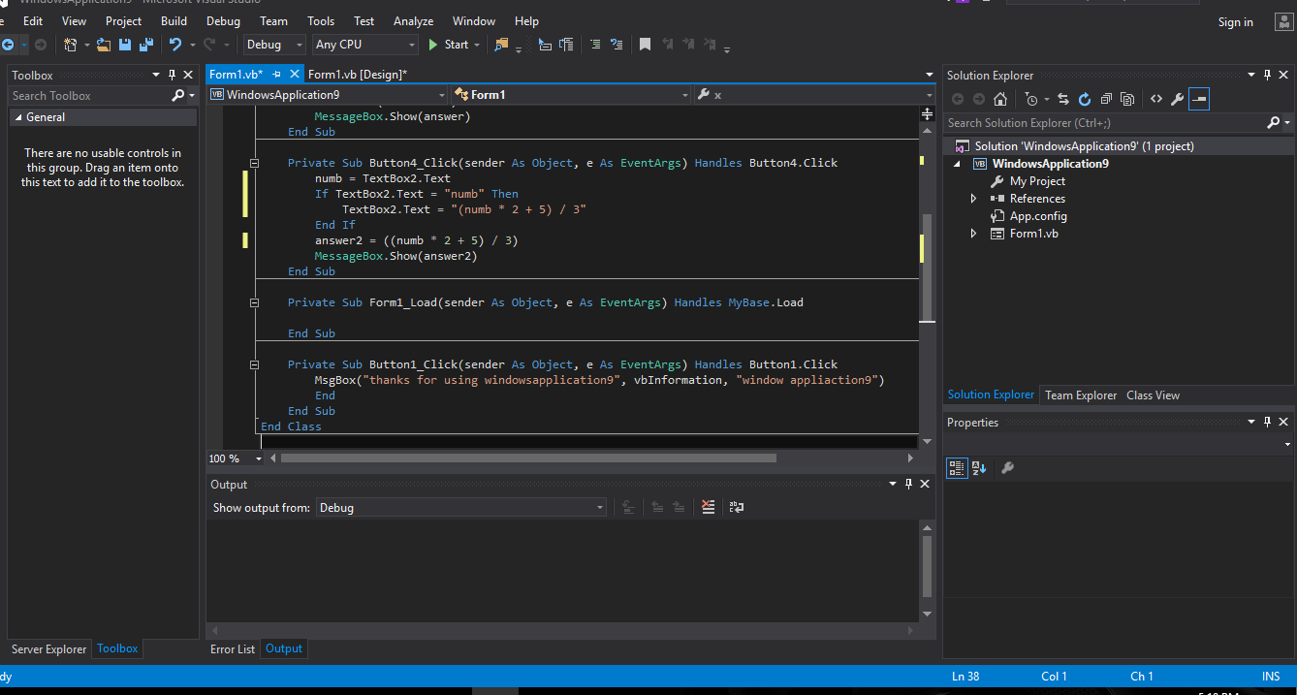

LABEL 3

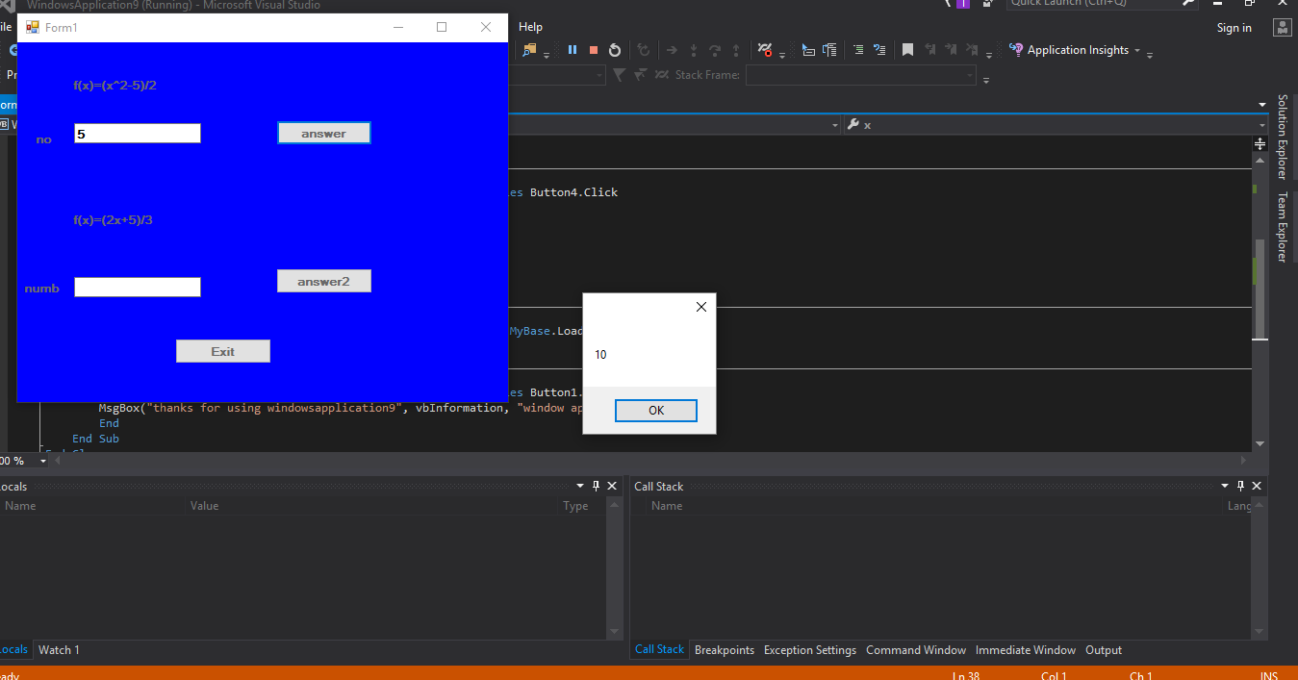

LABEL 4

LABEL 5

