NAME: UCHE-EWULE GIDEON E.
MATRIC NO: 16/SCI01/049
COMPUTER SCIENCE
CSC 201

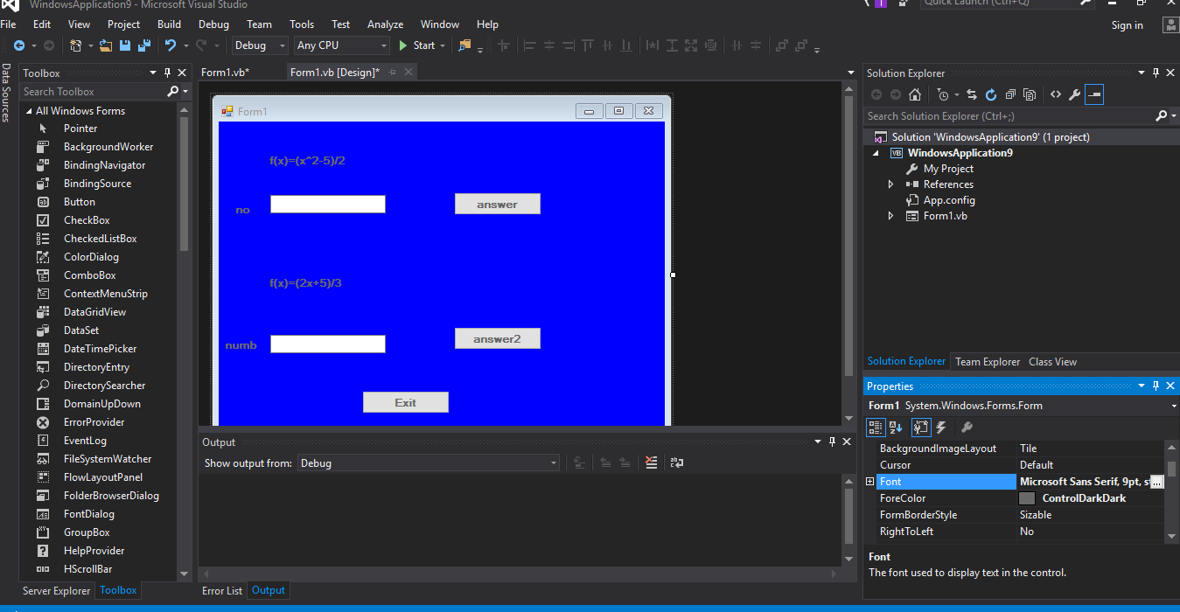
TEXTBOX.1
TEXTBOX.2 BUTTON 1
BUTTON 2

LABEL 1

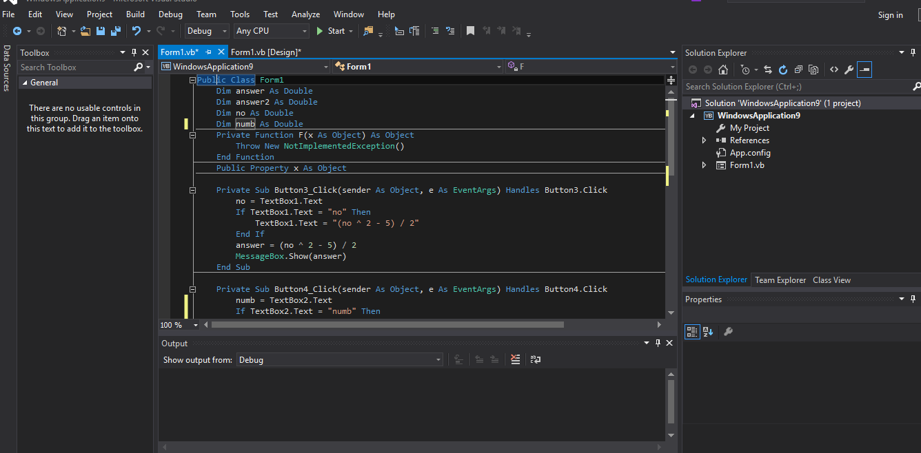

LABEL 2

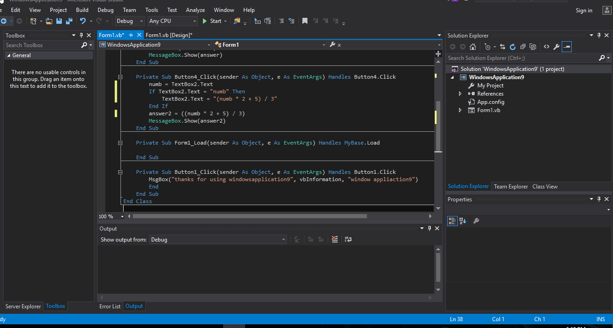

LABEL 3

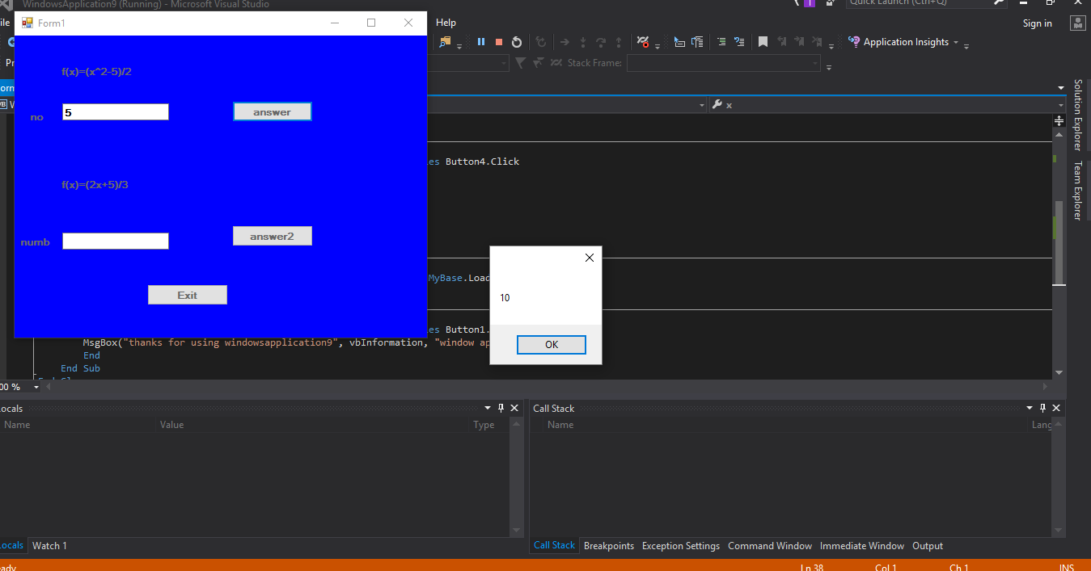

LABEL 4

LABEL 5

