NAME: UCHE-EWULE GIDEON E.
16/SCI01/049
COMPUTER SCIENCE
CSC 201
ASSIGNMENT

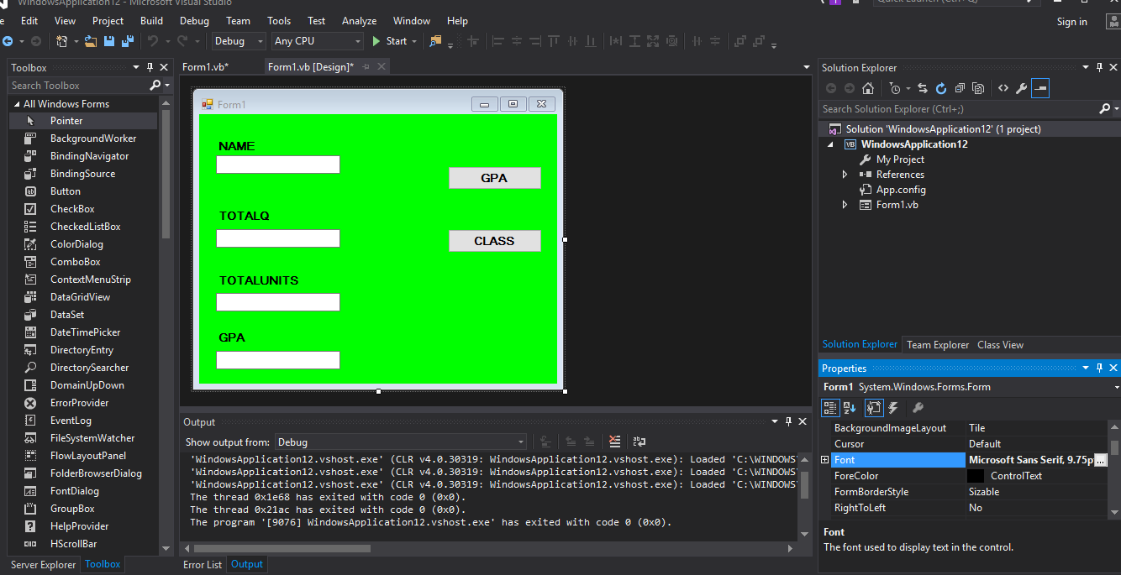
TEXTBOX.1
TEXTBOX.3 TEXTBOX.2 BUTTON 1
TEXTBOX.4
BUTTON 2
LABEL 1
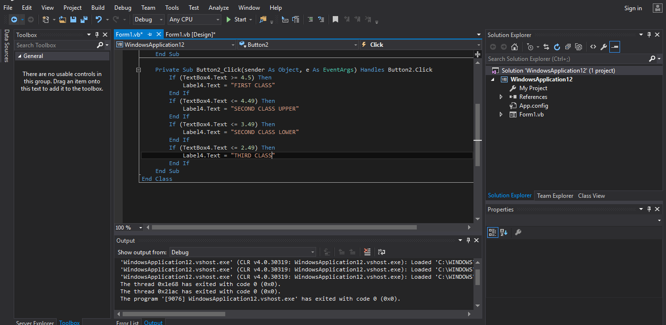

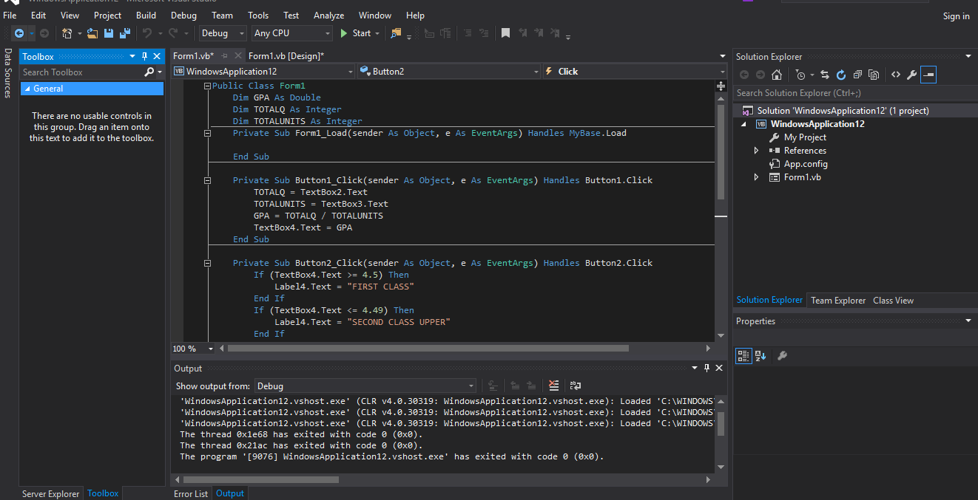

CODE
LABEL 2

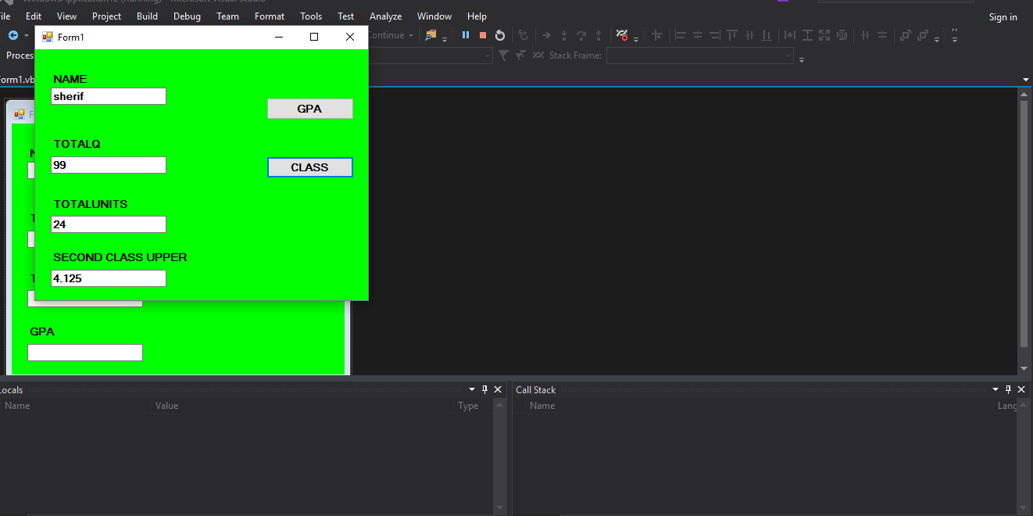
LABEL 3

