NAME: Okhifo Daniel

16/SCI14/010

CSC 201

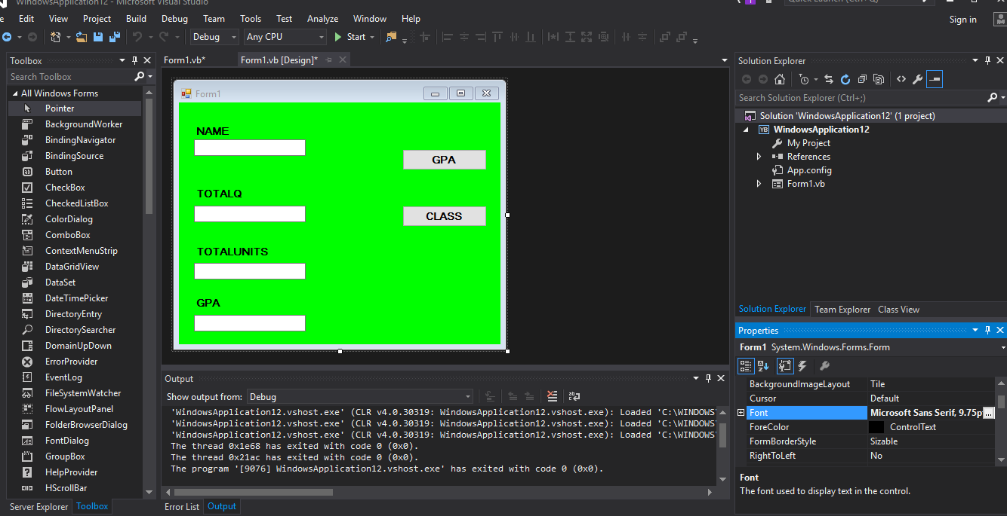

TEXTBOX.1

TEXTBOX.3 TEXTBOX.2 BUTTON 1

TEXTBOX.4

BUTTON 2

LABEL 1

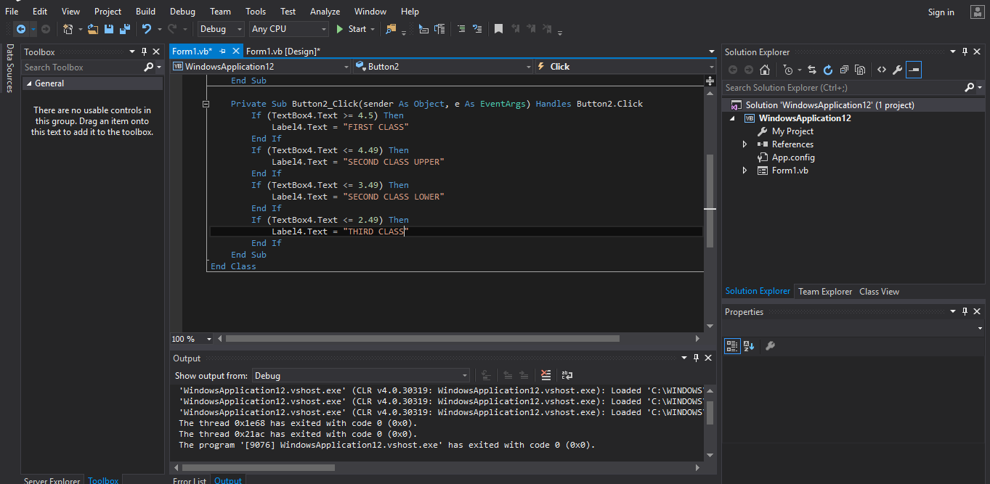

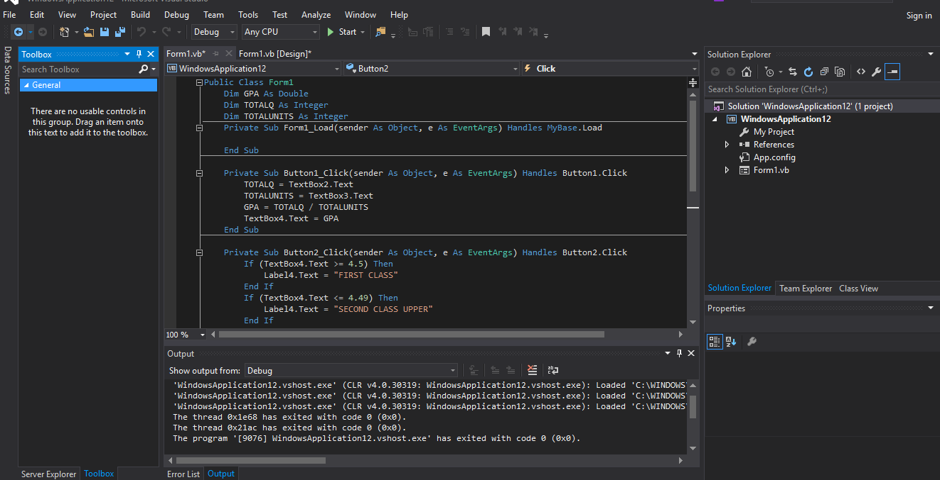

CODE

LABEL 2

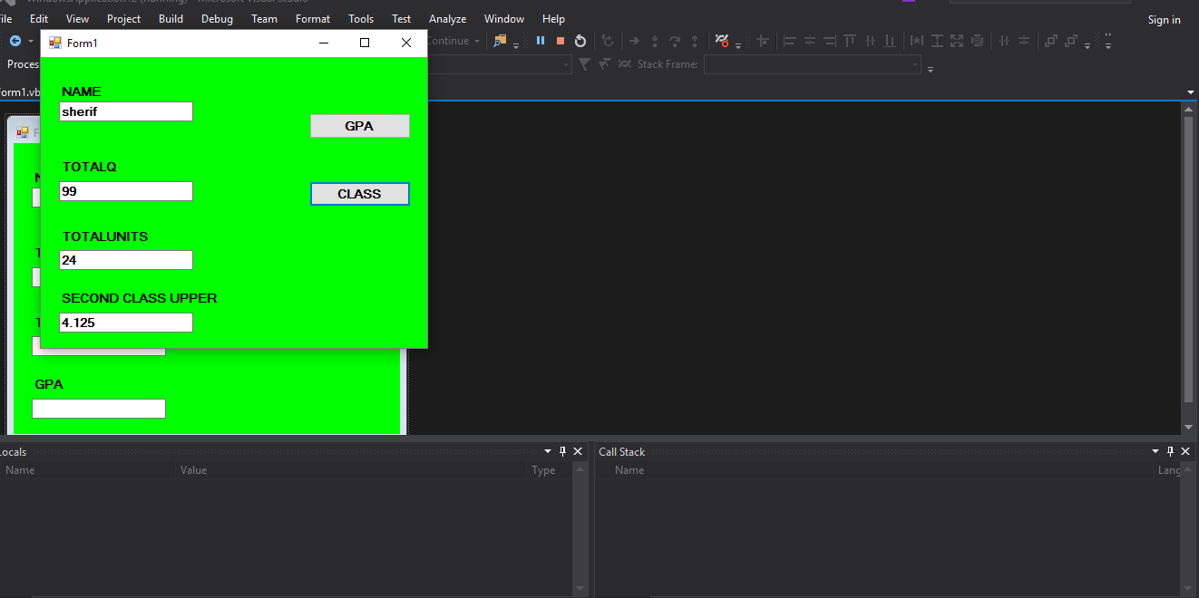

LABEL 3