NAME: Okhifo Daniel
MATRIC NO: 16/sci14/010
CSC 201

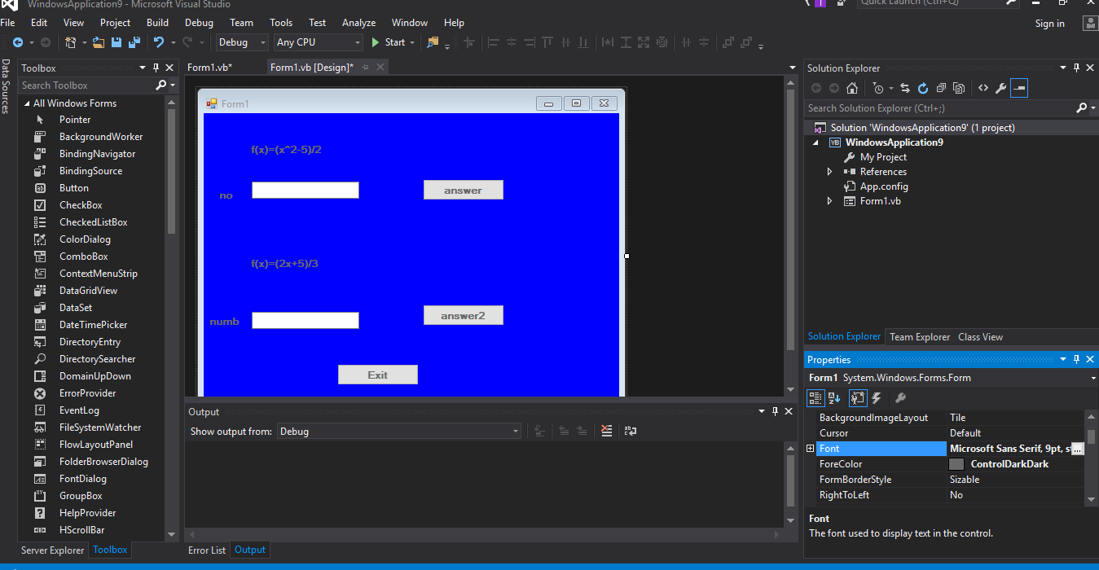
TEXTBOX.1
TEXTBOX.2 BUTTON 1
BUTTON 2

LABEL 1

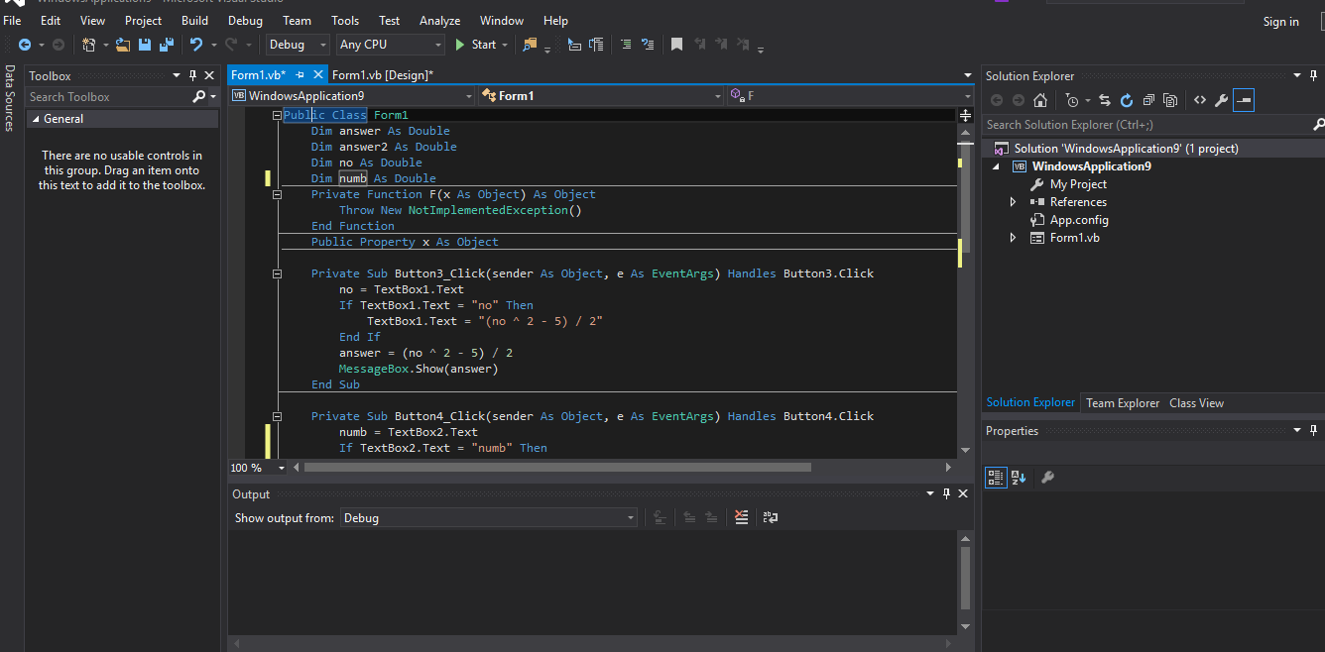

LABEL 2

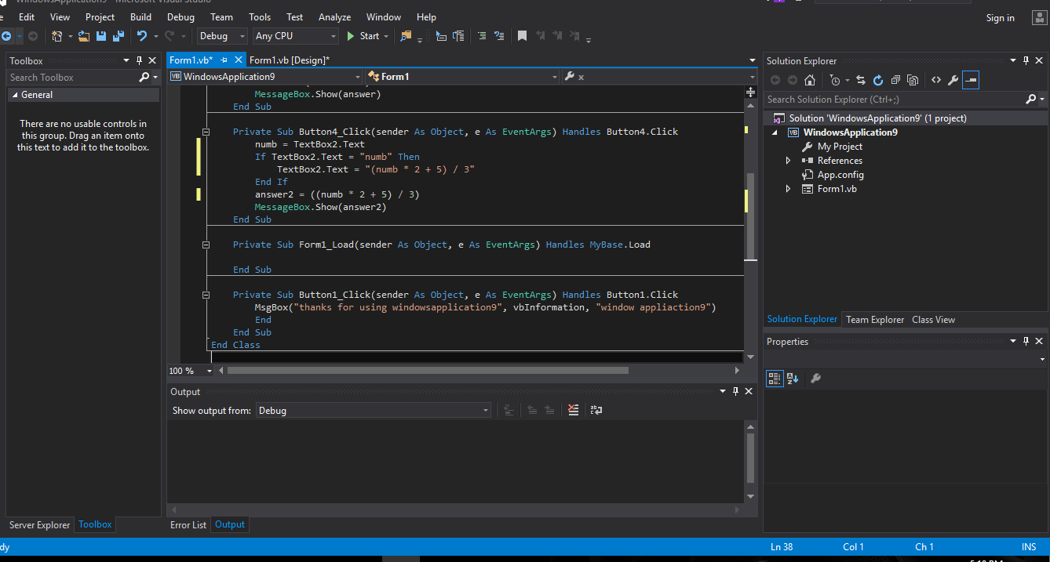

LABEL 3

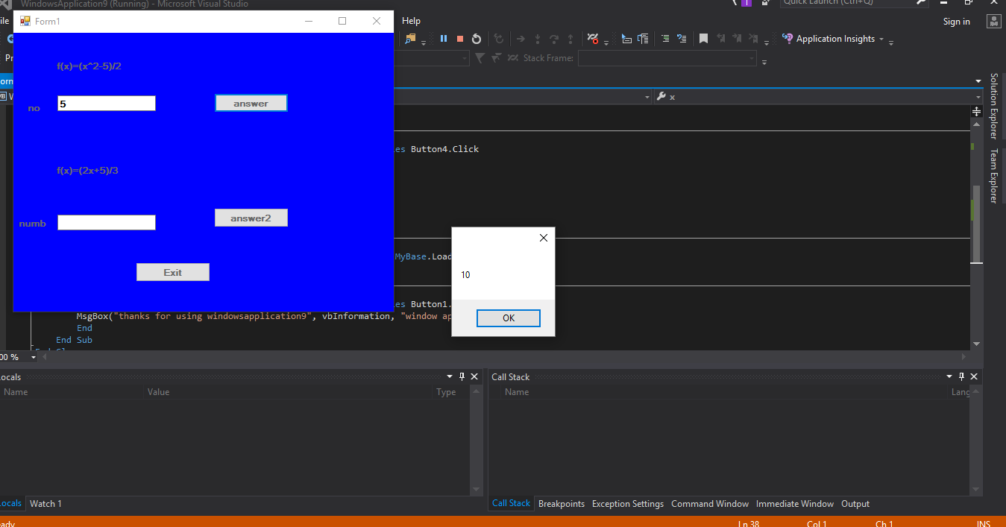

LABEL 4

LABEL 5

