DAYO AROGUNMATI
16/SCI01/007
COMPUTER SCIENCE
CSC 201

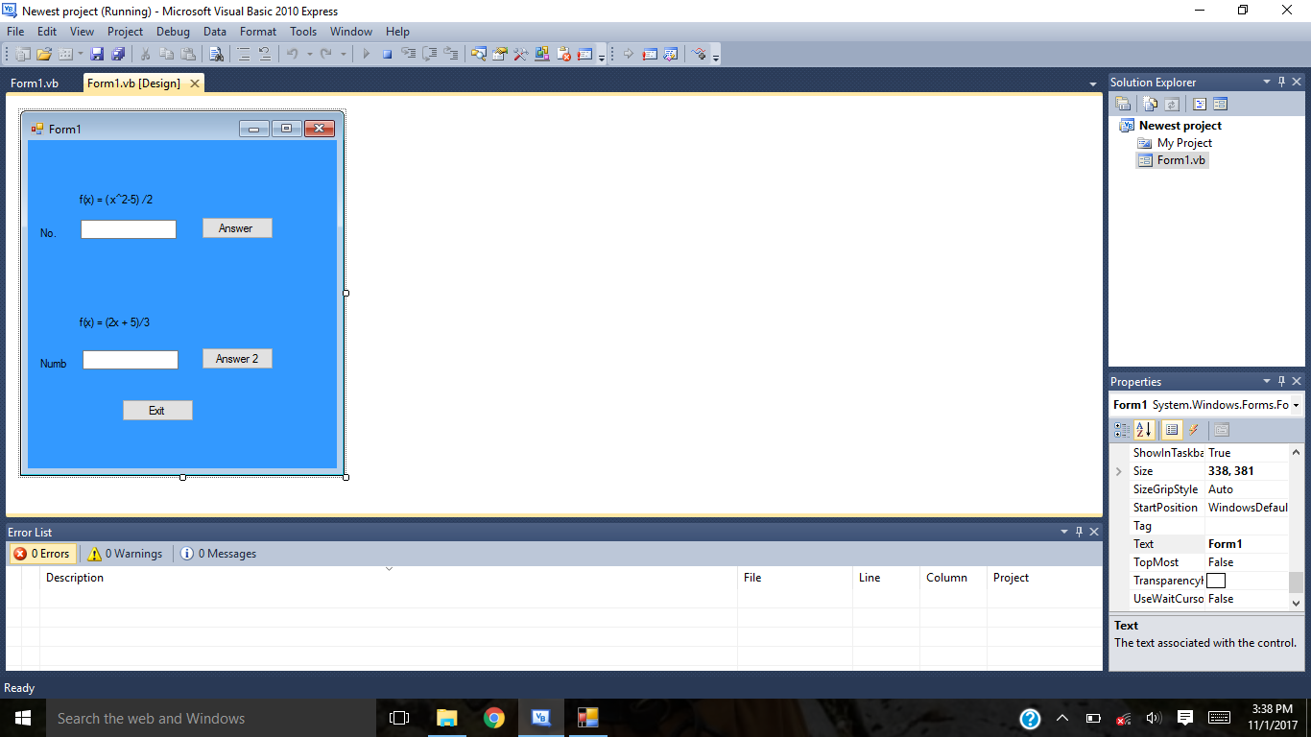
Textbox1 Answer button 2
Exit Textbox 2
Answer button 1

