DAYO AROGUNMATI
16/SCI01/007
COMPUTER SCIENCE
CSC 201

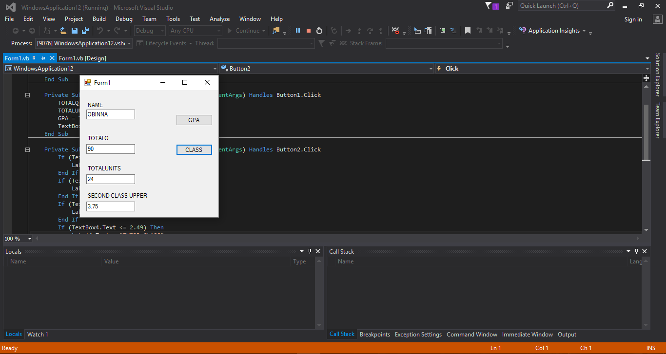

EXECUTED CODE

SECOND CLASS UPPER GPA
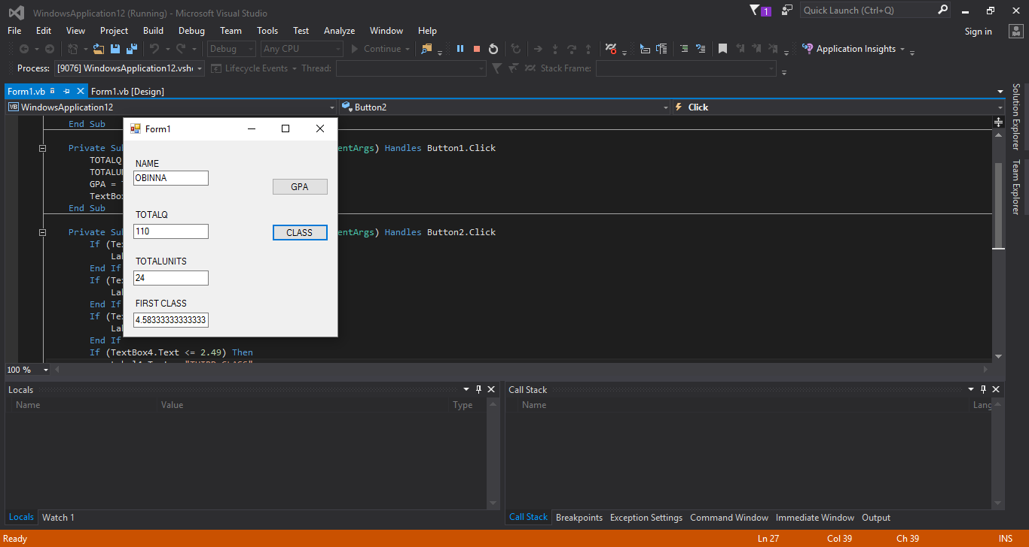

FIRST CLASS GPA

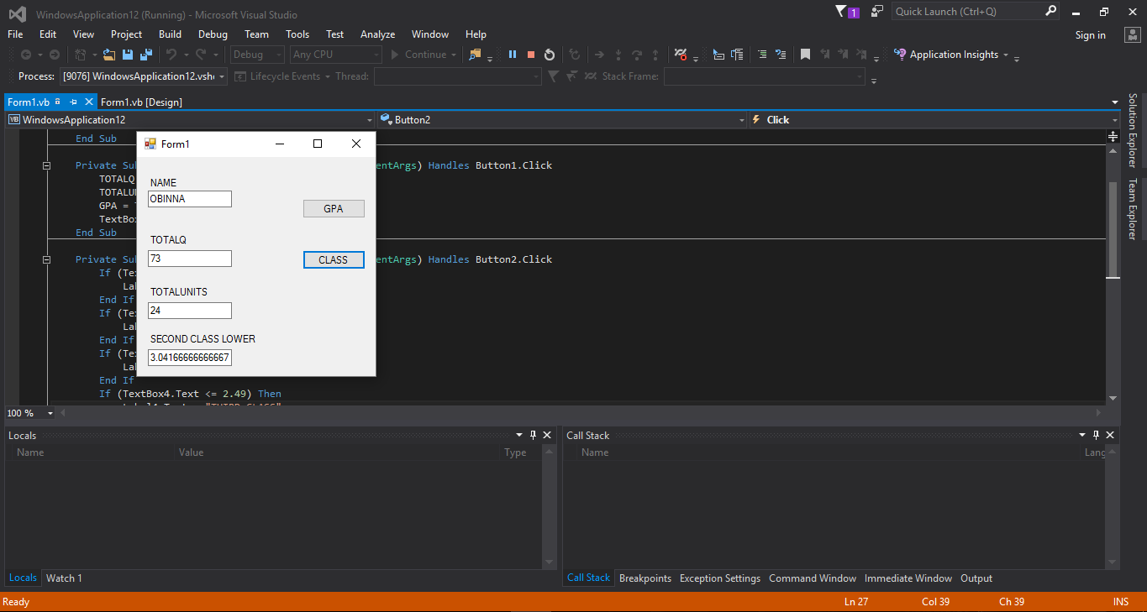

SECOND CLASS LOWER GPA

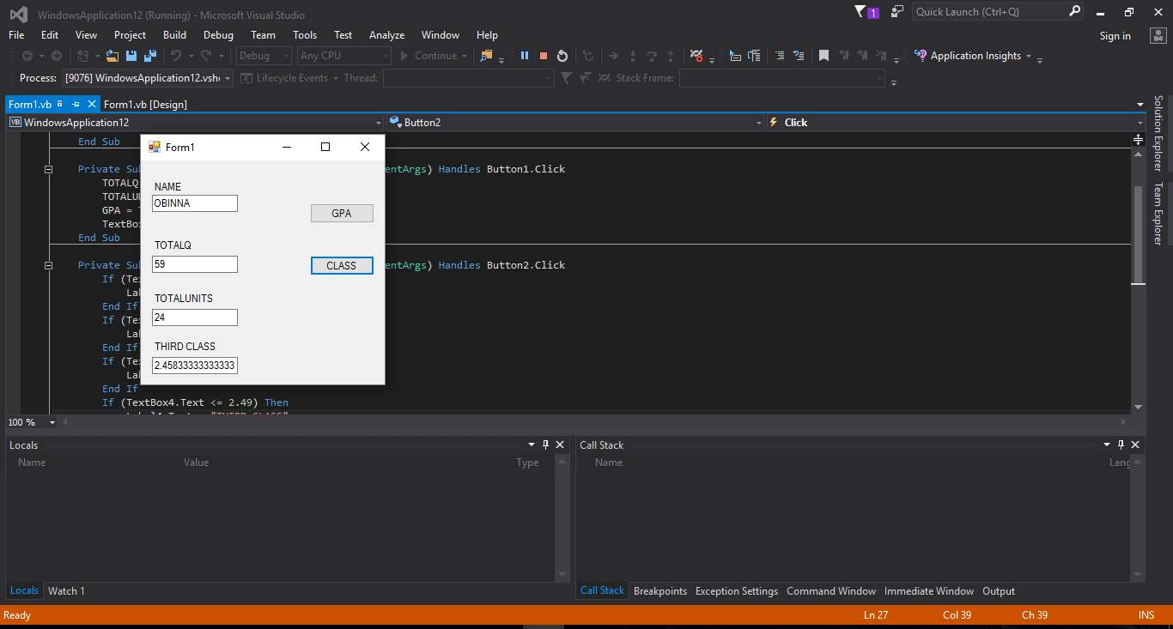

THIRD CLASS GPA

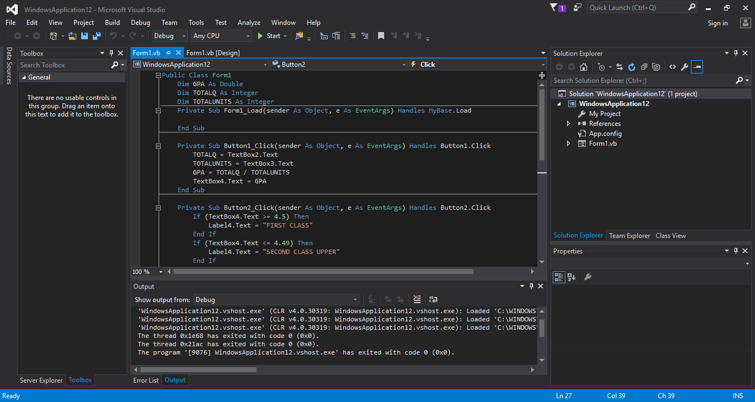

WRITTEN CODE

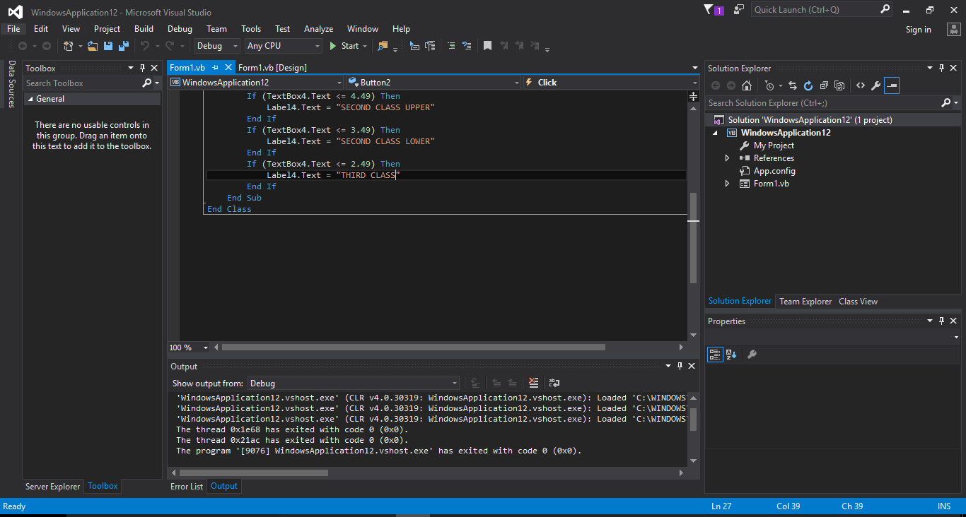

WRITTEN CODE
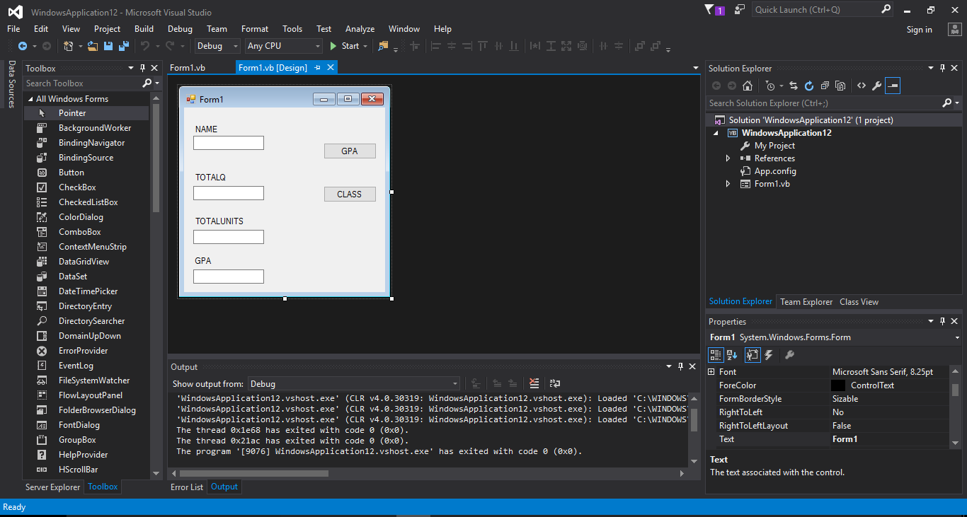

DESIGN VIEW

