AFE-BABALOLA UNIVERSITY

ATUZIE HAPPY RUHUOMA

14/ENG07/004

PETROLEUM ENGINEERING

MEASUREMENT OF GAS VOID FRACTION IN HORIZONTAL PIPE

ENG485: TECHNICAL REPORT WRITTING

THIS THESIS IS SUBMITTED IN PARTIAL FULFILMENT OF THE REQUIREMENTS FOR THE DEGREE OF THE BACHELOR OF ENGINEERING (B.ENG) DEGREE IN CHEMICAL ENGINEERING AT THE AFE BABALOLA UNIVERSITY ADO EKITI.

ACADEMIC YEAR: 2016-2017

SUPERVISOR: DR YAHAYA
NOVEMBER 2017.

ABSTRACT
Inaccurate measurement would introduce errors in product measurement with potentials for loss of revenue. Accurate measurement is often constrained by invasive and expensive online measurement techniques. This work focuses on the use of an aluminium pipe w to test the multi-beam gamma-ray measurement principles. The aluminium pipe, source and detector are mounted in a computer-controlled test platform, on which the detectors are positioned around the pipe to an accuracy of 61⁰. The CZT detector is moved by 8° between each measurement to obtain detector responses in several positions around the pipe with fixed flow regimes .It is concluded that using the multi-beam gamma-ray measurement principles, accurate measurements can be made when measurements of four detector positions around the pipe are combined. However, it should be noted that the results depend on the pipe-wall material and thickness, pipe dimensions, and finally, on the composition of the flow.

Introduction
The oil and gas production industry has a need for accurate measurements of the oil and gas fractions in pipelines. Improved production techniques have made it economically feasible to produce from smaller (marginal) reservoirs by using subsea and even down- hole production units. With several production lines running into a production separator on the platform, it is impossible to measure the gas fraction in each line. At present, the flow is separated and then the fractions are measured. A test separator is used to separate the flow and then the individual phases in each production line are measured at intervals. Usually, turbine meters and orifice plates are used to measure the oil and gas flows, respectively. One disadvantage of this technique is that test separators are large units and space costs on a production platform are high. A multiphase meter on each line that measures the water, oil and gas flows offers better production control than test separators, and online measurements of production at each unit are necessary to optimize production. During the past decade, much work has been devoted to the development of three-phase meters cap- able of measuring oil, gas and water in pipelines. Multi- phase meters should preferably have non-intrusive sensors for several reasons, including the elimination of pressure drop over the instrument, their lack of impact on the flow and the elimination of detector corrosion. Most multiphase meters include measurements of either single- or multi-energy gamma-ray attenuation for fraction measurements (1).
Conventional gamma-ray densitometers utilize a single 137Cs (662 Kev) source and detector (Photo Multi- plier Tube, PMT) located diametrically opposite each other. PMTs have a diameter of several centimeters. Gamma-ray densitometers have clamp-on capability, which is to say that these instruments can be installed and removed without shutting down the process. Where low-energy gamma-ray densitometers are used, the clamp-on capability is lost due to the need for radiation windows in the pipe walls. However, gamma-ray densitometers used in multiphase meters do not need to be clamp-on.
a-ray densitometry can be studied with the aid of the phantoms listed in Table 1-1, which have fixed void fractions and flow regimes. A PMT is located diametrically opposite the source (241Am). In Fig. 1-10 the measured void fractions of these known phantoms of the single-beam gamma- ray densitometer are presented. A steel cap with an Ø10 mm hole was used to collimate the PMT in order to minimize the contribution of scattered photons and to achieve a lower count rate. The deviation between the true void fraction and the measured void fraction appears Fig. 1-10. Measured void fraction versus true void fraction using single-beam gamma-ray densitometer with 241Am source. The solid line represents the ideal case, with no deviation between true and measured void fractions .regimes are the cause of the deviations between measured and true void fractions. Since the deviations appear to be similar for calculated and measured void fractions, the models used to describe the calculated void fraction of annular and stratified flows are satisfactory.
A performance study of the multi-beam gamma-ray measurement principle requires measurements obtained by a conventional gamma-densitometer. Such a densitometer was constructed: it consists of a single collimated 1 mCi 137Cs (661.7 keV) source and one 20 PMT, installed on a 90 mm steel pipe with a wall thickness of 5 mm. The phantoms shown in Table1-1 were used, as they had well-defined void fractions. In accordance with Eq. (1-8), the measured void fractions were found on the basis of the measured intensities for different void fractions and flow regimes. Fig.1-11 plots the measured void fractions against the true void fractions. By comparing the experimental data from the conventional gamma-densitometer with the data in Figs. 1-4 and 1-8, it can be seen that the data fit fairly well with the annular and stratified flows with parallel radiation beams, respectively.
It is obvious from Eq. (1-8) that the Igas/Ioil ratio expresses the sensitivity of the system.

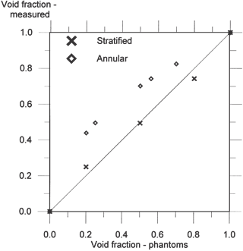
Figure 1-11: Measured Void Fraction Versus True Void Fraction Using Convectional Gamma-Ray Densitometer With 137cs Sources. The Solid Line Represents The Ideal Case With No Deviation Between True And Measured Void Fractions.
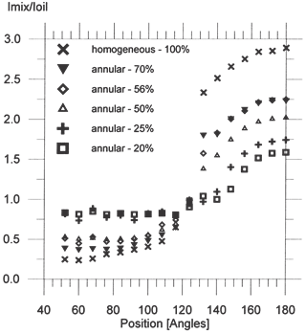
Figure 1-12: Imix/Ioil Ratios against Detector Position For Annular Flow Phantoms.
It can be seen that this ratio is higher than 1 in detectors that are registering transmitted photons, i.e. in the collimated beam (see Fig.1-12 and Fig.1-13). In multi-beam gamma-ray densitometry the Igas/Ioil ratio is smaller than 1 outside the beam. This means that in the oil–gas mixture the number of scattered photons decreases as void fraction increases, due to the lower probability of interactions in the gas.
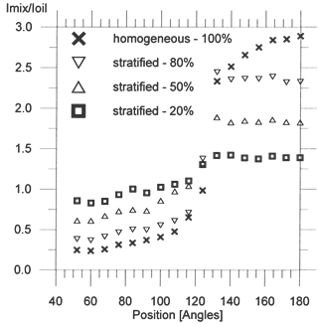
Figure 1-13: Imix/Ioil Ratios Plotted Versus Detector Position for Stratified Flow Phantoms.
Since the Igas/Ioil ratio is fixed for a given gamma-ray densitometer, the deviations between the real and measured void fraction must be found in the Imix/Ioil ratios. Figs.1-12 and 1-13 plot the Imix/Ioil ratios for all the phantoms. The ratios are found by counting the number of events with constant measurement time in the full energy peak. By comparing Figs.1-12 and 1-13 it can be seen that the Imix/Ioil ratios are 1.3–1.4 for stratified flow phantoms and are close to 1 for the annular flow phantoms at the detector position of 124. This means that at this detector position, the system will only be sensitive to the stratified flow phantoms. It can also be seen that the Imix/Ioil ratios of stratified flow phantoms are flat over the detector positions covered by the beam. This is due to the fact that the transmitted beam has a shorter path through the stratified phantoms at angles smaller than 180, com- pared with its path through annular flow phantoms. This suggests that the Imix/Ioil ratios of two detectors located in the beam could be used to detect whether the flow regime is stratified or not. It should be noted that the value of Imix/Ioil ratios versus detector position depends on the distribution of the photon emission from the source.
Using the data shown in Figs.1-12 and1-13, the void fraction can be calculated according to Eq. (1-8). The measured void fractions at 180 appear to be similar to the data obtained by the PMT (Fig. 1-10). In this position the measured void fractions with stratified flow phantoms are close to the true void fractions. It was discovered experimentally that several detector positions underestimated the void fraction of stratified and annular flow phantoms. By taking these void fractions into account, the dependency of the flow regime can be reduced. The measured void fraction based on the experimental data of stratified and annular flow phantoms from four detector positions were used to calculate the mean value of the void fraction. The mean values of the void fractions were compared to the true void fractions. Based on the detector positions giving the mean void fractions closed to the true void fractions, the detector positions were selected.
In Fig.1-14 the void fractions based on the experimental data obtained using the phantoms are plotted for detector positions at 180, 140, 68 and 52. Only scattered pho- tons are detected in the detector positions at 68 and 52. At 68 and 52, however, it can be seen that void fraction measurements of the annular flow phantoms are under- estimated and are closer to the true void fraction than measurements made at 180. It is interesting to note at 68 and 52, the measurements of annular flow phantoms are closer to the true void fraction than measurements of stratified flow phantoms. Fig. 1-14 and Fig. 1-15 suggest that the data are distributed more or less equally around the solid line, which Indicates that there was no deviation between measured and true void fraction.
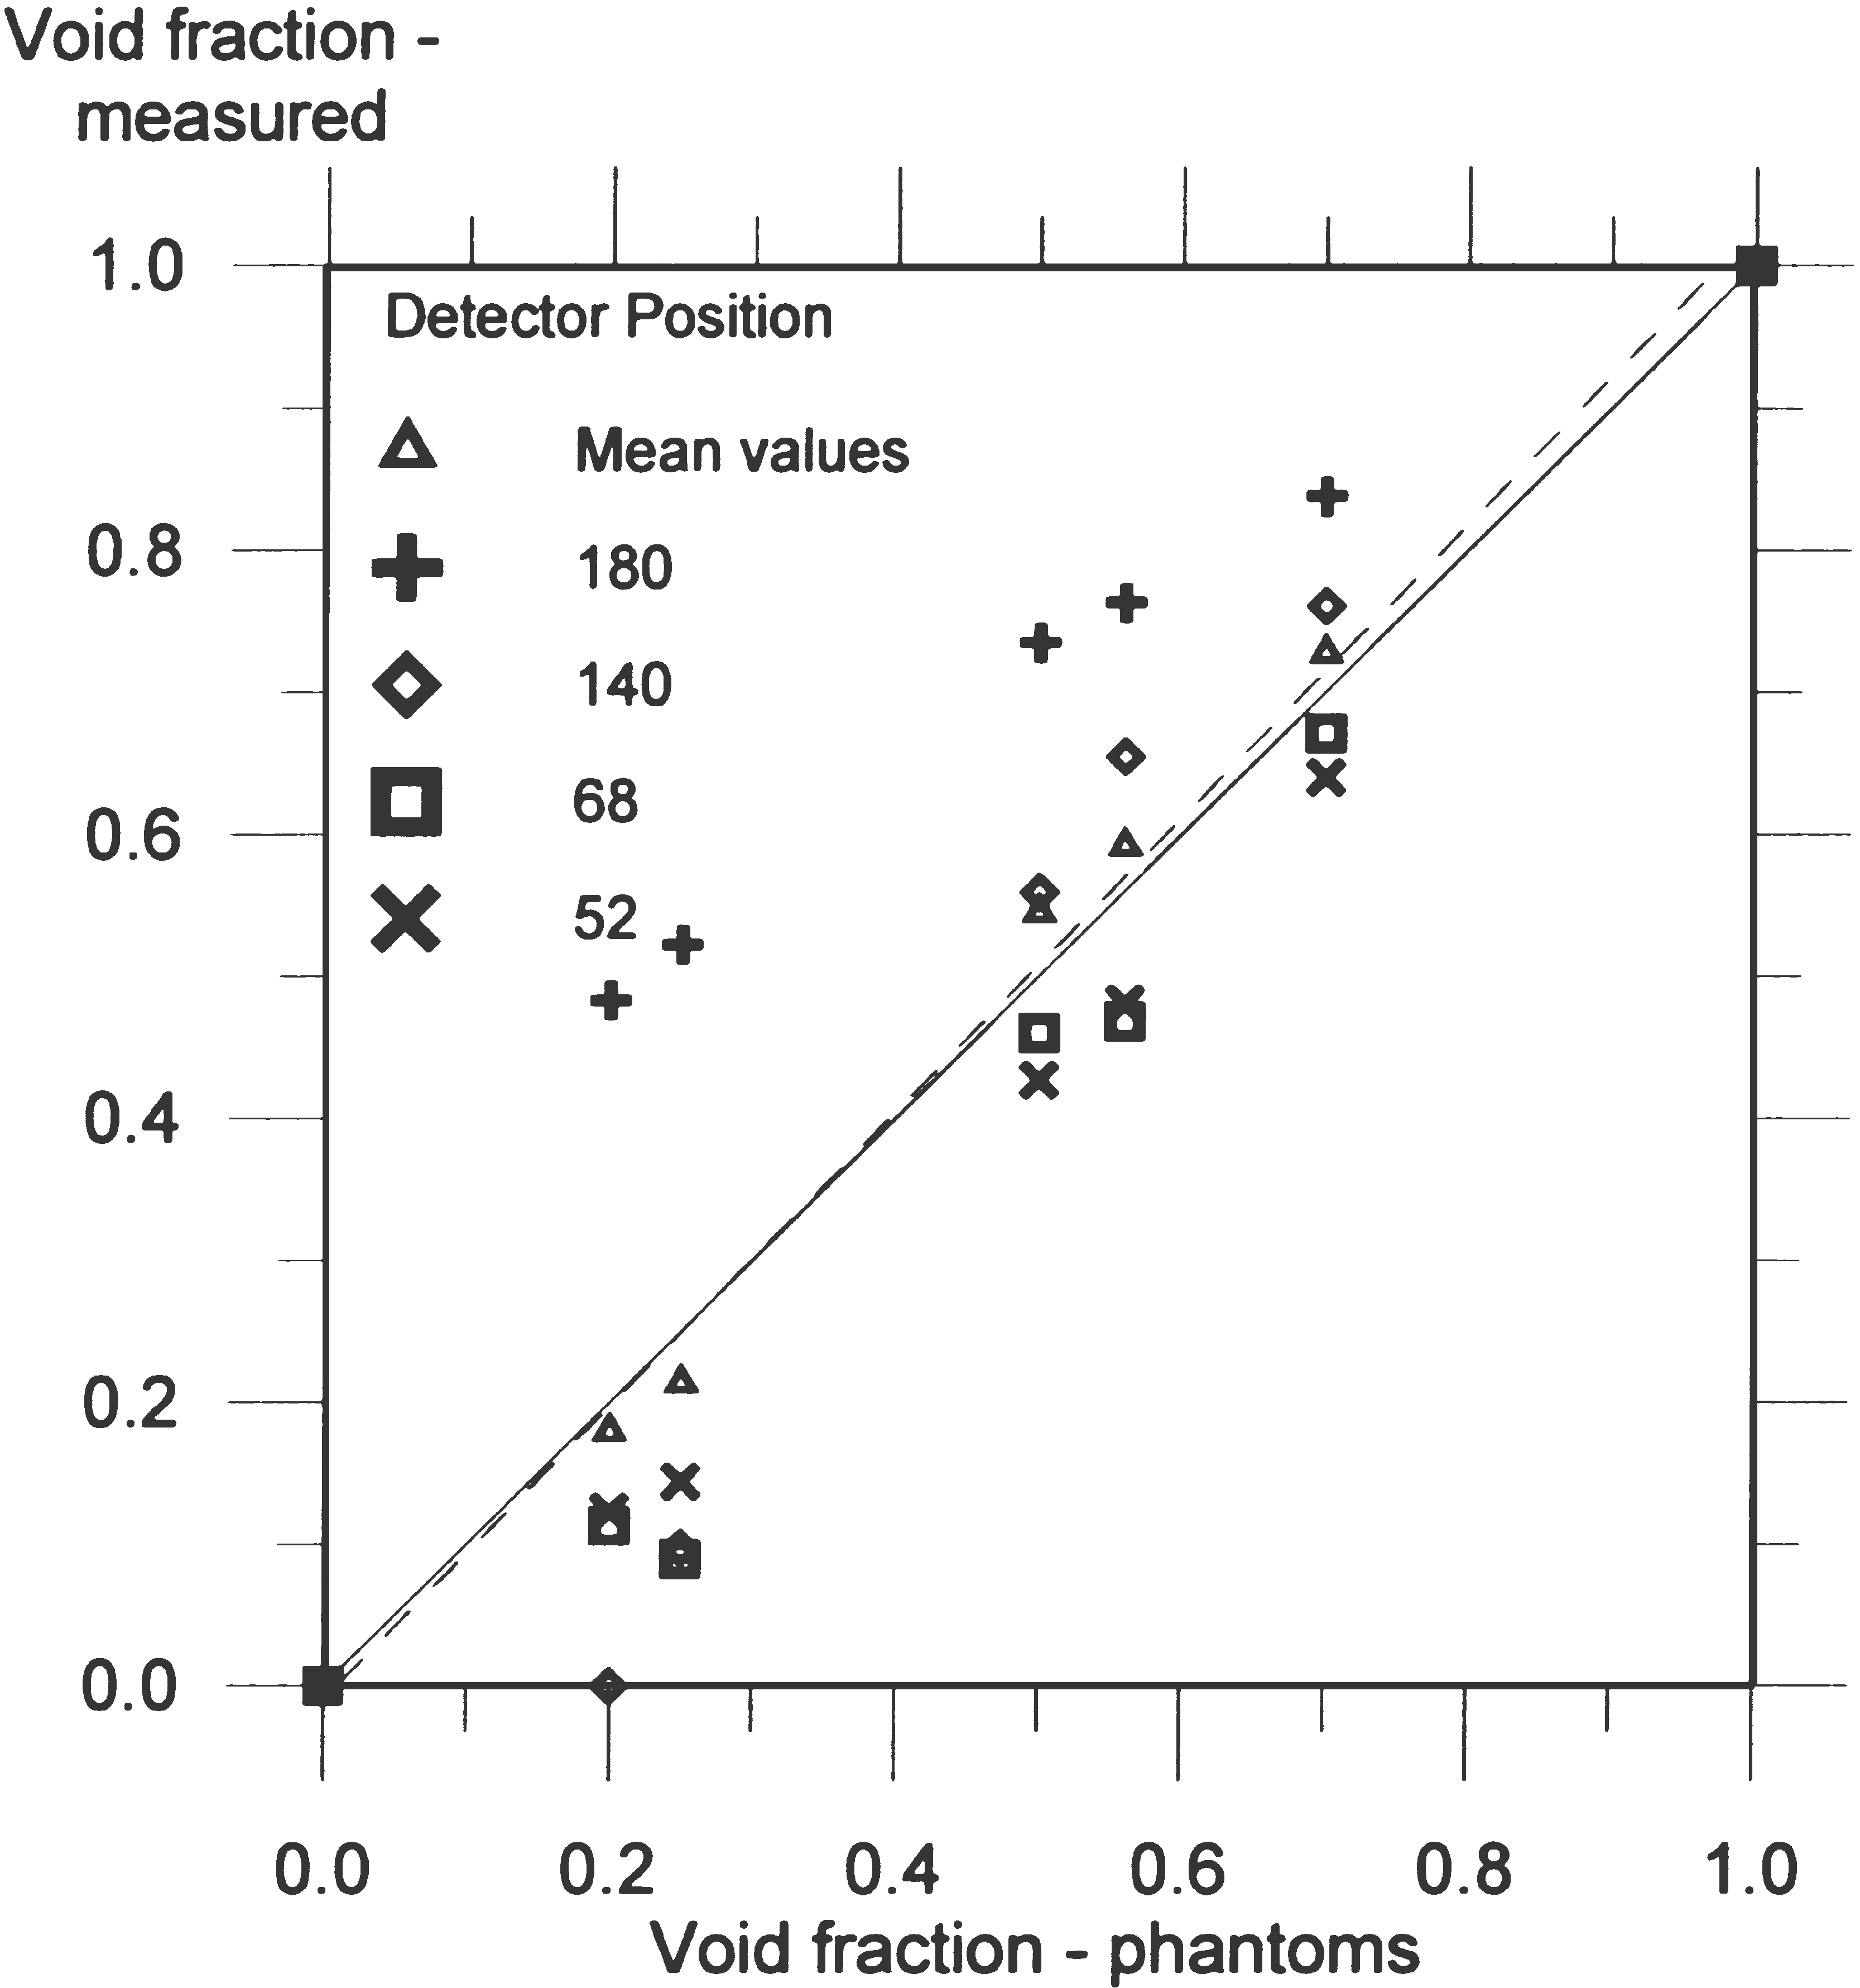
Figure 1-14: Measured Void Fraction versus True Void Fraction of the Annular Phantoms at Several Detector Positions. The Solid Line Represents The Ideal Case With No Deviation Between True And Measured Void Fractions. The Dashed Line Is The Best Curve Fit Of The Mean Values.
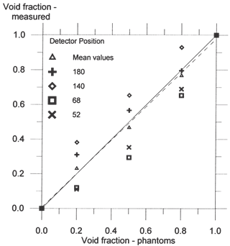
Figure 1-15: Measured Void Fraction versus True Void Fraction Of The Stratified Phantoms At Several Detector Positions. The Solid Line Represents The Ideal Case With No Deviation Between True And Measured Void Fractions. The Dashed Line Is the Best Curve Fit Of The
This means the mean values of the measured void fractions of the selected detector positions are close to the true void fractions. A curve fitting of the mean values gives a curve very close to the true void fraction of the phantoms, as shown in Fig. 1-14 and Fig.1-15. Around the pipe, the minimum number of counts in the full energy peak will be at detector positions outside the beam and when the void fraction is 1, due to the low probability of interaction in gas. The most important contribution to the total statistical error of the measured void fraction is made by positions with the lowest number of counts. The relative standard deviations due to the number of counts in detector positions 52° and 68° are 0.30% and 0.32%, respectively. This suggests that statistical fluctuations in the measured void fractions are negligible, and that the distributions of the data in Figs. 1-14 and 1-15 are caused by the different probabilities of scattered photons to reaching a given detector position with different phantoms.

Conclusions
Several measurements are performed around the pipe on the same cross-section, representing several detectors installed. Due to the low energy of the source, shielding requirements are reduced, with the result that the source and detectors can be integrated into the pipe-wall. Using the multi-beam gamma-ray measurement principles, it has been shown that accurate measurements can be made when measurements of four detector positions around the pipe are combined. However, it should be noted that the results depend on the pipe-wall material and thickness, pipe dimensions, and finally, on the com- position of the flow.

REFERENCES
[1] R. Thorn, G.A. Johansen, E. Hammer, recent developments in three-phase flow measurements, Meas Sci Tech 8 (1997) 691–701.
[2] P.S. Harrison, G.F. Hewitt, S.J. Parry, G.L. Shires. Development and testing of the “Mixmeter” multiphase flow meter. Proceedings of North Sea Flow Measurement Workshop, 1995.
[3] H. Linga. Measurements of two-phase flow details. Drang. Thesis, Norwegian Institute of Technology, University of Trondheim, 1991.
[4] E. Åbro, G.A. Johansen, H. Opedal. A radiation transport model as a design tool for gamma densitometers. Submitted for publication, 1998.
[5] H. Opedal. Integrated gamma densitometer and venturi meter for liquid phase measurements. M.Sc thesis, University of Bergen, 1997 (in Norwegian).
[6] G.A. Johansen, T. Frøystein, H. Pedersen, B. McKibben. A flexible test platform for investigating gamma-ray tomography geometries and applications. Proceedings of Frontiers in Industrial Process Tomography II, Delft (Netherlands), 9–12 April,

