A
TECHNICAL REPORT
ON
MEASUREMENT OF GAS VOID FRACTION IN HORIZONTAL PIPE

BY

OGOR ERNEST UVIENONA
15/ENG07/055

AFE BABALOLA UNIVERSITY, ADO EKITI.
TECHNICAL REPORT WRITING
(ENG485)

IN PARTIAL FULFILMENT OF THE REQUIREMENT OF THE DEPARTMENT OF CHEMICAL/PETROLEUM ENGINEERING,
AFE BABALOLA UNIVERSITY, ADO EKITI.
Academic Year: 2014- 2019

Supervisor: DR. YAHAYA
NOVEMBER, 2017

Table of Contents
LIST OF FIGURES 3
LIST OF TABLES 4
LIST OF EQUATIONS 5
LIST OF ABBREVIATIONS 6
ABSTRACT 7
ACKNOWLEDGEMENTS 8
INTRODUCTION 9
1 . GAMMA-RAY DENSITOMETERS 10
2. FLOW REGIME DEPENDENCE OF SINGLE-BEAM GAMMA DENSITOMETERS 13
2 . MULTI-BEAM GAMMA-RAY MEASUREMENT PRINCIPLES 19
3 . EXPERIMENTAL SETUP AND RESULTS 21
REFERENCES 26

LIST OF FIGURES
Figure 1. Typical flow regimes for vertical and horizontal flows. Black and white areas represent liquid and gas, respectively. 11
Figure 2. Single-beam gamma densitometer with point source and detector located diametrically opposite each other. 12
Figure 3. Cross-sectional and side views of an annular flow with a narrow fan radiation beam. 13
Figure 4. Deviation between calculated and true void fractions of annular flow for narrow fan and parallel radiation beam. The solid line represents the ideal case with no deviation between true and measured void fractions. 14
Figure 5. Cross-sectional and side views of stratified flow with narrow fan radiation beam. 16
Figure 6. Stratified flow with related parameters. 16
Figure 7. Deviation between measured and true void fraction of stratified flow with narrow fan beam with different source-detector orientations. The solid line represents the ideal case with no deviation between true and calculated void fractions. 17
Figure 8. Deviation between measured and true void fraction of stratified flow for narrow fan beam. The solid line represents the ideal case with no deviation between true and measured void fractions. 18
Figure 9. Compact low-energy multi-beam gamma-ray densitometer. 19

LIST OF TABLES
Table 1: Void fraction and flow regime phantoms made for the experiment 23
Table 2: The results of a grain-size analysis for a typical sandstone[10] 25

LIST OF EQUATIONS

$(3.1)$ 24

LIST OF ABBREVIATIONS
PMT  PHA  CZT | Photo Multiplier Tube  Pulse Height Analysis  Cadmium Zinc Telluride

ABSTRACT
Void fraction is an important parameter in two-phase flow. In the present work, the adiabatic two-phase air-water flow void fraction in a horizontal mini-channel has been studied experimentally. A transparent circular channel with 1.6 mm inner diameter was employed as the test section. Superficial gas and liquid velocities were varied in the range of 1.25 - 66.3 m/s and 0.033 - 4.935 m/s, respectively. Void fraction data were obtained by analysing the flow images being captured by using a high-speed camera. Here, the homogeneous (β) and the measured void fractions (ε), respectively, were compared to the existing correlations. It was found that: (1) for the bubbly and slug flows, the void fractions increase with the increase of JG, (2) for churn, slug-annular, and annular flow patterns, there is no specific correlation between JG and void fraction was observed due to effect of the slip between gas and liquid, and (3) whilst for bubbly and slug flows the void fractions are close to homogeneous line, for churn, annular, and slug-annular flows are far below the homogeneous line. It indicates that the slip ratios for the second group of flow patterns are higher than unity.

ACKNOWLEDGEMENTS
We appreciate the support provided by the mechanical workshop at the Department of Physics, University of Bergen in design advice and the supply of equipment for these experiments. This work has been funded by the Research Council of Norway.

INTRODUCTION
The oil and gas production industry has a need for accurate measurements of the oil and gas fractions in pipelines. Improved production techniques have made it economically feasible to produce from smaller (marginal) reservoirs by using subsea and even down- hole production units. With several production lines running into a production separator on the platform, it is impossible to measure the gas fraction in each line. At present, the flow is separated and then the fractions are measured. A test separator is used to separate the flow and then the individual phases in each production line are measured at intervals. Usually, turbine meters and orifice plates are used to measure the oil and gas flows, respectively. One disadvantage of this technique is that test separators are large units and space costs on a pro-duction platform are high
A multiphase meter on each line that measures the water, oil and gas flows offers better production control than test separators, and online measurements of pro- duction at each unit are necessary to optimize pro- duction. During the past decade, much work has been devoted to the development of three-phase meters cap- able of measuring oil, gas and water in pipelines. Multi- phase meters should preferably have non-intrusive sensors for several reasons, including the elimination of pressure drop over the instrument, their lack of impact on the flow, and the elimination of detector corrosion. Most multiphase meters include measurements of either single- or multi-energy gamma-ray attenuation for fraction measurements.
Conventional gamma-ray densitometers utilize a single 137Cs (662 keV) source and detector (Photo Multiplier Tube, PMT) located diametrically opposite each other. PMTs have a diameter of several centimetres. Gamma-ray densitometers have clamp-on capability, which is to say that these instruments can be installed and removed without shutting down the process. Where low-energy gamma-ray densitometers are used, the clamp-on capability is lost due to the need for radiation windows in the pipe walls. However, gamma-ray densitometers used in multiphase meters do not need to be clamp-on.

. GAMMA-RAY DENSITOMETERS
In two-component flows in which the components have sufficiently different densities, such as oil-gas mixtures, gamma densitometers can be used to measure the volume fractions, e.g. the gas fraction of the flow components. The void fraction is defined as the gas volume fraction divided by the total volume of the flow. Only two-phase flows are studied in this work. Measurements of gas fractions are generally dependent on the internal distribution of the components inside the pipe- line, i.e. on the flow regime. Fig. 1 shows typical two- phase flow regimes for vertical and horizontal flows.
Fig. 1 shows that there are three basic flow regimes. These are homogeneous flows (bubble flow in vertical and dispersed bubble flow in horizontal), annular flows, and stratified flows. The other flow regimes are essentially combinations of these basic flow regimes with periodicity. Several efforts have been made to design flow homogenizers to mix the flow components [2], and commercial multi-phase meters with mixers are avail- able. The advantage of mixers is that single-beam gamma-ray densitometers provide accurate measurements independent of the original flow regime. A disadvantage is the pressure drop, and for pipes where non- intrusive instruments are required other methods have to be considered. Any information about the flow regime is lost when mixers are utilized. In instruments without mixers, knowledge of the flow regimes has been used to obtain more reliable measurements of the void fraction. For instance, vertical upstream stratified flows will never occur.
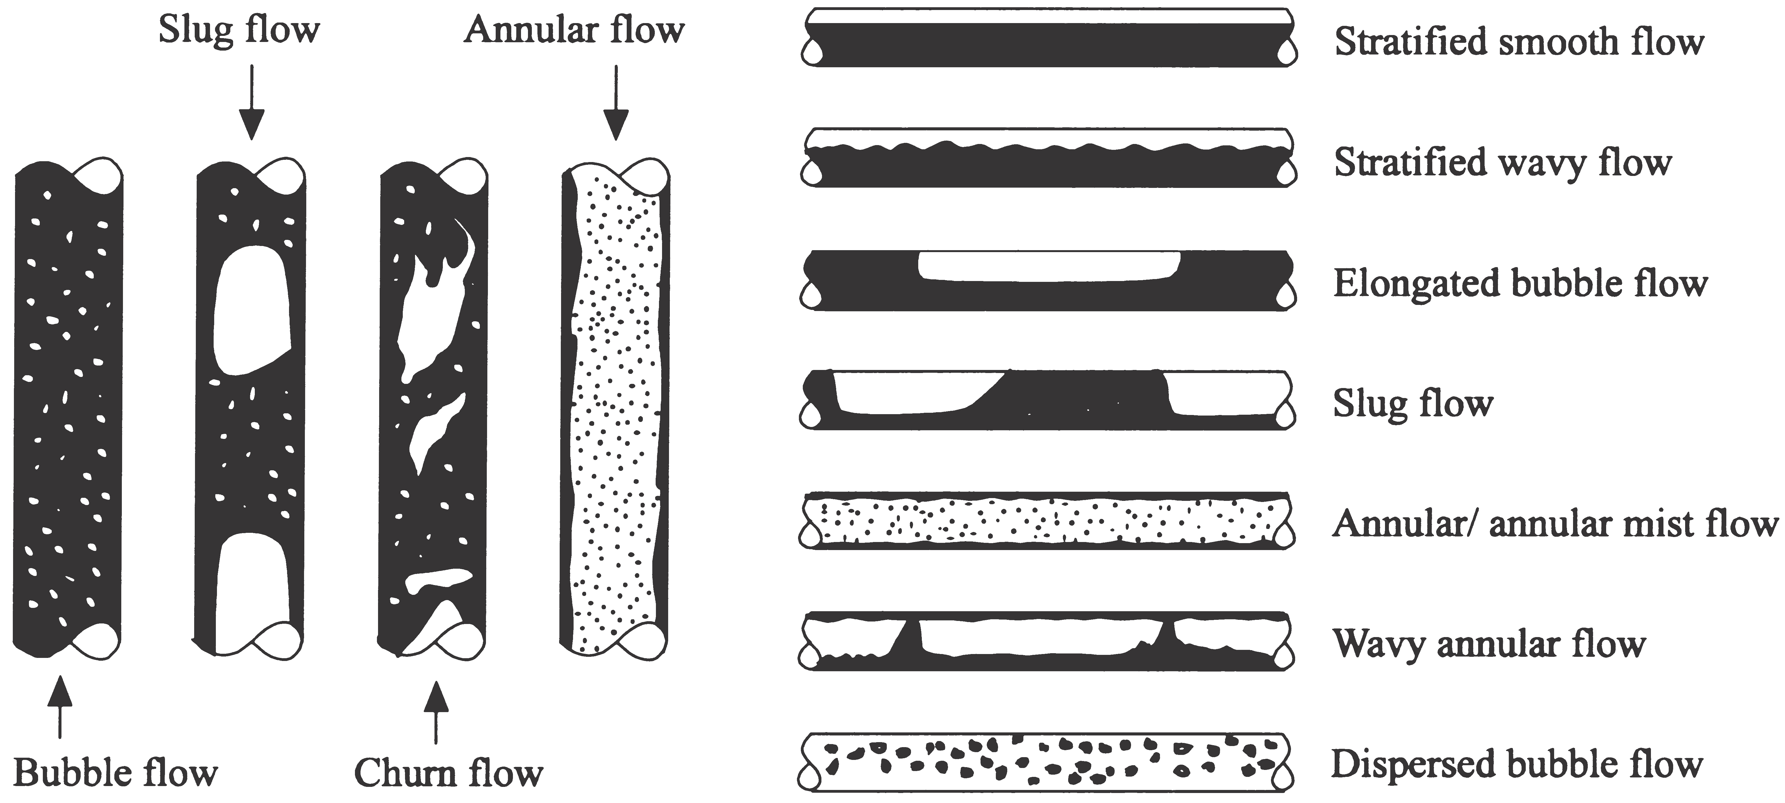
Figure 1. Typical flow regimes for vertical and horizontal flows. Black and white areas represent liquid and gas, respectively.
The most common measurement configuration for sin- gle-beam gamma densitometers is shown in Fig. 2. The void fraction is determined by measuring the average effective linear attenuation coefficient in the measurement volume over the cross-section of the pipe. The results obtained by using these single beam densitometers depend on the flow regime, since the measurement cross-section volume normally is less than that covered by the pipe cross-section [3].
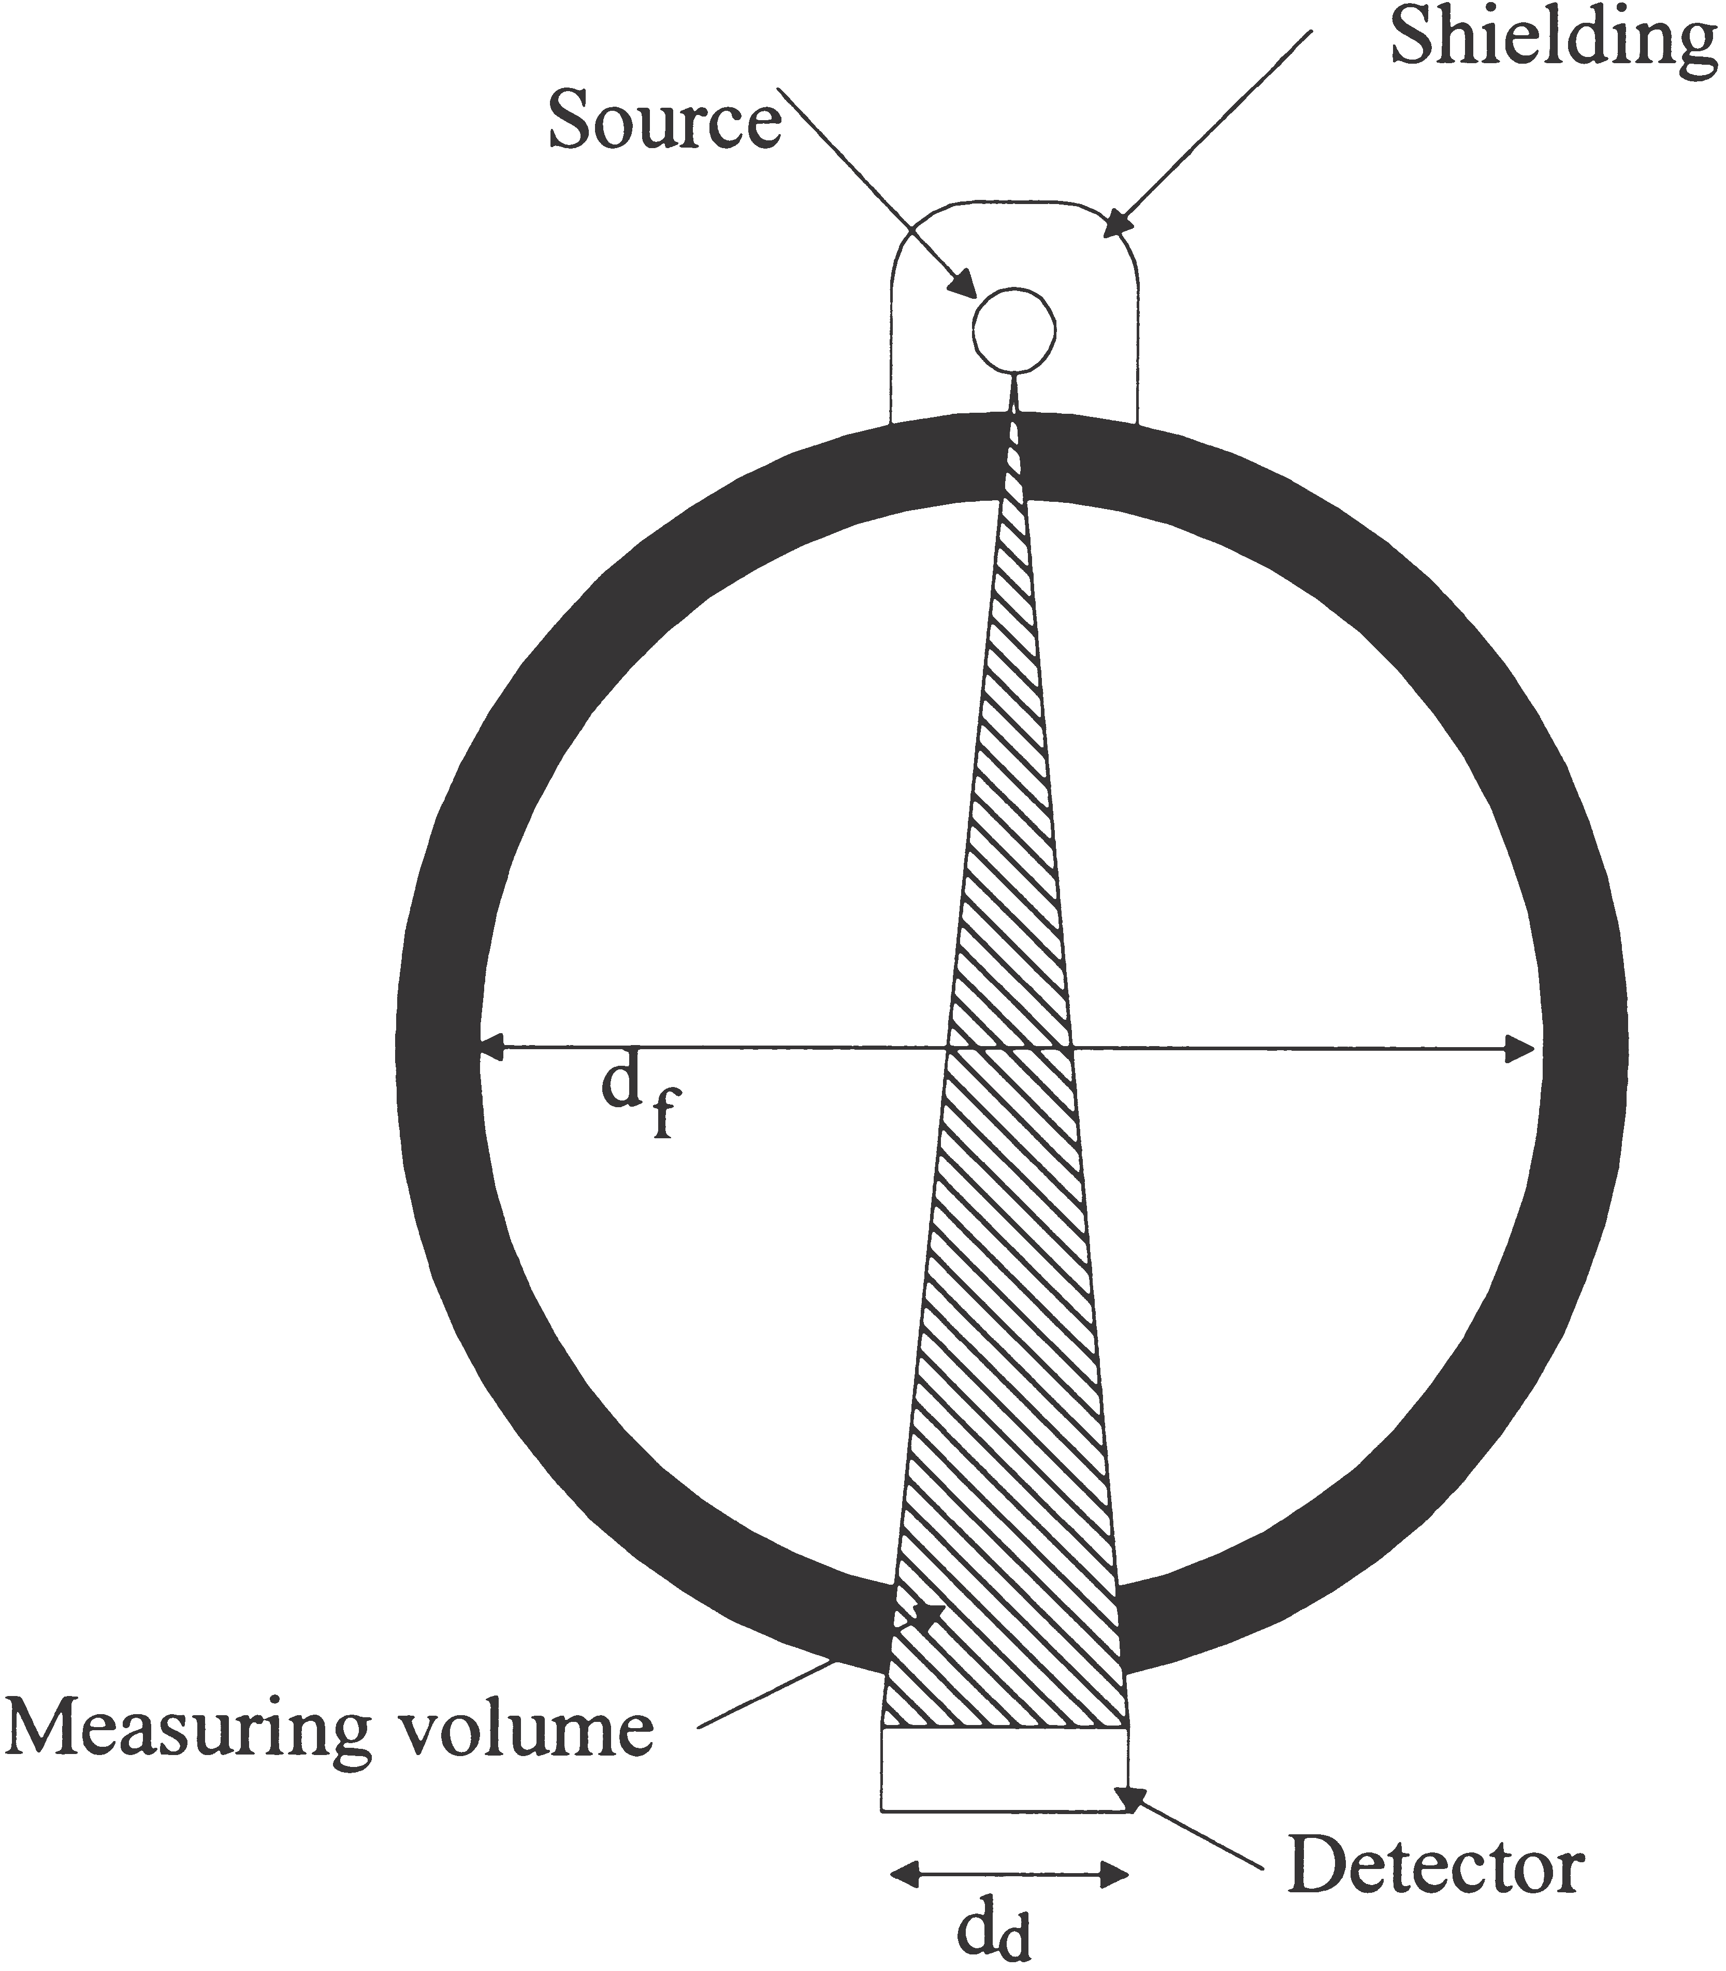
Figure 2. Single-beam gamma densitometer with point source and detector located diametrically opposite each other.
The true void fraction is the gas volume fraction of the total flow volume of the cross-section. The calculated void fraction is the gas fraction in the volume defined by the radiation beam and detector area, i.e. the measurement volume (see Fig. 2). By comparing the true void fraction and the calculated void fraction, the accuracy of the measurements for different flow regimes can be obtained.

FLOW REGIME DEPENDENCE OF SINGLE-BEAM GAMMA DENSITOMETERS
Only idealized flow regimes have been considered in this paper in order to simplify the calculations and to simplify the fabrications of the phantoms. Then, the ideal flow regimes eliminate any differences between the cal- culations and the phantoms used in the measurements.
It can been seen from Fig. 2 that the measurement volume depends on the detector area and collimation of the gamma-ray beam. The detector area thus influences sensitivity to the flow regime. In homogeneous flows the linear attenuation coefficient is similar over the entire cross-section. Measuring the linear attenuation coef- ficient at a single position provides sufficient information about the void fraction of the flow.
When the detector diameter is much smaller than the flow diameter (a narrow fan beam), the diameters of the areas defined by the beam and flow, d₁ and d₂, are assumed to be plane and parallel to the detector plane d as shown in Fig. 3. Furthermore, it is assumed the pipe wall is thin compared to the flow diameter, 2R. Thus, the measurement volume can be defined as a cone in the flow, as shown in Fig. 3. To simplify, perfect pipe axis symmetry is assumed, so the flow is symmetrical.
On the basis of the geometry illustrated in Fig. 3, the void fraction in the sensitive volume of annular flows
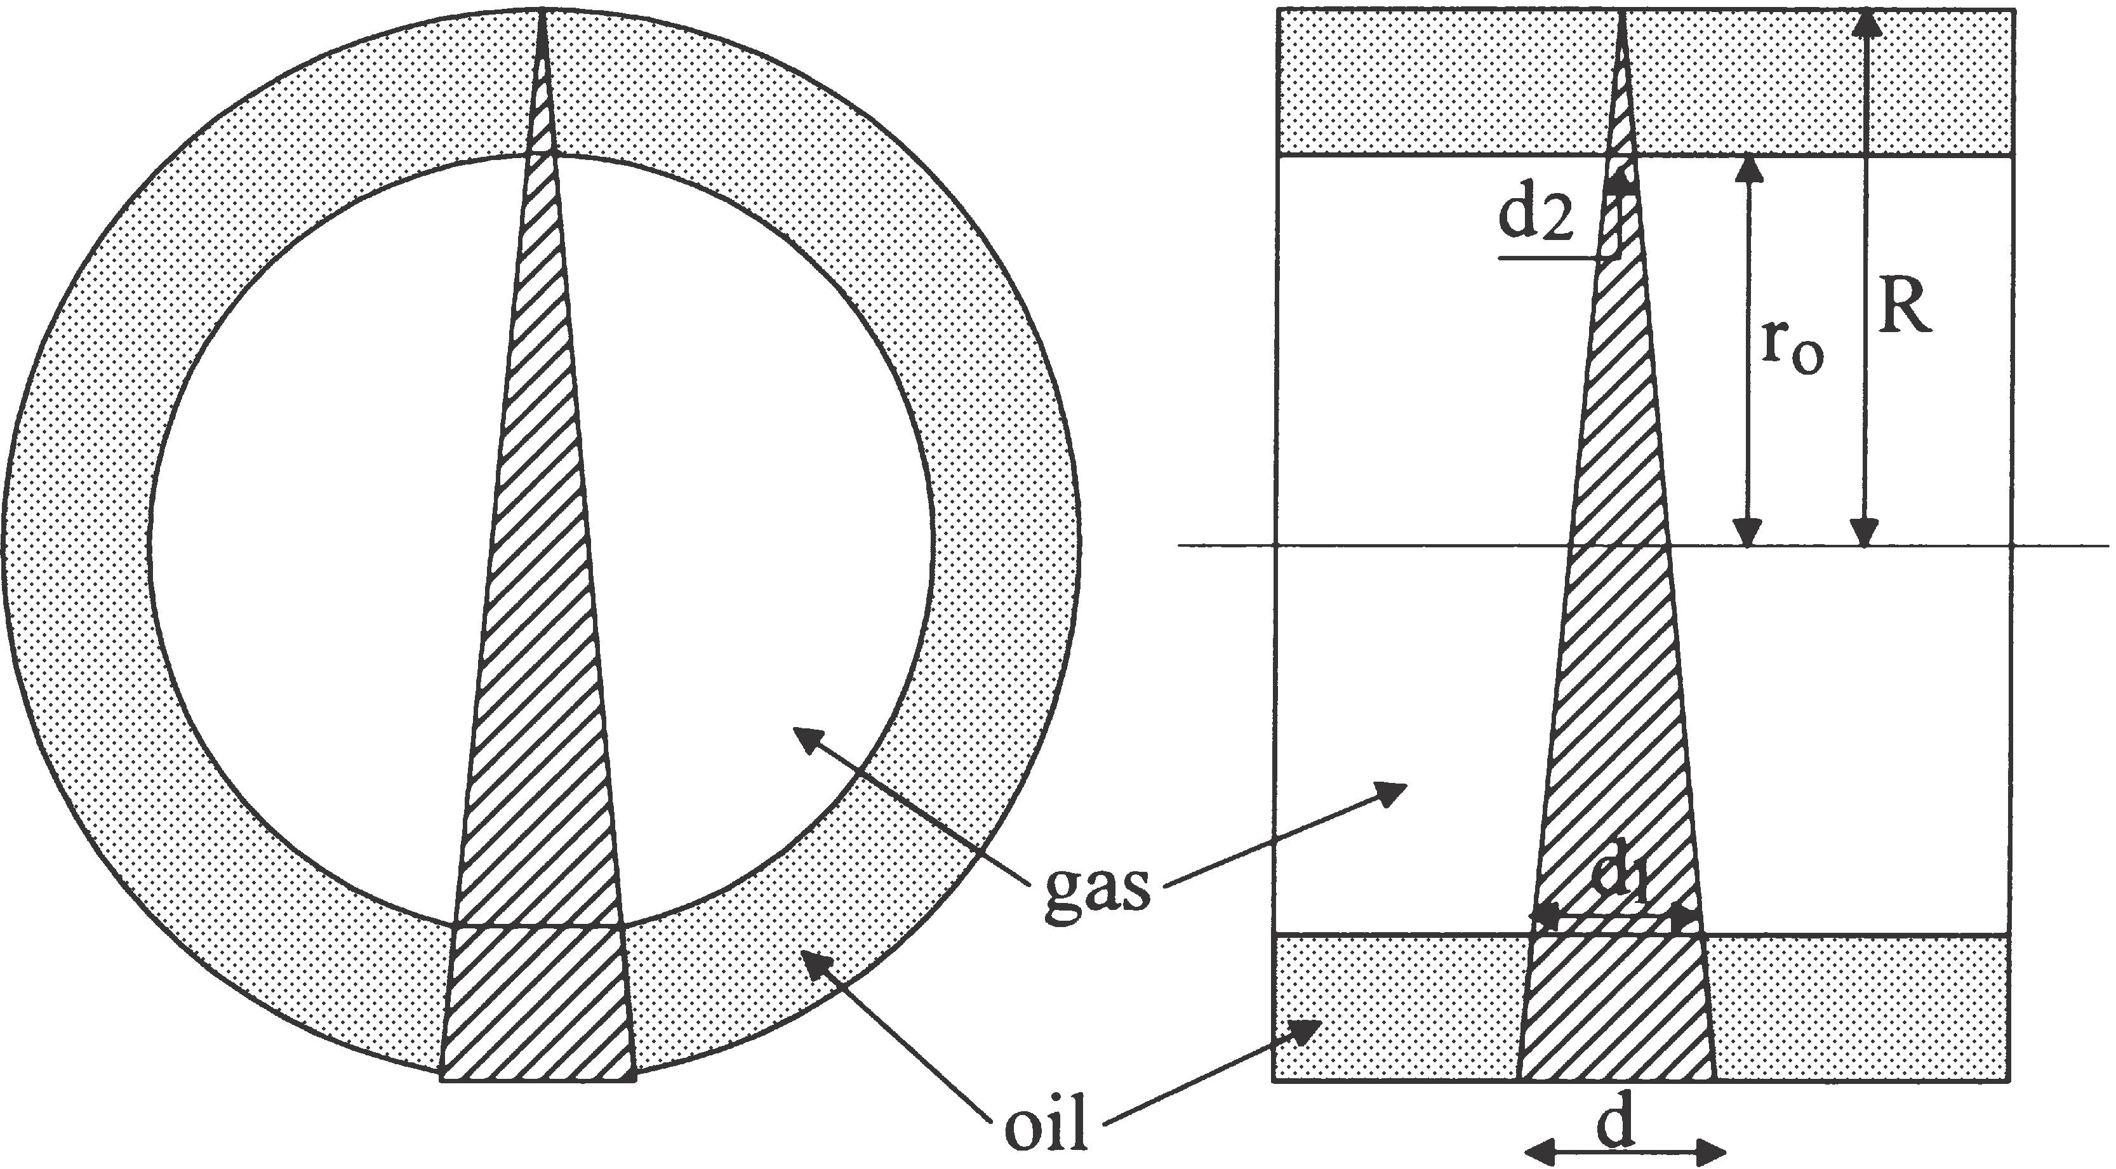
Figure 3. Cross-sectional and side views of an annular flow with a narrow fan radiation beam.
with a narrow fan radiation beam can be expressed as follows:

where R is the total radius of the flow and r₀ is the radius of the gas core. Similarly, an expression of the void fraction in the measured volume of annular flows with a parallel radiation beam can be found as follows:
From Fig. 3 it is evident that the true void fraction of an annular flow is calculated by:
By studying Equations. (1) – (3), it can be seen that for r₀ 5 0 and r₀ 5R the calculated void fraction, ac, and the true void fraction at are identical. However, within these limits, the calculated void fractions in annular flows with a narrow fan radiation beam are functions of 0, while for a parallel radiation beam the calculated void fraction is a function of r₀ and the true void fraction is a function of r₂. Obviously, measurements of the void fraction of annular flows are independent of the direction of the source–detector axis because of the symmetry of annular flows.
In Fig. 4 the calculated void fraction ac is plotted
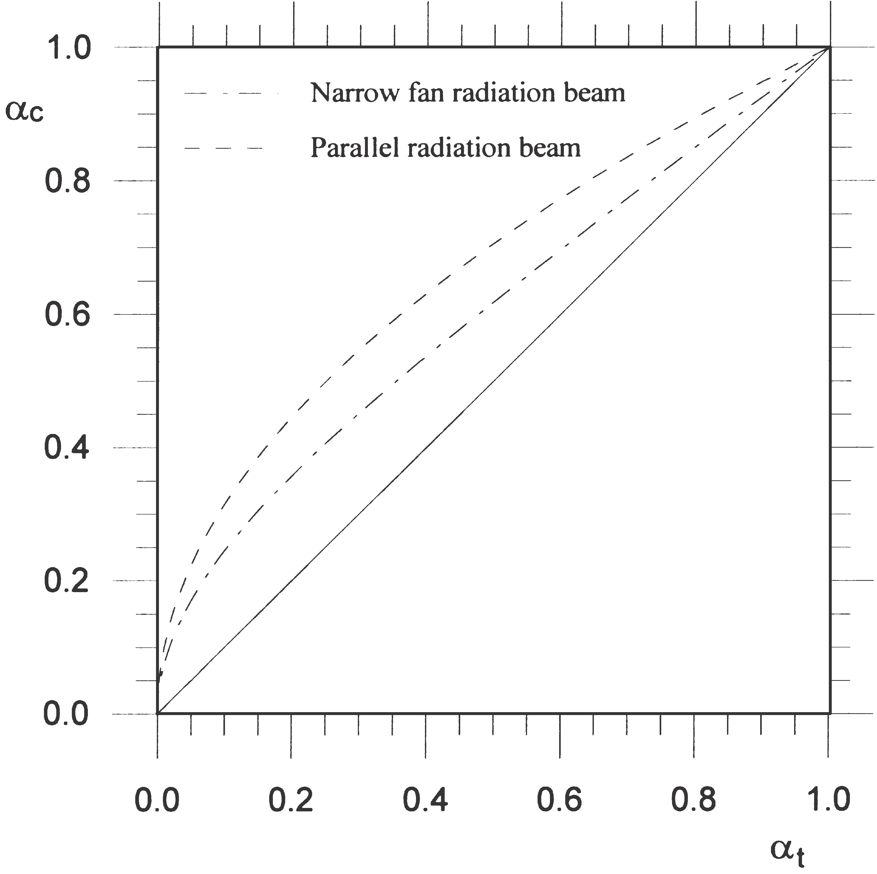
Figure 4. Deviation between calculated and true void fractions of annular flow for narrow fan and parallel radiation beam. The solid line represents the ideal case with no deviation between true and measured void fractions.
versus the true void fractions, at, with narrow fan and parallel radiation beams. There are no deviations between the calculated void fractions and the true void fraction when the flow is single phase, since the flow in the measured volume represents the flow over the entire cross-section. The maximum deviations appear when the true void fraction is between 0.1 and 0.6. Fig. 4 shows that calculated void fractions in annular flows are over- estimated, and that the narrow fan radiation beam gives a lower deviation than the parallel radiation beam.
In the same way as with annular flows, simplifications have been made with stratified flows, i.e. a much smaller detector diameter compared with the pipe diameter, and a thin pipe wall. The sensitive volume will then be as shown in Fig. 5. The lack of pipe-axis symmetry of stratified flows produces measurements of the void fraction that depend on the direction of the source–detector axis. In what follows, the direction will be called top– bottom configuration when the source is above and the detector is below the oil–gas interface, as shown in Fig.5. When the detector is above and the source is below the oil–gas interface the direction will be called bottom–top configuration. Finally, when the bottom–top configuration is turned 90º, the direction will be called side-by-side configuration.
For top–bottom configuration and stratified flows the calculated void fraction in the measurement volume with a narrow fan radiation beam can be written as:
where L₀ is the level of oil.
With bottom–top configuration the gas volume will not be equal to that of top–bottom configuration, and for bottom–top configuration the calculated void fraction of the measurement volume can be expressed as:
The calculated void fraction of stratified flows with par- allel beams can be found as:
With parallel beams, there are no differences between the top–bottom and bottom–top configurations, and the side-by-side configuration will appear to be identical to that of the side-by-side configuration with narrow fan beams, shown in Fig. 7.
For side-by-side configurations the calculated void fraction will be 1 and 0 for oil levels lower and higher than the detector, respectively. Due to the small detector diameter compared with the flow diameter, i.e. a small measurement volume, this side-by-side configuration will be highly sensitive to changes in oil level when this covers some of the measurement volume, as shown in Fig. 7.
Based on Fig. 6, it can be shown that the true void fraction of stratified flows can be found by [3]:
On the basis of Eqs. (4), (5) and (7) the deviations between the calculated void fractions and the total void fraction for stratified flows with different source–detec- tor directions are plotted in Fig. 7.
By inserting L0 5 2R and L0 5 0 into Equations. (4), (6) and (7), the calculated void fractions and the true void fraction are 0 and 1, respectively. When flows consist of only one component, it is obvious that the density, or more correctly, the linear attenuation coefficient, is equal over the entire cross-section of the flow. Therefore, no
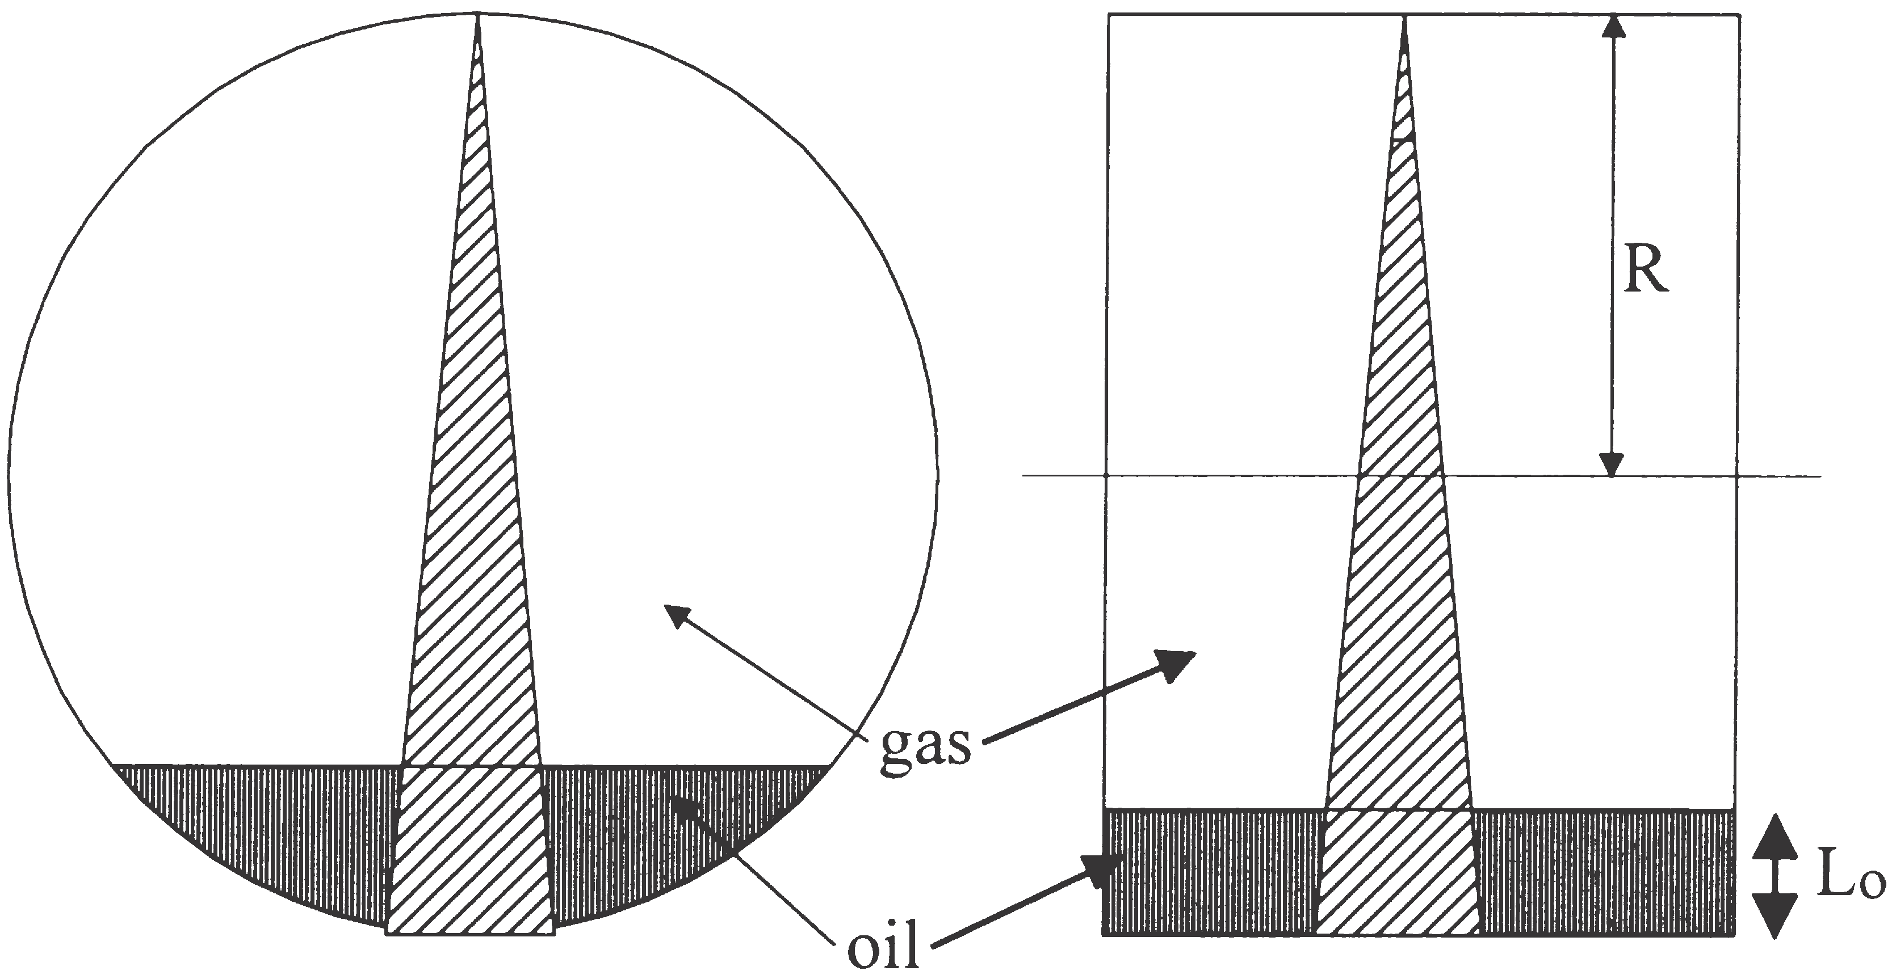
Figure 5. Cross-sectional and side views of stratified flow with narrow fan radiation beam.
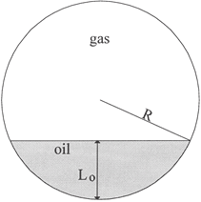
Figure 6. Stratified flow with related parameters.
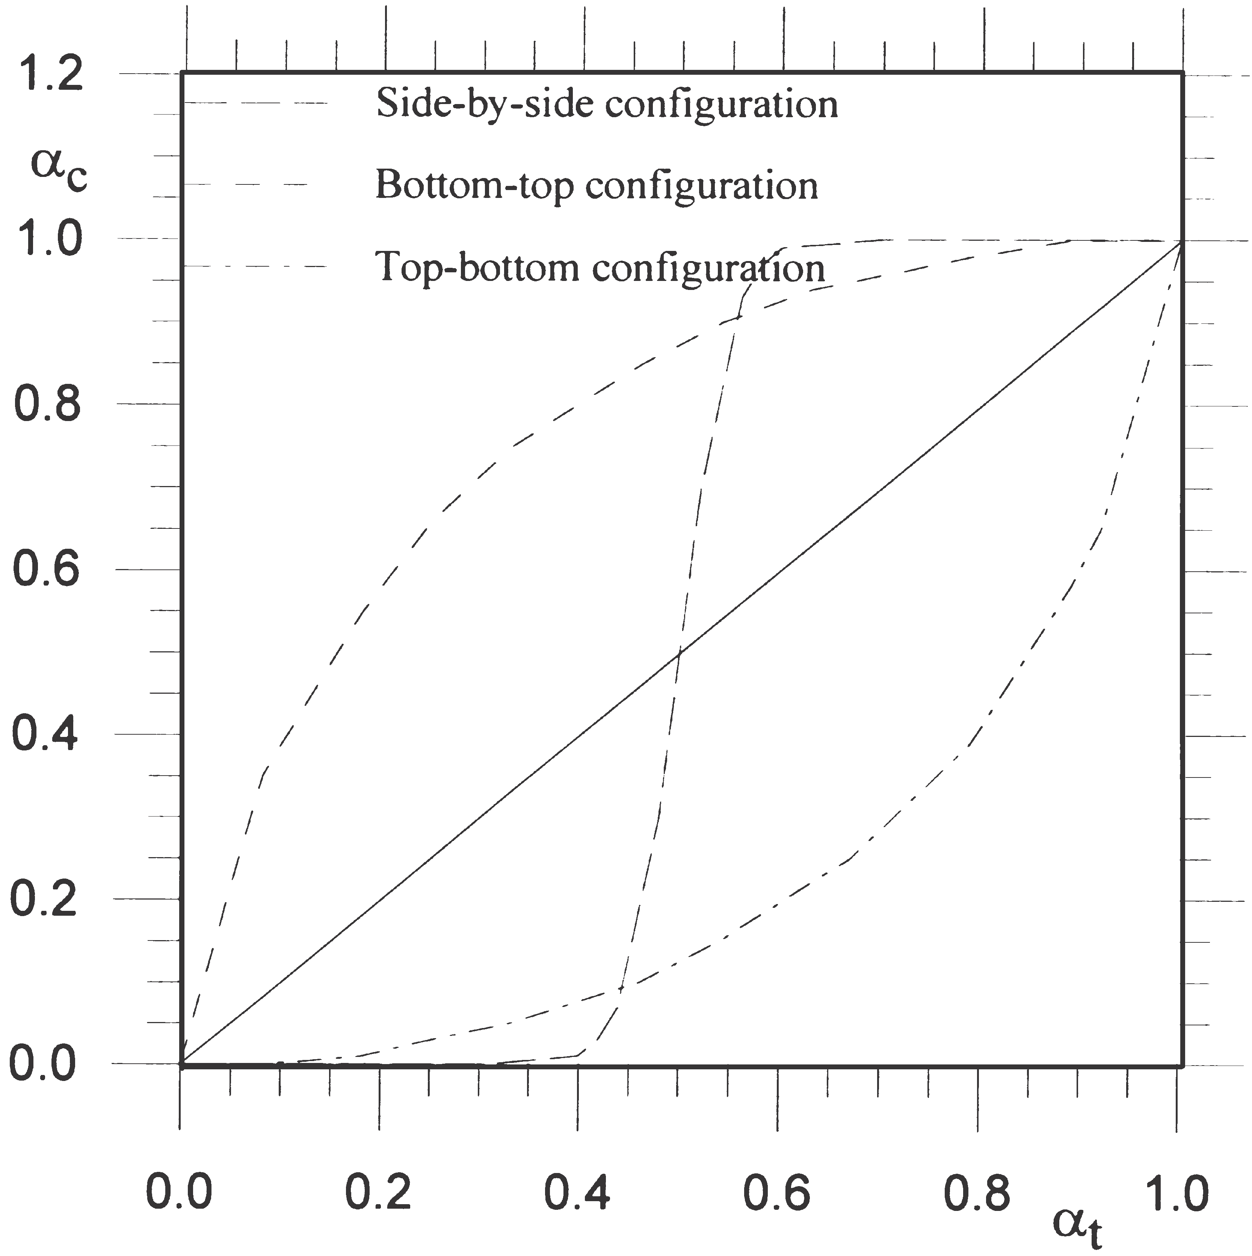
Figure 7. Deviation between measured and true void fraction of stratified flow with narrow fan beam with different source-detector orientations. The solid line represents the ideal case with no deviation between true and calculated void fractions.
deviation is observed between measured and true void fractions.
In Fig. 8 the calculated void fraction, ac, is plotted against the true void fraction, at, for stratified flows with top–bottom configuration. The deviation between the calculated and true void fractions is at a minimum with
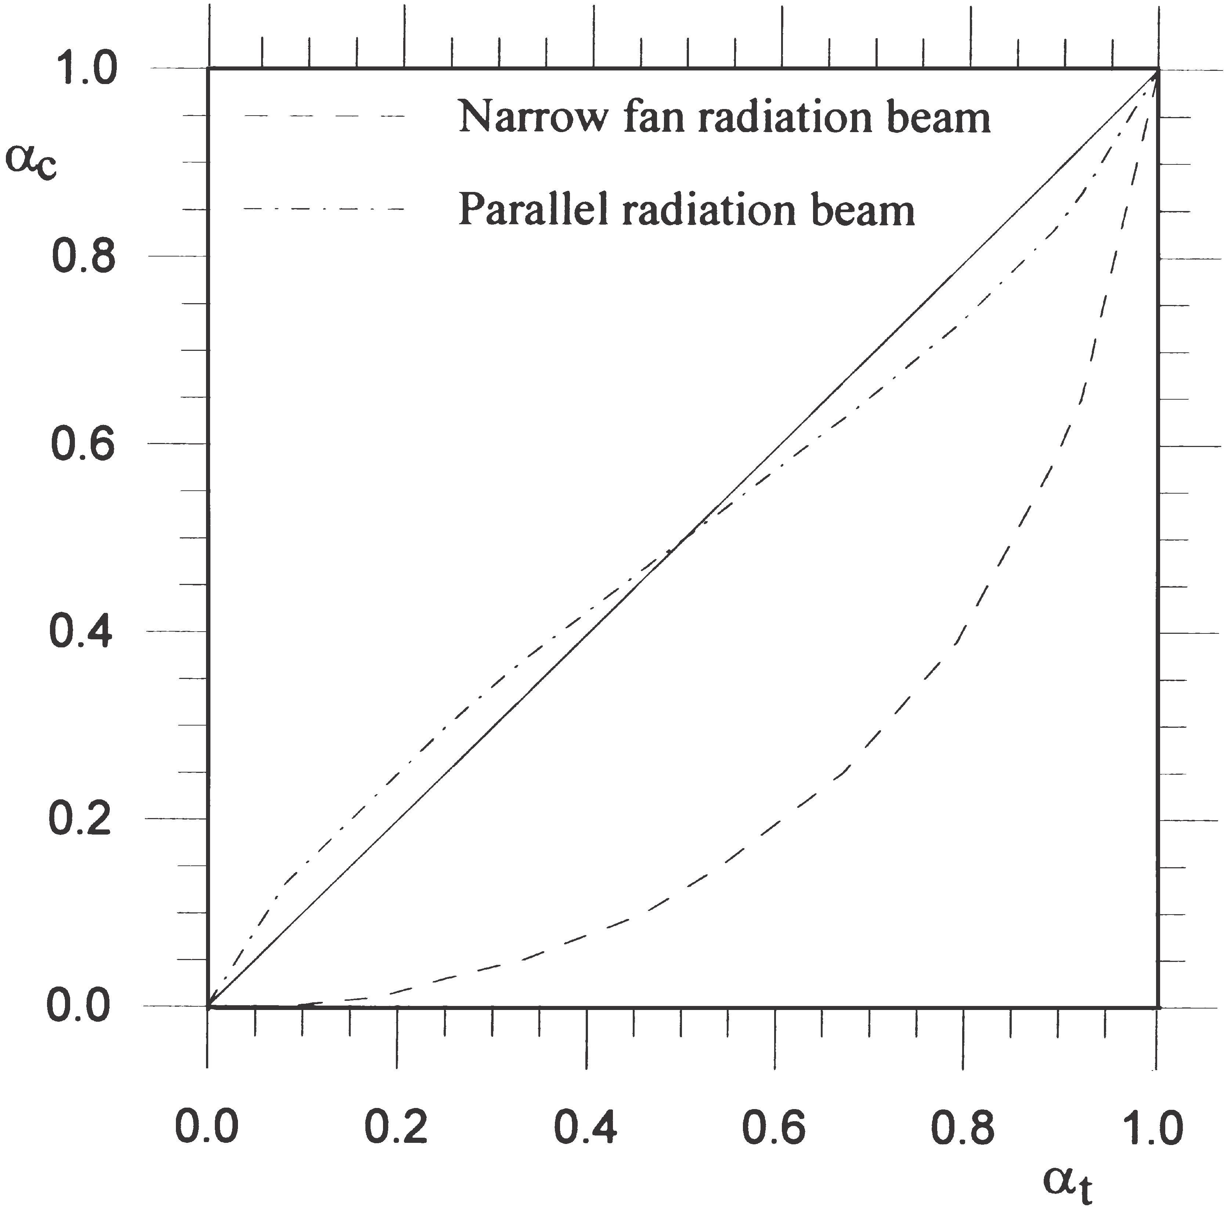
Figure 8. Deviation between measured and true void fraction of stratified flow for narrow fan beam. The solid line represents the ideal case with no deviation between true and measured void fractions.
parallel beams and reaches a maximum with narrow fan beams. In contrast to annular flows, the calculated void fraction of top–bottom configured stratified flows is underestimated. By comparing Figs. 4 and 8, we can see that the accuracy of void fraction measurements is highly dependent on the flow regime and the radiation beam. For this reason, in order to obtain accurate void fraction measurements, the flow regime must be taken into account.

. MULTI-BEAM GAMMA-RAY MEASUREMENT PRINCIPLES
Low-energy sources such as 241Am (59.5 keV) offer the possibility of a compact design as a result of low shielding requirements (2 mm of lead). Furthermore, the use of compact semiconductor detectors such as cadmium zinc telluride (CZT) detectors, allows multi-beam configurations which represent flow cross-section better than single-beam gamma-ray densitometry. In addition, thanks to the compactness of the source and detectors, low-energy gamma-ray densitometers can be integrated into the pipe wall, as shown in Fig. 9.
The predominant mechanisms of interaction for low- energy photons are the photoelectric effect and Compton scattering. Their probabilities of interaction depend on the atomic number of the absorber. The relationship is approximately linear for Compton scattering, which is to say that the interaction probability is directly proportional to the density of the absorber. For the photoelectric effect, the interaction probability is proportional to the atomic number to the power of 4-5.
Photon scattering is often regarded as an undesirable effect in gamma-ray attenuation measurements since it complicates the interpretation of the results. Build-up, i.e. the extra contribution to transmission measurements
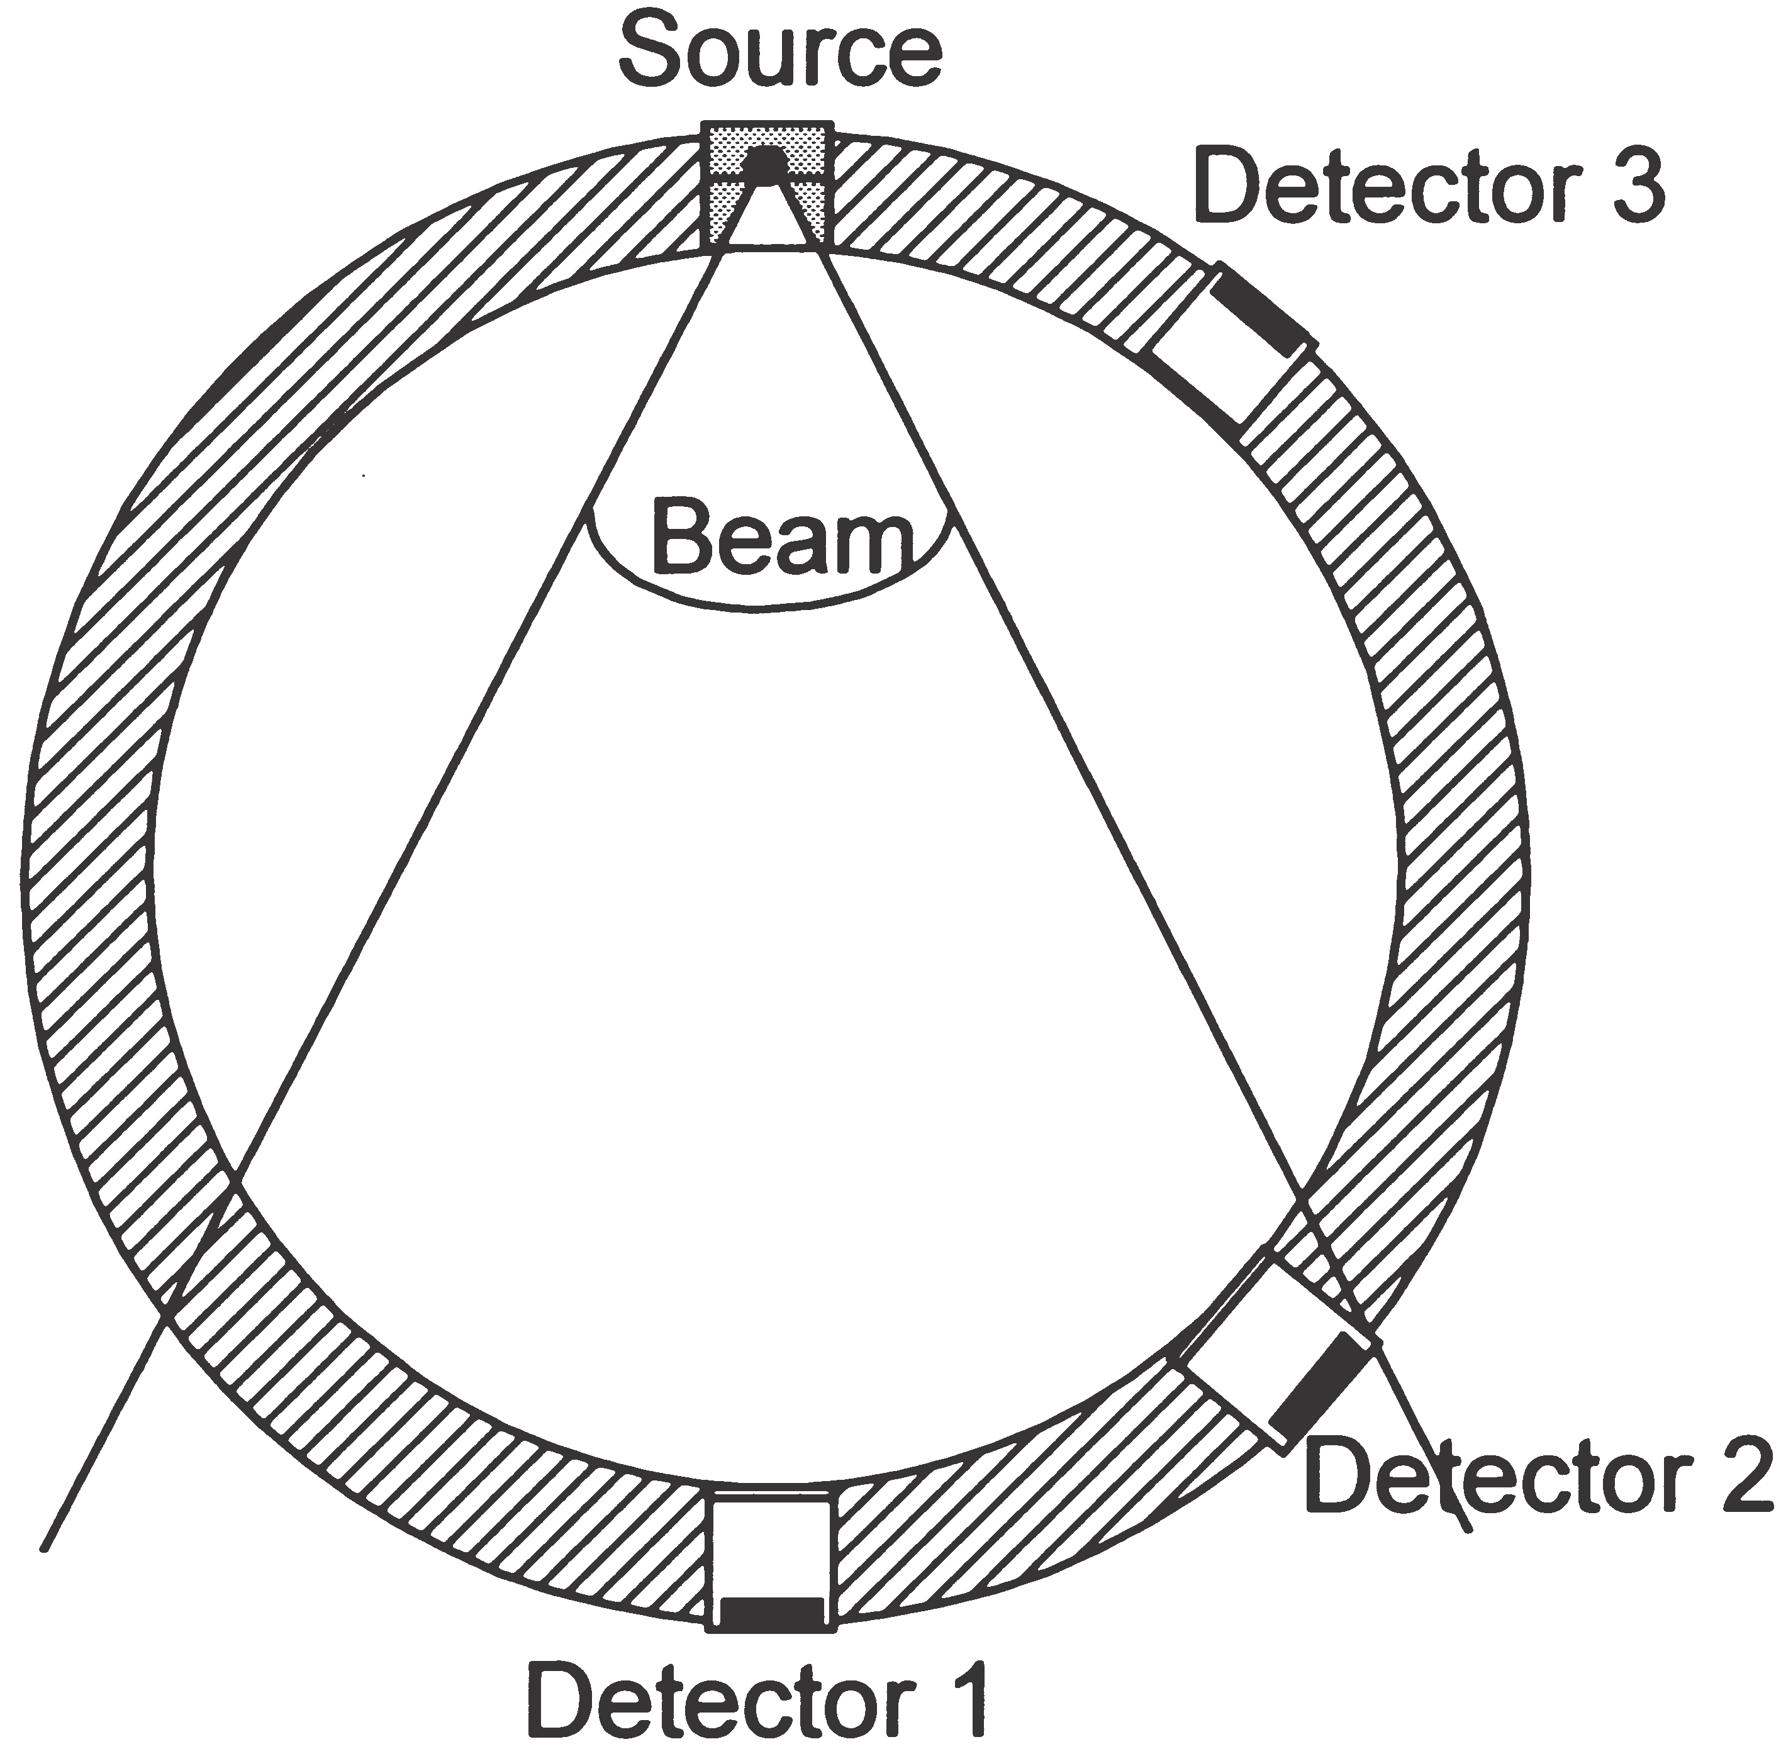
Figure 9. Compact low-energy multi-beam gamma-ray densitometer.
from scattered radiation, has to be considered, particularly if wide-beam measurement configurations are used [3]. In fluid flow fraction measurements, however, it is possible to take advantage of this effect since it effectively means that the gas–liquid distribution outside the geometrical volume defined by the source and the detector affects the measurement result [4]. This may to some extent be regarded as a geometrical measurement averaging over the pipe cross-section, especially for backscattered radiation where there is no contribution from transmission. A Monte Carlo simulation model has been developed and implemented in order to study trans- mitted and scattered photons over the pipe cross-section [5].
Measuring the spectral detector response at several positions around the pipe allows the transmitted and scattered photons to be detected in several positions. Pulse height analysis (PHA) is used to study the energy depositions in the detectors. Once the detector responses have been combined and utilized, the void fraction and flow regime can be determined. A suitable method, as used here, of examining single and multi-beam gamma-ray densitometry configurations, is to use phantoms made of polypropylene, and compare the data from the detector responses with a range of flow regimes and void fractions.

. EXPERIMENTAL SETUP AND RESULTS
In this work, an aluminium pipe was made to test the multi-beam gamma-ray measurement principles. Instead of oil phantoms of polypropylene (density 50.91 g/cm³) were employed. Such phantoms are necessary to obtain reliable reference values. The density of the phantoms is higher than that of most oils, but is close enough to verify the principle. The inner and outer diameters of the pipe are 80 mm and 90 mm, respectively. A 241Am (59.5 keV) source and a single eV A1361 CZT (CdZnTe) semiconductor detector were used in the experiments, in addition to a eV-550 preamplifier, a Tennelec TC244 amplifier and an Oxford PHA.
Using the phantoms, static measurements were performed. That means both the void fraction and flow regime were constant during the measurements, giving reliable references. A complete measurement series of one phantom consisted of detector responses from 17 positions around the pipe to represent the detector positions from 180^{O} (diametrical position) to 52^{O}.
In a system in which measurement values vary rapidly, the measurement time (integration time) plays an important role, since measurement time, and statistical error are closely related. Longer measurement times give lower statistical errors and vice versa. Fluctuations in measurement values will be smoothed out with a longer measurement time. It is important to use low Z-number pipe wall materials with low-energy gamma-ray densitometers in order to minimize beam attenuation in the walls. Suitable pipe wall materials include aluminum, titanium or plastics. Windows can be made of these materials rather than using them for the whole pipeline. In order to obtain short measurement times, the pipe wall material, and the source activity must be chosen carefully. In our experiments, a 14 mCi 241Am source and a measurement time of 600 s were chosen because of the static nature of the experiment. In a real dynamic system, a 241Am source with higher activity, and a shorter measurement time would have to be considered. The statistical error is inversely proportional to the square root of number of counts, thus a smaller measurement time will increase the statistical error. For instance, use of a 300 mCi source and a measurement time of 1 s will decrease the number of counts by 30, thus the statistical error will be increased by about 5.4 times.
The aluminum pipe, source and detector are mounted in a computer-controlled test platform, on which the detectors are positioned around the pipe to an accuracy of 6 1 [6]. The CZT detector is moved by 8 between each measurement to obtain detector responses in several positions around the pipe with fixed flow regimes. As shown in Table 1, various polypropylene phantoms are used to simulate flow regimes and void fractions.
More information is obtained with multi-beam densitometry than with single-beam gamma-ray densitometry. Void fraction measurements of the same pipe and phan- toms from single-beam and multi-beam low-energy gamma-ray configurations have been compared in order to study their performance.
The principle of single-beam gamma-ray densitometers is based on the concept of expressing the void fraction in terms of transmitted intensity, which is the number of photons detected in the full energy peak in the measurement time period. This means counting pho- tons with energy higher than a given threshold value, which was 40 keV in our experiments. The void fraction can be found as:

Table 1: Void fraction and flow regime phantoms made for the experiment
Void fraction (%) Flow regime phantom

0 Homogeneous
20 Stratified
20 Annular
25 Annular
50 Annular
50 Stratified
56 Annular
70 Annular
80 Stratified
100 Homogeneous

Mean size of particles: In clastic reservoir rocks, the particle size varies greatly in nature. In sieve analysis, each sieve actually retains an aggregate of different size particles. We thus know the size range of particles between the opening sizes of two adjacent sieves but grain-size of each particle. Therefore, it is very necessary to know the mean size of particles in each sieve for the study of rock texture. In an ordinary way, the mean size of particles in each sieve/fraction can be determined by the following formula[9]:
$$\frac{1}{di}= \frac{1}{2}\left(\frac{1}{d_{i}^{'}}+ \frac{1}{d_{i}^{''}}\right) (3.1)$$
where _di is the mean diameter of particles retained on ith sieve, lm; di′ is the opening size of last sieve (i-1th), lm; di″ is the opening size of ith sieve, lm.

Table 2: The results of a grain-size analysis for a typical sandstone[10]
Opening size of sieve (mm) | 0.833 | 0.701 | 0.589 | 0.417 | 0.35
Weight percent (%) | 2.10 | 13.11 | 18.50 | 7.44 | 4.70
Cumulative weight percent (%) | 2.10 | 15.21 | 87.86 | 95.30 | 100.0

REFERENCES
[1] X. Hu and S. Huang, Physical Properties of Reservoir Rocks. 2017.
[2] G. S. Distribution, “å,” 1989.
[3] R. C. Analysis and S. C. Analysis, “Routine core analysis.”
[4] M. Mahmoud and A. Latief, “Compiled by,” no. March, pp. 1–75, 2009.
[5] V. T. B. Volume, “Chapter 5 : Porosity,” vol. V, no. xiii, pp. 43–53, 2003.
[6] “Laboratory manual,” 2003.
[7] W. Abdel and F. Mohamed, “PVT Lab Manual,” vol. 6, no. 5, 2015.
[8] A. S. Abdulkareem and A. S. Kovo, “Simulation of the Viscosity of Different Nigerian Crude Oil,” no. 8, pp. 7–12, 2006.
[9] S. Z. Miska, FUNDAMENTALS OF DRILLING ENGINEERING, vol. 12. 2005.
[10] B. jr. A. T., Keith K. Millheim, M. E. Chenevert, and F. S. J. Young, “applieddrillingengineering-141127082809-conversion-gate02.pdf.” p. 54.

