AFE BABALOLA UNIVERSITY

HAMIDU ISAH
14/ENG07/009

Measurement of Gas Void fraction in Horizontal Pipe

AFE BABALOLA UNIVERSITY, ADO EKITI.
TECHNICAL REPORT WRITING (ENG485)

IN PARTIAL FULFILMENT OF THE REQUIREMENT OF THE DEPARTMENT OF CHEMICAL/PETROLEUM ENGINEERING, AFE BABALOLA UNIVERSITY, ADO EKITI.
Academic Year: 2014- 2019

Supervisor: DR. YAHAYA
NOVEMBER, 2017

ABSTRACT
The accurate prediction of the void fraction of the different phases flowing
in a pipe is of paramount importance to the oil and gas industry.
Some of the major challenges in performing accurate measurements result directly from the operating conditions of the system involved.
Our focus in this paper is the prediction of void fraction in horizontal pipelines using the gamma ray densitometer.
Gamma densitometer utilizes the concept of gamma attenuation in matter where the magnitude of attenuation is directly related to the density of the material through which the gamma ray passes, and to the intensity of the ray itself. By calibrating the gamma ray with a variety of known flow geometries, one can extrapolate the findings to cover all ranges of flow regimes present in a large horizontal pipe, typical of an oil transport pipeline.
In this experiment an aluminum pipe was used to test the multi-beam gamma-ray measurement principles. Instead of oil, phantoms of polypropylene (density 50.91 g/cm3) were employed.
From the results obtained, the flow regimes were successfully recognized in all cases studied here, meaning that the system also provides tomographic information.
The results also showed that the multi beam gamma ray densitometers are more effective in measuring the void fraction in a horizontal pipe.

ACKNOWLEDGEMENTS
We appreciate the support provided by the mechanical workshop at the Department of Physics, University of Bergen in design advice and the supply of equipment for these experiments. This work has been funded by the Research Council of Norway.

TABLE OF CONTENTS
_{ABSTRACT} _{I}
_{ACKNOWLEDGEMENTS} _{II}
_{LIST OF FIGURES} _{IV}
_{LIST OF TABLES} _{V}
_{LIST OF EQUATIONS} _{VI}
_{LIST OF ABBREVIATIONS} _{VII}

_{1 Introduction} ₁

_{2 Gamma-Ray Densitometers} ₂

3 Flow Regime Dependence Of Single-Beam Gamma Densitometers ₅

4 Multi-Beam Gamma-Ray Measurement Principles ₁₂

5 Experimental Set Up And Results ₁₄

_{6 Conclusion} ₂₃

_{References} ₂₄

LIST OF FIGURES
Figure 1:Typical flow regimes for vertical and horizontal flows. Black and white areas represent liquid and gas, respectively. 3
Figure 2:Single-beam gamma densitometer with point source and detector located diametrically opposite each other. 4
Figure 3:Cross-sectional and side views of an annular flow with a narrow fan radiation beam. 5
Figure 4:Deviation between calculated and true void fractions of annular flow for narrow fan and parallel radiation beam. The solid line represents the ideal case with no deviation between true and measured void fractions. 7
Figure 5:Stratified flow with related parameters. 9
Figure 6: Deviation between measured and true void fraction of stratified flow with narrow fan beam with different source-detector orientations. The solid line represents the ideal case with no deviation between true and calculated void fraction 10
Figure 7: Deviation between measured and true void fraction of stratified flow for narrow fan beam. The solid line represents the ideal case with no deviation between true and measured void fractions. 11
Figure 8: Compact low-energy multi-beam gamma-ray densitometer. 12
Figure 9: Measured void fraction versus true void fraction using single-beam gamma-ray densitometer with ²⁴¹Am source. The solid line represents the ideal case, with no deviation between true and measured void fractions. 17
Figure 10: Measured void fraction versus true void fraction using conventional gamma-ray densitometer with ¹³⁷Cs source. The solid line represents the ideal case with no deviation between true and measured void fractions. 18
Figure 11: Imix/Ioil ratios plotted against detector position for annular flow phantoms. 19
Figure 12: Imix/Ioil ratios plotted versus detector position for stratified flow phantoms 19
Figure 13: Measured void fraction versus true void fraction of the annular phantoms at several detector positions. The solid line represents the ideal case with no deviation between true and measured void fractions. The dashed line is the best curve fit of mean values 21
Figure 14: Measured void fraction versus true void fraction of the stratified phantoms at several detector positions. The solid line represents the ideal case with no deviation between true and measured void fractions. The dashed line is the best curve fit of the mean vales 21

LIST OF TABLES
Table 1: Void fraction and flow regime phantoms made for the experiment 14

LIST OF EQUATIONS
(3-1) 6
(3-2) 6
(3-3) 6
(3-4) 7
(3-5) 8
(3-6) 8
(3-7) 8
(3-8) 9
(5-1) 16

LIST OF ABBREVIATIONS
PMT | Photo Multiplier Tube
CZT | Cadmium Zinc Telluride
PHA | Pulse Height Analysis

INTRODUCTION

The oil and gas production industry has a need for accurate measurements of the oil and gas fractions in pipelines. Improved production techniques have made it economically feasible to produce from smaller (marginal) reservoirs by using subsea and even down- hole production units. With several production lines running into a production separator on the platform, it is impossible to measure the gas fraction in each line. At present, the flow is separated and then the fractions are measured. A test separator is used to separate the flow and then the individual phases in each production line are measured at intervals. Usually, turbine meters and orifice plates are used to measure the oil and gas flows, respectively. One disadvantage of this technique is that test separators are large units and space costs on a production platform are high.
A multiphase meter on each line that measures the water, oil and gas flows offers better production control than test separators, and online measurements of production at each unit are necessary to optimize production. During the past decade, much work has been devoted to the development of three-phase meters cap- able of measuring oil, gas and water in pipelines. Multi- phase meters should preferably have non-intrusive sensors for several reasons, including the elimination of pressure drop over the instrument, their lack of impact on the flow and the elimination of detector corrosion. Most multiphase meters include measurements of either single- or multi-energy gamma-ray attenuation for fraction measurements (1).
Conventional gamma-ray densitometers utilize a single ¹³⁷Cs (662 keV) source and detector (Photo Multiplier Tube, PMT) located diametrically opposite each other. PMTs have a diameter of several centimetres. Gamma-ray densitometers have clamp-on capability, which is to say that these instruments can be installed and removed without shutting down the process. Where low-energy gamma-ray densitometers are used, the clamp-on capability is lost due to the need for radiation windows in the pipe walls. However, gamma-ray densitometers used in multiphase meters do not need to be clamp-on.

GAMMA-RAY DENSITOMETERS

In two-component flows in which the components have sufficiently different densities, such as oil-gas mixtures, gamma densitometers can be used to measure the volume fractions, e.g. the gas fraction of the flow components. The void fraction is defined as the gas volume fraction divided by the total volume of the flow. Only two-phase flows are studied in this work. Measurements of gas fractions are generally dependent on the internal distribution of the components inside the pipe- line, i.e. on the flow regime. Figure 1 shows typical two- phase flow regimes for vertical and horizontal flows.
Figure 1 shows that there are three basic flow regimes. These are homogeneous flows (bubble flow in vertical and dispersed bubble flow in horizontal), annular flows, and stratified flows. The other flow regimes are essentially combinations of these basic flow regimes with periodicity. Several efforts have been made to design flow homogenizers to mix the flow components (2), and commercial multi-phase meters with mixers are avail- able. The advantage of mixers is that single-beam gamma-ray densitometers provide accurate measurements independent of the original flow regime. A disadvantage is the pressure drop, and for pipes where non- intrusive instruments are required other methods have to be considered. Any information about the flow regime is lost when mixers are utilized. In instruments without mixers, knowledge of the flow regimes has been used to obtain more reliable measurements of the void fraction. For instance, vertical upstream stratified flows will never occur.

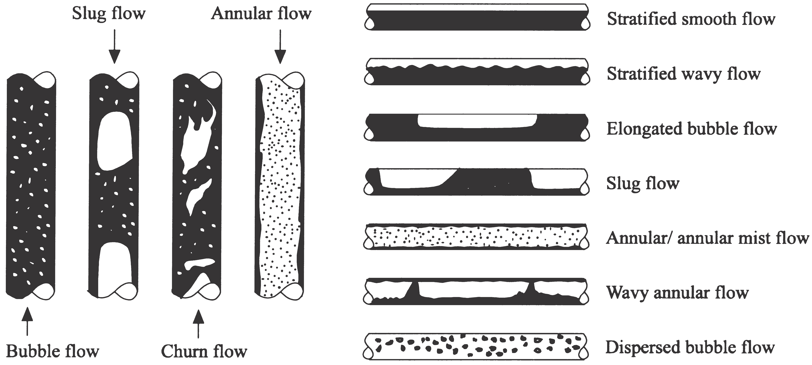
Figure 1:Typical flow regimes for vertical and horizontal flows. Black and white areas represent liquid and gas, respectively.
The most common measurement configuration for single-beam gamma densitometers is shown in Figure 2. The void fraction is determined by measuring the average effective linear attenuation coefficient in the measurement volume over the cross-section of the pipe. The results obtained by using these single-beam densitometers depend on the flow regime, since the measurement cross-section volume normally is less than that covered by the pipe cross-section (3).
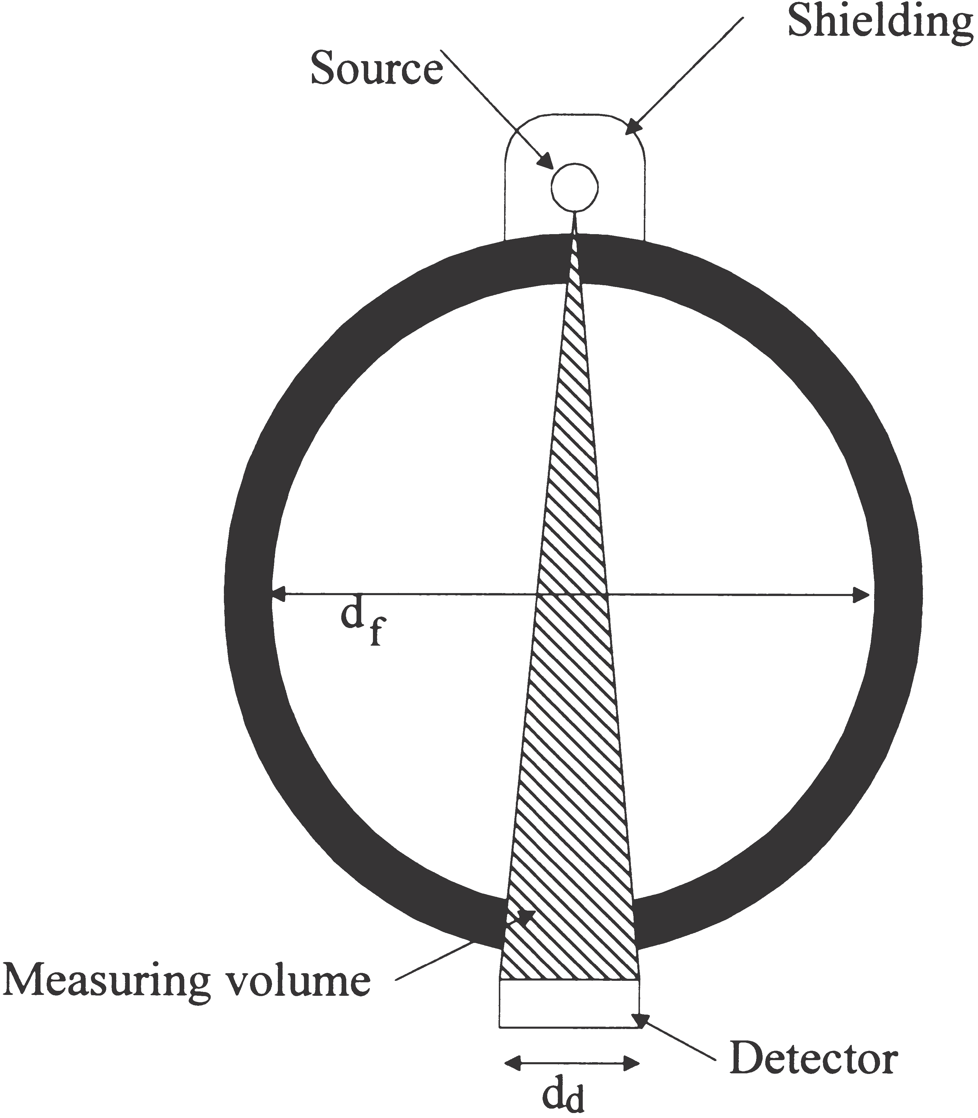
Figure 2:Single-beam gamma densitometer with point source and detector located diametrically opposite each other.
The true void fraction is the gas volume fraction of the total flow volume of the cross-section. The calculated void fraction is the gas fraction in the volume defined by the radiation beam and detector area, i.e. the measurement volume (see Figure 2). By comparing the true void fraction and the calculated void fraction, the accuracy of the measurements for different flow regimes can be obtained.

FLOW REGIME DEPENDENCE OF SINGLE-BEAM GAMMA DENSITOMETERS

Only idealized flow regimes have been considered in this paper in order to simplify the calculations and to simplify the fabrications of the phantoms. Then, the ideal flow regimes eliminate any differences between the calculations and the phantoms used in the measurements.
It can been seen from Figure 2 that the measurement volume depends on the detector area and collimation of the gamma-ray beam. The detector area thus influences sensitivity to the flow regime. In homogeneous flows the linear attenuation coefficient is similar over the entire cross-section. Measuring the linear attenuation coefficient at a single position provides sufficient information about the void fraction of the flow.
When the detector diameter is much smaller than the flow diameter (a narrow fan beam), the diameters of the areas defined by the beam and flow, d1 and d2, are assumed to be plane and parallel to the detector plane d as shown in Figure 3. Furthermore, it is assumed the pipe wall is thin compared to the flow diameter, 2R. Thus, the measurement volume can be defined as a cone in the flow, as shown in Figure 3. To simplify, perfect pipe axis symmetry is assumed, so the flow is symmetrical.
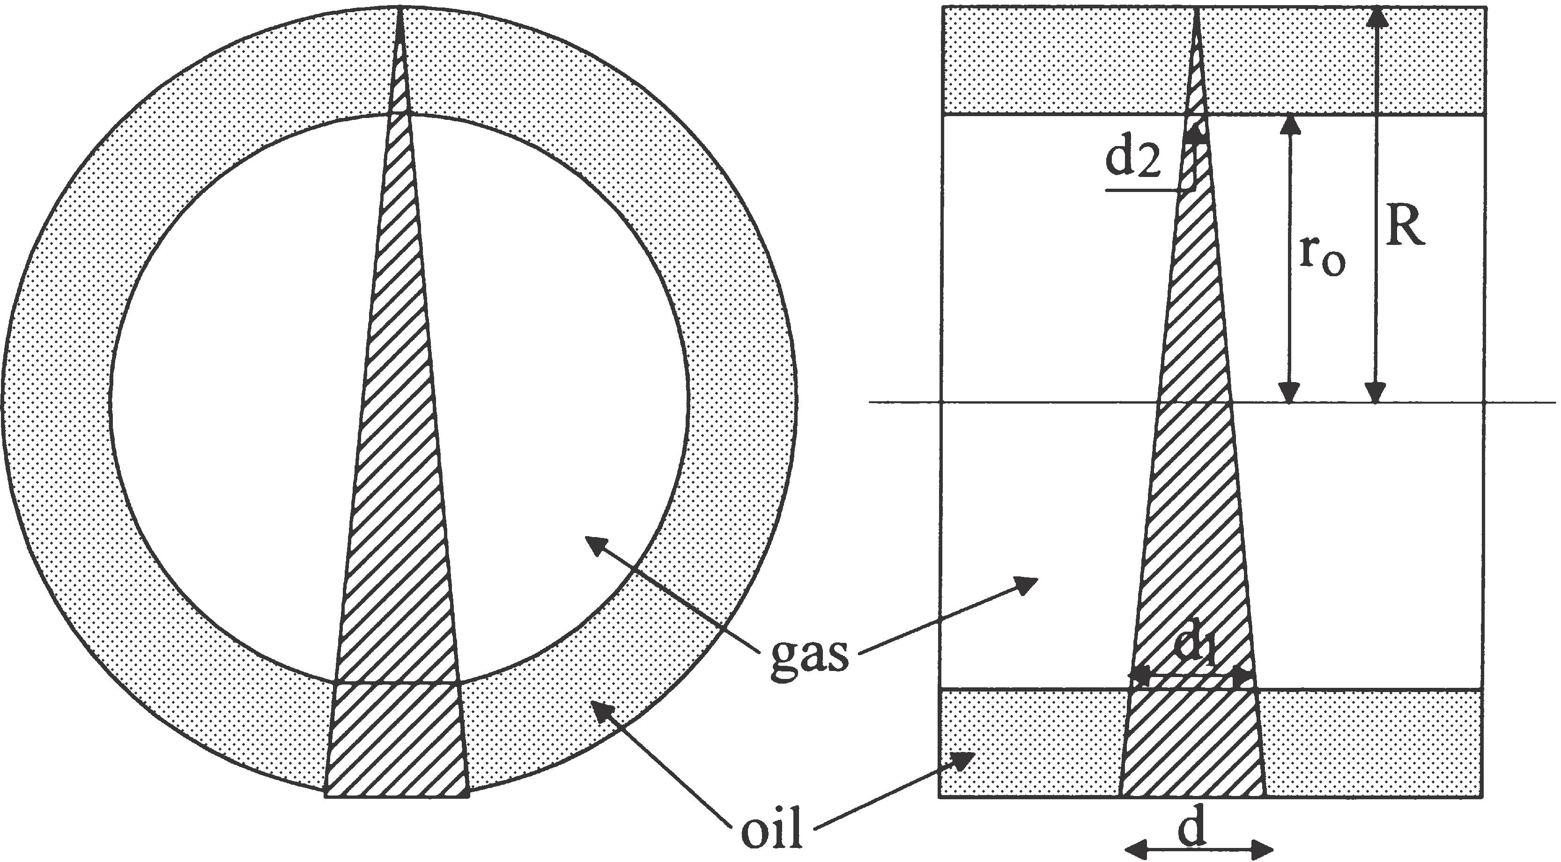
Figure 3:Cross-sectional and side views of an annular flow with a narrow fan radiation beam.
On the basis of the geometry illustrated in Figure 3, the void fraction in the sensitive volume of annular flows with a narrow fan radiation beam can be expressed as follows:

ac 54R3(3R2 1 r02) | (3-1)
where R is the total radius of the flow and r0 is the radius of the gas core. Similarly, an expression of the void fraction in the measured volume of annular flows with a parallel radiation beam can be found as follows
a 5 0  c R | (3-2)
From Figure 3 it is evident that the true void fraction of an annular flow is calculated by:
at 5 p·R2·d 5 R2 | (3-3)
By studying Equations (1-1) to (1-3), it can be seen that for r₀ 5 0 and r₀ 5 R the calculated void fraction, a_{c}, and the true void fraction, at, are identical. However, within these limits, the calculated void fractions in annular flows with a narrow fan radiation beam are functions of r²₀, while for a parallel radiation beam the calculated void fraction is a function of r₀ and the true void fraction is a function of r₀². Obviously, measurements of the void fraction of annular flows are independent of the direction of the source–detector axis because of the symmetry of annular flows.
In Figure 4 the calculated void fraction, a_{c}, is plotted versus the true void fractions, at, with narrow fan and parallel radiation beams. There are no deviations between the calculated void fractions and the true void fraction when the flow is single phase, since the flow in the measured volume represents the flow over the entire cross-section. The maximum deviations appear when the true void fraction is between 0.1 and 0.6. Figure 4 shows that calculated void fractions in annular flows are over- estimated, and that the narrow fan radiation beam gives a lower deviation than the parallel radiation beam.
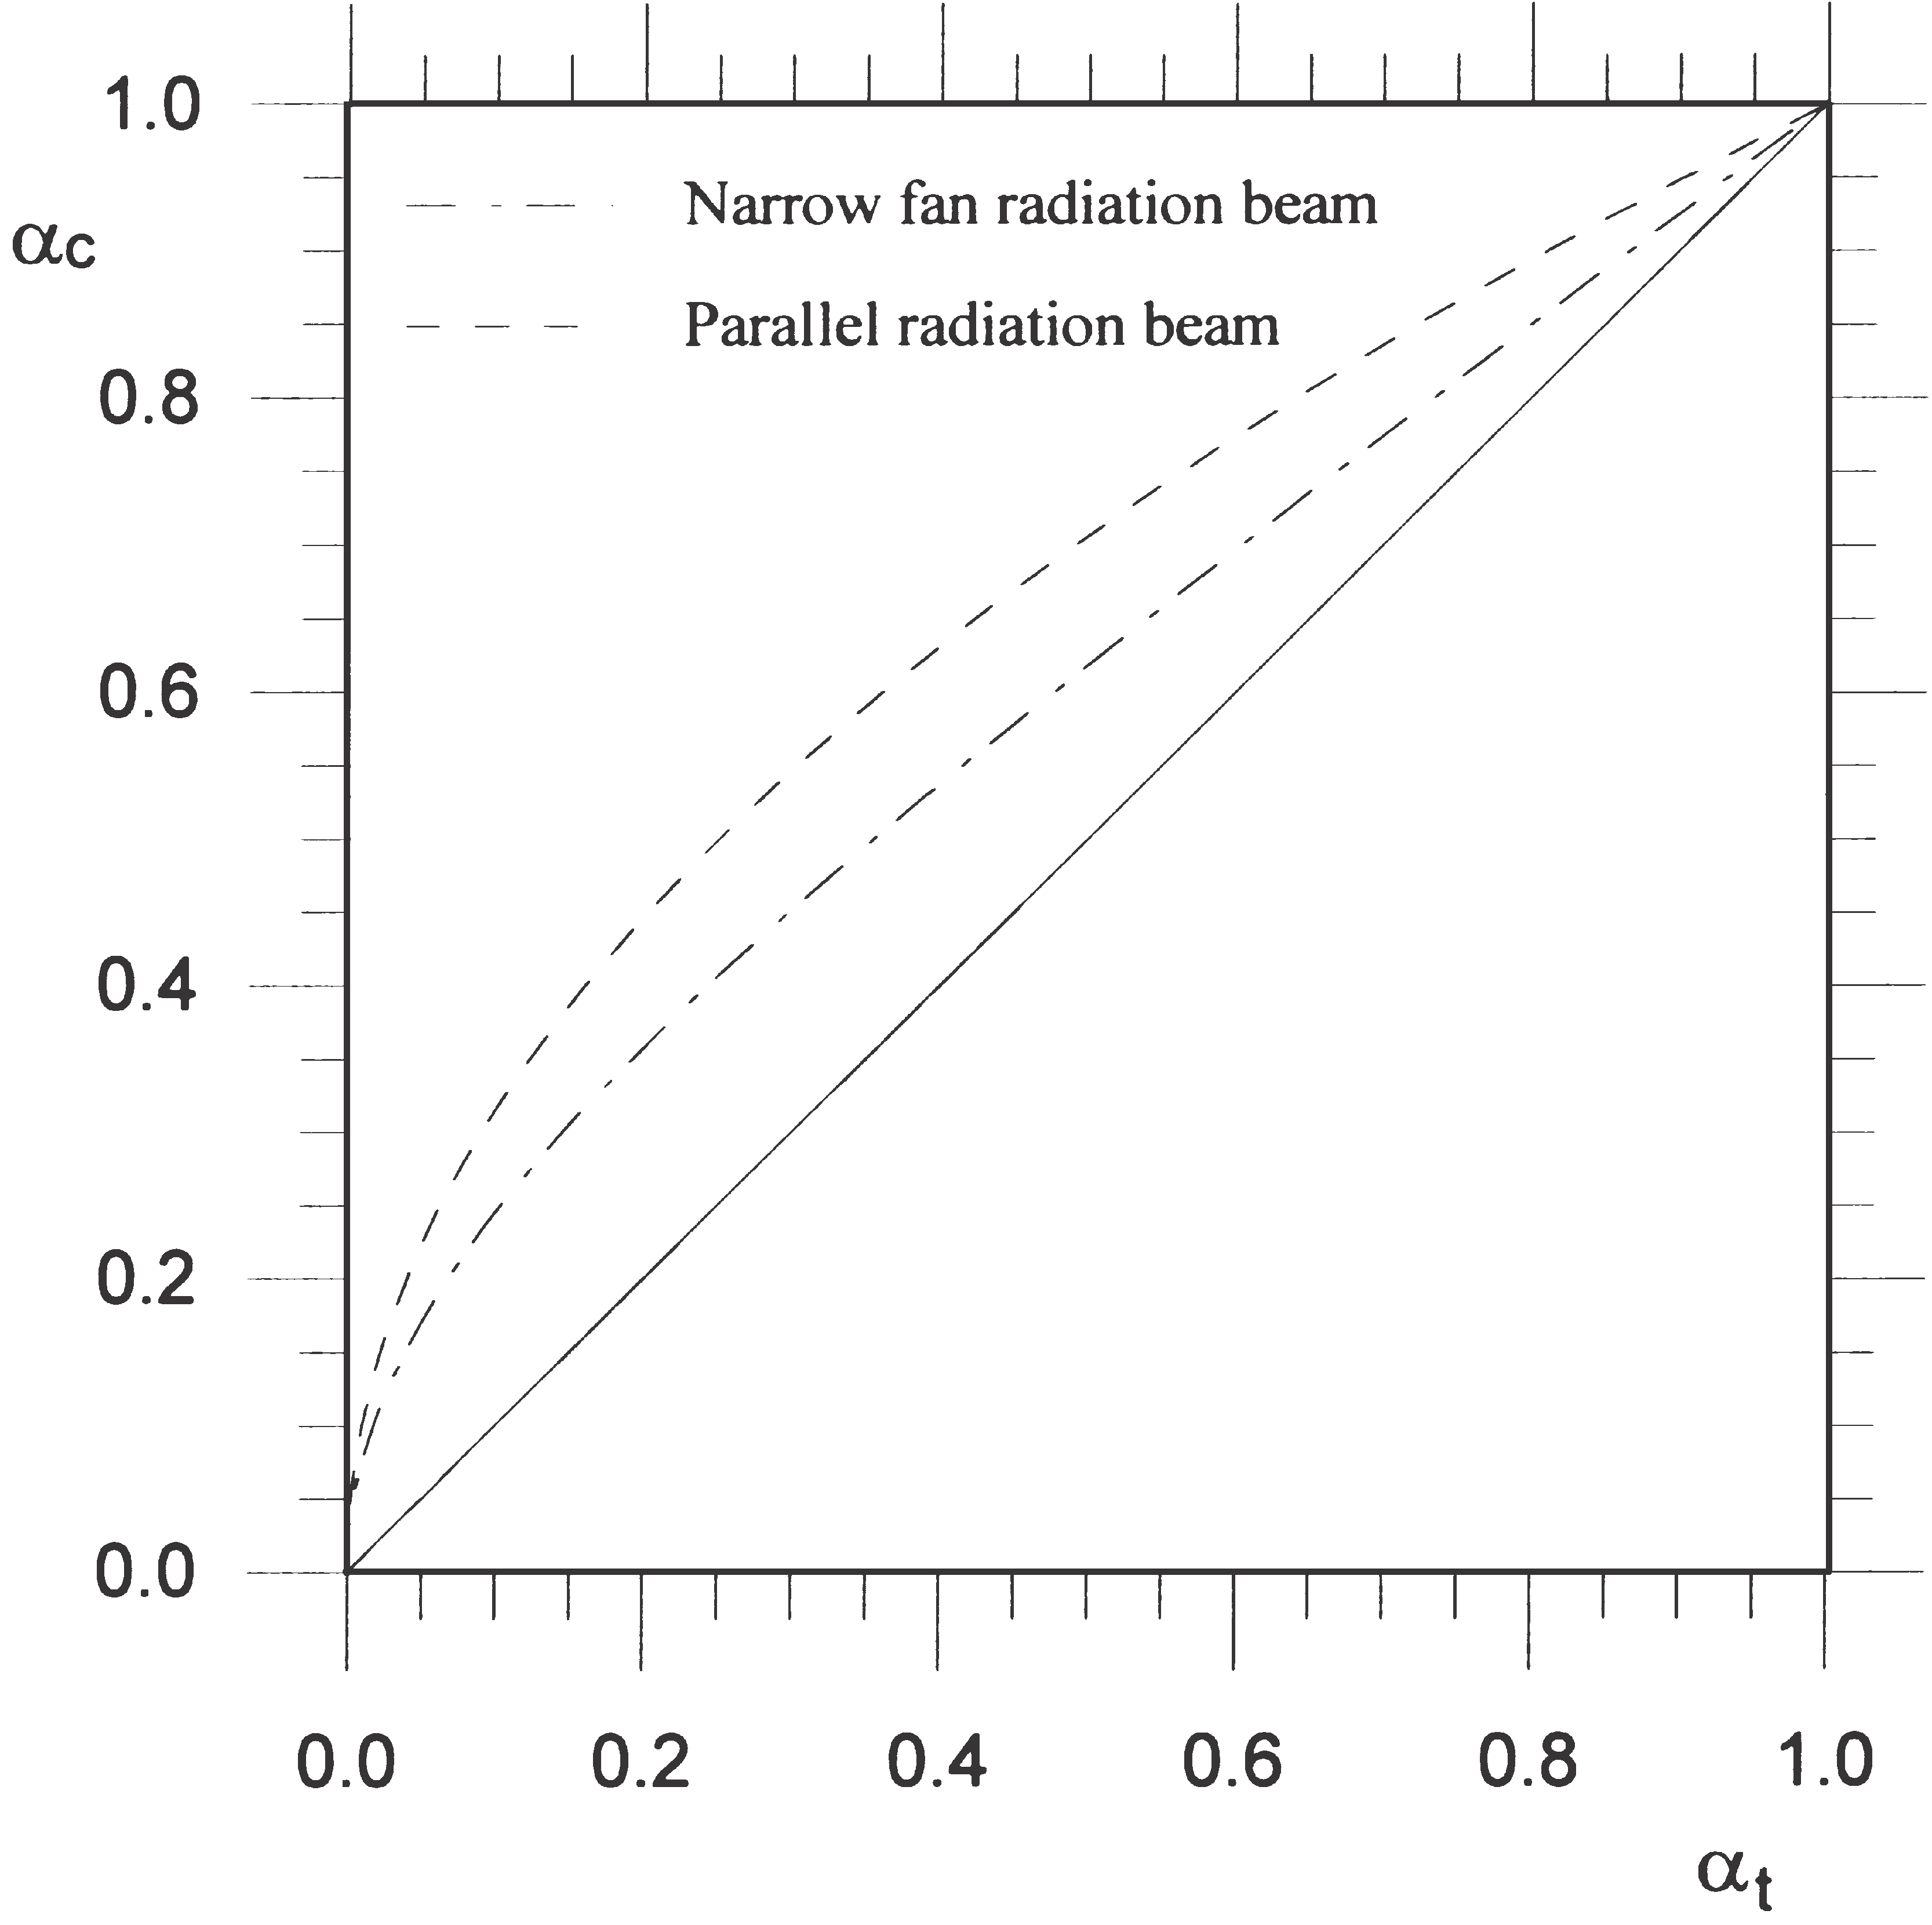
Figure 4:Deviation between calculated and true void fractions of annular flow for narrow fan and parallel radiation beam. The solid line represents the ideal case with no deviation between true and measured void fractions.
In the same way as with annular flows, simplifications have been made with stratified flows, i.e. a much smaller detector diameter compared with the pipe diameter, and a thin pipe wall. The sensitive volume will then be as shown in Fig.5. The lack of pipe-axis symmetry of stratified flows produces measurements of the void fraction that depend on the direction of the source–detector axis. In what follows, the direction will be called top– bottom configuration when the source is above and the detector is below the oil–gas interface, as shown in Fig.5. When the detector is above and the source is below the oil–gas interface the direction will be called bottom figuration is turned $δ$ 90⁰, the direction will be called side-by-side configuration.
For top–bottom configuration and stratified flows, the calculated void fraction in the measurement volume with a narrow fan radiation beam can be written as:
ac 52R 2 L0)3 /8R3 | (3-4)
where L₀ is the level of oil.
With bottom–top configuration the gas volume will not be equal to that of top–bottom configuration, and for bottom–top configuration the calculated void fraction of the measurement volume can be expressed as:
ac 5  (2R 2 L0) 2  8R3 ·(L0  1 2R·L0 1 4R2) | (3-5)
The calculated void fraction of stratified flows with parallel beams can be found as:
a 5 1 2 L0  c 2R | (3-6)
With parallel beams there are no differences between the top–bottom and bottom–top configurations, and the side-by-side configuration will appear to be identical to that of the side-by-side configuration with narrow fan beams, shown in Figure 6.
For side-by-side configurations the calculated void fraction will be 1 and 0 for oil levels lower and higher than the detector, respectively. Due to the small detector diameter compared with the flow diameter, i.e. a small measurement volume, this side-by-side configuration will be highly sensitive to changes in oil level when this covers some of the measurement volume, as shown in Figure 6.
Based on Figure 5, it can be shown that the true void fraction of stratified flows can be found by (3):
2 1 ·sinS2· arcosS  R 2 L0  R  DDG | (3-7)

2 1 ·sinS2· arcosS  R 2 L0  R  DDG | (3-8)

On the basis of Equation (3-4), (3-5) and (3-7) the deviations between the calculated void fractions and the total void fraction for stratified flows with different source–detector directions are plotted in Figure 6.
By inserting L0 5 2R and L0 5 0 into Equation (3-4), (3-6)and (3-7), the calculated void fractions and the true void fraction are 0 and 1, respectively. When flows consist of only one component, it is obvious that the density, or more correctly, the linear attenuation coefficient, is equal over the entire cross-section of the flow. Therefore, no deviation is observed between measured and true void fractions.

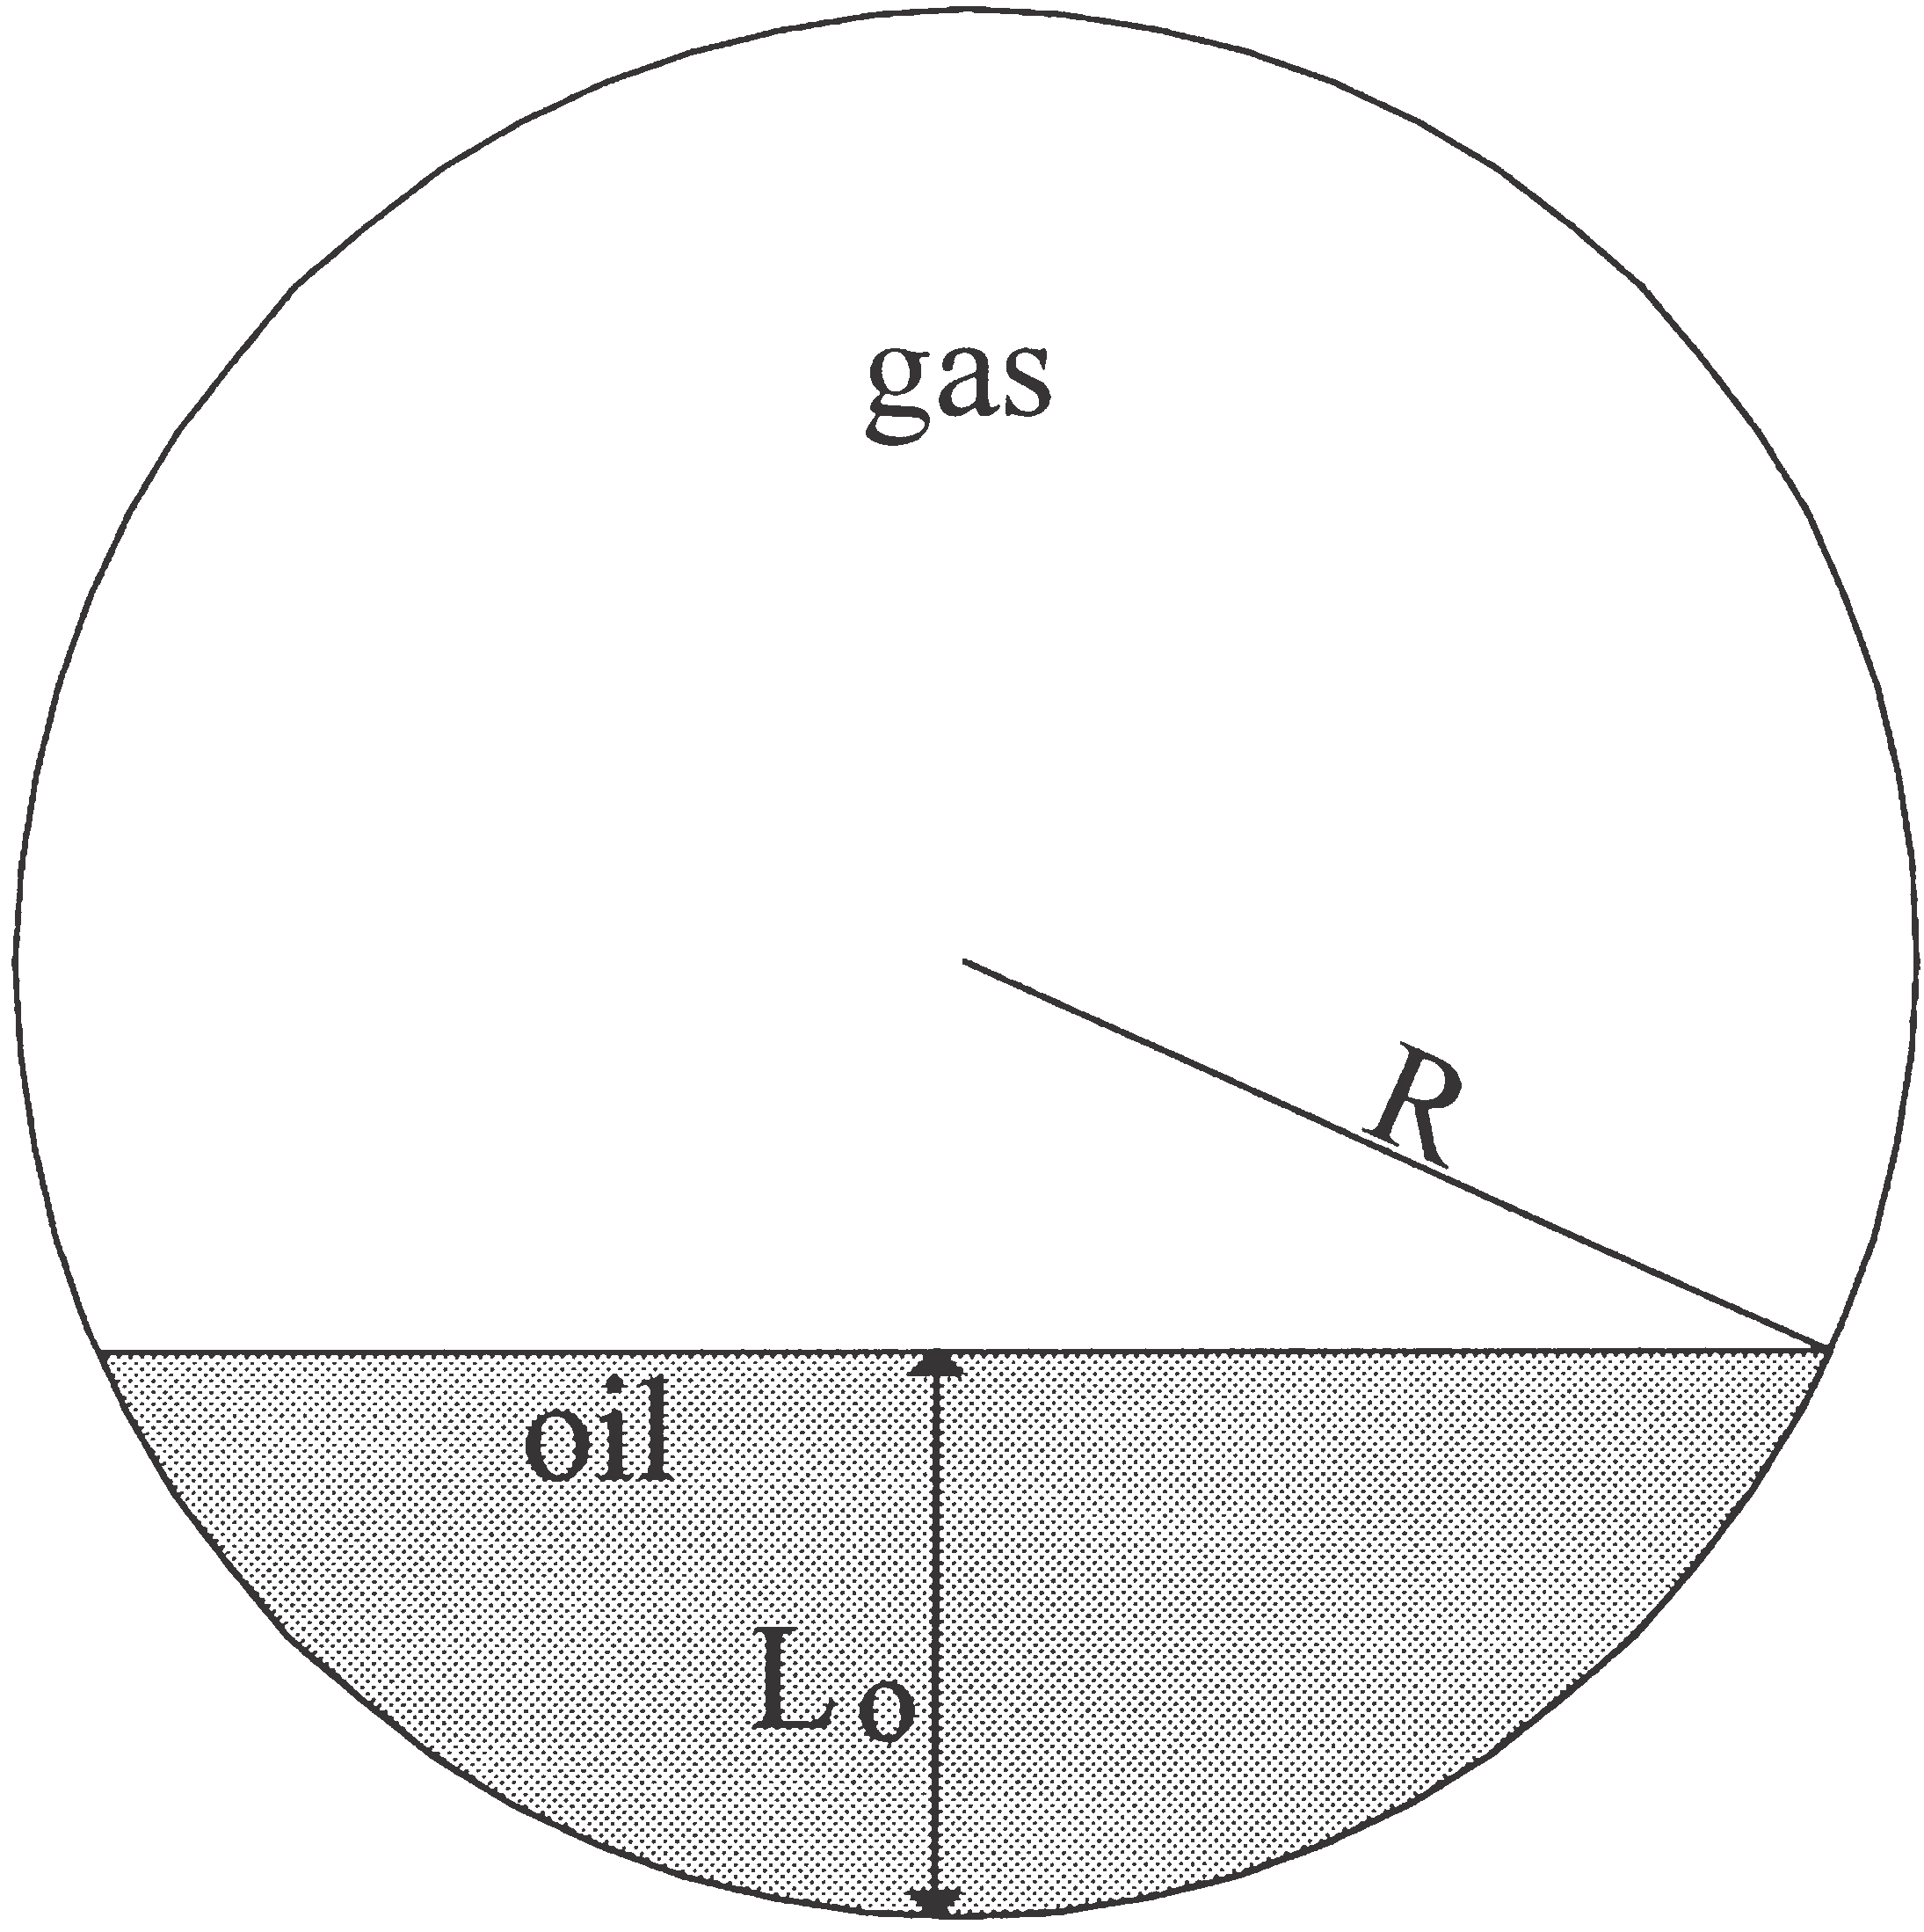
Figure 5:Stratified flow with related parameters.
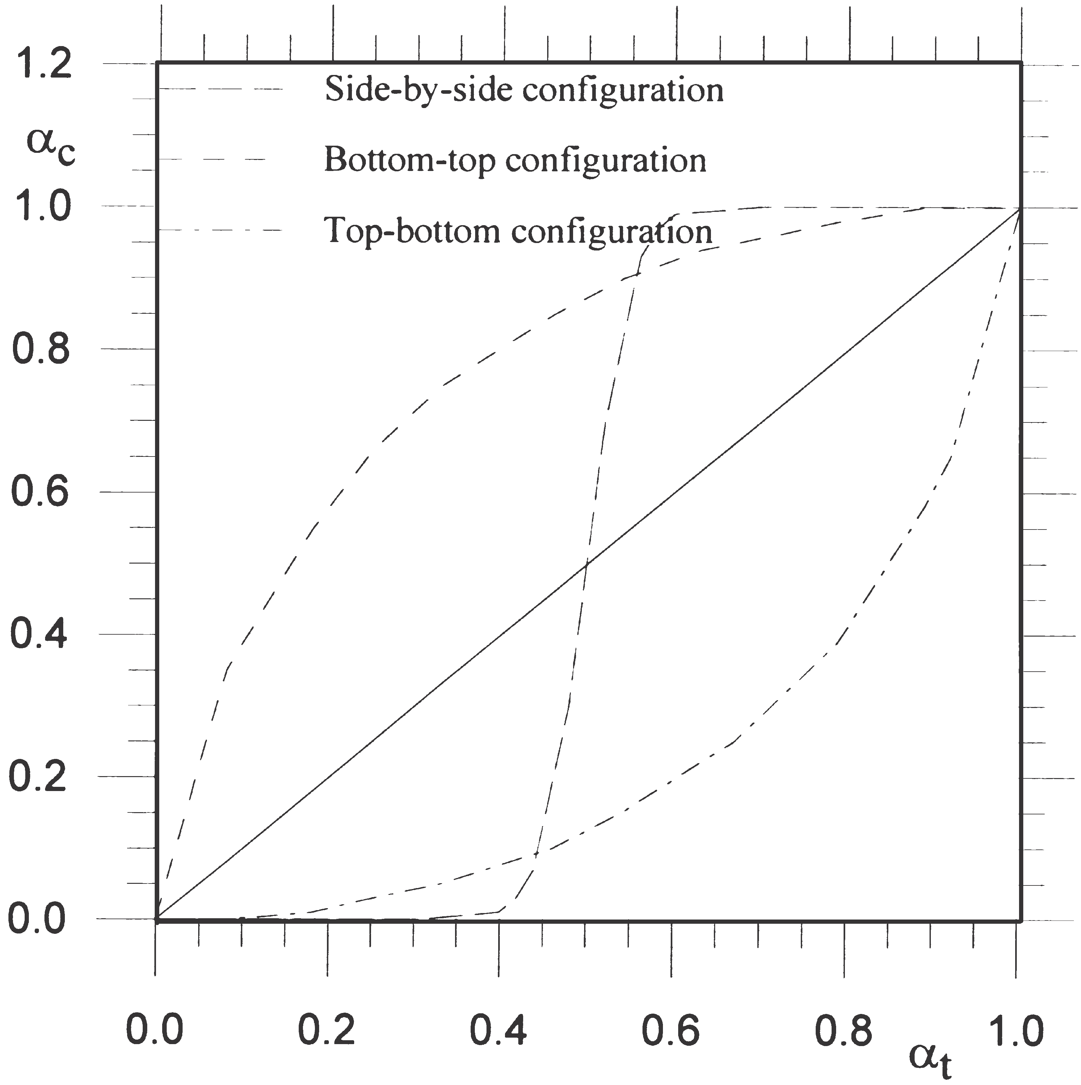
Figure 6: Deviation between measured and true void fraction of stratified flow with narrow fan beam with different source-detector orientations. The solid line represents the ideal case with no deviation between true and calculated void fraction
In Figure 7 the calculated void fraction, ac, is plotted against the true void fraction, at, for stratified flows with top–bottom configuration. The deviation between the calculated and true void fractions is at a minimum with parallel beams and reaches a maximum with narrow fan beams. In contrast to annular flows, the calculated void fraction of top–bottom configured stratified flows is underestimated.
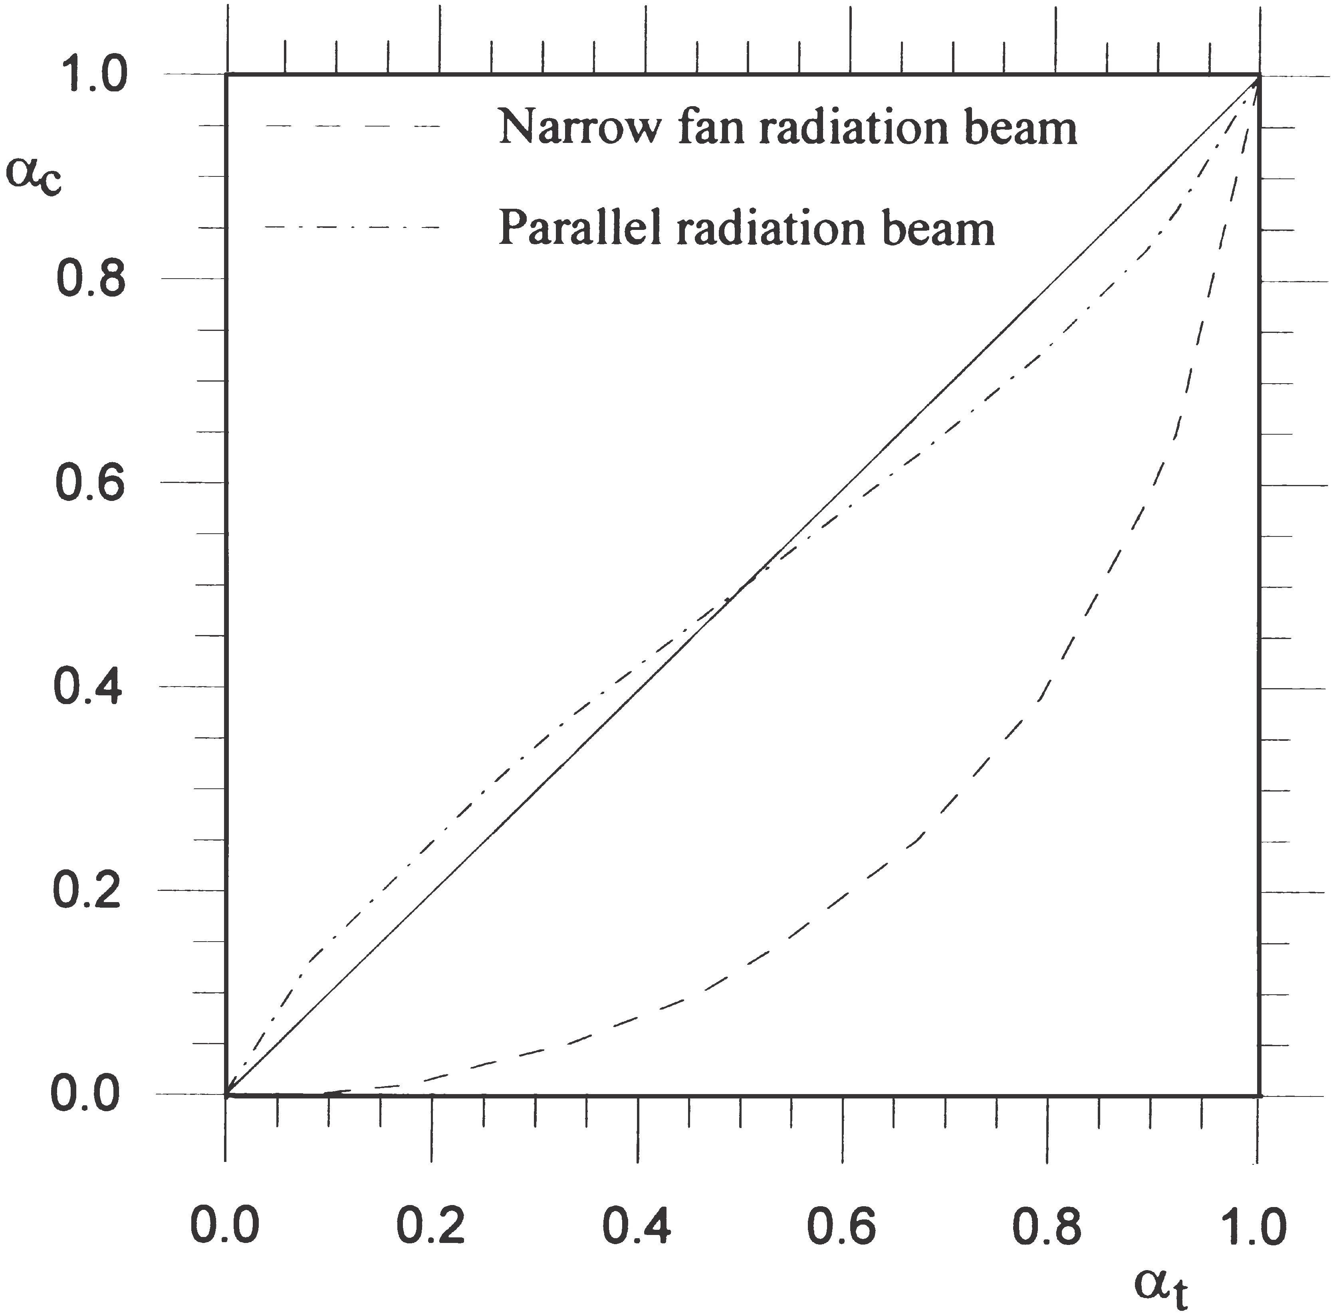
Figure 7: Deviation between measured and true void fraction of stratified flow for narrow fan beam. The solid line represents the ideal case with no deviation between true and measured void fractions.
By comparing Figure 4 and Figure 7, we can see that the accuracy of void fraction measurements is highly dependent on the flow regime and the radiation beam. For this reason, in order to obtain accurate void fraction measurements, the flow regime must be taken into account.

MULTI-BEAM GAMMA-RAY MEASUREMENT PRINCIPLES
Low-energy sources such as 241Am (59.5 keV) offer the possibility of a compact design as a result of low shielding requirements (2 mm of lead). Furthermore, the use of compact semiconductor detectors such as cadmium zinc telluride (CZT) detectors, allows multi-beam configurations which represent flow cross-section better than single-beam gamma-ray densitometry. In addition, thanks to the compactness of the source and detectors, low-energy gamma-ray densitometers can be integrated into the pipe wall, as shown in Figure 8.

The predominant mechanisms of interaction for low- energy photons are the photoelectric effect and Compton scattering. Their probabilities of interaction depend on the atomic number of the absorber. The relationship is approximately linear for Compton scattering, which is to say that the interaction probability is directly proportional to the density of the absorber. For the photo- electric effect the interaction probability is proportional to the atomic number to the power of 4–5.
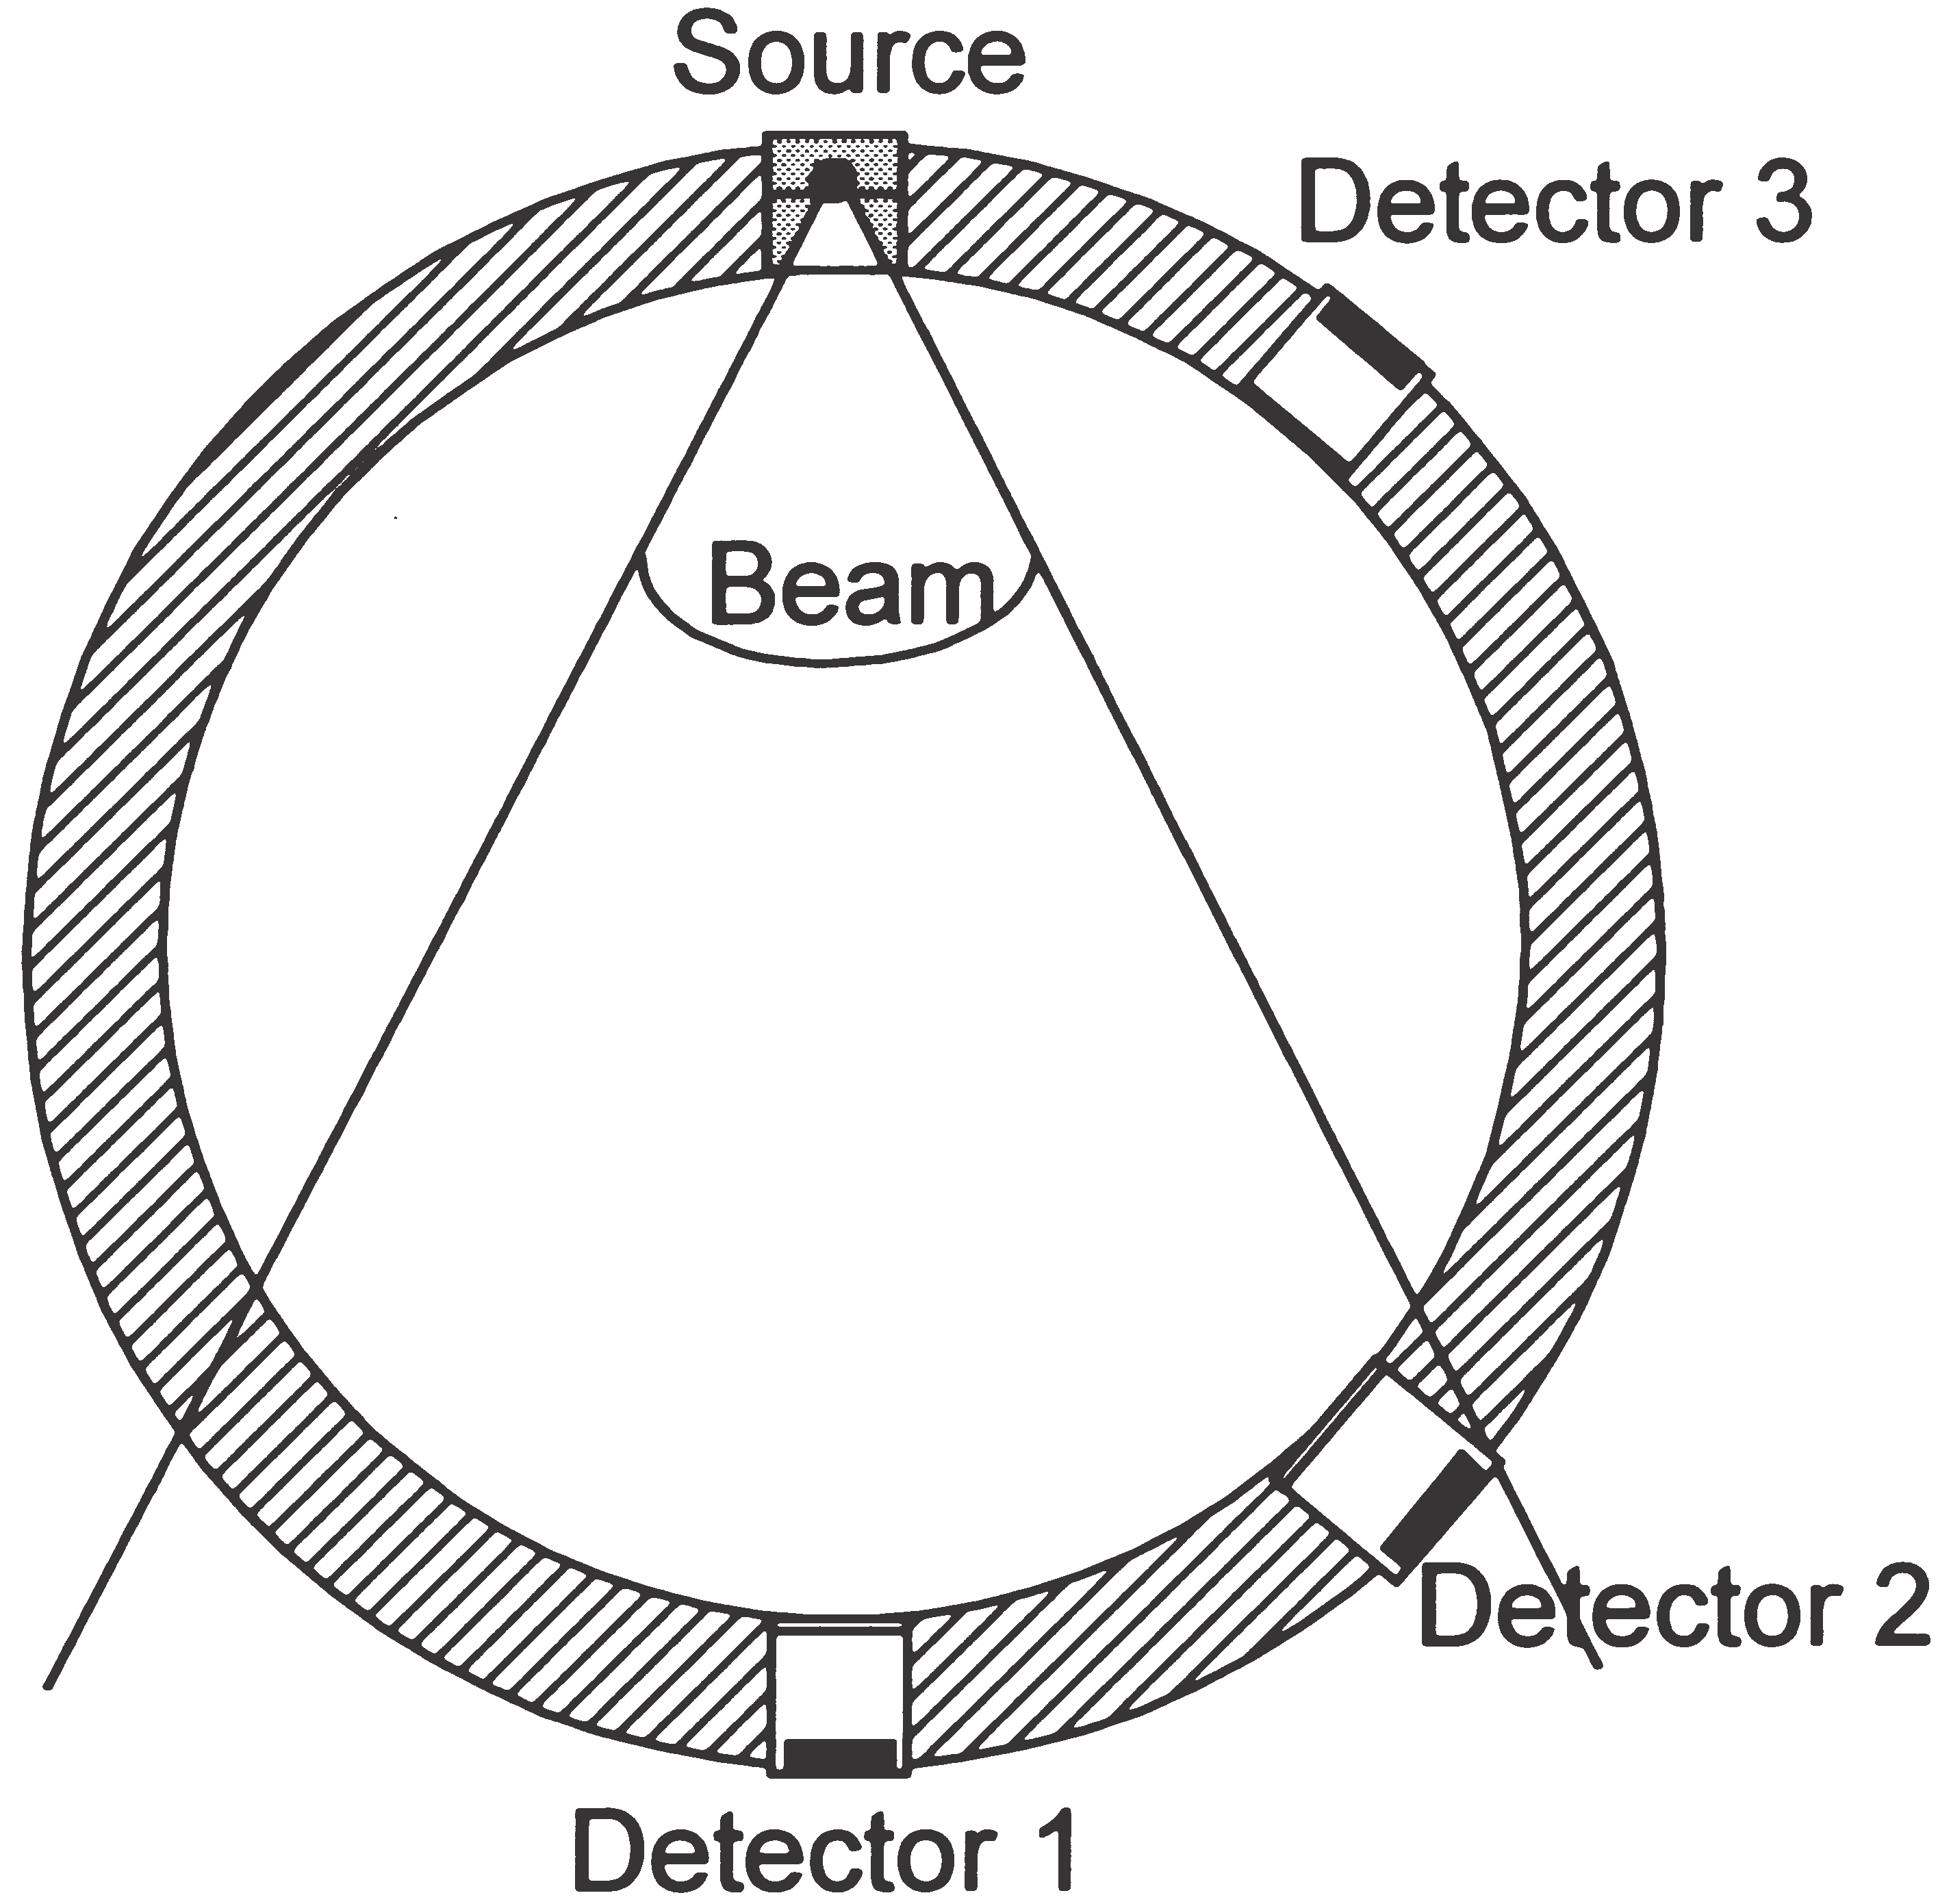
Figure 8: Compact low-energy multi-beam gamma-ray densitometer.
Photon scattering is often regarded as an undesirable effect in gamma-ray attenuation measurements since it complicates the interpretation of the results. Build-up, i.e. the extra contribution to transmission measurements from scattered radiation, has to be considered, particularly if wide-beam measurement configurations are used (3). In fluid flow fraction measurements, however, it is possible to take advantage of this effect since it effectively means that the gas–liquid distribution outside the geometrical volume defined by the source and the detector affects the measurement result (4). This may to some extent be regarded as a geometrical measurement averaging over the pipe cross-section, especially for backscattered radiation where there is no contribution from transmission. A Monte Carlo simulation model has been developed and implemented in order to study trans- mitted and scattered photons over the pipe cross-section (5).
Measuring the spectral detector response at several positions around the pipe allows the transmitted and scattered photons to be detected in several positions. Pulse height analysis (PHA) is used to study the energy depositions in the detectors. Once the detector responses have been combined and utilized, the void fraction and flow regime can be determined. A suitable method, as used here, of examining single- and multi-beam gamma- ray densitometry configurations, is to use phantoms made of polypropylene and compare the data from the detector responses with a range of flow regimes and void fractions.

EXPERIMENTAL SET UP AND RESULTS
In this work, an aluminium pipe was made to test the multi-beam gamma-ray measurement principles. Instead of oil, phantoms of polypropylene (density =0.91 g/cm3) were employed. Such phantoms are necessary to obtain reliable reference values. The density of the phantoms is higher than that of most oils, but is close enough to verify the principle. The inner and outer diameters of the pipe are 80 mm and 90 mm, respectively. A 241Am (59.5 keV) source and a single eV A1361 CZT (CdZnTe) semiconductor detector were used in the experiments, in addition to a eV-550 preamplifier, a Tennelec TC244 amplifier and an Oxford PHA.
Using the phantoms, static measurements were performed. That means both the void fraction and flow regime were constant during the measurements, giving reliable references. A complete measurement series of one phantom consisted of detector responses from 17 positions around the pipe to represent the detector positions from 180⁰ (diametrical position) to 52⁰.
In a system in which measurement values vary rapidly, the measurement time (integration time) plays an important role, since measurement time and statistical error are closely related. Longer measurement times give lower statistical errors and vice versa. Fluctuations in measurement values will be smoothed out with a longer measurement time. It is important to use low Z-number pipe wall materials with low-energy gamma-ray densitometers in order to minimize beam attenuation in the walls. Suitable pipe wall materials include aluminum, titanium or plastics. Windows can be made of these materials rather than using them for the whole pipeline. In order to obtain short measurement times, the pipe wall material and the source activity must be chosen carefully. In our experiments, a 14 mCi 241Am source and a measurement time of 600 s were chosen because of the static nature of the experiment. In a real dynamic system a 241Am source with higher activity and a shorter measurement time would have to be considered. The statistical error is inversely proportional to the square root of number of counts, thus a smaller measurement time will increase the statistical error. For instance, use of a 300 mCi source and a measurement time of 1s will decrease the number of counts by 30, thus the statistical error will be increased by about 5.4 times.
The aluminum pipe, source and detector are mounted in a computer-controlled test platform, on which the detectors are positioned around the pipe to an accuracy of 61⁰ (6). The CZT detector is moved by 8⁰ between each measurement to obtain detector responses in several positions around the pipe with fixed flow regimes. As shown in Table 1, various polypropylene phantoms are used to simulate flow regimes and void fractions.
More information is obtained with multi-beam densitometry than with single-beam gamma-ray densitometry. Void fraction measurements of the same pipe and phantoms from single-beam and multi-beam low-energy gamma-ray configurations have been compared in order to study their performance.
The principle of single-beam gamma-ray densitometers is based on the concept of expressing the void fraction in terms of transmitted intensity, which is the number of photons detected in the full energy peak in the measurement time period. This means counting photons with energy higher than a given threshold value, which was 40 keV in our experiments. The void fraction can be found as:
Table 1: Void fraction and flow regime phantoms made for the experiment
Void fraction (%) | Flow regime phantom
0 | Homogenous
20 | Stratified
20 | Annular
25 | Annular
50 | Annular
50 | Stratified
56 | Annular
70 | Annular
80 | Stratified
100 | Homogenous

lnSImix  Ioil D  a 5  ln Igas  Ioil D  S | (5-1)

where Ioil and Igas correspond to 100% oil and 100% gas, respectively. These values are used as calibration values. Imix is the measured intensity which depends on the amount of oil and gas in the flow. Equation(5-1) assumes that the contribution of scattered photons detected is negligible. The contribution of scattered photons depends on several parameters, including pipe wall material and thickness, void fraction (i.e. linear attenuation coefficient), distribution of oil and gas in the pipe (i.e. flow regime) and the presence of a detector collimator. During the calibration process scattered photons are included in the calibration values.
The performance of single-beam gamma-ray densitometry can be studied with the aid of the phantoms listed in Table 1, which have fixed void fractions and flow regimes. A PMT is located diametrically opposite the source (241Am). In Figure 9 the measured void fractions of these known phantoms of the single-beam gamma- ray densitometer are presented. A steel cap with a Ø10 mm hole was used to collimate the PMT in order to minimize the contribution of scattered photons and to achieve a lower count rate. The deviation between the true void fraction and the measured void fraction appears to be largest with annular flow regime phatoms, see Figure 9.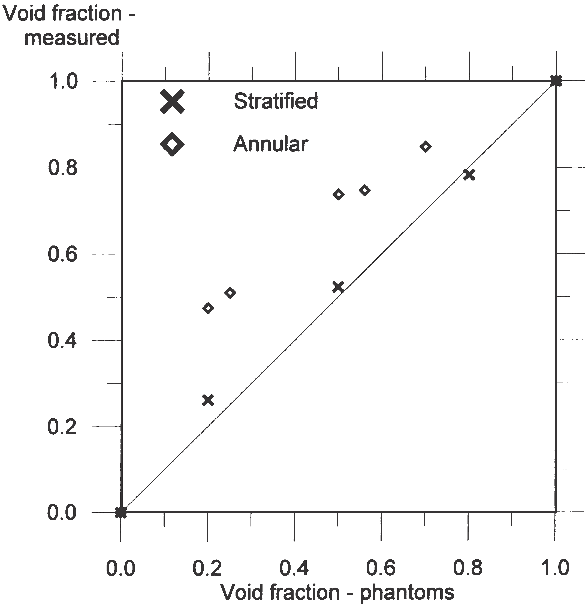
Figure 9: Measured void fraction versus true void fraction using single-beam gamma-ray densitometer with ²⁴¹Am source. The solid line represents the ideal case, with no deviation between true and measured void fractions.
By comparing the measured void fractions in Figure 9 with the calculated void fractions in Figure 4 and Figure 7, it can be seen that measured void fractions appear to be equal
to calculated void fractions for parallel beams. The flow regimes are the cause of the deviations between measured and true void fractions. Since the deviations appear to be similar for calculated and measured void fractions, the models used to describe the calculated void fraction of annular and stratified flows are satisfactory. A performance study of the multi-beam gamma-ray measurement principle requires measurements obtained by a conventional gamma-densitometer. Such a densitometer was constructed: it consists of a single colli- mated 1 mCi 137Cs (661.7 keV) source and one 20 PMT, installed on a 90 mm steel pipe with a wall thickness of 5 mm.
The phantoms shown in Table 1 were used, as they had well-defined void fractions. In accordance with equation (5-1), the measured void fractions were found on the basis of the measured intensities for different void fractions and flow regimes. Figure 10 plots the measured void fractions against the true void fractions. By comparing the experimental data from the conventional gamma-densitometer with the data in Figure 4 and Figure 7, it can be seen that the data fit fairly well with the annular and stratified flows with parallel radiation beams, respectively.
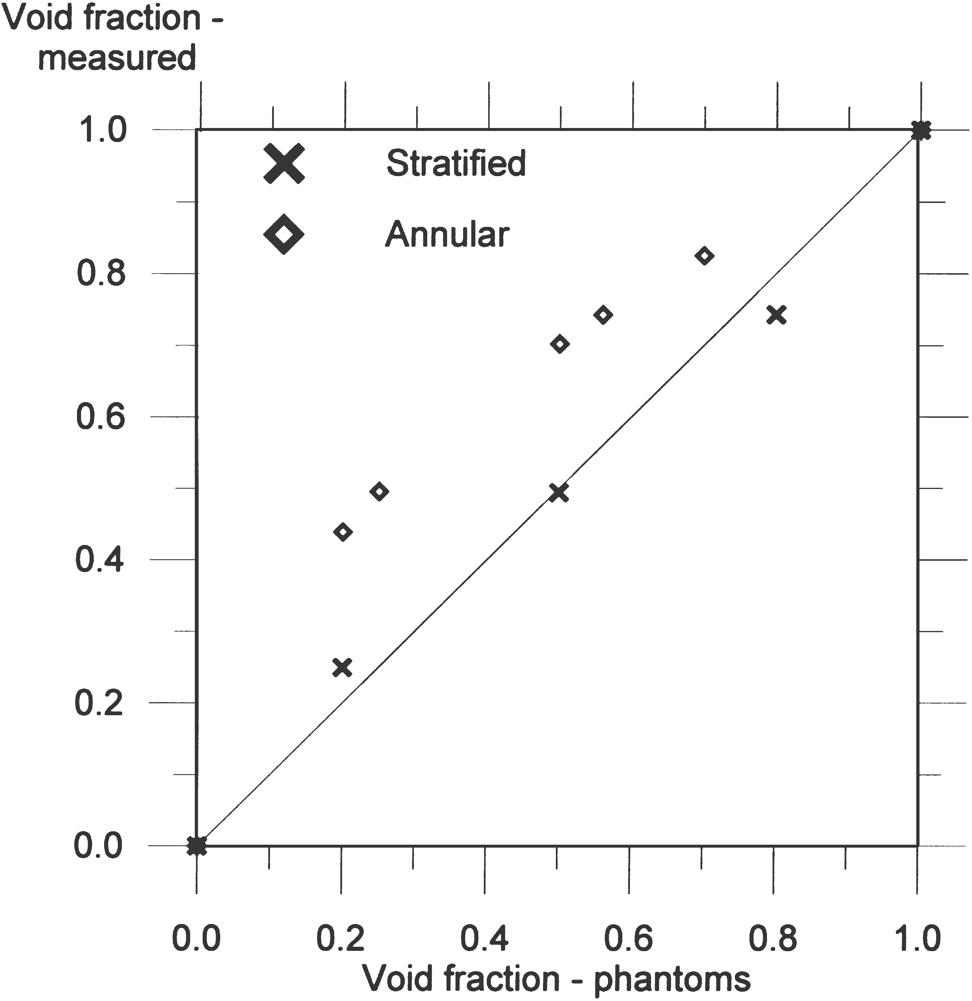
Figure 10: Measured void fraction versus true void fraction using conventional gamma-ray densitometer with ¹³⁷Cs source. The solid line represents the ideal case with no deviation between true and measured void fractions.
It is obvious from Eq. (8) that the Igas/Ioil ratio expresses the sensitivity of the system. It can be seen that this ratio is higher than 1 in detectors that are registering transmitted photons, i.e. in the collimated beam (see Figure 11 and Figure 12). In multi-beam gamma-ray densitometry the Igas/Ioil ratio is smaller than 1 outside the beam. This means that in the oil–gas mixture the number of scattered photons decreases as void fraction increases, due to the lower probability of interactions in the gas. Since the Igas/Ioil ratio is fixed for a given gamma-ray densitometer, the deviations between the real and measured void fraction must be found in the Imix/Ioil ratios.
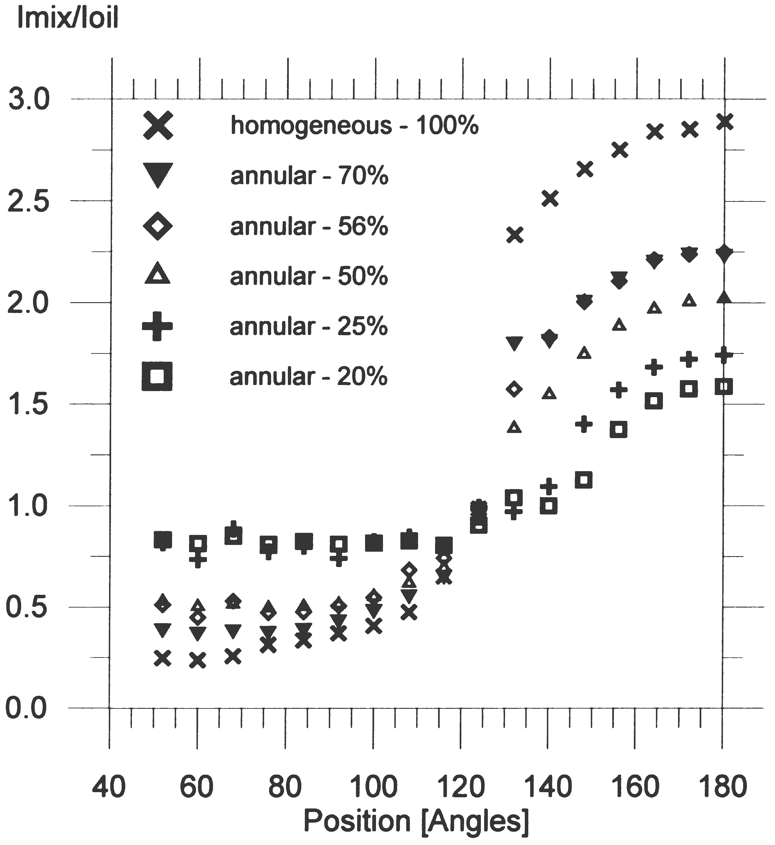
Figure 11: Imix/Ioil ratios plotted against detector position for annular flow phantoms.
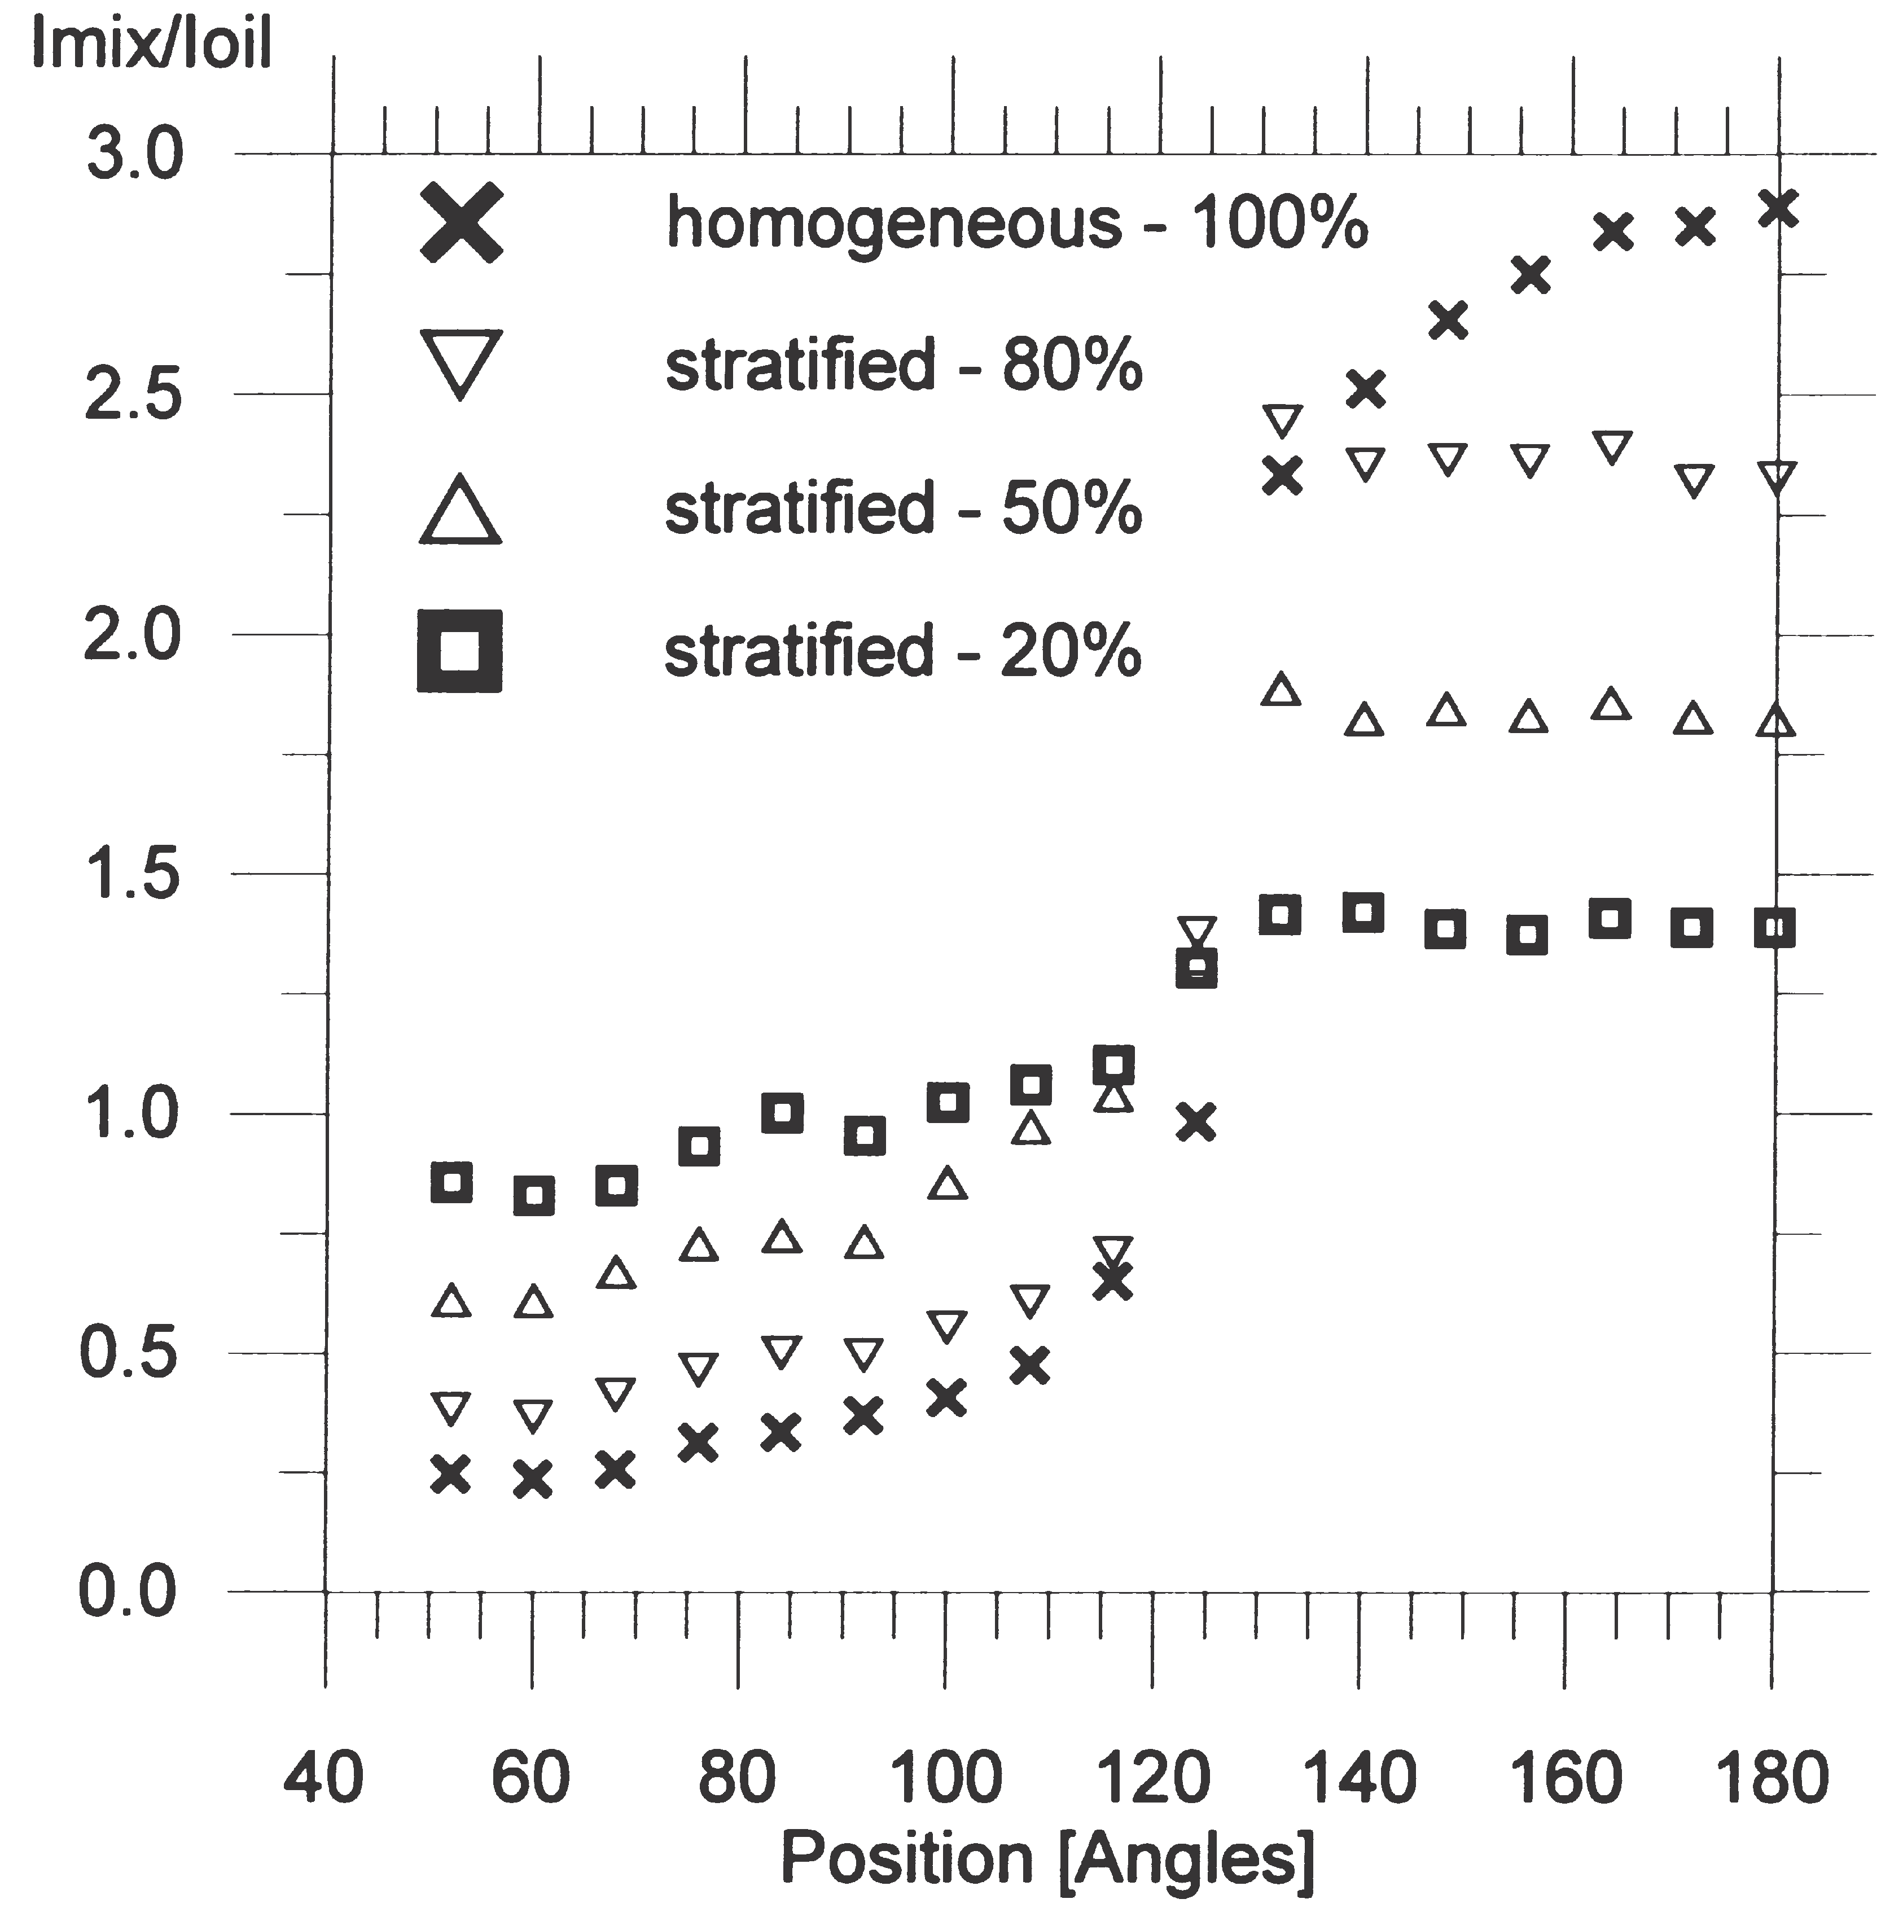
Figure 12: Imix/Ioil ratios plotted versus detector position for stratified flow phantoms

Figure 11 and Figure 12 plot the Imix/Ioil ratios for all the phantoms. The ratios are found by counting the number of events with constant measurement time in the full energy peak.
By comparing Figure 11and Figure 12 it can be seen that the Imix/Ioil ratios are 1.3–1.4 for stratified flow phantoms and are close to 1 for the annular flow phantoms at the detector position of 124⁰. This means that at this detector position, the system will only be sensitive to the stratified flow phantoms. It can also be seen that the Imix/Ioil ratios of stratified flow phantoms are flat over the detector positions covered by the beam.

This is due to the fact that the transmitted beam has a shorter path through the stratified phantoms at angles smaller than 180⁰, compared with its path through annular flow phantoms. This suggests that the Imix/Ioil ratios of two detectors located in the beam could be used to detect whether the flow regime is stratified or not. It should be noted that the value of Imix/Ioil ratios versus detector position depends on the distribution of the photon emission from the source.

Using the data shown in Figure 11 and Figure 12, the void fraction can be calculated according to Equation (5-1). The measured void fractions at 180º appear to be similar to the data obtained by the PMT (Figure 9). In this position the measured void fractions with stratified flow phantoms are close to the true void fractions.

It was discovered experimentally that several detector positions underestimated the void fraction of stratified and annular flow phantoms. By taking these void fractions into account, the dependency of the flow regime can be reduced. The measured void fraction based on the experimental data of stratified and annular flow phantoms from four detector positions were used to calculate the mean value of the void fraction. The mean values of the void fractions were compared to the true void fractions. Based on the detector positions giving the mean void fractions closed to the true void fractions, the detector positions were selected.

In Figure 13 the void fractions based on the experimental data obtained using the phantoms are plotted for detector positions at 180⁰, 140⁰, 68⁰ and 52⁰. Only scattered pho- tons are detected in the detector positions at 68⁰ and 52⁰. At 68⁰ and 52⁰, however, it can be seen that void fraction measurements of the annular flow phantoms are under- estimated and are closer to the true void fraction than measurements made at 180⁰. It is interesting to note at 68⁰ and 52⁰, the measurements of annular flow phantoms are closer to the true void fraction than measurements
of stratified flow phantoms.

Figure 13 and Figure 14 suggest that the data are distributed more or less equally around the solid line, which indicates that there was no deviation between measured and true void fraction. This means the mean values of the measured void fractions of the selected detector positions are close to the true void fractions. A curve fitting of the mean values gives a curve very close to the true void fraction of the phantoms, as shown in Figure 13 and Figure 14.
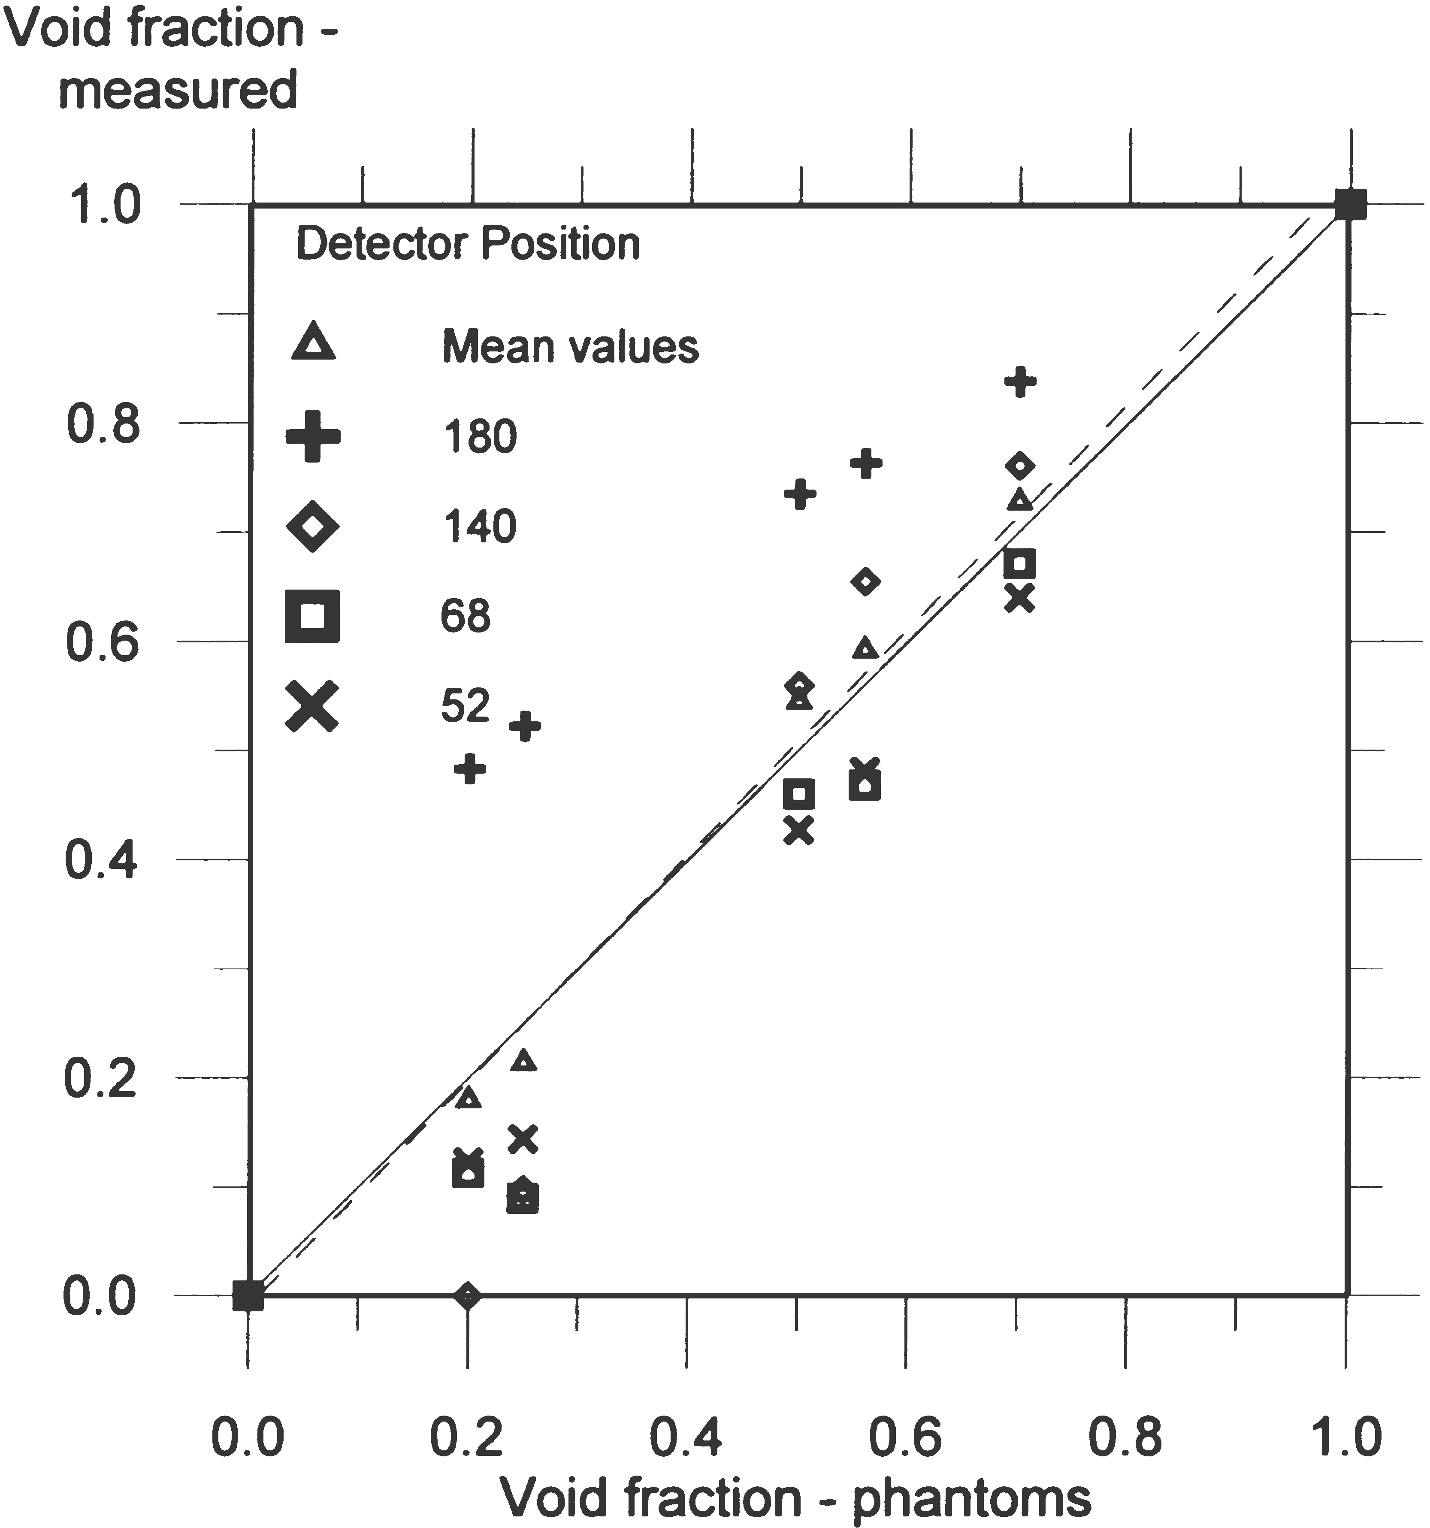
Figure 13: Measured void fraction versus true void fraction of the annular phantoms at several detector positions. The solid line represents the ideal case with no deviation between true and measured void fractions. The dashed line is the best curve fit of mean values
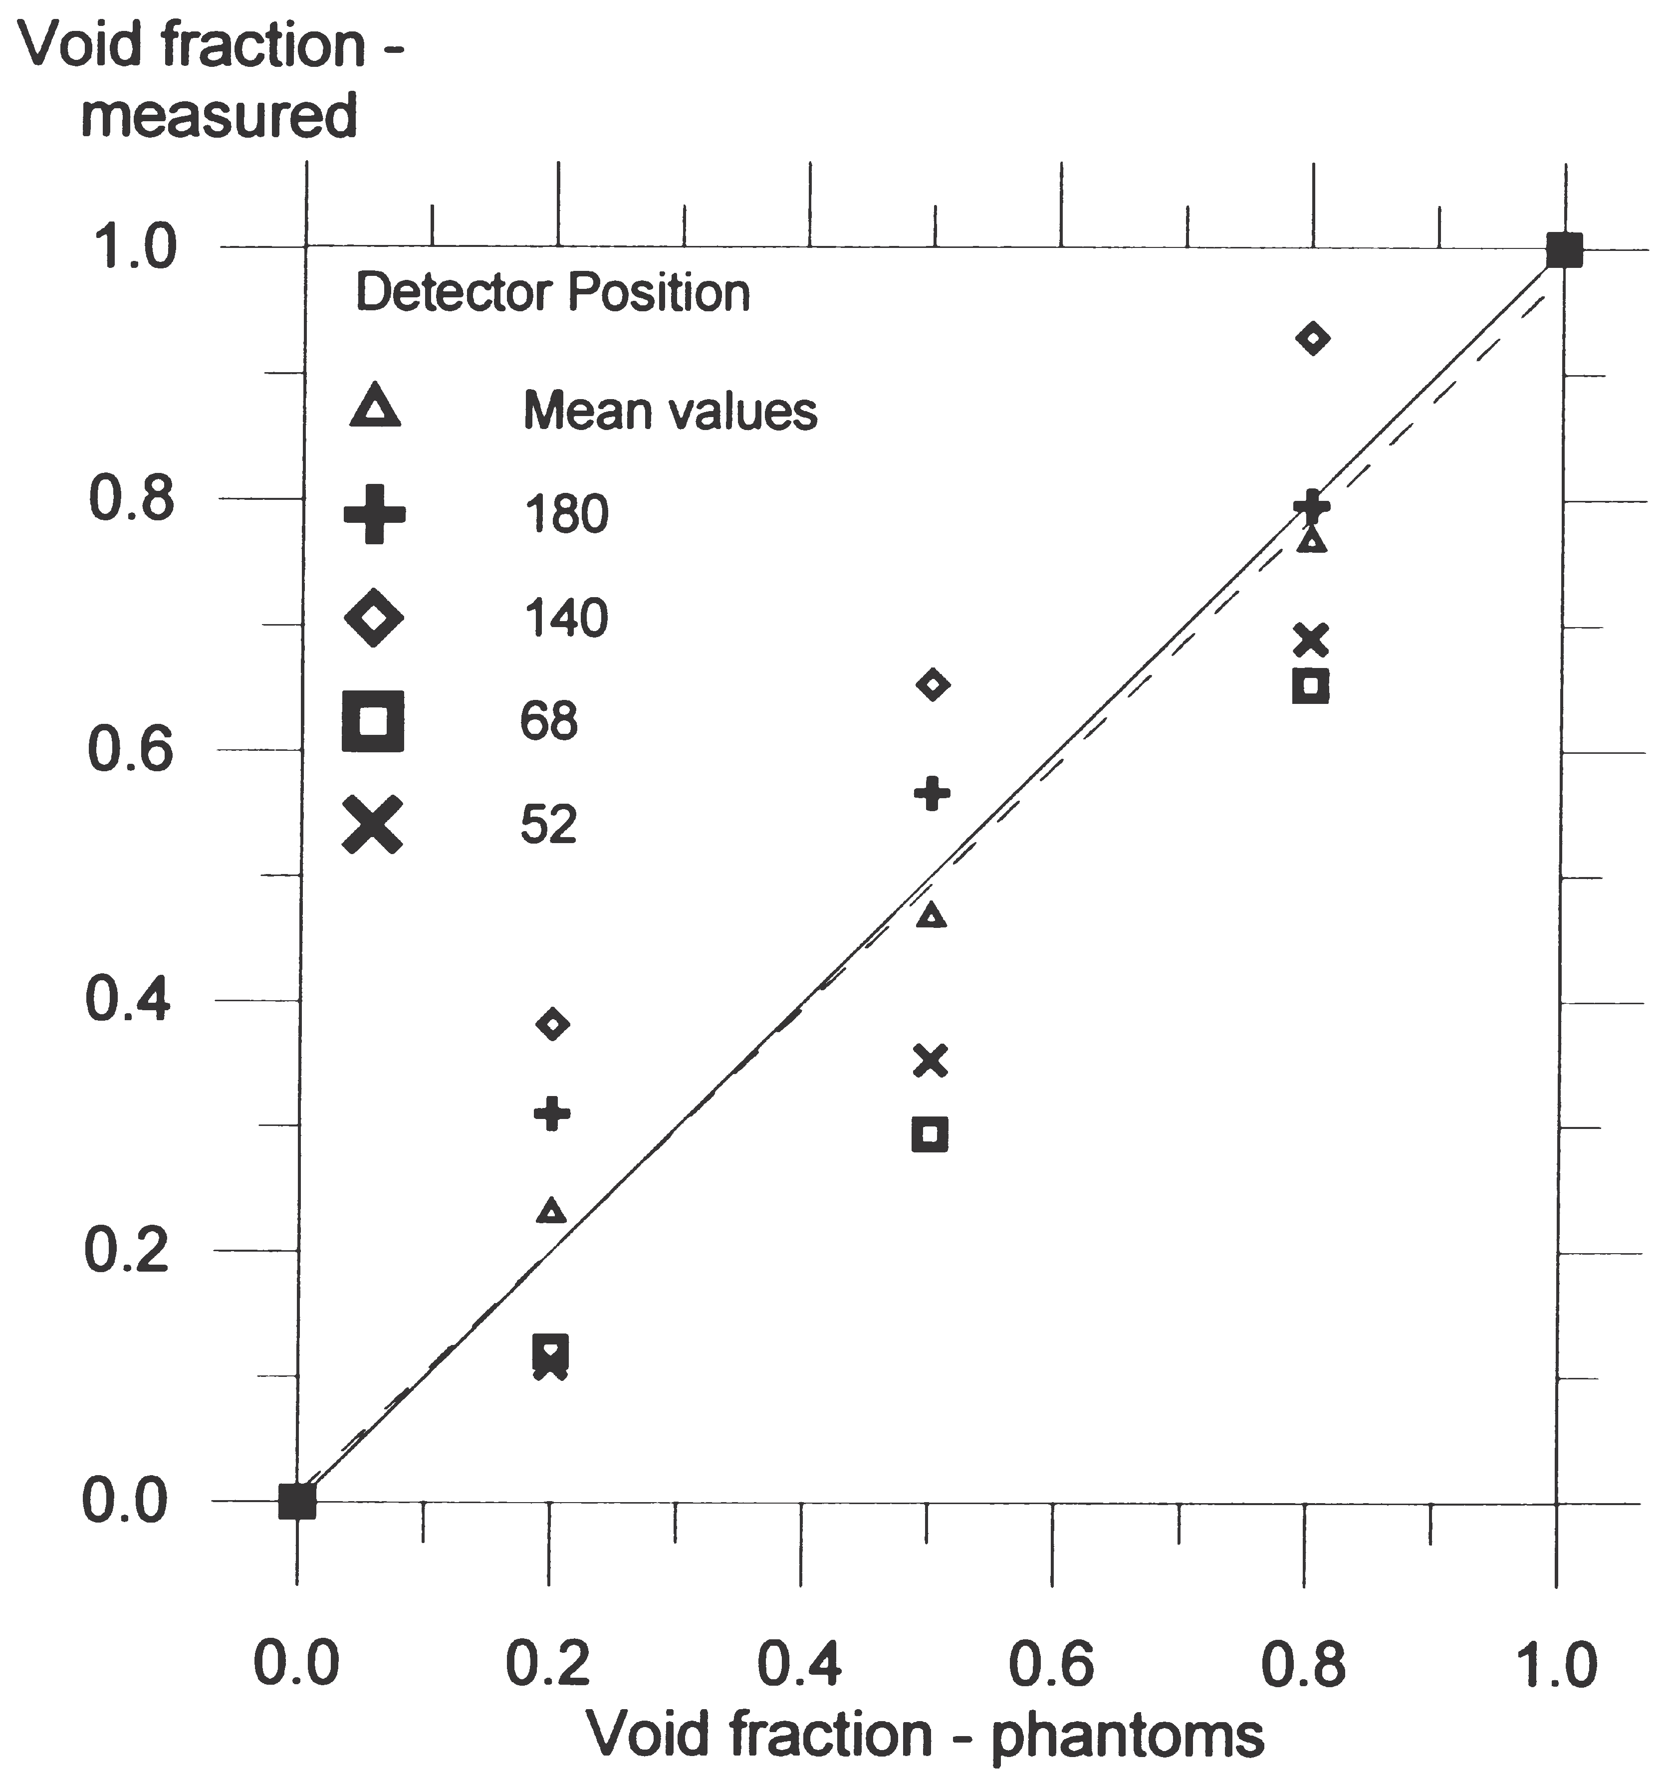
Figure 14: Measured void fraction versus true void fraction of the stratified phantoms at several detector positions. The solid line represents the ideal case with no deviation between true and measured void fractions. The dashed line is the best curve fit of the mean vales
Around the pipe, the minimum number of counts in the full energy peak will be at detector positions outside the beam and when the void fraction is 1, due to the low probability of interaction in gas. The most important contribution to the total statistical error of the measured void fraction is made by positions with the lowest number of counts. The relative standard deviations due to the number of counts in detector positions 52⁰ and 68⁰ are 0.30% and 0.32%, respectively. This suggests that statistical fluctuations in the measured void fractions are negligible, and that the distributions of the data in Figure 13 and Figure 14 are caused by the different probabilities of scattered photons to reaching a given detector position with different phantoms.

CONCLUSION

The performance of single-beam and multi-beam gamma-ray densitometry has been examined. It has been shown how the sensitivity of single-beam densitometers is related to the flow regime and the beam. With conventional technology, the sizes of PMT and shielding are an obstacle to obtaining a compact multi-beam densitometer. The low-energy multi-beam gamma-ray densitometry discussed in this paper is investigated by one single source and one CZT semiconductor detector. Several measurements are performed around the pipe on the same cross-section, representing several detectors installed. Due to the low energy of the source, shielding requirements are reduced, with the result that the source and detectors can be integrated into the pipe-wall.
Using the multi-beam gamma-ray measurement principles, it has been shown that accurate measurements can be made when measurements of four detector positions around the pipe are combined. However, it should be noted that the results depend on the pipe-wall material and thickness, pipe dimensions, and finally, on the composition of the flow.

REFERENCES
1. Thorn R, Johansen G, Hammer E. Recent developments in three phase flow measurements. Messi Sci Tech 8. 1997;691–701.
2. Harrison P, Hewitt G, Parry S, Shires G. Development and testing of the “Mixmeter” multiphase flow meter. Proc North Sea Flow Meas Work. 1995;
3. Linga H. Measurement of two phase flow details. Norwegian institute of technology, University of Trondheim; 1991.
4. Opedal H. Integration gamma densitometrs and venturi meter for liquid phase measurements. University of Bergen (in Norwegian); 1997.
5. Abro E, Johansen G, Opedal H. A radiation transport model as a design tool for gamma densitometers. 1998;
6. Johansen G, Frovstein T, Pedersen H, McKibben B. A flexible test platform for investigating gamma-ray tomography geometries and applications. Proc Front Ind Process Tomogr II, Delft(Netherlands). 1997;

