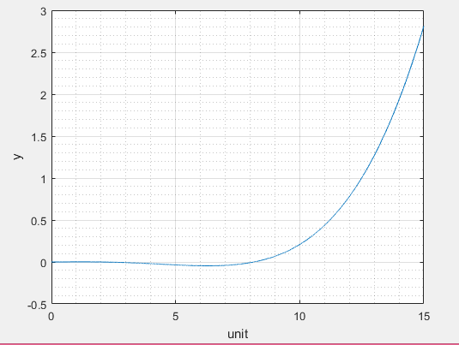

commandwindow
clear
clc
close all
x = 0:0.001:15
y = (15*x.^2-10*x.^3+x.^4)/7200
plot (x,y)
xlabel ('unit'),....
ylabel ('y')
grid on
grid minor

SAMUEL SETH CHINONYE
MECHANICAL ENGINEERING
15/ENG06/062
ENG 381

