NAME: PATRICK EMEKA OBIANWUZIA
DEPT: CHEMICAL ENGINEERING
MATRIC NO: 15/SCI18/018

1)

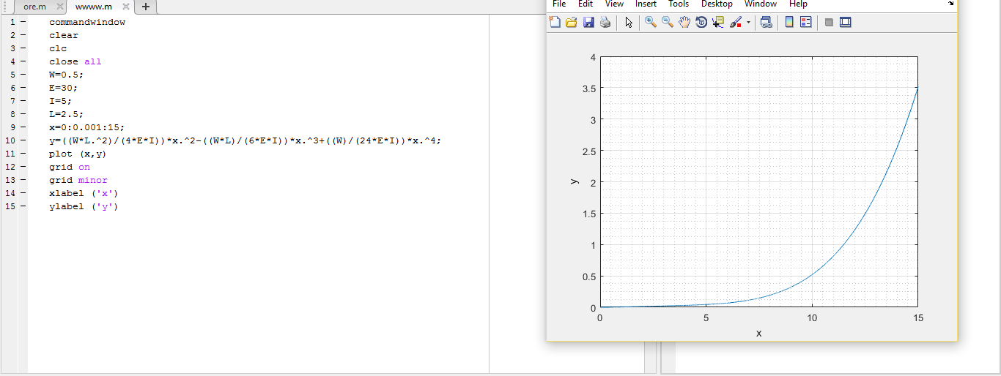

1b


