NAME: AGBEJA OREOLUWA AYOOLUWA
MATRIC NUMBER: 15/MHS01/012
DEPARTMENT:COMPUTER ENGINEERING

1A
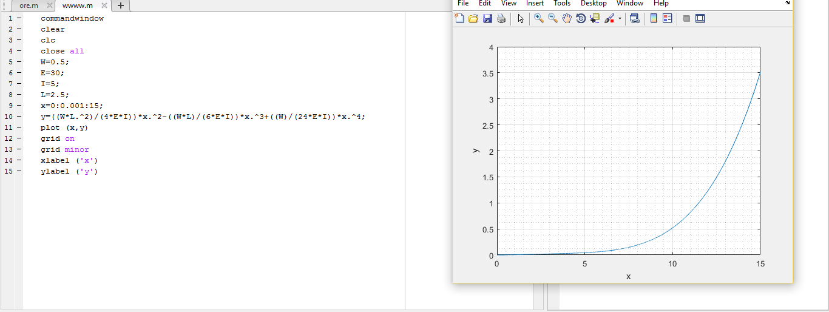

1B
