NAME : ATENI OLATUNBOSUN
MATRIC NO : 15/ENG07/007
DEPARTMENT ; PETROLEUM ENGINEERIMG
COURSE CODE : ENG381 (ENGINEERING MATH)

- commandwindow
clear
clc
close all
x=0:0.001:15
y=(0.5/3600)*(6.25*(x.^2)-2.5*(x.^3)+(x.^4))
plot(x,y)
grid on
grid minor
xlabel ('x')
ylabel ('y')

- 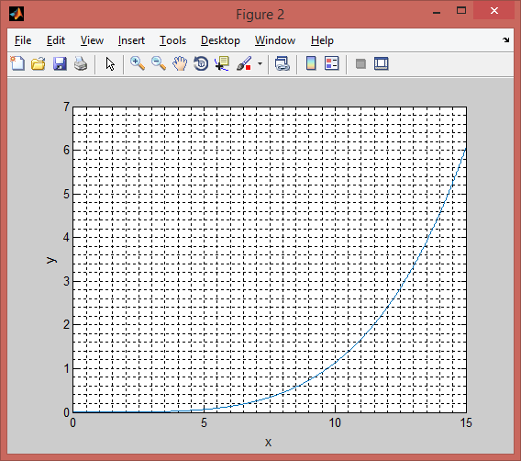commandwindow
clear
clc
close all
t=0:0.001:1
n=2.89*exp(4*t)+2.19*exp(-3*t)-12*(t.^3)+3*(t.^2)-5.5*t-0.0833
plot (t,n)
grid on
grid minor
xlabel ('t(hrs)')
ylabel ('n')

