NAME: CHIJIOKE CHIOMA MIRIAM
MAT No: 14/ENG02/034
DEPT: CHEMICAl ENGINEERING
CHE 531 ASSIGNMENT 5

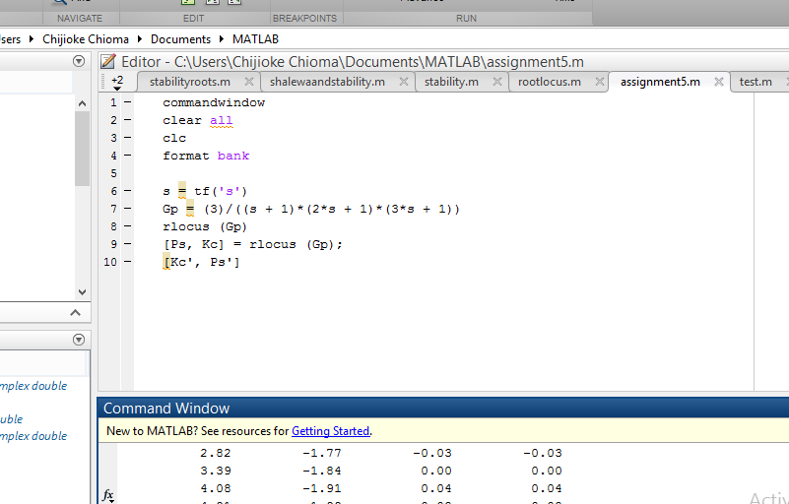

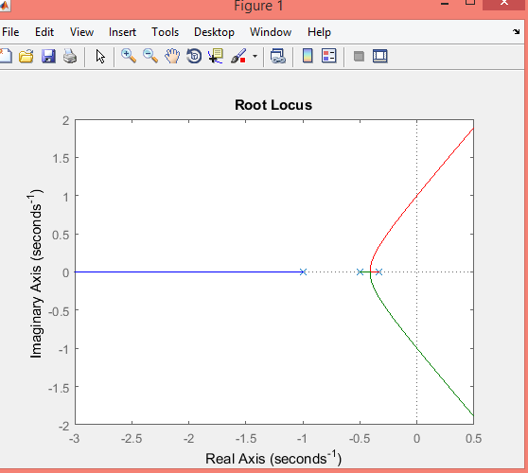
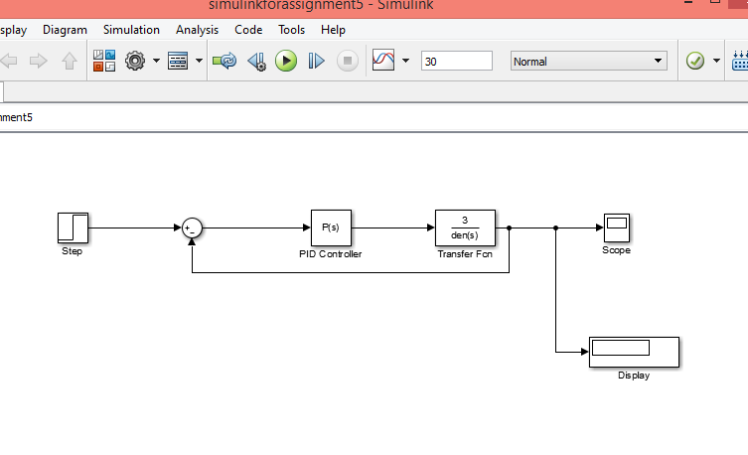

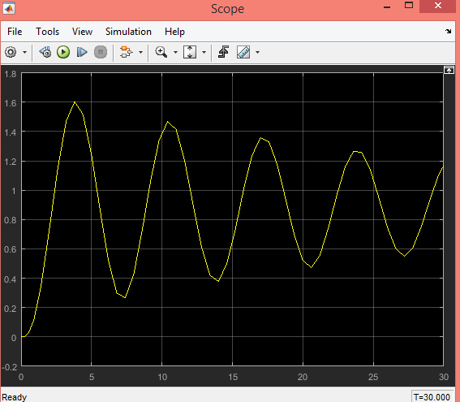
At a kc < 3, the plot obtained in simulink is stable but at kc >3 the plot is unstable.

