AKOMOLAFE DAVID OLUSEGUN
15/ENG01/003
CHEMICAL ENGINEERING

clc
clear
x = 0:0.001:15
a = x.^2
b = x.^3
c = x.^4
y = ((a)/192)-((b)/720)+((c)/4200)
plot(x,y)
xlabel('X')
ylabel('Y')
grid on
grid minor

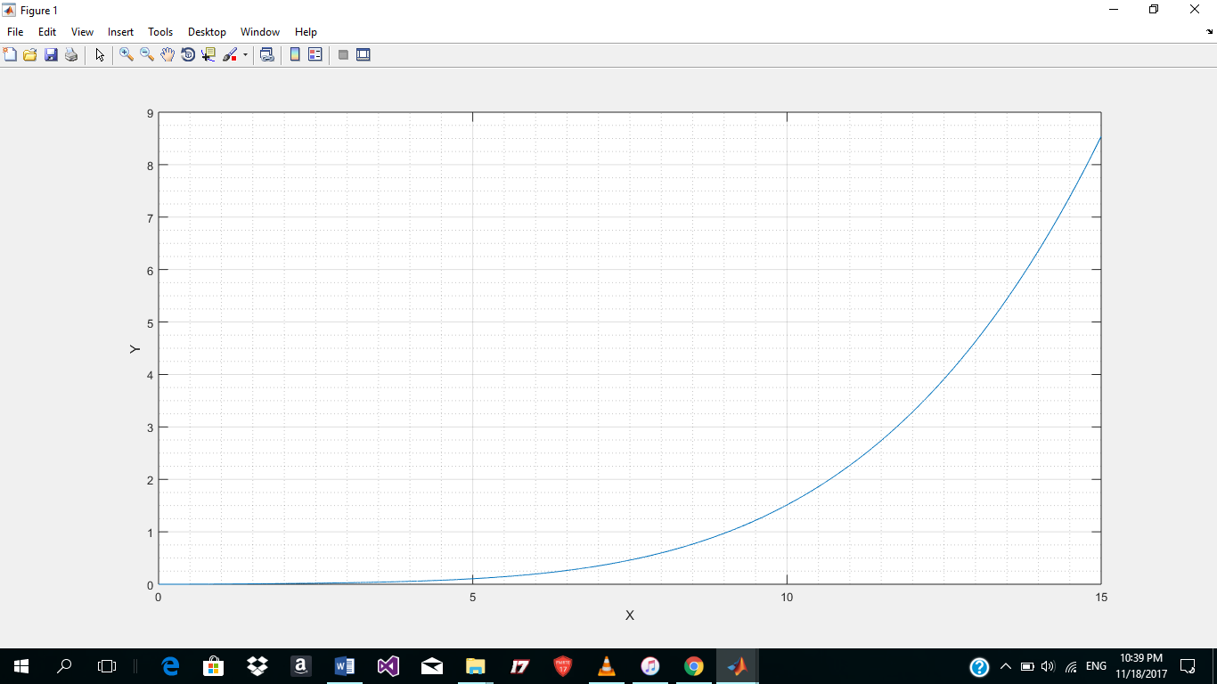

QUESTION 1B
Formula for n = (2.07*EXP(4*A2))+(2.93*EXP(-3*F3A2))-(12*A2^3)+(3*A2^2)-(6.5*A2)
time in hours | amount of product, n
0 | 5
0.01 | 4.933171716
0.02 | 4.872878313
0.03 | 4.819112856
0.04 | 4.771876383
0.05 | 4.73117808
0.06 | 4.697035461
0.07 | 4.669474552
0.08 | 4.648530105
0.09 | 4.634245807
0.1 | 4.626674511
0.11 | 4.625878481
0.12 | 4.631929648
0.13 | 4.644909877
0.14 | 4.664911258
0.15 | 4.692036401
0.16 | 4.726398758
0.17 | 4.768122952
0.18 | 4.817345125
0.19 | 4.874213312
0.2 | 4.938887816
0.21 | 5.011541619
0.22 | 5.092360802
0.23 | 5.18154499
0.24 | 5.27930781
0.25 | 5.385877384
0.26 | 5.501496833
0.27 | 5.626424805
0.28 | 5.760936034
0.29 | 5.905321921
0.3 | 6.059891133
0.31 | 6.224970243
0.32 | 6.400904388
0.33 | 6.588057956
0.34 | 6.786815309
0.35 | 6.997581536
0.36 | 7.220783231
0.37 | 7.456869315
0.38 | 7.706311888
0.39 | 7.969607115
0.4 | 8.247276159
0.41 | 8.539866143
0.42 | 8.847951158
0.43 | 9.172133316
0.44 | 9.513043841
0.45 | 9.871344215
0.46 | 10.24772736
0.47 | 10.64291888
0.48 | 11.05767836
0.49 | 11.4928007
0.5 | 11.94911749
0.51 | 12.42749855
0.52 | 12.92885334
0.53 | 13.45413264
0.54 | 14.00433014
0.55 | 14.58048418
0.56 | 15.18367951
0.57 | 15.81504922
0.58 | 16.47577659
0.59 | 17.16709716
0.6 | 17.89030085
0.61 | 18.64673409
0.62 | 19.43780215
0.63 | 20.26497149
0.64 | 21.12977224
0.65 | 22.03380076
0.66 | 22.97872233
0.67 | 23.96627394
0.68 | 24.99826717
0.69 | 26.07659124
0.7 | 27.20321615
0.71 | 28.38019593
0.72 | 29.60967209
0.73 | 30.89387712
0.74 | 32.23513822
0.75 | 33.63588116
0.76 | 35.09863422
0.77 | 36.62603243
0.78 | 38.22082184
0.79 | 39.8858641
0.8 | 41.62414111
0.81 | 43.43875994
0.82 | 45.3329579
0.83 | 47.31010786
0.84 | 49.37372377
0.85 | 51.52746638
0.86 | 53.77514924
0.87 | 56.12074491
0.88 | 58.56839144
0.89 | 61.12239911
0.9 | 63.78725745
0.91 | 66.56764254
0.92 | 69.46842461
0.93 | 72.49467596
0.94 | 75.65167919
0.95 | 78.94493576
0.96 | 82.38017495
0.97 | 85.96336309
0.98 | 89.70071328
0.99 | 93.59869541
1 | 97.66404668

